caTissue Suite v1.2

User’s Guide

Document Change History

|  |  |  |  |
| --- | --- | --- | --- |
| Version Number | Date | Description | Contributor |
| 1.0 | 8/27/10 | Incorporated all new functionalities and enhancements. | caTissue Release 1.2 Development Team |
| 1.1 | 9/1/10 | Biospecimen summary page and Query chapter updates | Dave Mulvihill |
| 1.2 | 9/1/10 | Consents, specimen operations, bulk operations | Amy Brink |
| 1.3 | 10/2010 | Convert to caBIG template | Laura Jackel |
| 1.4 | 11/8/2010 | Edits/clarifications to Chapter 4. | Dave Mulvihill |
| 1.5 | 11/16/2010 | Updates to Chapter 14. | Dave Mulvihill |
| 1.6 | 11/18/2010 | Updates to Chapter 1  (What’s new in 1.2 added) | Dave Mulvihill |
| 1.7 | 11/23/2010 | Updates to Chapter 13 | Dave Mulvihill |
| 1.8 | 11/29/2010 | Updates to Chapter 1 and Chapter 2 | Dave Mulvihill |
| 1.9 | 11/29/2010 | Updates to Chapter 3 IdP | Dave Mulvihill |
| 2.0 | 12/1/2010 | Final review | Dave Mulvihill |
| 2.1 | 12/7/2010 | Final formatting | Laura Jackel |
| 2.2 | 12/27/2010 | Updated license details and corrected references to 1.0 in Chapter 2 | Dave Mulvihill |
| 2.3 | 3/16/2011 | Updated ant command syntax | caTissue Dev |

This is a U.S. Government work.

Copyright and License Information

**Copyright Notice.** Copyright 2010 Washington University in St. Louis (“caBIG® Participant”). caTissue was created with NCI funding and is part of the caBIG® initiative. The software subject to this notice and license includes both human readable source code form and machine readable, binary, object code form (the “caBIG® Software”).

This caBIG® Software License (the “License”) is between caBIG® Participant and You. “You (or “Your”) shall mean a person or an entity, and all other entities that control, are controlled by, or are under common control with the entity. “Control” for purposes of this definition means (i) the direct or indirect power to cause the direction or management of such entity, whether by contract or otherwise, or (ii) ownership of fifty percent (50%) or more of the outstanding shares, or (iii) beneficial ownership of such entity.

**License.** Provided that You agree to the conditions described below, caBIG® Participant grants You a non-exclusive, worldwide, perpetual, fully-paid-up, no-charge, irrevocable, transferable and royalty-free right and license in its rights in the caBIG® Software, including any copyright or patent rights therein, to (i) use, install, disclose, access, operate, execute, reproduce, copy, modify, translate, market, publicly display, publicly perform, and prepare derivative works of the caBIG® Software in any manner and for any purpose, and to have or permit others to do so; (ii) make, have made, use, practice, sell, and offer for sale, import, and/or otherwise dispose of caBIG® Software (or portions thereof); (iii) distribute and have distributed to and by third parties the caBIG® Software and any modifications and derivative works thereof; and (iv) sublicense the foregoing rights set out in (i), (ii) and (iii) to third parties, including the right to license such rights to further third parties. For sake of clarity, and not by way of limitation, caBIG® Participant shall have no right of accounting or right of payment from You or Your sublicensees for the rights granted under this License. This License is granted at no charge to You. Your downloading, copying, modifying, displaying, distributing or use of caBIG® Software constitutes acceptance of all of the terms and conditions of this Agreement. If you do not agree to such terms and conditions, you have no right to download, copy, modify, display, distribute or use the caBIG® Software.

Your redistributions of the source code for the caBIG® Software must retain the above copyright notice, this list of conditions and the disclaimer and limitation of liability of Article 6 below. Your redistributions in object code form must reproduce the above copyright notice, this list of conditions and the disclaimer of Article 6 in the documentation and/or other materials provided with the distribution, if any.

Your end-user documentation included with the redistribution, if any, must include the following acknowledgment: “This product includes software developed by Washington University in St. Louis.” If You do not include such end-user documentation, You shall include this acknowledgment in the caBIG® Software itself, wherever such third-party acknowledgments normally appear.

You may not use the names ”Washington University in St. Louis”, “The National Cancer Institute”, “NCI”, “Cancer Bioinformatics Grid®” or “caBIG®” to endorse or promote products derived from this caBIG® Software. This License does not authorize You to use any trademarks, service marks, trade names, logos or product names of either caBIG® Participant, NCI or caBIG®, except as required to comply with the terms of this License.

For sake of clarity, and not by way of limitation, You may incorporate this caBIG® Software into Your proprietary programs and into any third party proprietary programs. However, if You incorporate the caBIG® Software into third party proprietary programs, You agree that You are solely responsible for obtaining any permission from such third parties required to incorporate the caBIG® Software into such third party proprietary programs and for informing Your sublicensees, including without limitation Your end-users, of their obligation to secure any required permissions from such third parties before incorporating the caBIG® Software into such third party proprietary software programs. In the event that You fail to obtain such permissions, You agree to indemnify caBIG® Participant for any claims against caBIG® Participant by such third parties, except to the extent prohibited by law, resulting from Your failure to obtain such permissions.

For sake of clarity, and not by way of limitation, You may add Your own copyright statement to Your modifications and to the derivative works, and You may provide additional or different license terms and conditions in Your sublicenses of modifications of the caBIG® Software, or any derivative works of the caBIG® Software as a whole, provided Your use, reproduction, and distribution of the Work otherwise complies with the conditions stated in this License.

THIS caBIG® SOFTWARE IS PROVIDED "AS IS" AND ANY EXPRESSED OR IMPLIED WARRANTIES (INCLUDING, BUT NOT LIMITED TO, THE IMPLIED WARRANTIES OF MERCHANTABILITY, NON-INFRINGEMENT AND FITNESS FOR A PARTICULAR PURPOSE) ARE DISCLAIMED. IN NO EVENT SHALL WASHINGTON UNIVERSITY IN ST. LOUIS OR ITS AFFILIATES BE LIABLE FOR ANY DIRECT, INDIRECT, INCIDENTAL, SPECIAL, EXEMPLARY, OR CONSEQUENTIAL DAMAGES (INCLUDING, BUT NOT LIMITED TO, PROCUREMENT OF SUBSTITUTE GOODS OR SERVICES; LOSS OF USE, DATA, OR PROFITS; OR BUSINESS INTERRUPTION) HOWEVER CAUSED AND ON ANY THEORY OF LIABILITY, WHETHER IN CONTRACT, STRICT LIABILITY, OR TORT (INCLUDING NEGLIGENCE OR OTHERWISE) ARISING IN ANY WAY OUT OF THE USE OF THIS caBIG® SOFTWARE, EVEN IF ADVISED OF THE POSSIBILITY OF SUCH DAMAGE.

|  |  |  |
| --- | --- | --- |
| Names of Development Team(s) here | | |
| Development | User’s Guide | Program Management |
| Vishvesh Mulay | Amy Brink | Srikanth Adiga |
| Sagar Baldwa | Dave Mulvihill | Bijoy George |
| Poornima Govindrao | Laura Jackel | Mark Watson |
| Deepti Shelar | Rashmi Dixit | Rakesh Nagarajan |
| Niharika Sharma |  |  |
| Ketaki Pujari |  |  |
| Supriya Dankh |  |  |
| Nitesh Marwaha |  |  |
| Pooja Deshpande |  |  |
| Chitra Garg |  |  |
| Santosh Ganacharya |  |  |
| Ketaki Pujari |  |  |
| Prachi Sharma |  |  |

|  |  |  |
| --- | --- | --- |
| **Contacts and Support** | | |
| Knowledge Center Main Page | <https://cabig-kc.nci.nih.gov/Biospecimen/KC/index.php/Main_Page> |
| Knowledge Center Discussion Forum | <https://cabig-kc.nci.nih.gov/Biospecimen/forums/> |
| Knowledge Center Contact | [tbpt_kc_support@mga.wustl.edu](mailto:tbpt_kc_support@mga.wustl.edu) |

Contents

About This Guide 1

Purpose 1

Typical User 1

Topics Covered 1

Related Documentation 2

Text Conventions Used 2

Chapter 1 Overview of caTissue Suite 5

Background of Biospecimen Banks 5

caTissue Suite Overview 5

What’s New in caTissue Suite 1.2 6

caTissue Suite Demos 6

Viewing the Public Demo Site 6

Installing caTissue Suite Locally 7

Chapter 2 Getting Started with caTissue Suite 9

Migration from Suite v1.1.x to Suite v1.2 9

Self Registration 10

caTissue Suite User Roles 10

Logging into caTissue Suite 11

Reporting Problems 11

caTissue Suite Application Workspace 11

caTissue Suite General Workflow 12

Using caTissue Suite 13

Your Profile 13

Performing Administrator Duties 14

Managing Biospecimen Data 14

Searching in caTissue Suite 15

Getting Help in caTissue Suite 15

Chapter 3 Setting Up caTissue Suite (Administrative Data) 17

Setting up caTissue Suite for Biospecimen Bank – System Administrator Tasks 17

Setting Up Institutes 18

Adding an Institute 18

Searching for and Editing an Institute 18

Setting Up Departments 19

Adding a Department 19

Searching for and Editing a Department 19

Setting Up Cancer Research Groups (CRGs) 20

Adding a Cancer Research Group (CRG) 20

Searching for and Editing a Cancer Research Group (CRG) 20

Provisioning caTissue Suite Users 21

Adding and Editing a User 23

Reviewing and Approving/Rejecting New Users 23

Assigning Privileges at User Level 24

Searching for and Editing a User 26

Migrating Existing Users to Existing Identity Providers 26

Setting Up Sites 27

Adding a Site 27

Searching for and Editing a Site 28

Setting Up Storage Containers 29

Storage Types and Storage Containers 29

Container Restrictions 29

Creating Storage Types 30

Adding a Storage Type 30

Searching for and Editing a Storage Type 32

Creating Storage Containers 32

Adding a Storage Container 32

Viewing the Storage Container Hierarchy 34

Searching For and Editing a Storage Container 35

Setting Up Biohazards 36

Adding a Biohazard 36

Searching for and Editing a Biohazard 36

Setting Up Specimen Arrays 37

Adding a SpecimenArray Type 37

Searching for and Editing a Specimen Array 39

Chapter 4 Setting Up Protocols (Administrative Data) 41

Setting Up Collection Protocols 41

Setting Up a Planned Collection Protocol (CP) 42

Adding a Collection Protocol 43

Understanding the Specimen Events Tree and Saving the CP 52

Setting Up an Unplanned Specimen Collection Protocol or General Tissue Banking Protocol 53

Setting Up a Complex Longitudinal Collection Protocols 54

Editing a Collection Protocol 57

Setting Up Distribution Protocols 58

Editing Administrative Objects 59

Chapter 5 Creating Dynamic Extensions in the caTissue Suite User Interface (Administrative Data) 61

Dynamic Extensions Overview 61

Creating a Form 61

Creating a Sub-Form (Containment) 72

Using *n* Level Form Containment 73

Creating Lookup Associations 74

Inheriting Attributes from a Common Form 76

Editing the Conditions for a Collection Protocol 79

Editing a Form 80

Editing an Attribute 82

Entering Data for Dynamic Extensions 83

Additional Enhancements in Dynamic Extensions 85

Chapter 6 Setting Up Consent Tracking (Administrative Data) 87

Information Consent and Consent Tiers 87

Setting Up Consent Tracking 88

Recording Participant Responses During Registration 89

Registration Level 89

Specimen Collection Group (SCG) Level 90

Specimen Level 91

Chapter 7 Handling Biospecimens for Technicians and Supervisors (Biospecimen Data) 95

Registering Participants and Collecting Biospecimens 95

Collection Protocol (CP) Based View 96

Registering a Participant to a Collection Protocol 97

CP Based Data Entry 104

Specimen Operations 112

What is the Difference Between an Aliquot and a Derivative? 115

Aliquoting a Biospecimen 115

Creating Biospecimen Derivative 116

Adding Multiple Specimens 117

Adding a Biospecimen Event 119

Performing Bulk Operations for Specimens 122

Adding a Specimen Array 125

Editing Biospecimen Objects 129

Chapter 8 Surgical Pathology Report (SPR) (Biospecimen Data) 133

Surgical Pathology Report (SPR) Overview 133

What You Can Do With the Surgical Pathology Report 134

Conflicting SPRs 136

Chapter 9 Biorepository Summary Page 137

Chapter 10 Introduction to Clinical Annotations 139

Pathology Information 139

Clinical and Health Information 140

Features of Clinical Annotations (CA) 141

Clinical Annotations Workflow 141

Assigning Annotations to a Collection Protocol 141

Adding Clinical and Pathological Data to an Annotation 143

Querying on Annotations 145

Chapter 11 Ordering Biospecimens (Biospecimen Data) 147

Biospecimen Distribution and Ordering Overview 147

Displaying Specimen Distribution Reports 149

Displaying Array Distribution Reports 149

Ordering Workflow 150

Step 1: Add Specimens of Interest to My List 152

Step 2: Order Biospecimens from My List 152

Ordering a Specimen and Specimen Derivatives from an Existing Derivative 154

Ordering an Existing Specimen 154

Ordering a Derivative From an Existing Specimen 155

Ordering Specimens Associated with a Surgical Pathology Report (SPR) 156

Ordering a Specimen Associated with an Surgical Pathology Report 157

Ordering a Specimen Associated with an SPR Not Collected 157

Ordering a User-Defined Specimen Arrant Associated with an SPR 158

Ordering Biospecimen Arrays 159

Ordering Existing Biospecimen Array 159

Ordering a User-Defined Array 160

Distributing Ordered Items 161

Distributing a Parent and Derived Specimen 162

Distributing an Existing Array and a User-Defined Array 164

Distributing a Specimen and Arrays Associated with an SPR 166

Chapter 12 Shipping and Tracking (Biospecimen Data) 169

Introduction to Shipping and Tracking 169

Viewing the Dashboard 170

Creating a New Shipment 172

Requesting a Shipment 174

Processing the Shipment or Shipment Request 177

Processing a Shipment Request 177

Processing a Received Shipment 178

Creating a Shipment or a Shipment Request 180

Editing a Shipment and Shipment Request 181

Editing a Shipment Request 181

Editing a Shipment 181

Chapter 13 Performing Searches 183

Performing a Simple Search 183

Using the Advanced Query Wizard 184

Defining Limits 186

Advanced Options 186

Connecting the Limits 189

Information Panel 190

Defining the Results View 190

Reviewing the Results View 191

Hierarchical Data Representation 192

Spreadsheet Data Representation 192

Defining Attributes in a Spreadsheet 192

Saving the Query 193

Managing Regularly-Scheduled (Canned) Queries 193

Managing Parameterized or Saved Queries 195

Sharing the Saved Queries 197

Accessing the Saved Queries 197

Executing the Saved Queries 198

Performing a Temporal Query 199

Creating a Temporal Query 200

Editing and Deleting a Temporal Query 202

Viewing Search Results 203

Saving and Executing a Temporal Query with User-Defined Values 204

Performing a Keyword Search 206

Searching for Labels and Barcodes using Keyword Search 207

Searching by Attributes 207

Searching by Type Serum 208

Searching with “AND” and “OR” Operators 208

Search Using Wild Card Character 208

Chapter 14 Bulk Operations 209

About Bulk Operations CSV File and XML Template 209

Using Bulk Operations 209

Running Bulk Operations from caTissue Suite 209

Chapter 15 Deriving Plasma and Serum and RNA and DNA 213

Deriving Plasma and Serum 213

Deriving RNA and DNA 214

Appendix A Clinical Annotations 215

Data Entry for Clinical Information Annotation 215

Lab Annotation 215

Family History Annotation 216

Treatment Annotation 216

Rad RX Annotation 217

Chemo RX Annotation 217

Treatment Regimen 218

Environmental Exposure Health Annotation 219

Alcohol Health Annotation 219

Smoking Health Annotation 220

Health Examination Annotation 220

New Diagnosis Health Annotation 220

No Evident Disease Health Annotation 221

Recurrence Health Examination Annotation 221

Local Recurrence Health Examination Annotation 221

Distant Recurrence Health Examination Annotation 222

Pathology-Specimen Collection Group Clinical Annotation 222

Base Solid Tissue Pathology Annotation 223

Base Hematology Tissue Pathology Annotation 225

Radical Prostatectomy Pathology Annotation 226

Needle Biopsy Prostate Pathology Annotation 229

Retropubic Enucleation Pathology Annotation 231

Transurethral Prostatic Resection Pathology Annotation 233

Pancreas Pathology Annotation 236

Lung Biopsy Pathology Annotation 238

Lung Resection Based Pathology Annotation 240

Kidney Biopsy Based Pathology Annotation 242

Kidney Nephrectomy Pathology Annotation 244

Melanoma Pathology Annotation 247

CNS Pathology Annotation 250

Breast Pathology Annotation 252

Local Excision Baseds Pathology Annotation 255

Excisional Biopsy Based Colorectal Pathology Annotation 258

Resection Based Colorectal Pathology Annotation 261

Pathology-Specimen Clinical Annotation 264

Specimen Based Solid Tissue Pathology Annotation 265

Colorectal Specimen Pathology Annotation 265

Specimen Pathology Annotation 266

Melanoma Specimen Pathology Annotation 267

CNS Specimen Pathology Annotation 268

Prostate Specimen Pathology Annotation 269

Kidney Specimen Pathology Annotation 270

Lung Specimen Pathology Annotation 271

Breast Specimen Pathology Annotation 272

Appendix B Complex Querying 275

Queries on Participants 275

Sample 1 Participant Query 275

Sample 2 Participant Query 277

Sample 3 Participant Query 278

Sample 4 Participant Query 279

Sample 5 Participant Query 280

Sample 6 Participant Query 281

Queries on Specimen Collection Group (SCG) 282

Sample Specimen Collection Group Query 282

Queries on Specimens 283

Sample 1 Specimen Query 283

Sample 2 Specimen Query 284

Sample 3 Specimen Query 285

Sample 4 Specimen Query 286

Sample 5 Specimen Query 286

Sample 6 Specimen Query 287

Outer Join Query 287

Queries on Orders 288

Sample 1 Order Query 289

Sample 2 Order Query 289

Sample 3 Order Query 290

Queries on Surgical Pathology Reports (SPRs) 290

Sample 1 SPR Query 290

Sample 2 SPR Query 291

Queries on Annotations 293

Sample 1 Annotation Query 293

Sample 2 Annotation Query 293

Temporal Queries 294

Sample 1 Temporal Query 294

Sample 2 Temporal Query 296

Sample 3 Temporal Query 297

Sample 4 Temporal Query 298

Sample 5 Temporal Query 300

Sample 6 Temporal Query 301

Sample 7 Temporal Query 303

Sample 8 Temporal Query 304

Sample 9 Temporal Query 305

Sample 10 Temporal Query 307

Appendix C Error Messages 310

Administrative Data Tab Errors 310

Biospecimen Data Tab Errors 310

Search Tab Error Messages 312

Appendix D Glossary 314

Index 317

About This Guide

This section introduces you to the *caTissue Suite User's Guide.* caTissue Suite is an integrated biospecimen banking information system.

Topics in this section include:

* on this page
* on this page
* on this page
* on page 2
* on page 2

## Purpose

The *caTissue Suite User’s Guide* provides instructions on how to maximize the usefulness of the application.

## Typical User

This guide is designed for Tissue Bankers, System Administrators, Supervisors, Technicians, and Scientists.

## Topics Covered

If you are new to , read this brief overview, which explains what you will find in each chapter and appendix.

* provides a high-level overview of workflow, data, and features.
* provides general information and instructions to start using .
* provides step-by-step instructions for setting up administrative data.
* provides step-by-step instructions for creating collection and distribution protocols in .
* Chapter 5 provides step-by-step instructions for creating dynamic extensions in .
* provides step-by-step instructions to set up consent tracking.
* provides step-by-step instructions on registering participants and collecting biospecimens.
* provides information and instructions on using the Surgical Pathology Report (SPR).
* Chapter 9 outlines the details available in the Biorepository Summary page.
* provides an introduction to clinical annotations.
* provides step-by-step instructions to order biospecimens.
* provides step-by-step instructions to perform Shipping and Tracking of biospecimens across repository sites.
* provides step-by-step instructions to perform simple and advanced queries.
* provides information about the Bulk Operations.
* provides step-by-step instructions to derive plasma and serum and RNA and DNA.
* lists all clinical annotation formats.
* provides example queries.
* lists error messages.
* provides information to ensure United Kingdom (UK) compatibility.
* provides a glossary of terms for .

## Related Documentation

You can access all documentation and training items by clicking **Help**. The following is a list of other documentation:

* *Technical Guide*
* Training demonstrations
* UML Model diagrammatic representation

## Text Conventions Used

This section explains conventions used in this guide. The various typefaces represent interface components, keyboard shortcuts, toolbar buttons, dialog box options, and text that you type.

| Convention | Description | Example |
| --- | --- | --- |
| Bold | Highlights names of option buttons, check boxes, drop-down menus, menu commands, command buttons, or icons. | Click Search. |
| URL | Indicates a Web address. | http://domain.com |
| text in Small Caps | Indicates a keyboard shortcut. | Press Enter. |
| text in Small Caps + text in Small Caps | Indicates keys that are pressed simultaneously. | Press Shift + Ctrl. |
| Italics | Highlights references to other documents, sections, figures, and tables. | See Figure 4.5. |
| Italic boldface monospace type | Represents text that you type. | In the New Subset text box, enter Proprietary Proteins. |
| Note: | Highlights information of particular importance. | Note: This concept is used throughout this document. |
| { } | Surrounds replaceable items. | Replace {last name, first name} with the Principal Investigator’s name. |

# Overview of

This chapter provides an introduction to concepts and functionality.

Topics in this chapter include:

* on this page
* on page 5
* on page 5
* on page 6
* on page 7

## Background of Biospecimen Banks

Advances in molecular technologies and sophistication in clinical trial design have increased the importance of biospecimen banks in collecting, processing, storing, and distribution of human specimens for correlative science cancer research. Once, biospecimen banks distributed paraffin tissue sections for immunohistochemical analysis, biospecimen banks are now responsible for collecting and distributing multiple human specimen types for molecular studies.

In order to accommodate the functional complexity of the 21st century, biospecimen banks and informatics systems now need functionality to track multiple specimens from the same participant, track refined materials (for example: RNA, DNA, and Protein) that are used for molecular analysis, and annotate specimens with accumulating experimental data, as they are successively used for clinical correlative studies.

Existing tissue-banking systems have some of the above-mentioned features. For example, some systems have specimen-tracking capability, while others provide billing and financial capability. Still others have automated pathology and clinical annotation or associated experimental data for specimens. is the first single system capable of handling all of the these functions.

## caTissue Suite Overview

is a comprehensive solution for biospecimen inventory, tracking, and annotation. can be used by biospecimen resource facilities, regardless of the nature of biospecimen transactions that occur or the type of biospecimens involved in the transaction. integrates the functionality of the existing caBIG® TBPT (Tissue Bank and Pathology Tools) and enables data sharing over the caGrid infrastructure. The following three applications developed by the TBPT Workspace are integrated in this release of :

* **caTissue Core v1.2:** caTissue Core provides the central biospecimen management functionalities needed in biobanking facilities.
* **cancer Text Information Extraction System (caTIES) v2.3**:caTIES provides a means to automate the process of coding, de-identifying, storing, and retrieving data from free-text pathology reports.
* **caTissue Clinical Annotation Engine:** caTissue Clinical Annotation Engine provides a Web-based user interface for standards-based manual annotation of biospecimens with clinical information.

## What’s New in caTissue Suite 1.2

caTissue Suite v1.2 supports many new features. Some of the significant ones being:

* Generic features
* Google-like free text-based search functionality
* Enhanced public summary page
* Integration with other identity providers
* Biospecimen data features
* PPI auto generation facility
* Collection Protocol (CP) Enhancements
* Restrict containers by specimen type
* Specimen data entry enhancements
* “My List” enhancements
* CSV-based Bulk Operation
* Performance enhancements
* Support for label generation at the Collection Protocol, Specimen level, aliquot, and derivative level.
* Advanced query features
* Shared queries
* Query dashboard
* Dynamic Extensions
* Copy/Paste feature for bulk data upload
* New controls
* Single line display
* Calculated attributes
* Skip logic

## caTissue Suite Demos

### Viewing the Public Demo Site

To learn more about , view training material or login to a public demonstration site, see the Tissue/Biospecimen Banking and Technology Tools Knowledge Center: <https://cabig-kc.nci.nih.gov/Biospecimen/KC/index.php/Main_Page>

## Installing caTissue Suite Locally

If you would like to evaluate caTissue locally, you can install on any standard desktop computer or a laptop:

Visit thethe Tissue/Biospecimen Banking and Technology Tools Knowledge Center: <https://cabig-kc.nci.nih.gov/Biospecimen/KC/index.php/Main_Page> for more information on deploying caTissue locally or using a virtual appliance to perform more extensive evaluations.

# Getting Started with

This chapter describes how to log into and review the general functions available in .

Topics in this chapter include:

* on this page
* on page 10
* on page 10
* on page 11
* Reporting Problems *on page 11*
* on page 11
* on page 12
* on page 13

## Migration from Suite v1.1.x to Suite v1.2

The following table describes the migration of data from Suite v1.1.x to Suite v1.2.

| Summary | After Migration |
| --- | --- |
| Migration of Administrators | All Administrators are migrated as Super Administrators and have access to all sites. |
| Migration of Supervisors | Supervisors are made Supervisors for ALL repository sites with default Supervisor privileges for all current and future collection protocols. |
| Migration of Technicians | Technicians are made Technicians for ALL repository sites with default Technician privileges for all current and future collection protocols. |
| Edit privileges of migrated users | Super Administrators or Administrators can edit the privileges of Supervisors and Technicians as required.  **Note:** Users cannot edit their own user role privileges. An Administrator or higher level Administrator must be contacted to perform that task. |
| Demotion of Super Administrators | After the upgrade is complete, any Super Administrator can demote other Super Administrators to Administrators of a particular site/s through or theAPI. |
| Migration of Scientists | All Scientists are migrated as Scientists. The privileges they have if they are protocol Principal Investigators (PIs) or coordinators are maintained. If the Scientists have been allowed/disallowed read privilege on any protocol, those privileges are migrated appropriately. |
| Migration of container privileges | After migration, collection protocols are not associated with any user or site. An Administrator must first associate the collection protocols to the appropriate site, and then the Administrator must associate the user with the site to ensure access to those collection protocols. |

## Self Registration

If you want to be added as a user to :

1. Click the **Sign Up** link on the home page of the application (get this information from your local caTissue system administrator).

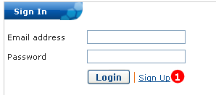

Figure : Sign In Page

The Sign Up page opens.

1. Enter or change your **E-mail Address**.
2. Enter or change your **Last Name** and **First Name**.
3. Enter or change your **Street** (address), **City**, **State**, and **ZIP Code**.
4. Specify your **Country** of residence.
5. Enter your **Phone Number** and **Fax Number** in the format ###-###-####. The Fax Number is optional.
6. Select an **Institution**, **Department**, and **Cancer Research Group**.
7. To add a new one of these items, click **Add New** and enter a new entry. Click **Submit**, and the name is added to the list.
8. When you are done making changes, click **Submit**. The message *Your membership request has been received*. Please wait for an approval email from the Administrator.

## caTissue Suite User Roles

Based on the user role in which you are assigned in , you will have access to certain options and functions within in . provides the following user roles:

|  |  |
| --- | --- |
| Role | Description |
| Super Administrator | The first user created during the deployment of caTissue Suite is the Super Administrator. In , the Super Administrator has administrative privileges on all sites and collection protocols. A Super Administrator can perform any operation in . |
| Administrator | Registers new users, containers, and collection protocols and distribution protocols into . |
| Supervisor | Adds participants and registers them to collection protocols. |
| Technician | Adds specimens into . |
| Scientist | Performs a query and orders specimens and specimen arrays of interest. |
| Custom | This role is customizable with certain required privileges. |

## Logging into

To log into , go to the URL for your instance of . The log in window lists the certified browsers and optimal resolutions to use with . Once you have the appropriate browser and resolution set up:

1. Enter the **E-mail Address** registered in for your name. Enter your password.

**Note:** The **Forgot Password** link was removed from the home page of the application, because sending a password over e-mail was insecure. If you forget your password, send a request to your Administrator, and the Administrator can call you on the phone or other secure media.

1. Click **Signin**.

The application workspace opens.

## Reporting Problems

To report a problem with caTissue, select the “Report Problems” link from the main menu bar. Users are required to enter email address, name, affiliation, subject and a message. The more details entered about how to recreate a problem will allow system administrators to more quickly diagnose and repair the problem.

Administrators can review caTissue Suite issues forwarded from users by clicking the **Administrative Data** tab and **Reporting Problems**. The View Reported Problems page opens listing any problems or issues that users encountered in this instance of caTissue Suite.

To review the issue, click the **Title** link. The Report Problem page opens. Review the issue. The current **Status** is **Pending**. Click **Submit** to submit the problem. Once the issue is resolved, change the Status to **Closed**.

## caTissue Suite Application Workspace

Once you log in to , the workspace comprises of different areas. Based on your user role in , you may not have access to all functions described in this guide.

The following table lists the different areas of the Application Workspace.

|  |  |
| --- | --- |
| Name | Description |
| Blue Bar | The blue bar is at the top of the workspace and has the following functions.   * **Keyword Search:** Fill to search for information in this caTissue instance. * **Report Problems**: Fill in the form to email a problem about . * **Contact Us**: Email the address shown to ask a question or enter a comment about . * **Summary**: Review the total count of available specimens according to their classification. * **Log Out**: Click to log out of . |
| Menu bar | The menu bar is below the blue bar and lists the options available in . Based on your user role, not all options may appear in your instance of . |
| Workflow graphic | The graphic in the middle of the workspace displays a general workflow for . |
| Signin | The Signin area lists the username of the current user and the current version of . |
| Quick Links | QuickLinks provides links to the caBIG and the NCI-CBIIT home pages. There is also a link to the Privacy Notice, Disclaimer, and Accessibility statement. |

## caTissue Suite General Workflow

The following is a general workflow of how the user roles will function within :

1. The Administrator registers new users and adds sites, storage containers (Chapter 3), creates collection and distribution protocols (Chapter 4), and sets up consent tracking (Chapter 6).
2. The Supervisor registers a new participant (associated with a protocol) into (Chapter 7).
3. Once a participant is registered into , Supervisors or Technicians may register accessions (biospecimen collection events) associated with the participant (Chapter 7).

* For surgical specimens, the accession number is the same as the surgical pathology report number.
* For any given accession, one or more specimens may be added as per the collection protocol or user-defined requirements.

1. The Technician may then manipulate the specimen to generate aliquots and/or derived specimens (Chapter 7).
2. User roles may also perform the following tasks within the workflow:

* Supervisors or Technicians can record general properties concerning specimen quality assurance (QA), location, and tracking history.
* Supervisors or Technicians may move any specimen from a site as a result of a Biospecimen Ordering and Distribution (Ordering Biospecimens (Biospecimen Data))
* Administrators or Supervisors may query for available biospecimens using identified data (Performing Searches)
* Technicians and Scientists may query for available biospecimens using de-identified data (Performing Searches).

The following figure is a graphic representation of the described workflow.

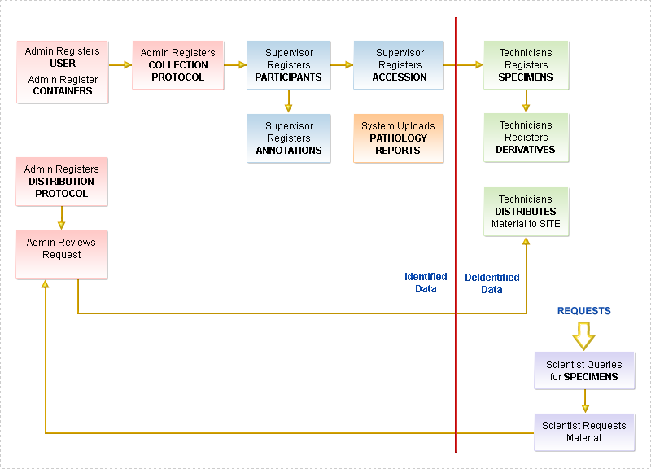

Figure : Biospecimen Banking Workflow Using

## Using

This section provides general information about the different functional areas of :

### Your Profile

Your profile contains general information, such as email address, address, phone number, and institution information. Your profile also lists the privileges that you have in . These can be changed by your Administrator only.

**Note:** If you need to change your password, notify your Administrator.

1. Enter or change your **E-mail Address**.
2. Enter or change your **Last Name** and **First Name.**
3. Enter or change your **Street** (address), **City**, **State**, and **ZIP Code**.
4. Specify your **Country** of residence.
5. Enter your **Phone Number** and **Fax Number** in the format ###-###-####. The Fax Number is optional.
6. Select an **Institution**, **Department**, and **Cancer Research Group**.
7. To add a new one of these items, click **Add New** and enter a new entry. Click **Submit,** and the changes are to the list.
8. When you are done making changes, click **Submit**.

### Performing Administrator Duties

To perform Administrator tasks, click the **Administrative Data** tab on the menu bar. The following table lists the options available.

| Option | Description |
| --- | --- |
| User | Set up users that will use . |
| Institution | Set up, edit, and delete an institution that employs users of . Each user of is associated with one of these institutions. |
| Department | Set up, edit, and delete departments within an institute that wish to store their samples. |
| Can  cer Research Group | Set up, edit, and delete a group of people who are working for a particular research study, e.g., Breast Cancer Research Group. |
| Site | Set up, edit, and delete a physical location where a biospecimen is collected, processed, stored, or analyzed. |
| Storage Container Type option | Set up, edit, and delete a template for storage of biospecimens, e.g., the general definition of a freezer or a shelf. |
| Storage Container | Set up, edit, and delete a physical container used for storing collected biospecimens. |
| Specimen Array Type | Set up, edit, and delete a definition of the class and types of specimens that can be stored in an array type, e.g., a 96-well PCR plate holding molecular specimens along with the dimensions of the array. |
| Biohazard | Set up, edit, and delete a biohazard to be referred to in . |
| Collection Protocol | Set up, edit, and delete a set of guidelines that explains what, how, and when biospecimens are to be collected in order to be utilized for a particular research study. |
| Distribution Protocol | Set up, edit, and delete an abbreviated set of written procedures that outlines what, how many, and how much of a biospecimen or biospecimens will be utilized for the research. |
| Local Extensions | Set up, edit, and delete dynamic extensions in . |
| Reported Problems | Display a list of issues reported from users. |
| Conflicting SPRs | Display a list of Surgical Pathology Reports that are conflicting. |

### Managing Biospecimen Data

To manage biospecimens, click the **Biospecimen Data** tab on the menu bar.

The following table lists the options available.

|  |  |
| --- | --- |
| Option | Description |
| Collection-Based View | Display a view of a collection group and associated information. |
| Participant | Set up, edit, and delete a participant which is an individual from whom biospecimens are collected.  **Note:** A participant is not necessarily a patient. |
| Specimen | Set up, edit, and delete a circumscribed piece of tissue or body fluid that is collected from a Participant as part of a Specimen Collection Group. |
| Specimen Array | Edit, derive, aliquot, add events, or add multiple specimen arrays which are a a collection of biospecimens arranged in an ordered pattern, e.g., a 96-well PCR plate. |
| Distribution | Create Specimen and Array reports. |
| Order Review | Display a list of all the current orders. |
| Shipping and Tracking | Create shipments and place shipment requests. |

### Searching in

To perform and save searches in , click the **Search** tab on the menu bar. The following table lists the options available.

|  |  |
| --- | --- |
| Option | Description |
| Saved Queries | Display, access, and manage your saved queries which can be queries that are run on a regular basis. |
| Simple | Create simple queries of information. |
| Advanced | Create advanced queries of information |
| My List View | Display, access, and manage your advanced queries. |

### Getting Help in

To obtain more information about using , click the **Help** tab on the menu bar.

The following table lists the options available.

|  |  |
| --- | --- |
| Option | Description |
| Help Home | Provides access to helpful documents and links concerning .   * **User Guide** downloads the  *User’s Guide* in pdf format. * **Technical Guide** downloads the  *Technical Guide* in pdf format. * **Training** displays the Welcome e-Learning page. There are training sessions to perform based on user role. * **UML Model** downloads a diagrammatic representation of the UML model of caTissue in .jpg format. * **Knowledge Center Forum** accesses the discussion forum for posting end user queries related to application usage, deployment, and other end user requests. * **Knowledge Center** provides a centralized, authoritative repository of knowledge, information, and web-based support to facilitate the deployment and ongoing development of caTissue Suite. |
| User Guide | Downloads the current version of the  *User Guide* in pdf format. |
| UML Model | Downloads a diagrammatic representation of the UML model of in .jpg format. |

# Setting Up (Administrative Data)

This chapter provides Administrators with instructions to begin adding administrative data and users for a biospecimen bank in .

**Prerequisites**:   
Before you configure the administrative data, you may want to customize the roles and privileges and the label/barcode generation schemes. For more information, refer to the *Technical Guide* present under the help link of the application. When you complete the customization, proceed to configure the administrative data and grant access to your tissue bankers for entering the biospecimen data.

Topics in this chapter include:

* on this page
* on page 18
* on page 19
* on page 20
* on page 21
* on page 27
* on page 36
* on page 37

## Setting up caTissue Suite for Biospecimen Bank – System Administrator Tasks

Before you can access caTissue Suite, the administrative data must be created. The following figure shows the process of setting up a biospecimen bank. This involves creating institutes, departments and cancer research groups, creating users, creating sites, collection protocols, and distribution protocols, and creating storage types, containers, and arrays.

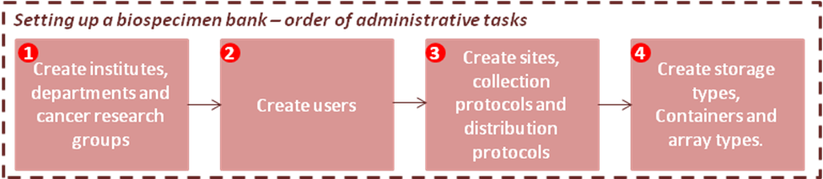

Figure : Setting up a Biospecimen Bank - Order of Administrative Tasks

**Note:** Due to interdependencies in the data, you mustfollow the instructions in Chapters 3 through 5 in the order presented.

The first user created during the deployment of caTissue is the Super Administrator. In a caTissue instance, the Super Administrator has administrative privileges on all sites and collection protocols. Super Administrator is a Super Honest Broker, who has access to all the PHI data in the system.

A Super Administrator can perform any operation in caTissue. The following operations can be performed only by a Super Administrator:

* Create new institutions, departments, cancer research groups, sites, storage types, and all other objects that appear under the **Administrative Data**tab.
* Create new users and associate them with multiple sites and multiple collection protocols or both.
* Create collection and distribution protocols and associate the collection protocols with one or more sites.
* Add new annotations, handle reported problems, and resolve conflicting issues.

## Setting Up Institutes

An *institute* is an institution that employs users who use to set up the tissue bank and participate in the biospecimen collection and processing.

### Adding an Institute

To add an institute to :

1. Click the **Administrative Data** tab.
2. Click **Institution > Add**. The Add Institution page opens.  
     
   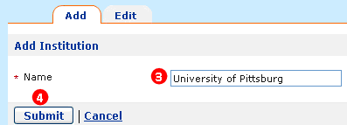

Figure : Add Institution Page

1. Enter the **Name** of the institute.
2. Click **Submit**.

The institute is added to .

### Searching for and Editing an Institute

To add edit an institute in :

**Note:** If you are on the Add Institute page, click the **Edit** tab to search for and edit an institute.

1. Click the **Administrative Data** tab.
2. Click **Institution > Edit**. The Institution Search page opens.
3. Click **Attribute** and specify whether to search for a value within the institute **Name** or **Identifier**.
4. Specify the Condition to apply to the search:

* **Starts With** finds attributes that start with the specified value. **Ends With** finds attributes that end with the specified value.
* **Contains** finds attributes that contain the specified value anywhere within the attribute.
* **Equals** finds attributes that exactly equal the specified value.   
  **Not Equals** finds attributes that are not the same as the specified value.
* If you select **is Null** or **is Not Null**, the Value is disabled

1. Enter the Value for which to search, if available.
2. Click **Submit**.

If there is one match, the Edit Institution page opens. If there is more than one match, double click on the institute in the list to open the Edit Institution page.

1. Make changes to an institution and click **Submit.** The message *Institution successfully updated* appears.

## Setting Up Departments

A *department* resides within an institute and stores institute samples.

### Adding a Department

To add a department to :

1. Click the **Administrative Data** tab.
2. Click **Cancer Research Group > Add**. The Add Department page opens.

Enter the **Name** of the department.

1. Click **Submit**.

The department is added to .

### Searching for and Editing a Department

To edit an department in :

**Note:** If you are on the Add Department page, click the **Edit** tab to search for and edit a department.

1. Click the **Administrative Data** tab.
2. Click **Institution > Edit**. The Department Search page opens.
3. Click **Attribute** and specify whether to search for a value within the department **Name** or **Identifier**.
4. Specify the Condition to apply to the search:

* **Starts With** finds attributes that start with the specified value. **Ends With** finds attributes that end with the specified value.
* **Contains** finds attributes that contain the specified value anywhere within the attribute.
* **Equals** finds attributes that exactly equal the specified value. **Not Equals** finds attributes that are not the same as the specified value.
* If you select **is Null** or **is Not Null**, the Value is disabled.

1. Enter the Value for which to search, if available.
2. Click **Search**.
3. If there is one match, the Edit Department page opens. If there is more than one match, double click on the department in the list to open the Edit Department page.
4. Make changes to the department, and click **Submit.** The message *Department successfully updated* appears.

## Setting Up Cancer Research Groups (CRGs)

A *Cancer Research Group* is a group of people who are working for a particular research study.

### Adding a Cancer Research Group (CRG)

To add a CRG to :

1. Click the **Administrative Data** tab.
2. Click **Department > Add**. The Add Cancer Research Group page opens.

Enter the **Name** of the CRG.

1. Click **Submit**. The CRG is added to .

### Searching for and Editing a Cancer Research Group (CRG)

To edit a CRG in :

**Note:** If you are on the Add Cancer Research Group page, click the **Edit** tab to search for and edit a CRG.

1. Click the **Administrative Data** tab.
2. Click **Institution > Edit**. The Cancer Research Group Search page opens.
3. Click **Attribute** and specify whether to search for a value within the CRG **Name** or **Identifier**.
4. Specify the Condition to apply to the search:

* **Starts With** finds attributes that start with the specified value. **Ends With** finds attributes that end with the specified value.
* **Contains** finds attributes that contain the specified value anywhere within the attribute.
* **Equals** finds attributes that exactly equal the specified value. **Not Equals** finds attributes that are not the same as the specified value.
* If you select **is Null** or **is Not Null**, the Value is disabled.

1. Enter the Value for which to search, if available.
2. Click **Search** and the Edit Cancer Research Group page opens.
3. If there is one match, the Edit Cancer Research Group page opens. If there is more than one match, double click on the CRG in the list to open the Edit Cancer Research Group page.
4. Make changes to a CRG and click **Submit.** The message *Cancer Research Group successfully updated* appears.

## Provisioning Users

Due to the sensitive nature of data stored in , an Administrator must register and approve the user before giving access to .

By default, certain privileges are assigned to each role. The following table describes the default privileges that for each role.

| Privilege | Description | Role |
| --- | --- | --- |
| User Provisioning | Create a user and assign privileges. | Administrator |
| Storage Administration | Add and edit storage containers. | Administrator |
| Protocol Administration | * Add and edit CP * Assign privileges for each protocol | Administrator |
| Registration | * Add or edit a Participant without registration * Register Participants, Consents, and Specimen Collection Group(SCG) * Add and edit Specimen and Consents | Administrator or Supervisor |
| Specimen Processing | * Aliquot and Derive * Add Events * Add Specimen Annotations * Create Specimen Array * Specimen Array Aliquots | Administrator, Supervisor, or Technician |
| Distribution | * View orders * Process Ordering Requests(changing status of specimen orders) * Distribution | Administrator, Supervisor, or  Technician |
| Read Denied | Disallow read access to data under a CP. | Scientists except the Principal Investigator or the coordinators of the CP. By default Scientists have de-identified read privilege to everything. |

A user with User Provisioning privilege can register and approve a new user. By default, an Administrator has the User Provisioning privilege. A user with User Provisioning privilege can perform the following operations:

* Add users and restrict their access to specific sites and collection protocols.
* Override the default privileges, delete the existing privileges, or add privileges.
* Edit the role to promote or demote the existing users.
* View, approve, or reject registration request for a new user.

There are two possible ways of adding a user to caTissue Suite:

Self Registration:

1. User submits a request using the *Sign Up* link.
2. Administrator reviews and approves or rejects the request.
3. If approved, the new user receives a notification with a password.

Registered by Administrator:

1. New user informs administrator via a personal user request.
2. Administrator logs into caTissue Suite and adds the user to the system.
3. New user receives an email notification with the password.

These two methods are shown in the following figure:

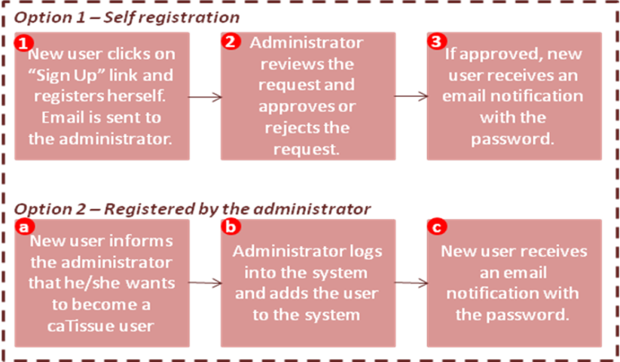

Figure : Two Methods to Register Users in caTissue Suite

### Adding and Editing a User

If you need to add a user:

1. Click the **Administrative Data** tab.
2. Click the **User>Add**. The Add Users page opens.
3. Fill in the User information.
4. Click **Submit**. The user is added to caTissue Suite.
5. To edit the user information, click the **Edit** tab or select the **Administrative Data** tab and click **User>Edit**.

### Reviewing and Approving/Rejecting New Users

To review any user requests that you, the Administrator, received:

1. Click the **Administrative Data** tab.
2. Click **User > Approve New Users**. The Approve Users page opens and all new users that require approval are listed.
3. Select the e-mail address of the user you wish to approve, and the details of the user registration request are displayed.

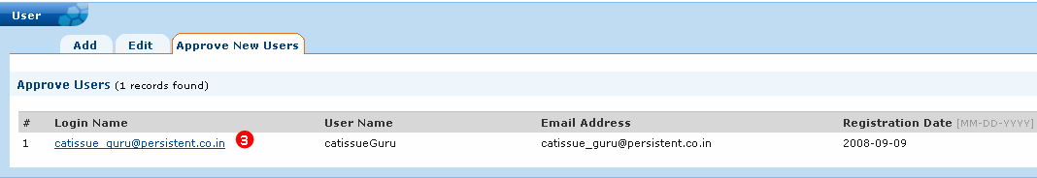

Figure : Approve New Users Page

1. Once you select the e-mail address of the new user, the details of the user registration request are displayed. You can approve or reject the user registration request. After approving the request, the user with the User Provisioning privilege can assign role to the user, associate the user with multiple sites and collection protocols, and assign privileges. The user with User Provisioning privilege can associate the new user with only those sites to which he/she has access. For example: Smith is assigned the User Provisioning privilege for the site Ellis RNA Bank only. After Smith logs in to the system and adds a new user, Smith can view only the Ellis RNA Bank in the Site list. Smith can now associate the new user with this site.

**Note:** Any user with the User Provisioning privilege can add a new user. This new user can be added to the system without being assigned a role or a site.

## Assigning Privileges at User Level

To add a new user and to assign privileges:

1. Click **User** on the **Administrative Data** tab. The User Details page opens.
2. Enter the necessary details like **E-mail Address**, **Last Name**, and the remaining fields.

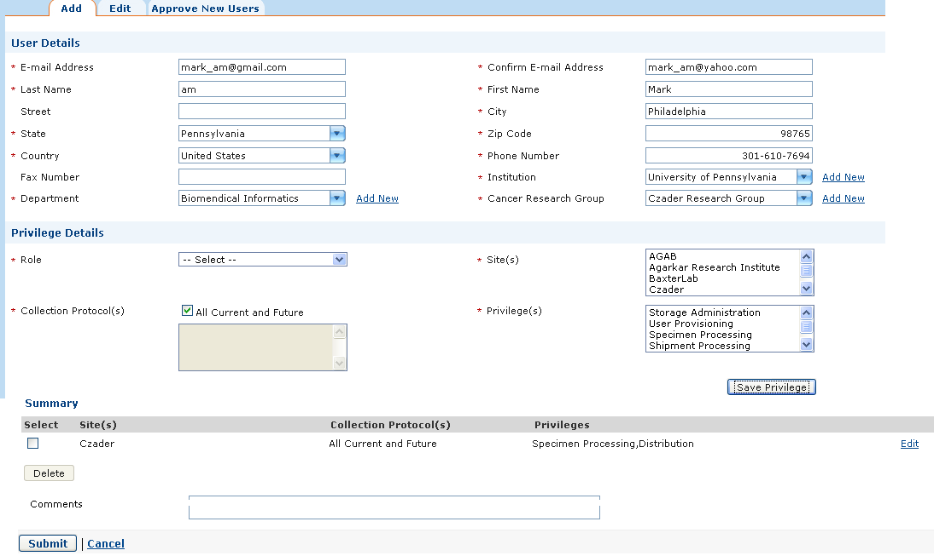

Figure : Add User Page

1. Select the **Role** that you want to assign to the new user. Only a Super Administrator can create another Super Administrator.

**Note:** If you select Super Administrator from the Role drop-down list, the Site(s), Collection Protocol(s) list, and Privilege(s) list are disabled as the Super Administrator is the overall Administrator of the caTissue instance. If you select Scientist, the Site(s) list is disabled as a Scientist is not associated with any site. A READ_DENIED privilege is applicable only to the Scientists. A user with the User Provisioning privilege can restrict a Scientist to a specific collection protocol. This Scientist cannot access data belonging to the restricted collection protocol. If you do not want to assign a READ_DENIED privilege to the Scientist then just click the **Submit** button. There is no need to click the **Save Privilege** button.

1. Select **Custom** from the **Role** drop-down list to customize the role and assign specific privileges to the user.
2. Select the site from the **Site(s)** list. Collection protocols associated with the selected site are populated in the **Collection Protocol(s)** list under the Privilege details section.

The default role-based privileges are assigned and validated for a site of type Repository. Super Administrators have access to all the privileges.

**Note:** A user can be associated with more than one site. If you are an Administrator, not a Super Administrator, the Site(s) list, displays those sites to which you have access.

1. Click **Show Details** in **Privilege Details** section to assign and view privilege details.
2. Select the collection protocol you want to associate with the user from the **Collection Protocol(s)** list.

**Note:** Optionally, select the **All Current and Future** check box if you want to associate the user with all the collection protocols that exist in the site or will be created in the future.

1. Select the required privileges from the **Privilege(s)** list if you choose the **Custom** role. The default privileges for the other roles are selected and highlighted.

**Note**: If you select a particular protocol from the Collection Protocol(s) list, collection protocol related privileges such as Registration, Specimen Processing, and Distribution are populated in the Privilege(s) list.

1. Click **Add** **Privilege** to assign the selected privileges to the user.
2. The **Summary** section displays the details of the privileges assigned to the user.

**Note:** Click **Edit** next to the required row to reassign the privileges. To delete a privilege, select the check box next to the required row and click **Delete**.

1. Click **Submit** to save the user privileges.

The privileges assigned on the User page are restricted to the sites to which the user is associated. A single user can have different privileges for different sites. For example: Smith can have a Supervisor role for Site 1 and a Technician role for Site 2.

Within a single site, a user can have different privileges for different collection protocols. For example: for Site 1, Smith can be assigned the Supervisor role for collection protocol CP1, and the Technician role for collection protocol CP2.

Known issues with the user page:

* The **Save Privilege** button is enabled even if no privilege is selected in the list box. The Save Privilege button should be enabled only if a privilege is selected in the list box.
* Create a scientist user. After submitting the user, in edit mode, the Scientist role is selected, but now ALL privileges are shown in the list box instead of just showing "READ DENIED.”

### Searching for and Editing a User

To edit a user profile and privileges:

**Note:** If you are on the User Details page, click the **Edit** tab to search for and edit a user.

1. Click the **Administrative Data** tab.
2. Click **Site > Edit**. The User Search page opens.
3. Click **Attribute** and specify the type of value for which to search.
4. Specify the Condition to apply to the search:

* **Starts With** finds attributes that start with the specified value. **Ends With** finds attributes that end with the specified value.
* **Contains** finds attributes that contain the specified value anywhere within the attribute.
* **Equals** finds attributes that exactly equal the specified value. **Not Equals** finds attributes that are not the same as the specified value.
* If you select **is Null** or **is Not Null**, the Value is disabled.

1. Enter the Value for which to search, if available.
2. Click **Search**.

If there is one match, the Edit User page opens. If there is more than one match, double click on the user in the list.

1. Make changes to the user, and click **Submit.** The message *User successfully updated* appears.

### Migrating Existing Users to Existing Identity Providers

caTissue Suite can be now be configured to authenticate using existing Identity Providers. In earlier versions, every user had to be created explicitly within caTissue to access caTissue functions. However, all institutions may have one or more Identity Providers with whom the users are already registered.

**Note:** Please refer to the *caTissue Suite Deployment Manual* for details on how to configure caTissue Suite with one or more Identity Providers.

When caTissue Suite is setup with an Identity Provider, existing users can be migrated to this Identity Provider. Rules have to be specified (which are explained in the Deployment Manual) which allow caTissue to find out which users have to be migrated.

1. Once the existing user logs in with caTissue credentials and once the rules are satisfied, the Migration page opens.
2. On the User Account Migration page, enter the login name and password for the Identity Provider.

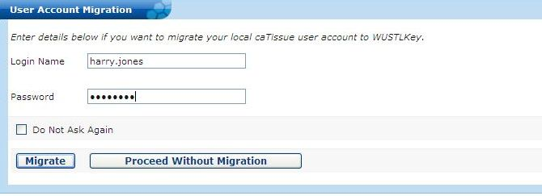

Figure : User Account Migration Page

1. If you choose to proceed with Migration, click **Migrate**. caTissue Suite links the Identity Provider login with the caTissue user name created earlier and the home page of the displayed user. From then on, the user should use their identity provider credentials to use the caTissue system as before.
2. If the user chooses to **Proceed Without Migration**, then the user is logged into caTissue and taken to the home page. The next time the user logs in with the same Identity Provider credentials, the Migration page opens. If the checkbox “**Do Not Ask Again**” is checked, the user will not be migrated and the Migration page will not be shown again.

## Setting Up Sites

A *site* represents a physical location associated with a biospecimens collection, storage, processing, or utilization.

### Adding a Site

To add a site:

1. Click the **Administrative Data** tab.
2. Click **Site > Add**. The Add Site page opens.

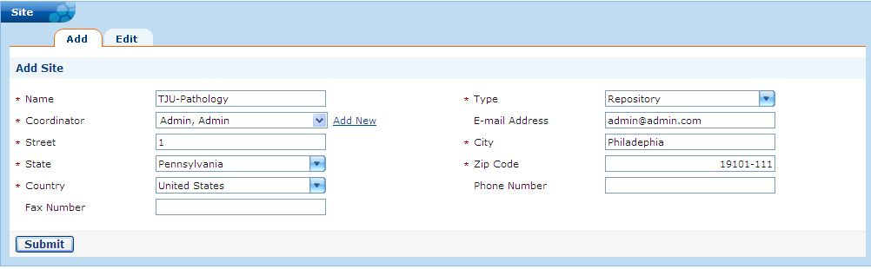

Figure : Add Site Page

1. Enter the site **Name**.
2. Specify the **Type** of site:

|  |  |
| --- | --- |
| Type | Description |
| Collection Site | Location where biospecimens are collected. |
| Laboratory | Location where biospecimens are processed. |
| Repository | Location where biospecimens are stored. |
| Not Specified | Location is not specified. |

1. Click **Submit**.

### Searching for and Editing a Site

To edit a site:

**Note:** If you are on the Add Site page, click the **Edit** tab to search for and edit a Site.

1. Click the **Administrative Data** tab.
2. Click **Site > Edit**. The Site Search page opens.
3. Click **Attribute** and specify the type of value for which to search.
4. Specify the Condition to apply to the search:

* **Starts With** finds attributes that start with the specified value. **Ends With** finds attributes that end with the specified value.
* **Contains** finds attributes that contain the specified value anywhere within the attribute.
* **Equals** finds attributes that exactly equal the specified value. **Not Equals** finds attributes that are not the same as the specified value.
* If you select **is Null** or **is Not Null**, the **Value** is disabled.

1. Enter the Value for which to search, if available.
2. Click **Search**.

If there is one match, the Edit Site page opens. If there is more than one match, double click on the site in the list.

1. Make changes to the Site, and click **Submit.** The message *Site successfully updated* appears.

## Setting Up Storage Containers

The *storage container* structure in is very flexible and aimed at supporting any type of storage hierarchy.

**Note:** By default, the Administrator has the Storage Administration privilege. If you have the Storage Administration privilege, you can add storage containers to the sites to which you have access.

Before creating a storage hierarchy, it is necessary to understand the basic properties of storage containers.

* Storage Types and Storage Containers
* Container Restrictions

### Storage Types and Storage Containers

A *storage type* comprises the basic properties and default values applied to all the containers of that type. For example, Freezer (F1), Rack (R1), and Box (B1) are types of containers. Types are generally presented in a hierarchy. For the Freezer, Rack, Box example, the Box is the lowest in hierarchy and smallest in size. The Freezer is the largest.

A storage container is the actual physical entity and is always identified with a Storage type. For example, Freezer *F1*, Rack *F1_R1*, Box *F1_R1_B1* are the actual physical locations of containers.

### Container Restrictions

You can define restrictions to a container type, so that certain kinds of specimens are stored in a certain container type. If the container is the smallest container (lowest in hierarchy), such as a box, you may want to apply the restriction based on collection protocol and specimen class or both.

The restrictions on the container cannot be reduced once it is occupied, so if the capacity of the container is set up to accommodate 12 racks, and it contains five racks, it is not possible to reduce the capacity of the container.

One example of restrictions applied to a container hierarchy could specify that the Freezer (F1) holds racks only, and Racks (R1) holds test tubes only, and the Text Tubes (TT1) holds a blood sample from a particular study only. You could go into more levels of restrictions. A storage container could be restricted to a particular Collection Protocol. For example, *-80 Freezer* is restricted to CP *B&B Study* and *BCP*, meaning it can only be used for specimens collected under these two collection protocols and not for specimens collected under other CPs.

**Note:** Applying a restriction on the parent container does not automatically apply to the containers placed in that container.

If you do not apply restrictions based on a collection protocol, container type, specimen class, or specimen array type, any type of biospecimens may be stored at any available location. This leads to a disorganized storage container. For example, if your biospecimen bank currently comprises of freezers that hold boxes that hold only tissue, if you do not place restrictions on the freezer, you may have freezers storing fluid specimens along with tissue.

While creating the container, you can restrict the container based on factors like:

1. Type of containers (freezer can only hold racks and racks can only hold boxes).
2. Type of biospecimens (tissue box can only hold tissues specimens).
3. Collection protocol (box 1 can only hold biospecimens from the Breast Cancer Research collection protocol).

**Note:** You can apply more than one of the above restrictions to make the restriction more specific.

## Creating Storage Types

To create and manage storage types:

* Adding a Storage Type
* Searching for and Editing a Storage Type

The following table list the types of sites.

|  |  |
| --- | --- |
| Type | Description |
| Collection Site | Location where biospecimens are collected. |
| Laboratory | Location where biospecimens are processed. |
| Repository | Location where biospecimens are stored. |
| Not Specified | Location is not specified. |

### Adding a Storage Type

To add a storage type:

**Important:**   
Once you know your storage hierarchy, add the container types in from ***smallest*** to ***largest***. A container hierarchy could be a Freezer can hold a Rack, a Rack can hold Box, and a Box can hold tissues. You need to define the Box first, then the Rack, and then the Freezer last (biggest).

1. Click the **Administrative Data** tab.
2. Click **Storage Type > Add**.

The Add Storage Type page opens

.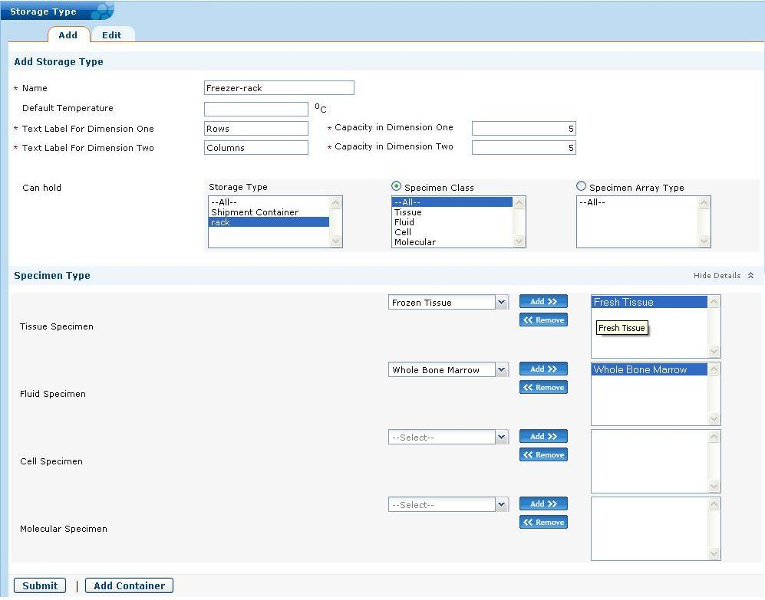

Figure : Add Storage Type Page

1. Enter the **Name** for the storage type.
2. Enter the details of the container. **Capacity in Dimension One** is Row in the following figure and this freezer has five rows. **Capacity in Dimension Two** is the capacity of what the given container can hold for its second dimension. The Capacity in Dimension Two is Column and the freezer has five columns.
3. Enter the **Can hold** details.
4. Specify what the storage type **Can Hold**. Here the storage type can hold another storage type or it can be restricted to hold a particular type of specimen or specimen array type.
5. Under Specimen Type, select if the storage type is to be restricted to hold a particular type of Tissue or Fluid. If Fresh Tissue is selected, this container can hold only Fresh Tissue and no other Tissue Type.
6. Click **Submit.**

**Note:** If you click **Add Container**, the Add Storage Container page opens with the selected container type and restrictions filled in.

### Searching for and Editing a Storage Type

To edit a storage type:

**Note:** If you are on the Add Storage Type page, click the **Edit** tab to search for and edit a Storage Type.

1. Click the **Administrative Data** tab.
2. Click **Storage Type > Edit**. The Edit Storage Type page opens.
3. Click **Attribute** and specify the type of value to which to search.
4. Specify the Condition to apply to the search:

* **Starts With** finds attributes that start with the specified value. **Ends With** finds attributes that end with the specified value.
* **Contains** finds attributes that contain the specified value anywhere within the attribute.
* **Equals** finds attributes that exactly equal the specified value. **Not Equals** finds attributes that are not the same as the specified value.
* If you select **is Null** or **is Not Null**, the Value is disabled.

1. Enter the Value for which to search, if available.
2. Click **Search**.

If there is one storage type found, the Edit Storage Type page opens.  
If there is more than one match, double click on the storage type in the list.

1. Make changes to the storage type, and click **Submit.** The message *Storage Type successfully updated* appears.

## Creating Storage Containers

To create and manage storage containers:

* Adding a Storage Container
* Viewing the Storage Container Hierarchy
* Searching For and Editing a Storage Container

### Adding a Storage Container

A storage container is the actual physical entity and is always of a certain Storage Type. To add a storage container:

1. Click the **Administrative Data** tab.
2. Click **Storage Container > Add**. The Add Storage Container page opens.

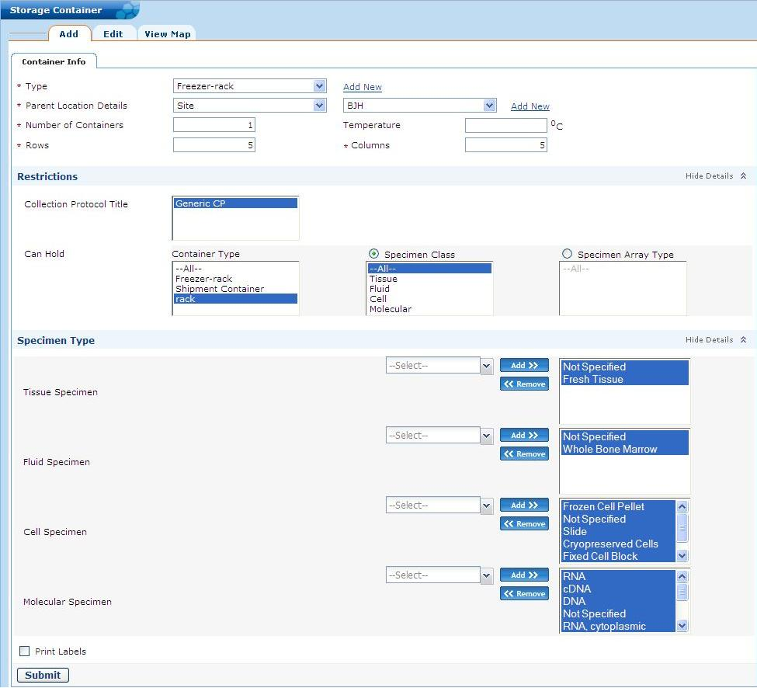

Figure : Add Storage Container Page

1. Select the **Type** of the container being created. If the type does not exist, click **Add New** to create the new type.

**Note:** Do not use Shipment Container storage type and In Transit site to create the storage container.

1. The **Parent Location Details** indicates if the container will be stored within another container or in a site. automatically suggests the next available parent container and the position within it. If this is incorrect, you can change the parent container suggested by . The topmost container in the hierarchy is always stored in a site

* If you select the **Auto** option in **Parent Location Details**, then the appropriate storage containers belonging to the sites for which you have access are displayed in the drop-down list.
* Select the **Site** or **Parent Container** to specify location of the container.
* If you select the **Site** option in **Parent Location Details**, then only those sites for which you have the access are displayed. If you select the **Manual** option in **Parent Location Details**, you can view and add the storage containers for those sites to which you have the access.
* For example, Smith has Storage Administration privilege on the site, Ellis RNA Bank. Smith can view the Ellis RNA Bank site under View Map**,** and can add storage containers only to this site.

1. Specify the **Number of Containers** that you want to create and the **Temperature** for the container.
2. **Capacity** is populated automatically based on the storage type created. You can edit the capacity, if required.
3. Within a site, you can restrict the storage container to specific collection protocols in that site. After you select a site, collection protocols belonging to the selected site are populated. Within the site, you can associate the containers to those collection protocols to which you have the access. By default each container is available for all collection protocols. Specify the collection protocol restrictions for the container in **Collection Protocol Title**.
4. Edit the **Can Hold** section, if required.
5. Click **Submit**. The storage container is added.

### Viewing the Storage Container Hierarchy

To view the storage container hierarchy:

1. Click the **Administrative Data** tab.
2. Click **Storage Container > View Map**. The Storage Container window appears and the complete storage container hierarchy opens.
3. Select the required container from the left pane. This displays the Edit Storage Container page for the selected container.
4. Select the **Container Map** tab.

The Storage Container map displays. The top right pane displays the selected restrictions on that container. The bottom right pane displays the dimensions and the contents of the container.

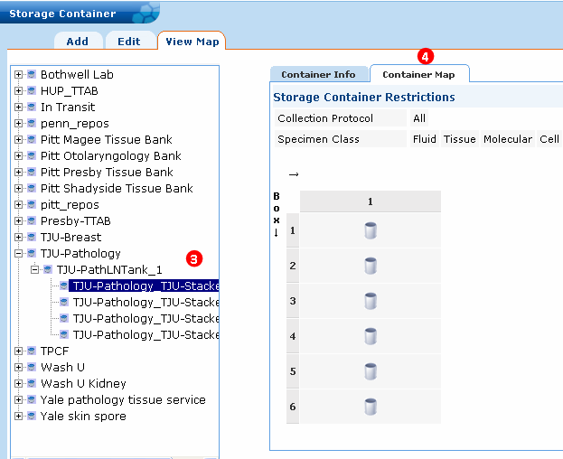

Figure : Storage Container View Map Panel

### Searching For and Editing a Storage Container

To edit a storage container:

**Note:** If you are on the Add Storage Container page, click the **Edit** tab to search for and edit a storage container.

1. Click the **Administrative Data** tab.
2. Click **Storage** **Container > Edit**. The Edit Storage Container page opens.
3. Click **Attribute** and specify the type of value to which to search.
4. Specify the Condition to apply to the search:

* **Starts With** finds attributes that start with the specified value. **Ends With** finds attributes that end with the specified value.
* **Contains** finds attributes that contain the specified value anywhere within the attribute.
* **Equals** finds attributes that exactly equal the specified value. **Not Equals** finds attributes that are not the same as the specified value.
* If you select **is Null** or **is Not Null**, the Value is disabled.

1. Enter the Value for which to search, if available.
2. Click **Search**.

If there is one match, the Edit Storage Container page opens.  
If there is more than one match, double click on the storage container in the list.

1. Make changes to the storage container, and click **Submit.** The message *Storage* *Container successfully updated* appears.

## Setting Up Biohazards

### Adding a Biohazard

To add a biohazard:

1. Click the **Administrative Data** tab.
2. Click **Biohazard > Add**. The Add Biohazard Type page opens.
3. Enter a **Name** for the biohazard.
4. Specify the **Type** of biozard:

* Carcinogen
* Infectious
* Mutagen
* Not Specified
* Radioactive
* Toxic

1. Enter any comments to describe the biohazard.
2. Click **Submit**. The biohazard is added.

### Searching for and Editing a Biohazard

To edit a biohazard:

**Note:** If you are on the Add Biohazard page, click the **Edit** tab to search for and edit a biohazard.

1. Click the **Administrative Data** tab.
2. Click **Biohazard > Edit**. The Edit Biohazard page opens.
3. Click **Attribute** and specify the type of value to which to search.
4. Specify the Condition to apply to the search:

* **Starts With** finds attributes that start with the specified value. **Ends With** finds attributes that end with the specified value.
* **Contains** finds attributes that contain the specified value anywhere within the attribute.
* **Equals** finds attributes that exactly equal the specified value. **Not Equals** finds attributes that are not the same as the specified value.
* If you select **is Null** or **is Not Null**, the Value is disabled.

1. Enter the Value for which to search, if available.
2. Click **Search**.

If there is one match, the Edit Biohazard page opens.   
If there is more than one match, double click on the biohazard in the list.

1. Make changes to the biohazard, and click **Submit.** The message *Biohazard successfully updated* appears.

## Setting Up Specimen Arrays

A *specimen array* in is a collection of biospecimens arranged in an ordered pattern, e.g., a 96-well PCR plate. In the , you can create an array based on an array type, create aliquots, and store and distribute them to investigators.

To create specimen arrays, you must first create an array type. The array type pre-defines the class and types of specimens that can be stored in that array type along with dimensions for the array.

To manage specimen arrays:

### Adding a SpecimenArray Type

To create a specimen array type:

**Note:** If you are on the Add Specimen Array Type page, click the **Edit** tab to search for and edit a specimen array type.

1. Click the **Administrative Data** tab.
2. Click **Specimen Array Type > Add**.

The Add Specimen Array Type page opens.

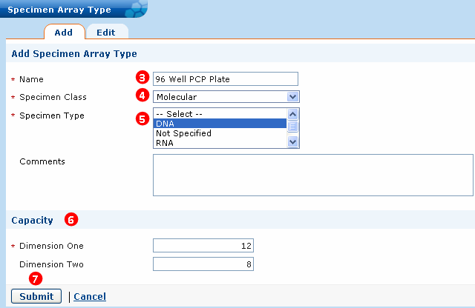

Figure : Add Specimen Array Type

1. Enter a name for the array in the **Name** field.
2. Select an option from the **Specimen Class** drop-down list.
3. Select an option from the **Specimen Type** list that auto-populates based on the selected **Specimen Class**.
4. Specify the capacity of the array under **Capacity**.
5. Click **Submit**. The specimen array is added.

### Searching for and Editing a Specimen Array

To edit a specimen array:

**Note:** If you are on the Add Specimen page, click the **Edit** tab to search for and edit a specimen array.

1. Click the **Administrative Data** tab.
2. Click **Specimen Array > Edit**. The Edit Specimen Array page opens.
3. Click **Attribute** and specify the type of value for which to search
4. Specify the Condition to apply to the search:

* **Starts With** finds attributes that start with the specified value. **Ends With** finds attributes that end with the specified value.
* **Contains** finds attributes that contain the specified value anywhere within the attribute.
* **Equals** finds attributes that exactly equal the specified value. **Not Equals** finds attributes that are not the same as the specified value.
* If you select **is Null** or **is Not Null**, the Value is disabled.

1. Enter the Value for which to search, if available.
2. Click **Search**.

If there is one match, the Edit Specimen Array page opens.  
If there is more than one match, double click on the specimen array in the list.

1. Make changes to the specimen array, and click **Submit.** The message *Specimen Array successfully updated* appears.

# Setting Up Protocols (Administrative Data)

This chapter provides Administrators with instructions to set up collection protocols and distribution protocols in .

**Note:** By default, an Administrator has the Protocol Administration privilege and can add a user only to a collection protocol to which the Administrator has access.

**Note:** Due to interdependencies in the data, you mustfollow the instructions in Chapters 3 through 5 in the order presented.

Topics in this chapter include:

* on this page
* on page 58

## Setting Up Collection Protocols

A *collection protocol* contains a set of guidelines that delineate what, how, and when the biospecimens are to be collected. In a multi-repository scenario, the sites can operate in any of the following ways:

* **Independent sites**: Multiple sites operate independently and on different protocols in a single instance of caTissue.
* **Shared protocols**:
* More than one site accession objects to a shared protocol, but the bank staff performs specimen accessioning and processing independently. The bank staff can perform specimen processing only on the specimens to which they have physical access.
* More than one site accessions objects to a shared protocol and transfers the specimens across sites for further processing or storage.

For the scenarios mentioned above, an Administrator assigns users to the appropriate privileges at the collection protocol level. The Principal Investigator (PI) of the study decides the guidelines of the protocol and applies for IRB (Institutional Review Board) approval. Once approved, the PI requests the Administrator to add the protocol to .

There are two types of collection protocols:

* **Planned** specimen collection protocol
* **Unplanned** specimen collection protocol or general tissue banking protocol

The following topics provide instructions on how to set up different types of collection protocols:

## Setting Up a Planned Collection Protocol (CP)

A *planned collection protocol* has a pre-defined set of specimen requirements and facilitates the collection of specimen through a scheduled plan.

A planned collection protocol process is as follows:

1. Basic protocol information like title, short title and IRB ID is collected
2. Consent tiers are defined.
3. Events (time points) are added
4. Specimen requirements are added per time point.

The following figure graphically presents the planned collection protocol process.

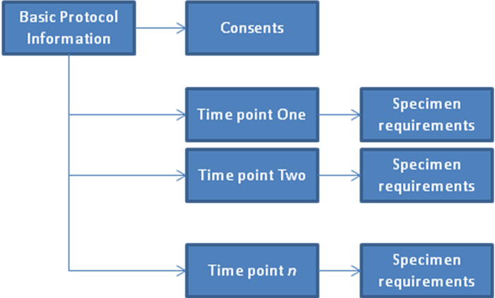

Figure : Planned Collection Protocol Process

### Adding a Collection Protocol

The process to create a planned collection protocol is divided into six steps as shown in the following figure:

1. Basic information like title, short title and IRB ID.
2. Consent tiers.
3. Events (time points).
4. Specimen requirements per time point.
5. Privileges assigned to the users.
6. Save the Collection Protocol.

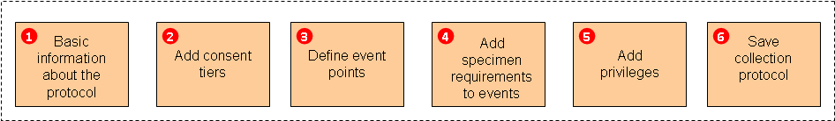

Figure : Workflow to Create a Collection Protocol

To create a planned collection protocol:

1. Click the **Administrative Data** tab.
2. Click **Collection Protocol > Add**.

The Collection Protocol Details page opens.

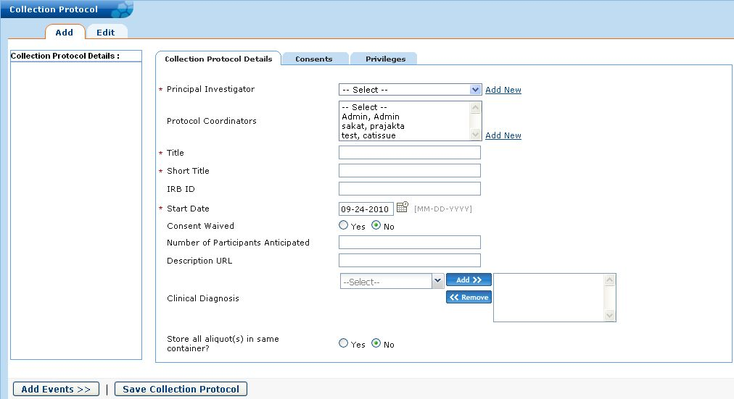

Figure Creating a Collection Protocol - Collection Protocol Details Tab

1. Select the **Principal Investigator.** There is only one Principal Investigator for a single Collection Protocol. To add a new PI, click Add New. Select one **or more Protocol Coordinators**. To select more than one coordinator, <Ctrl> click. To add a new coordinator, click Add New. Enter the **Title, Short Title, Start Date,** Consent Waived, and Number of Participants Anticipated. The **Description URL** allows you to enter a web address from where additional information regarding the collection protocol may be obtained.

You can specify the **Clinical Diagnosis**.

**Note:** It is possible to select a subset of Clinical Diagnosis applicable to the Collection Protocol. Only these selected values will be available at every event level of the Collection Protocol. When a Specimen Collection Group is created for this Collection Protocol, only this subset will be available in the clinical diagnosis dropdown.

The selection of a subset of Clinical Diagnosis is optional. If none are selected, the entire list will be available at all events of the Collection Protocol. Once a Collection Protocol is created with a subset of Clinical Diagnosis, you will be able to add new values to this subset, but will not be able to remove any which were selected earlier.

1. It is possible to set a label format at the collection protocol level. There are three formats:

* **Parent Specimen Label Format** – applied to all parent specimens created for the Collection protocol.
* **Derivative Specimen Label Format** – applied to all derivative specimens created in the Collection Protocol.
* **Aliquot Specimen Label Format** – applied to all the aliquots created in the Collection Protocol.

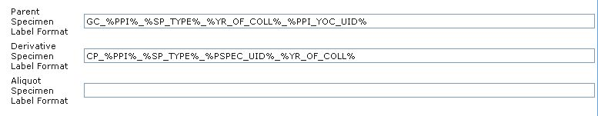

Figure Specifying Label Format Tokens To a Collection Protocol

The format of the label can be any of the following:

* **Empty** – In this case, will not generate any label. The label must be entered manually.
* **A string containing characters and supported tokens**: Tokens create labels with data like the PPI and can be combined with hard-coded strings to create the required format.

The list of supported tokens are listed below:

| Token Name | Description |
| --- | --- |
| %SYS_UID% | For adding the default label. This creates a system-wide unique identifier for the specimen. |
| %PPI% | For adding participant protocol identifier in the specimen label. |
| %SP_TYPE% | For adding specimen type abbreviation. The abbreviations are picked up from “Abbreviations.xml” present in JBOSS_HOME/servers/default /catissuecore-properties folder. |
| %YR_OF_COLL% | For adding year of collection of specimen. |
| %PPI_YOC_UID% | For adding a unique sequence number related to specific PPI and year of collection. |
| %PSPEC_LABEL% | For adding the label of the Parent specimen. |
| %PSPEC_UID% | For adding a unique sequence number related to the parent specimen. |
| %CP_DEFAULT% | For using the same label format as specified at collection protocol level. |

Example label formats are:

* Parent specimen label format: GC_%PPI%_%SP_TYPE%_%YR_OF_COLL%_%PPI_YOC_UID%

This will generate a label of the sort: GC_1892_WB_1999_1 – this for a specimen with PPI 1892, type is Whole Blood, collected in the year 1999 with a unique number 1.

* Derivative/Aliquot specimen label format: 'CP_%PPI%_%SP_TYPE%_%PSPEC_UID%_%YR_OF_COLL%

This will generate a label of the sort: CP_1890_S_1_2010 – for a specimen with PPL 1890, type Saliva, 1st child specimen for the particular parent, and year of collection being year 2010.

**Note:** The label format chosen must create a unique label for a specimen. Currently validation is not performed when the label format is set for a collection protocol. To ensure that the label format is unique add a UID token. returns an error *Specimen Label already exists* when you attempt to generate a non-unique label specimen.

**Note:** If you want all aliquots from this collection protocol to be stored together, select **Yes** for theradio button **Store all aliquot(s) in same container?**  located at the bottom of the page. searches for the container having an appropriate or required number of unused spaces. If it does not find a container that can accommodate all the aliquots, it stores them in different containers.

1. Click the **Consents** tab to define consents.

**Note:** When you add or edit a collection protocol, adding consent data is not mandatory. You can submit a collection protocol without associated consent data.

The Consents page opens.

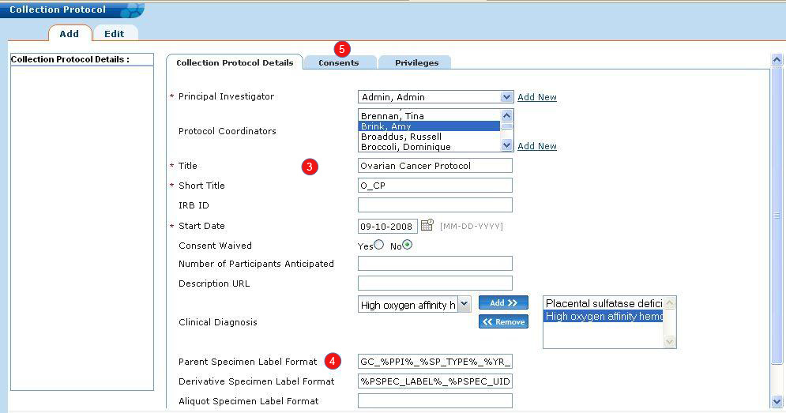

Figure : Creating a Collection Protocol - Collection Protocol Details Tab

**Note:** You can add as many consent tiers as needed. Click **Add More** to add new consent tiers. To delete any unwanted consent tiers, select the check box next to the required statement and click **Delete**.

Since simple lines of text cannot fully describe the consent process, the collection protocol should reference an electronic version of a full unsigned consent document. This is an optional requirement, but you can provide a link in the **Unsigned Form URL** field.

**Note:** When you add or edit a collection protocol, adding consent data is not mandatory. You can submit a collection protocol without associated consent data.

Consent tiers can be edited or deleted till a participant gets registered to that protocol. Once a participant is registered to a CP, you cannot edit or delete Consent tiers. You can add Consent tiers to a collection protocol at any time even if a participant has been previously registered under this protocol. Additional Consent tiers can be applied on the future registrations of a participant to that protocol.

1. Click the **Privileges** tab to define privileges for the protocol.

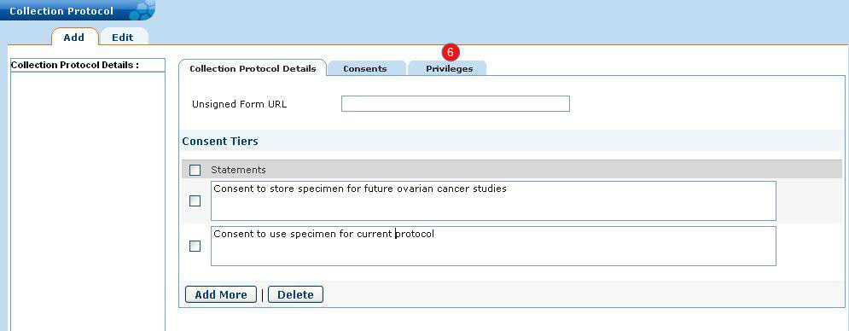

Figure : Creating a Collection Protocol - Privileges Tab Clicked

1. Select a site from the **Site** list with which you want to associate the collection protocol. All the users associated with the selected site get populated in the **User** list box.

**Note:** You can share a collection protocol between multiple sites. To share a collection protocol, select the sites from the Site list. The user can share the collection protocol only across the sites for which he/she has the administrative privilege.

1. Click **Save Privilege**. For this collection protocol, all the users for the selected site acquire the privileges that were assigned to them on the user page.

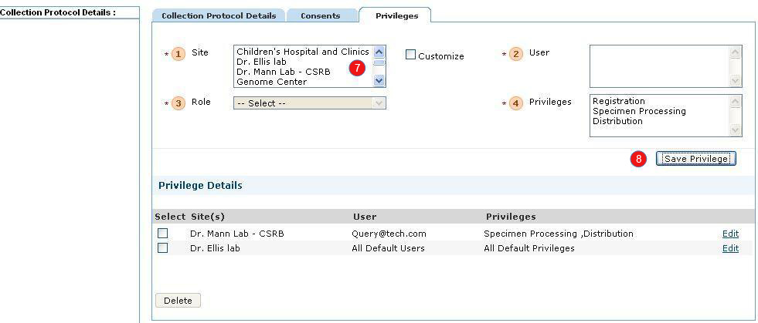

Figure : Creating a Collection Protocol - Privileges Tab

To customize any user’s role for the current collection protocol:

1. Select an option from the **Site** list.

If you want to give default privileges to all users of the selected site to this collection protocol, then click **Save Privileges**. If the user of that site was given ‘All current and future protocol’ default privileges during user creation, then the user will get default privileges at this step.

1. In order to customize the privilege for particular users. Select the **Customize** check box.
2. Select a user from the **User** list. Users are populated based on the site selected.
3. Select a role for the user from the **Role** drop-down list. The four roles available at collection protocol level are: Supervisor, Technician, Scientist, and Custom.
4. Select an option from the **Privileges** list if the role you select is **Custom**.

**Note:** If the role is Supervisor, the user gets Registration, Specimen Processing, and Distribution privileges. If the role is Technician, the user gets Specimen Processing and Distribution privileges. If the role is Scientist and he/she performs a query, you can restrict the Scientist from viewing objects associated with the selected protocol. To do this, select the READ_DENIED privilege.

1. Click **Save Privilege**.

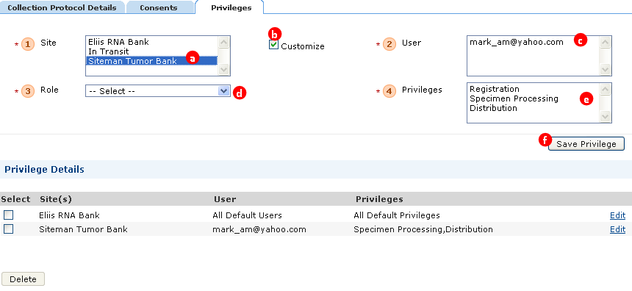

Figure : Assigning Privileges for a Collection Protocol – Privileges tab

**Note:** For a single protocol, a user cannot have different privileges across different sites. For example: Collection protocol CP1 is shared across Tissue Bank 1 and Tissue Bank 2. Mary is the user associated with both the sites. If Mary has the Supervisor privilege for CP1 for Tissue Bank 1, then Mary has the Supervisor privilege for CP1 for Tissue Bank 2 as well.

The **Privilege Details** sectiondisplays the summary of the privileges assigned to the user.

Click **Edit** next to the required row to reassign privileges. To delete privileges, select the check box next to the required row, and click **Delete**.

1. Click **Add Events**.

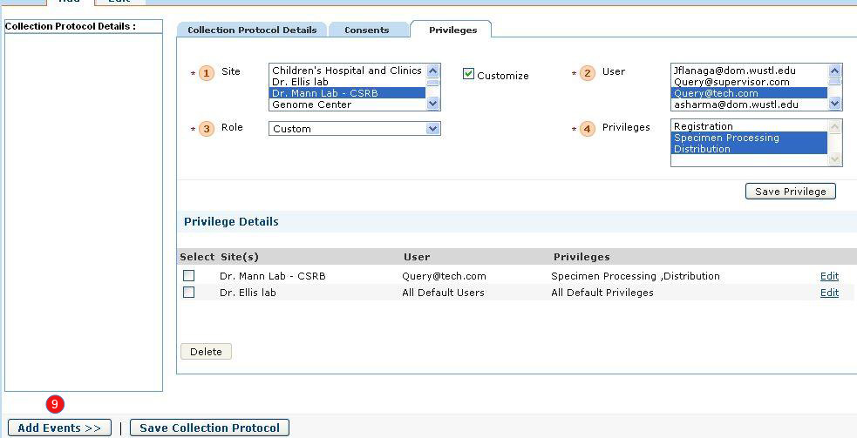

Figure : Click Add Events

The Event Details page is displayed.

1. Enter the details of the event like **Study Calendar Event Point**, **Collection Point Label**, and other details.

The **Clinical Diagnosis** can be selected by clicking the map icon.

The following table describes the fields on the Event Details tab.

| Field | Description |
| --- | --- |
| Study Calendar Event Point | It describes the Time point (in number of days) within the study calendar on which the specimen collection or registration is due. |
| Collection Point Label | It describes the name or designation for this time point. For example: Pre-Therapy, Surgery, 90 day follow-up, Relapse, and so on. |
| Clinical Status | It describes the current position of the participant at a particular time point in the collection protocol. For example: Pre-Surgery, Post-Surgery, or Control. |
| Clinical Diagnosis | It describes the determination of a disease in a participant based on the study of signs and symptoms. For Clinical Diagnosis, there are certain values that are prefaced with [M] for example [M]Malignant melanoma NOS while there is also a value named Malignant melanoma (disorder). All the items with [M] * are histological diagnoses and map directly to the old ICD-O codes (using the NCI Metathesaurus) and are children of body structure. The diagnoses * (disorder) are clinical diagnoses and are children of clinical disorder. So, the rule of thumb is to use [M] * for diagnoses determined by the pathologist and to use * (disorder) for diagnoses assigned through non-pathology studies. |

1. Click **Add Specimen Requirements** to add specimen details to the event.

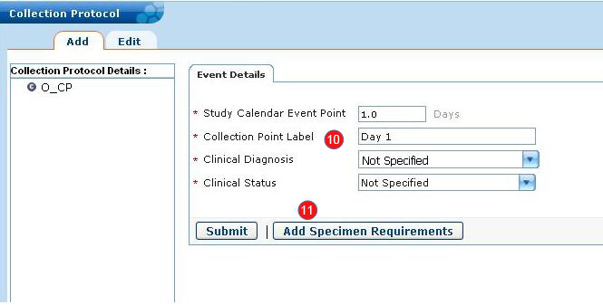

Figure : Creating a Collection Protocol - Event Details Tab

The Specimen Requirement page is displayed

1. On theSpecimen Requirementpage, you can:
2. Enter the specimen details such as **Class**, **Type**, **Quantity**, and other details.
3. Add derivative specimen details that will be created from the specimen.
4. Add aliquot details that will be created from the specimen.
5. Mention **Storage location** details for the specimen, its aliquots, and derivatives. You can specify storage location as auto, manual, or virtual. Auto storage means when a specimen is collected, the system automatically assigns a storage location to the specimen. If a container contains one specimen from a Specimen Collection Group and there is no available storage location, the system searches for the next available container to store the other specimens. Manual storage means the system allows you to select a storage container using the *MAP* option. Virtual storage means the storage location is not assigned to the specimen. For example: aliquots should be created of a fluid specimen as soon as it is received. In such a situation, there is no need to assign a storage location to the fluid specimen as aliquots will be created. The storage location for such a specimen is mentioned as virtual.
6. Mention the label format for a derivative or aliquot. This label format will be used for all derivatives or aliquots created for this specimen.
7. Click **Save Specimen Requirements**.

The following figure shows the Specimen Requirement information.

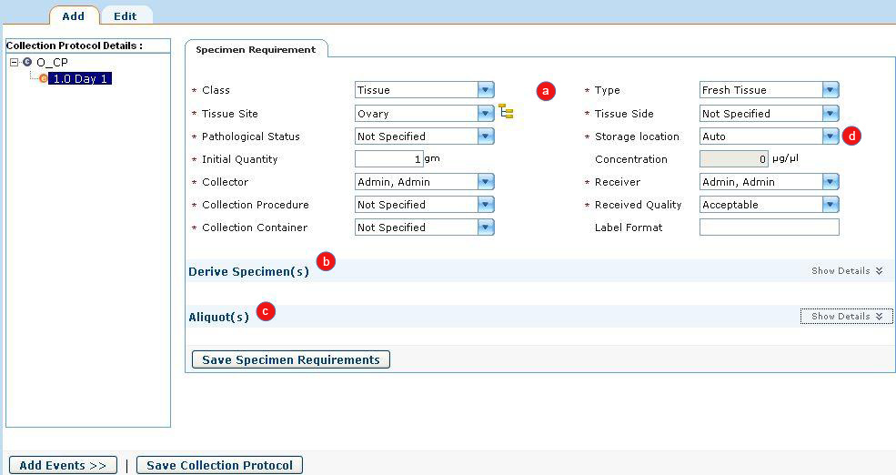

Figure -a: Creating a Collection Protocol - Add Specimen Requirements Page

The following figure shows the Derive Specimen information.

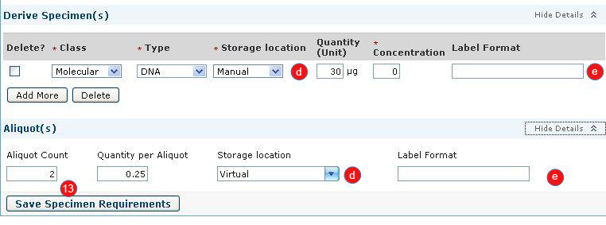

Figure -b: Creating a Collection Protocol - Add Derivative Specimens

Once you define a specimen requirement with aliquots or derivatives, the tree on the left pane is refreshed to display them as shown in the following figure.

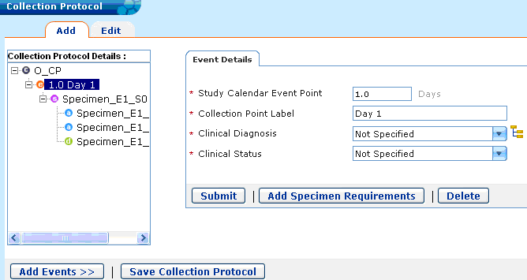

Figure : Creating a Collection Protocol – Tree is Refreshed in Left Pane

Click Add **Events** to add another event.

### Understanding the Specimen Events Tree and Saving the CP

The *specimen events tree* shows a summary of the event points and specimens collected in this collection protocol. The tree grows with every new event or specimen requirements along with the aliquots and derivatives added to the protocol.

The icons indicate:

 The red c is the first level and indicates an event.

 The purple s is the second level and indicates a specimen.

 The blue e is the third level and indicates an aliquot.

 The green d is the fourth level and indicates a derivative.

The following figure shows a specimen events tree with the following organization:

* Contains two events: *Day 1* at time point 1.0 and *PostSurgery* at time point 10.0.
* The time point *Day 1* contains two parent specimens.
* From the first parent specimen, two aliquots and one derivative are created.
* From the first aliquot, a derivative is created.
* The time point *PostSurgery* contains one parent specimen.
* The parent specimen of the second time point has three aliquots and one derivative.  
    
  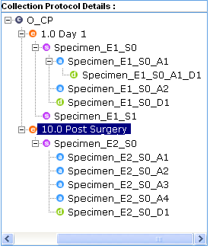

Figure : Specimen Events Tree

To save the collection protocol, click **Save Collection Protocol**.

A success message opens signifying the addition of the collection protocol.

**Note:** It is very important to click **Save Collection Protocol**. Although at each page, you save information, you still must click **Save Collection Protocol**.

### Setting Up an Unplanned Specimen Collection Protocol or General Tissue Banking Protocol

An *unplanned collection protocol* does not have a pre-defined set of specimen requirements. Once you add an event, add a single specimen requirement to each event. This will allow you to save the collection protocol. If a specimen requirement is not added, an error message displays. These specimen requirements are dummy requirements. To create an unplanned collection protocol, perform the same steps used in creating a planned collection protocol (Setting Up a Planned Collection Protocol (CP)).

The following figure shows an unplanned specimen collection protocol with three events with each event having at least one specimen requirement.

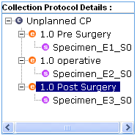

Figure : Unplanned Specimen Collection Protocol

### Setting Up a Complex Longitudinal Collection Protocols

A *longitudinal collection protocol* is a collection protocol that requires many samples at multiple time points to be collected for proteomic, genomic, metabolomic, or pharmacokinetic studies. Essentially, most cancer studies have study arms and study phases. The arms and phases are defined as sub-protocols. Sub-protocols introduce one more level in the hierarchy in the collection protocol definition.

* Study arms are alternative pathways with alternative visit timelines, and participants are assigned to one of these alternative arms by inclusion criteria and/or randomization. Collection time points are often different on different arms.
* Study phases are successive pathways that may or may not apply in the cause of a treatment for one participant. Some phases may apply to all participants and some phases are used for unplanned course of disease progression or relapse. For example, many studies may include a pre-surgical treatment phase with chemo and/or radio therapy to reduce tumor mass. This tends to be a single protocol for all newly-diagnosed patients. Based on the surgical and pathological findings after the surgical removal of the tumor, the participant may be assigned to one of the treatment arms according to their inclusion criteria and randomization. Thus, in the pre-surgery phase, only the time points up to the surgery can be planned. In the post-surgery phase, when the participant is assigned to one of the arms, the next set of SCGs for the respective collection protocol events of that arm can be scheduled. A participant will not be assigned to a relapse phase and the disease progression phase unless the cancer reoccurs.
* Cycles are groups of study events that follow in regular intervals. A cycle can include multiple specimen collections either during one visit or during a close succession of visits. A cycle functions like a phase, but it has sequences of actions that are usually repeated multiple times within a phase.

**Note:** Currently, there is no support to define multiple sub-protocols within a collection protocol. The sub-protocols must be inserted into via the API.

Once the sub-protocols are added to , the same process is followed as described in the planned collection protocol.

The following figure outlines the longitudinal collection protocol process, which shows how basic protocol information and consents are defined for a collection protocol. The collection protocol comprises Sub-protocol 1 and Sub-protocol 2. Each sub-protocol comprises two time points or events and each event has one specimen requirement.

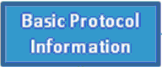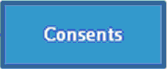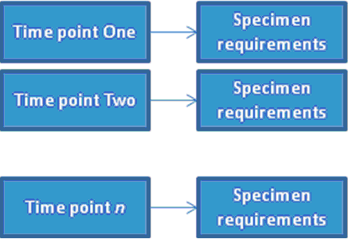

Figure : Basic Structure of a Longitudinal Collection Protocol

#### Understanding the Specimen Details Tree

The specimen details display the hierarchy of sub-protocols present within the main longitudinal protocol. Sub-protocols can be added under the main protocol and can also be added within other sub-protocols. Each sub-protocol further contains specimen collection groups.

The icons indicate:

 The black C indicates the current participant is not registered to this cycle.

 The orange C indicates the current participant is registered to this cycle.

 The black P indicates the current participant is not registered to this phase.

 The blue P indicates the current participant is registered to this phase.

 The black A indicates the current participant is not registered to this arm.

 The purple A indicates the current participant is registered to this arm.

The following figure shows a sample specimen details tree. This sample contains four phases:

* Osteo Serum and Plasma Pre-Surgery-new
* Osteo Serum and Plasma Post Surgery-new
* Osteo Post ttm Follow UP-new
* Osteo Relapse-new  
  …where the participant is registered to the first two phases as denoted by the blue colored icon. The participant is not yet registered to the remaining two phases as denoted by the black colored icon.

This sample also contains four arms under the second phase:

* Post Good Response MAP
* Post Good Response MAPfin-new
* POST Poor Response MAP-new
* POST Poor Response MAPIE-new  
  …where the participant is registered to the first arm as denoted by the magenta colored icon. The participant is not registered to the remaining three arms as denoted by the black colored icon.

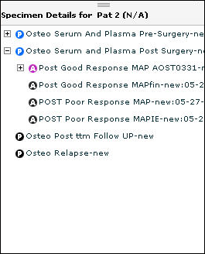

Figure : Longitudinal CP Specimen Events Tree

### Editing a Collection Protocol

Before any participant is registered to the collection protocol, you can edit the following attributes:

* Principal Investigator
* Protocol Coordinators - can be added/removed
* Title
* Short Title
* IRB ID
* Start Date
* Consent Waived
* Number of Participants Anticipated
* Description URI

You can also perform the following tasks:

* Add/Delete consents.
* Add/Update/Delete collection events. If deleted, delete all specimen requirements under it after showing warning.
* Add/Update/Delete specimen requirements. If deleted, delete all child specimen requirements under it after warning.
* Add/Update/Remove privileges.

After a participant is registered to the collection protocol, you can edit following attributes:

* Principal Investigator
* Protocol Coordinator - can be added/removed
* Title
* Short Title
* IRB ID
* Start Date
* Consent Waived
* Number of Participants Anticipated
* Description URL

You can also perform the following tasks:

* Add consents
* This will take effect to only new registrations.
* Old registrations will still have the consents with which the registration was defined on the protocol during that particular registration.
* Add new specimen events and requirements. You cannot edit existing events and specimen requirements.
* Add/Update/Remove privileges.

To edit a Collection Protocol:

**Note:** If you are on the Add Collection Protocol page, click the **Edit** tab to search for and edit a collection protocol.

1. Click the **Administrative** tab.
2. Click **Collection Protocol > Edit**. The Edit Collection Protocol page opens.
3. Click **Attribute** and specify the type of value for which to search
4. Specify the Condition to apply to the search:

* **Starts With** finds attributes that start with the specified value. **Ends With** finds attributes that end with the specified value.
* **Contains** finds attributes that contain the specified value anywhere within the attribute.
* **Equals** finds attributes that exactly equal the specified value. **Not Equals** finds attributes that are not the same as the specified value.
* If you select **is Null** or **is Not Null**, the Value is disabled.

1. Enter the Value for which to search, if available.
2. Click **Search**.

If there is one match, the Edit Collection Protocol page opens.   
If there is more than one match, double click on the collection protocol in the list.

1. Make changes to the collection protocol details, consents, and privileges.
2. Click **Save Protocol.** The message *Collection Protocol successfully updated* appears.

## Setting Up Distribution Protocols

The Administrator follows a set of guidelines designed by the Principal Investigator (PI) to distribute the biospecimens as requested by the users. In order to distribute a specimen to a PI, that PI must have a distribution protocol registered in . An Administrator can create the distribution protocol based on the guidelines submitted by the (PI).

**Note:** Even though the specimen requirements data is collected in the distribution protocol, it is currently not used by to validate the distributions. Therefore, it is optional to enter specimen requirements for a distribution protocol.

To create a new distribution protocol:

1. Click the **Administrative Data** tab.
2. Click **Distribution Protocol > Add**. The Add Distribution Protocol page opens.

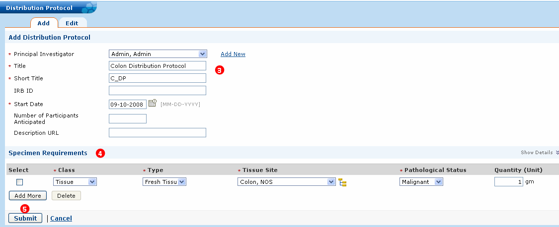

Figure : Adding a Distribution Protocol

1. Enter the **Principal Investigator**, **Title**, **Short Title**, Internal Review Board IRB **ID**, **Start Date** of the protocol, and indicate the **Number of Participants Anticipated**.

You can also provide a **Description URL**, which is the web address having details of the IRB-approved distribution protocol.

1. Enter the **Specimen Requirement** details that are the details of the specimen to be distributed through this distribution protocol.
2. Click **Submit**.

To add a new row under Specimen Requirements, click **Add More**.

To delete a row, select the check box corresponding to the specimen to be deleted, and click **Delete**.

## Editing Administrative Objects

You can edit all the objects under the Administrative Data tab except Reported Problems and Conflicting Reports. The following procedure outlines how you can perform basic editing.

To perform an edit operation:

1. Click **Edit** button under the required object on the **Administrative Data** tab. For example: **User**, **Institution**, and so on. The relevant search window is displayed.
2. Select the required options from the **Attribute** and **Condition** drop-down lists, and enter the required value in the **Value** field.
3. Click **Search**. The Search Result page displays the matching records.
4. Double-click the record of interest. The Edit page is displayed. For example: if you search for storage type, the Edit Storage Type page will be displayed.
5. Make the required changes and click **Submit**. A success message is displayed once the record is updated.

# Creating Dynamic Extensions in the User Interface (Administrative Data)

This chapter provides Administrators with instructions to create new dynamic extensions in .

**Note:** Due to interdependencies in the data, you mustfollow the instructions in Chapters 3 through 5 in the order presented.

Topics in this chapter include:

* on this page
* Entering Data for Dynamic Extensions on page 80
* on page 86

## Dynamic Extensions Overview

### Creating a Form

This section describes how to build a simple form using dynamic extensions. Only a user with administrative privileges can execute these procedures.

To create a new form:

1. Click the **Administrative Data** tab.
2. Select **Local Extensions > Add**. A Warning page opens indicating that the tables in the caTissue database will be created or altered if you create or edit a Dynamic Extentions.
3. Click **Next**. The Build Annotation Form page opens.

**Note:** As an Administrator, you can preview the Dynamic Extensions once the creation process is complete. For data entry, an Administrator must execute “deploy_app” ant target and restart the JBoss server. Please refer to the *caTissue Deployment Manual* for more details.

1. Click **Hook Entity** and select an association between the local extension and an entity.
2. Hook Entity is a static class in caTissue Suite to which the dynamically created annotation form is linked. The entity you choose depends on the annotations you are defining. If your form contains fields (attributes) like hair color, height, and sexual orientation, you can associate it with a Participant, since these attributes are characteristics of a person. In case your form is used to record the details of the analysis of a particular block of tissue, you can associate the annotation form with Specimen. Specimen Collection Group associates the extension with one or more collection protocols.
3. Select the Collection Protocol to which the annotation form is relevant. The annotation form is available to all users who enter or query for data under that protocol. For example, select the protocol B & B study (Blood and Biopsy Study). Once created, the form will appear for all the participants registered under B & B study (Blood and Biopsy study) collection protocol only.
4. Click **Submit**.

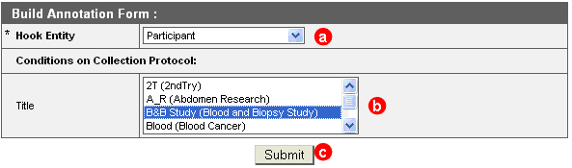

Figure : Build Annotation Form Page

The application navigates to the Define Group page.The next step is to create an annotations group.

1. From the 1 Define Group page, specify whether to create a new group or select annotations from an existing group.

* To create a new group, click **Create New**.
* Enter the **Group Title**. The **Group Title** name should not contain any special characters or any spaces.
* Add a **Definition** for the group title, if needed.
* Click **Next**.The Build a Form page options.

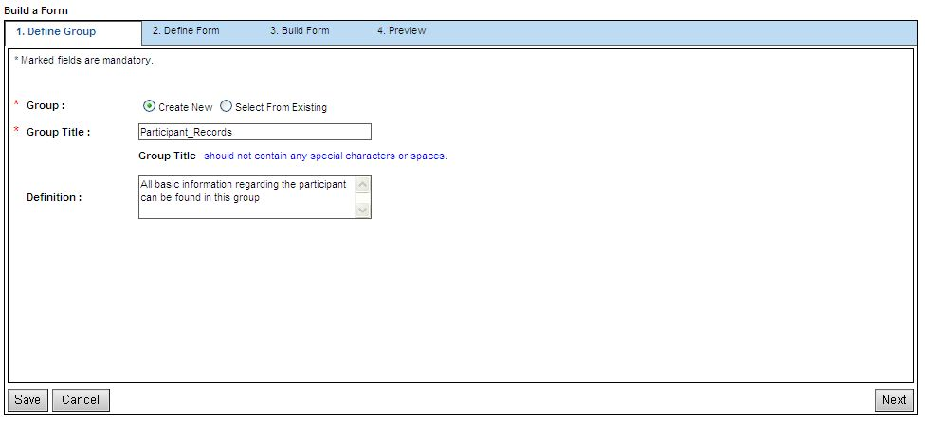

Figure : Define Group Tab

To select an existing group, click **Select From Existing**.

* From the **Group Title** list, select the appropriate group.
* Click **Next**.

**Note**: Please note that the Group Title name should not contain any special characters or any space

The Define Form page opens.

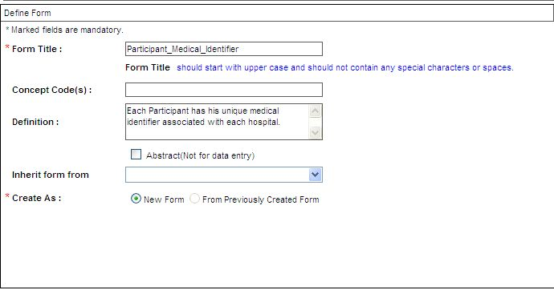

Figure : Defining a Form

1. To define a form:
2. Enter the **Form Title**. This title appears as the name of the form when it opens in for data entry. The **Form** title name should not contain any special characters or any spaces.
3. Enter EVS concept code that defines the form title in the **Concept Code(s)** field.
4. Enter a free text definition of the form in the **Definition** field.
5. Check **Abstract/Not for data entry** or keep unchecked.
6. Select where to select an existing form from **Inherit form from** list.
7. To create the form from an existing form, click **From Previously Created Form**. To create a new form, select **New Form**.
8. Click **Next**. The Build Form page opens.

#### Adding Attributes to the Form

Once the form is defined, and you navigate to the Build Form page, you can add attributes to your form include:

Additional form setup tasks are:

##### Adding an Edit Box

With the Edit BoxProperties page, you can collect a value which is not pre-defined. For example, an Edit Box could capture a dimension of a container, an age of a patient, or an address of a treatment center.

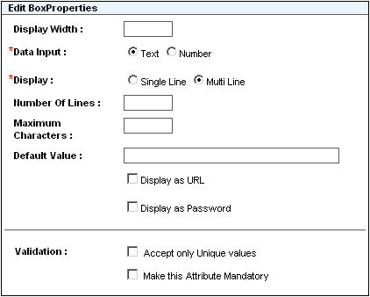

Figure : Edit BoxProperties page

The following table lists the attributes of the Edit Box Attribute Type.

| Attribute Type | Description |
| --- | --- |
| Display Width | Enter the field width, which is the width of the box to be displayed. This is not the same as the length of the value that can be entered, which is the Maximum Characters listed below. |
| Data Input | **Text**: Select this option if the value to be entered for the attribute is text. |
| **Number**: Select this option if numerical value is to be entered for the attribute. |
| Display | **Single Line**: Select this option to keep the data display limited to one line. |
| **Multi Line**: Select this option to display the data across multiple lines. Also, specify the Number Of Lines across which the data is to be displayed. A multi-line display is useful when you expect that the user will be typing more than a few words. |
| Maximum Characters | Enter the limit for maximum number of characters that can be entered in the data field. |
| Default Value | Enter a value to display it as the default value for the given attribute. This is optional. |
| **Display as URL**: Select this option to display the default value entered as URL.  **Note**: To display as a URL, set a default value is mandatory. |
| **Display as Password**: Select this option if you do not want the screen to display the exact letters or numbers a user is typing in, but rather to indicate each character with ‘#’. |
| Validation | **Accept only Unique values**: Select this option to accept only unique values for the attribute. This will allow users to enter only a unique value in each record. Do not select this option if it is ever possible that the same value will be specified for this field in two different instances of this form. |
| **Make this Attribute Mandatory**: Select this option to make data entry mandatory for the given attribute. |
| **Accept Values Includes Min.& Max.Values**: Select this option to restrict the values the user can enter value within a specified range. This option is available only if data input is of type Number. |

##### Adding a Check Box

The Check BoxProperties page is used if an attribute has only one out of two values, and the two values are of type *yes* or *no*. For example, a Check Box can be used to ask if the patient has high blood pressure or not, or the tumor stage can be determined or not.

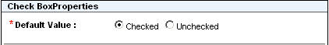

Figure : Check Box

The following figure shows a Multiselect check box to check off multiple options.

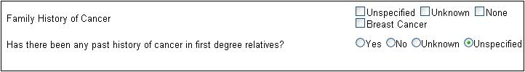

Figure : Multiselect check box

The following table lists the attributes for the Check Box Attribute Type.

| Attribute Type | Description |
| --- | --- |
| Default Value | Select the Checked option to allow the attribute data field to appear as checked. Select Unchecked if you do not want the attribute data field to appear as checked. |

##### Adding an Option Button

The Option ButtonProperites page provides a radio button attribute type. The Option Button type is used to select one value from a small list of multiple possible values, which is more than two. For example, an Option Button is used to capture information on Sex, where the values are Male, Female, and Unknown.

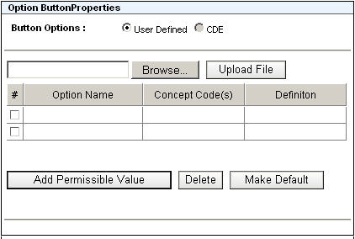

Figure : Option ButtonProperties page

The following table lists the attributes of the Option Button Attribute Type.

| Attribute Type | Description |
| --- | --- |
| Button Options | **User Defined**: This is the default option, which allows you to enter permissible values of your choice manually.  **CDE**: This option allows you to search for a caDSR Value Domain and fetch the permissible values from the standard repository. However, this option is not yet implemented and is currently disabled. |
| Browse | You can upload a file containing the permissible values by clicking **Browse** and then clicking **Upload** **File**. The file should be in comma-separated-value format, with each line containing a permissible value, concept code, and definition. The three elements in each line must be separated by commas.  You can also enter these values manually under Add Permissible Value. The latter is useful in the case where certain required values are not available in the uploaded file. |
| Add Permissible Value | Click this button to add a row and enter the permissible values, concept code(s), and definition. |
| **Option Name:** Click within the cell on the grid to enter the permissible value. |
| **Concept Code(s):** Click within the cell on the grid to enter the concept code. This is optional. |
| **Definition**: Click within the cell on the grid to add the definition. This is optional. |
| Delete | Select the check box next to the row(s) for which the permissible value(s) need to be deleted and then click Delete. |
| Make Default | Select the permissible value you want to make the default selected value on the screen. |

##### Adding a List Combo Box

The List Combobox Properties page is used to select one or more values for an attribute from a long list of possible values. For example, you can use a List Box or Combo Box for a long list of anatomical sites in the body, and you can select one (Combo Box type) or more than one (List Box type) value from that list.

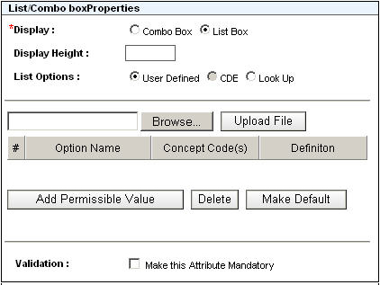

Figure : List Combo Box

A Multi-select Combo Box attribute type is also available to select and remove multiple values from a list.

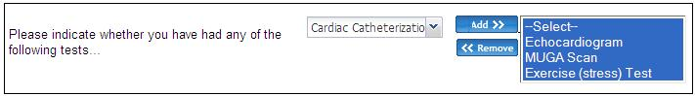

Figure : Multiselect Combo Box

The following table lists the attributes for the List Combo Box Attribute Type.

| Attribute Type | Description |
| --- | --- |
| Display | Select the Combo Box option to display the permissible values as a drop down list. You can select only one permissible value from the combo box.  Select the List Box option to display the data as a list. To select multiple values, click a value, press down the [CTRL] key, and then select another value. |
| Display Height | Enter a value to specify the height of the List Box (maximum number of permissible values that can be displayed in the list box at a time). |
| List Options | **User Defined**: This is the default option, which allows you to enter permissible values of your choice manually.  **CDE**: This option allows you to search for a caDSR Value Domain and fetch the permissible values from the standard repository. However, this option is not yet implemented and is currently disabled.  Click the Look Up option to link forms. |
| Browse | Click this button to browse to the location of a file, which contains the permissible values, concept codes, and definition in a CSV format.  Once you locate the file, click **Upload File**. |
| Add Permissible Value | Click this button to add a row and enter the permissible values, concept code(s), and definition. |
| **Option Name**: Click within the cell on the grid to enter the permissible value. |
| **Concept Code(s):** Click within the cell on the grid to enter the concept code. This is optional. |
| Definition: Click within the cell on the grid to add the definition. This is optional. |
| Delete | Select the check box in front of the rows for which the permissible values need to be deleted, and then click **Delete**. |
| Make Default | Select the permissible value you want to make the default selected value on the screen. |
| Validation | **Make this Attribute Mandatory**: Select this option to make date entry mandatory for the given attribute. |

##### Adding a Date Picker

The Date PickerProperties page is used to enter only date (or time) value for an attribute in a particular date format.

For example, you can use the Date Picker to collect the date of birth of a patient or the date when a particular treatment began.

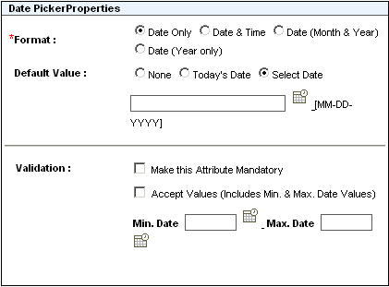

Figure : Date PickerProperties page

The following table lists the attributes for the Date Picker Attribute Type.

| Attribute Type | Description |
| --- | --- |
| Format | Select one of the options to set format for the date type attribute. |
| **Date Only**: Select this option to display only the date. |
| **Date & Time**: Select this option to display the date as well as the time. |
| **Date (Month & Year)**: Select this option to display a month and the year. |
| **Date (Year only)**: Select this option to display the year only. |
| Default Value | Select one of the three options to set the default date. |
| **None**: Select this option if you do not want to set a default date. |
| **Today’s Date**: Select this option to set the current date as the default. |
| **Select Date**: Select this option to set a date-default of your choice. Select the date (and/or time) from the calendar displayed. |
| Validation | **Make this Attribute Mandatory**: Select this option to make data entry for the given attribute mandatory. |
| **Accept Values** (Includes Min.& Max.Date Values): Select this option to allow the user to enter the date value within a specified range. |

##### Adding a File Upload Attribute

Use the File UploadProperties page to upload a file of particular type.

For example, you can use the Upload File attribute type to upload the photograph of a patient as a JPEG file or as a DOC file containing the details of a collection protocol.

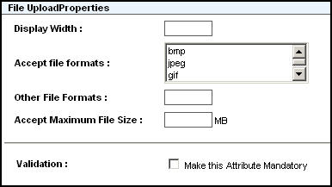

Figure : File UploadProperties page

The following table lists the attributes for the File Upload Attribute Type.

| Attribute Type | Description |
| --- | --- |
| Display Width | Enter the field width, which will be displayed on the screen. |
| Accept File Formats | Select the required format for the file that you want to upload. The available formats are bmp, jpg, gif, doc, and pdf. |
| Other File Formats | Enter the file format, which is other than the ones available in Accept File Formats option. |
| Accept Maximum File Size | Enter the maximum limit for file size in MB. If the file is larger than the specified size, it will not be uploaded. |
| Validation | **Make this Attribute Mandatory**: Select this option if you want to make data entry for the given attribute mandatory. |

#### Building a Form

To build a form:

1. Enter a **Label** for the attribute. Also, enter values for **Concept Code(s)** and **Definition,** if required.

**Note:** The Label name should start with a lower case letter and should not contain any special characters or any spaces.

1. Select the required attribute type from the Form Attributes List.
2. Enter the properties for the selected attributes.
3. Select the **Make this Attribute Mandatory** check box if required to make data entry for an attribute mandatory.
4. Click **Submit Attribute**.
5. The attribute gets added to the Form Attributes List on the right pane as shown in the following figure.

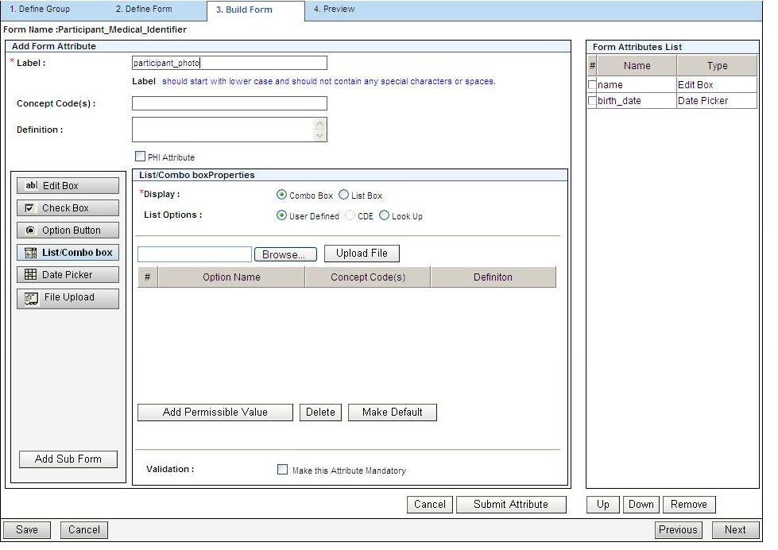

Figure : Build a Form - Add Form Attribute Page

1. Click **Next** once you have added all the required attributes. The Preview tab displays the form you created as shown in the following figure.

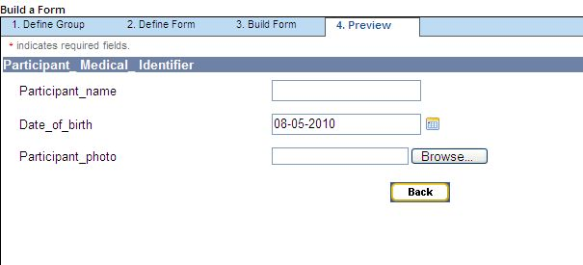

Figure : Build a Form - Preview Page

1. Click **Back** to navigate back to the Build Form page.
2. Click **Save**. The form is saved.

### Creating a Sub-Form (Containment)

You can add a sub-form to the current or main form if required. Sub-forms contain data that is related to the main form.

To add a sub-form create a main form first, and then to add a sub-form, navigate to the Build Form page.

1. Click **Add Sub-Form**.

The Define Sub-form page opens.

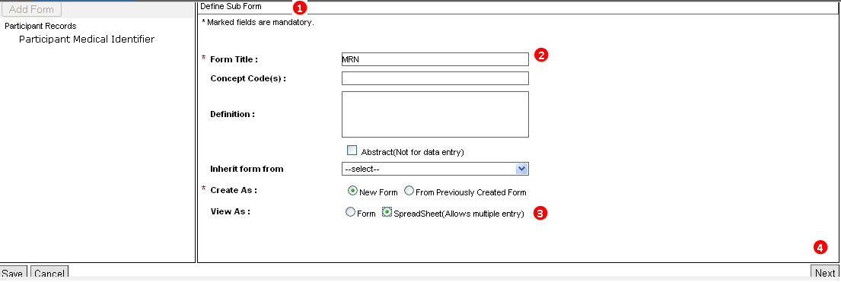

Figure : Add Sub-Form - Define Sub-Form Page

1. Enter the **Form Title**.
2. Select the **Form** or **SpreadSheet (Allows multiple entries)** radio button under View As. If you select Form, you can add a single record for the sub-form. If you select SpreadSheet (Allows multiple entries), you can add multiple records to the sub-form.
3. Click **Next**.
4. Add attributes to this sub-form.

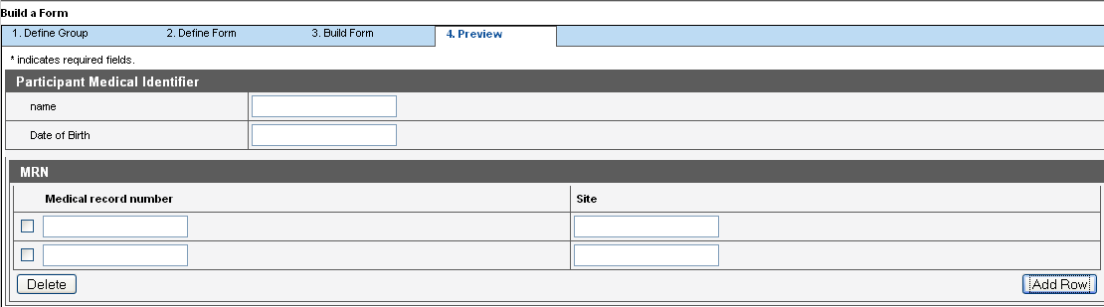

Figure : Add Sub-Form - Preview Page

1. To add rows to the sub-form, click **Add Row**. To delete a row, select the check box next to the required row and click **Delete**.
2. Click **Next** to navigate to the Preview page.

### Using *n* Level Form Containment

The supports *n* level containment. For example: consider there is a main form Participant Medical Identifier. This form has an attribute Medical Record Number and a sub-form called Site. Now, the Site form has its own attributes Site Name and Site Type. The Site sub-form also contains a sub-sub-form called Coordinator. This sub-form has attributes like First Name, Last Name, and Email Address. The Coordinator form contains a nested sub-form Address, which has attributes like Street, City, State, and Countr*y*.

The sub-sub-sub-form Address can further nest another sub-form. This type of containment is called n level containment where a form can have a sub-form up to unlimited levels contained in it.

The following figure shows *n* level containment: The Main Form is the Participant Medical Identifier form, which comprises sub-form Site, Sub Sub-form Coordiantor, and Sub Sub Sub-form Address. The Site sub-form comprises a Site Name and Site Type. Further, the Coordinator Sub-Sub form collects a First Name, Last Name, Email Address, and the Address Sub-Sub-Sub-form collects the complete address..

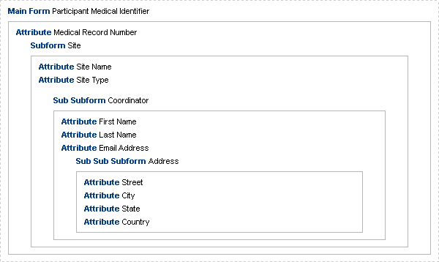

Figure : n Level Containment

### Creating Lookup Associations

You can link various forms across any groups. This feature is useful to access data across various forms. That is, the values entered for attribute(s) of one form can be available as permissible values of an enumerated attribute in another form.

For example, there is a form called Participant Medical Identifier with an attribute Medical Record Number. Data entry is done for this attribute. Create another form called Participant with attributes First Name, Last Name, Date of Birth, and so on. Now, make the data entered for Medical Record Number attribute of the Participant Medical Identifier form available to the Participant form. To do this, create an attribute MRN in the Participant form and link it to the Medical Record Number attribute of the Participant Medical Identifier form.

The following procedure explains the preceding example. To link forms:

1. Create a form called Participant Medical Identifier with an attribute called Medical Record Number.
2. Create another form called Participant with attributes First Name, Middle Name, and so on.
3. Add another attribute called MRN to link to the Medical Record Number attribute of Participant Medical Identifier form as follows:
4. Select the **List/Combo** box option.
5. Select the **Look Up** radio button from the **List Options**.
6. Select the required **Group**. Based on the group selected, data is populated in the **Form** field.
7. Select the required form. In this example, Participant Records is the Group and Participant Medical Identifier is the Form.
8. Select the attribute **Medical Record Number** under **Available Attributes**.
9. Click **Add** to add this attribute to the list of **Selected Attributes**.

To add multiple attributes from the Available Attributes list, select the attributes and click **Add** to add them to the Selected Attributes list.

**Note:** To add more than one attribute, select a separator to separate the values that will be entered for each of these multiple attributes. To do this, select an option from theSeparate with drop-down list. The available options are Colon, Comma, Dot, and Space. The attribute values, separated by the chosen separator are represented as a single-line permissible value combination.

1. Click **Submit Attribute**.

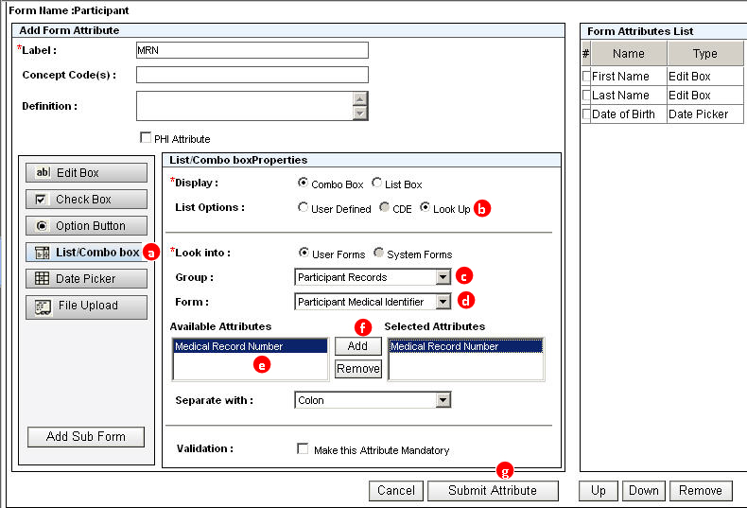

Figure : Linking Forms

1. Click **Next**. The Preview page opens.

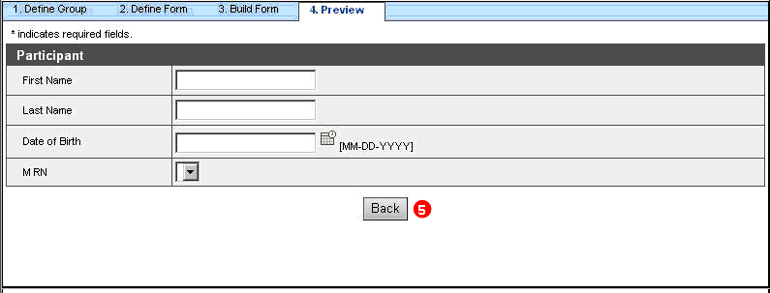

Figure : Linking Forms - Preview Page

1. Click **Back**. The Build Form page opens.
2. Click **Save**. The form is saved

**Note:** Records entered for the Medical Record Number attribute of Participant Medical identifier form are populated in the MRN drop-down list of the Participant form.

### Inheriting Attributes from a Common Form

This feature is useful when you want attributes of a certain form to appear across various forms. Instead of creating the same attributes across multiple forms, you can inherit them from a common form. For example: you have a form *Environmental Exposures Health* *Annotation* and it contains attributes like *Agent*, *Other* *Agent*, and so on. To import all these attributes in some other form, for example: *Smoking* *Health* *Annotation* and *Alcohol* *Health* *Annotation*, use the Inherit form from option while creating these child forms. This will populate the child forms with all the attributes from the parent form.

**Note:** The supports *n* level inheritance. This means that a child form can also be a parent form to another form.

The following procedure explains how to inherit a form based on the preceding example. To inherit a form:

1. Create a parent form Environmental Exposures Health Annotation with attributes like Agent, Other Agent, and Years Agent Free.

**Note:** Select the Abstract (Not for data entry) option on the Define Form page if you do not want to use the parent form for any data entry.

1. Create a child form Smoking Health Annotation.
2. Select the parent form Environmental Exposures Health Annotation from the Inherit form from drop-down list on the Define Form page as shown in the following figure.
3. Click **Next**. The Define Form opens.

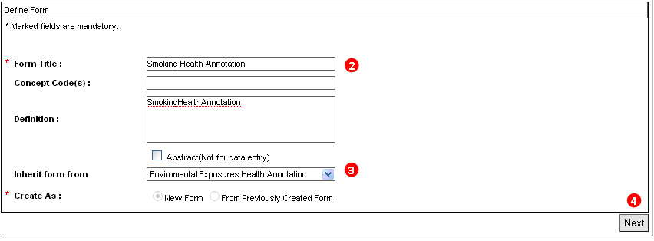

Figure : Inheriting Form - Define Form Page

1. On the Build form page, add the unique attributes of the derived form, if any.
2. Click **Next**.

The Preview page displays the attributes you created, as well as the inherited attributes of the parent form Environmental Exposures Health Annotation.

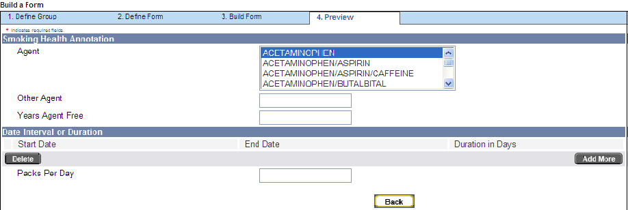

Figure : Inheriting Form - Preview Page

Click **Back** and then click **Save**.You can view a form by navigating to the Collection Protocol Based View under Biospecimen Data.

**Note:** The caTissue Suite supports n level inheritance. This means the child form, for example: *Smoking Health Annotation* will inherit all the attributes of the parent form *Environmental Exposure Health Annotation*, and the *Smoking Health Annotation* form can also be a parent form to another form, for example: *Participant Medical Identifier*. Hence, the form *Participant Medical Identifier* will contain the attributes of its parent form (*Smoking Health Annotation*) as well as the parent of the parent form (*Environmental Exposure Health Annotation*).

1. Click the **Biospecimen Data** tab, and select **Collection Protocol Based View**.

* Select the annotation and click the **Go** button.

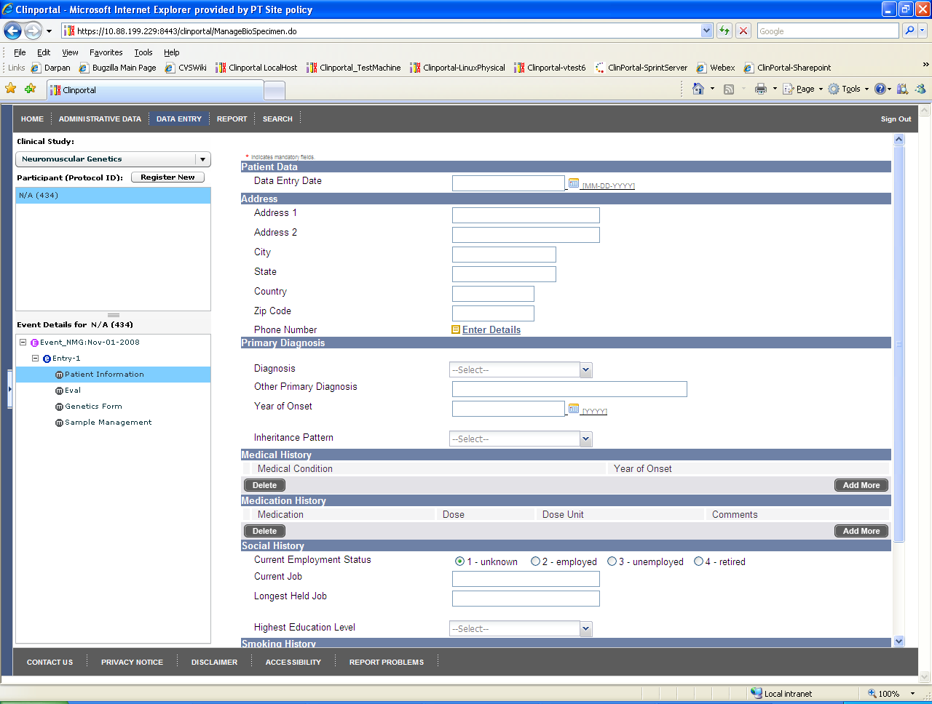

Figure 16: Importing XMI - Data Entry Form

**Note:** The data entry form fields are created based on control type. control type properties and other definitions are specified in the form definition CSV.

**Known Issue in caTissue Suite 1.2:** Data entry is not working for forms created with inheritance using the UI form builder. But this works fine when UML model is loaded via XMI. Refer to technical guide for details on how to create DE forms using XMI import option.

### Editing the Conditions for a Collection Protocol

To edit conditions for a collection protocol:

1. Select the required group under **Group** on the Build Annotation Form page.
2. Click **Edit** under **Conditions** for the required form under **Form Title** as shown in the following figure.

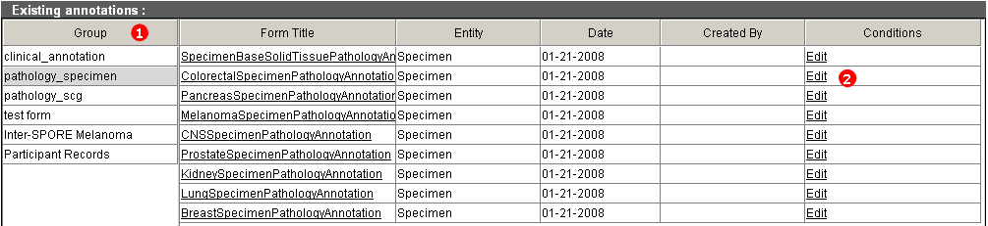

Figure : Editing Conditions for a Collection Protocol

1. Select the required collection protocol or collection protocols under **Title** as shown in the following figure.
2. Click **Submit** to update the changes.

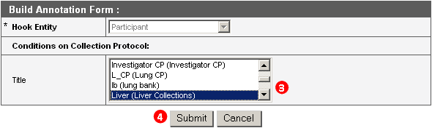

Figure : Editing Conditions for a Collection Protocol - Build Annotation Form Page

You can modify a form based on your requirements. You cannot modify attribute data type and attribute properties once records are entered for that form. Similarly, you cannot change the parent form for inheritance after data entry. However, you can change the validations as well as the order of attributes in the form. The following procedure explains how to edit a form.

### Editing a Form

To edit a form:

1. Click the **Administrative Data** tab.
2. Click **Local Extensions > Edit**. A Warning page opens.
3. Click **Next**.

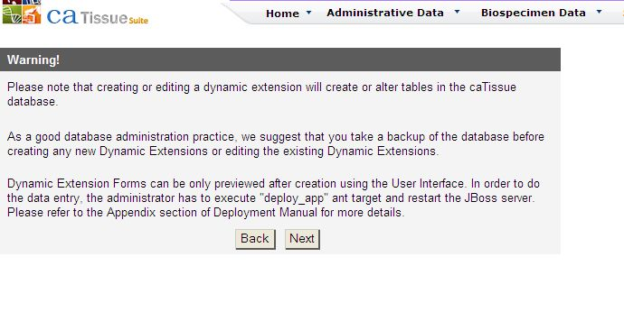

Figure : Editing Form - Navigating to DE

The Existing annotations page opens.

1. Select the required group under **Group**, and then click a link corresponding to the required form under **Form Title** as shown in the following figure.

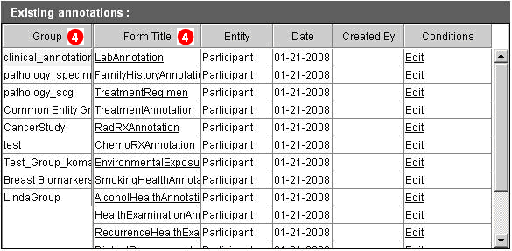

Figure : Editing Form - Group and Form Title Page

1. The **Select From Existing** radio button is selected and the form that you want to edit opens under **Group Title** as shown in the following figure. Click **Next** and proceed to the Build Form page.

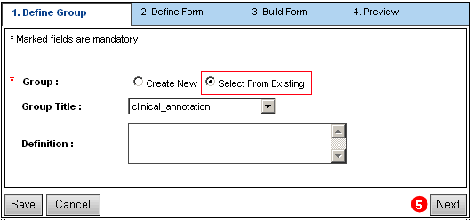

Figure : Editing Form - Define Group Page

1. On the Define Form page, as shown in the following figure:
2. Edit the **Form Title**.
3. If the form does not inherit data from any other form, then select a parent form from the **Inherit Form From** drop-down list.
4. If the form inherits data from another parent form, select a different parent form from the I**nherit Form From** drop-down list.
5. Enter or edit the **Definition** for the **Form Title**, if required.
6. Enter or edit the **Concept Code(s)** for the Form Title.
7. Click **Next** to navigate to the Build Form page.

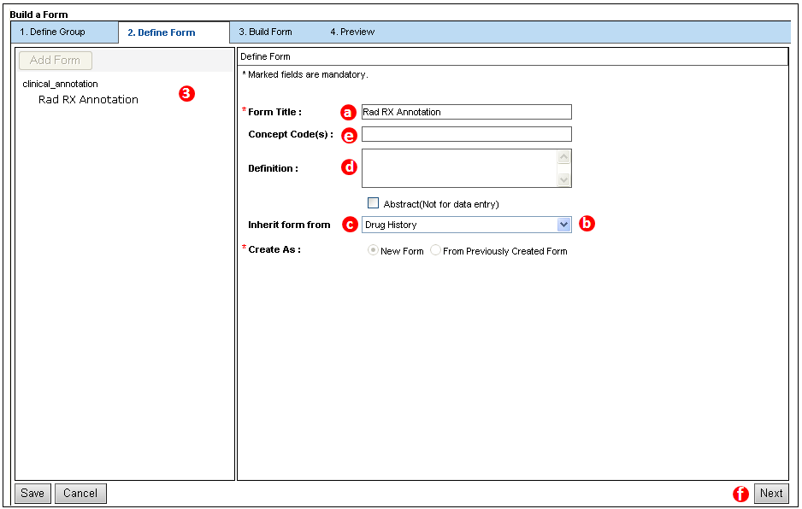

Figure : Editing Form - Define Form Page

### Editing an Attribute

The following procedure explains how to edit an attribute. To edit an attribute:

1. Select the required attribute under **Form Attributes List** on the right pane on the Build Form page.
2. The Edit Form Attribute page opens as shown in the following figure. Edit the attribute.
3. Edit the **Label** of the attribute.
4. Change the data type of the attribute.
5. Edit the properties of the attribute.
6. Edit the **Validation** on the attribute.
7. Click **Submit Attribute** to save the changes.

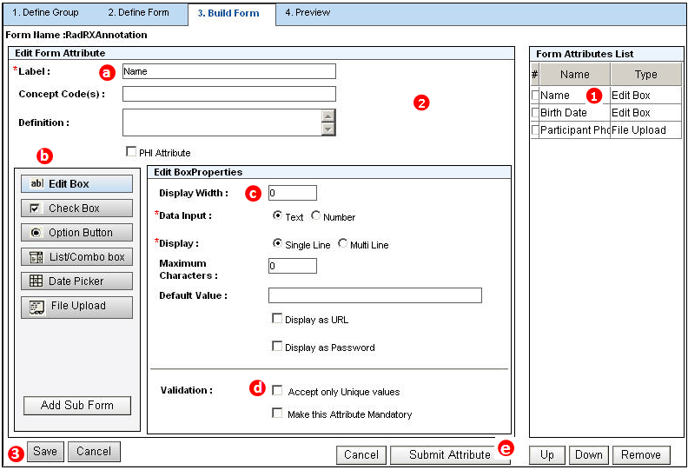

Figure : Editing an Attribute

1. Click **Save** to update the changes made to the form and its attributes.

**Note:** To change the display order of the attributes, use the **Up** and **Down** buttons. To remove an attribute from the Form Attributes List, select the check box against it, and click **Remove**.

## Entering Data for Dynamic Extensions

There may be a requirement to annotate a patient, accession, or biospecimen data with additional information from time to time. To do so, you need to enter relevant data for the dynamic extensions.

1. Select **Biospecimen Data**.
2. Select **Collection Protocol Based View**.
3. On the left pane, select the corresponding collection protocol.

Since the dynamic extensions created are hooked to an entity, each form is visible only under that entity. Select the hook entity (in our example: Participant).

1. Click the **View Annotation** tab.

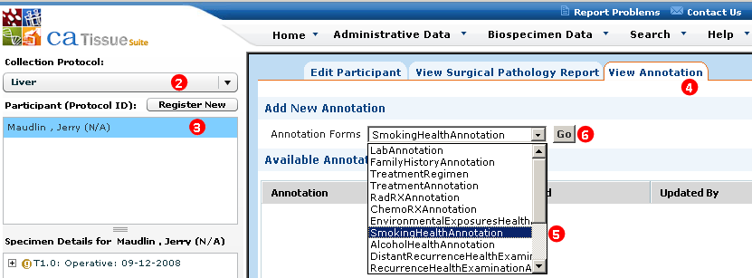

Figure : Viewing Annotation

1. Select the **Smoking Health Annotation** form from the Annotation Forms drop-down list as shown in the following figure.

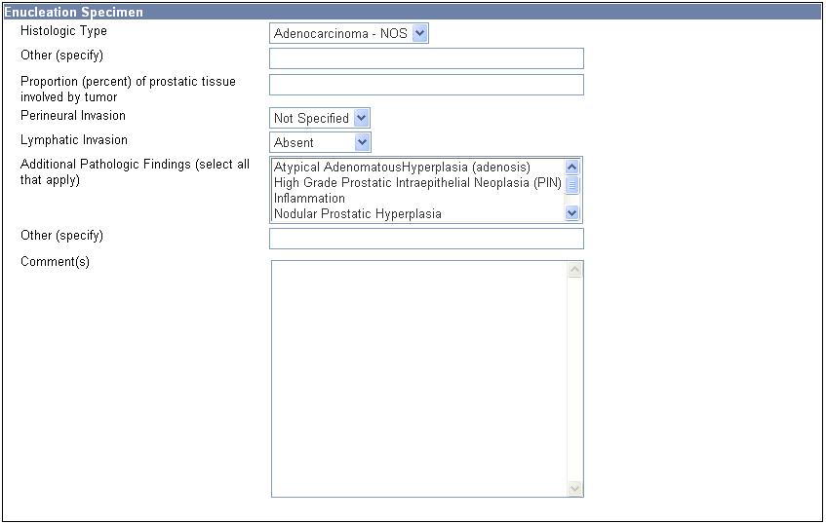

Figure : Annotation Forms drop-down list

1. Click **Go**.

The result screen opens as shown in the following figure.

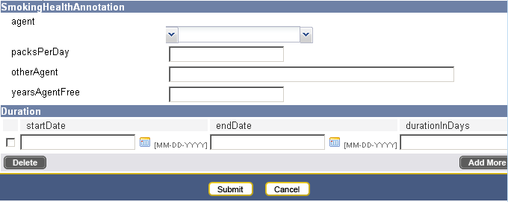

Figure : Viewing Form - Result Page

Sometimes, a particular annotation that is restricted to one Collection Protocol (CP) is required in another CP, or a particular annotation that is restricted to multiple CPs is required only under a subset of that CPs. To make an annotation available or unavailable under one or more CPs, you need to edit the conditions on the CPs. The following procedure explains how to edit conditions for a collection protocol.

### Additional Enhancements in Dynamic Extensions

The following are new enhancements that you may find useful during the form creation process.

#### Copying/Pasting for Bulk Data Upload

Dynamic Extensions (DE) supports copying data from Microsoft Excel cells directly into DE the form. This is particularly useful for forms having large number of controls.

You can configure this feature for particular DE forms during form creation. If you configure the form for DE form, caTissue Suite shows a **Paste** button on the Data entry page for the DE form. You can copy the contents from the required cells from Excel, and paste the contents in multiple DE controls.

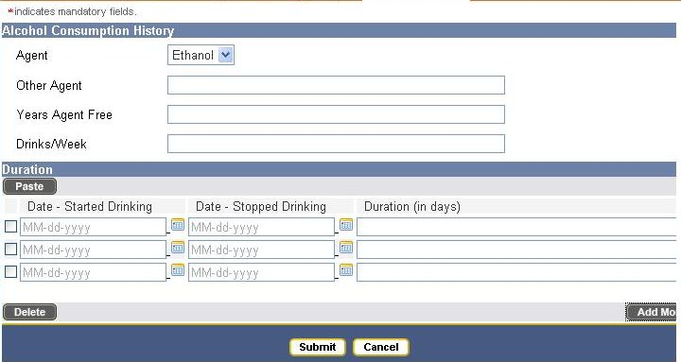

Figure : “Paste” Button for Bulk Upload

# Setting Up Consent Tracking (Administrative Data)

This chapter provides instructions for consent tracking.

Topics in this chapter include:

* on this page
* on page 120
* on page 121

## Information Consent and Consent Tiers

*Informed consent* refers to the process where a participant provides specific permissions for their collected biospecimens to be used related to a collection protocol. The collection protocol includes the definition of the informed consents. Sometimes biospecimens, collected for research purposes, can be used under one or more circumstances. These specific permissions are referred to as *consent tiers*.

Examples of consent tiers are:

* Consent to allow use of a collected biospecimen for specific studies described in the protocol.
* Consent to store and allow future use of a collected biospecimen for an Internal Review Board (IRB) approved studies related to this disease.
* Consent to store and allow future use of a collected biospecimen for IRB- approved studies related to other diseases.
* Consent to establish contact in the future to gather additional medical information or to participate in other studies.
* Consent to allow genetic data generated from biospecimens to be shared with other authorized investigators through the Internet.
* Consent to allow anonymized genetic data generated from biospecimens. This data is posted to a publicly accessible data repository.
* Consent to allow collected biospecimens to be propagated *in vitro* or in a living organisms.

An Institutional Review Board (IRB) can rule that a protocol does not require participant consent.depending on the way in which the biospecimens are collected.

**Note:** Currently, does not support any association between collection and distribution protocol. However, there is a direct one-to-one relationship between a collection protocol and a distribution protocol. The consent defined in the collection protocol directly pertains to the use of biospecimens as dictated by the distribution protocol.

The pre-requisite for an informed consent process is that a participant agrees or disagrees to one or more consent tiers while registering the participant to a collection protocol.

A participant can respond to each consent tier by specifying one of the following options:

| Consent Status | Description |
| --- | --- |
| Yes | Participant agrees to the consent tier. |
| No | Participant does not agree to the consent tier |
| Not Specified | Participant does not record any response for a particular consent tier. |
| Withdrawn | Participant has withdrawn the agreement from the consent tier. |

## Setting Up Consent Tracking

To set up consent tracking in , follow this workflow:

1. Define consent tiers at the collection protocol level.
2. Register a participant to the collection protocol and record the participant’s responses for individual consent tiers. For more information, refer to *.*
3. Track consent tier status at the individual specimen level.
4. Validate consent status at the individual specimen level prior to distribution of the biospecimen.

The workflow is also outlined in the following figure:

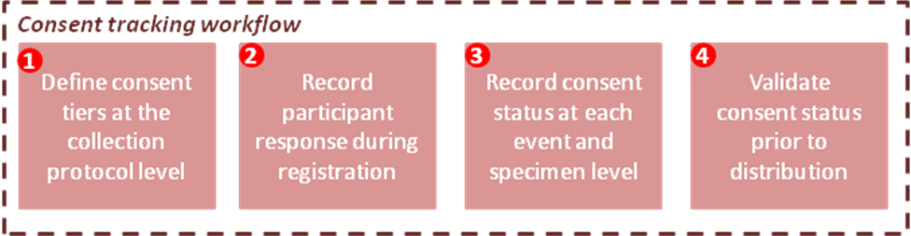

Figure : Consent Tracking Workflow

## Recording Participant Responses During Registration

You can record participant consent responses at three levels:

### Registration Level

To record participant consent responses at the registration level:

1. After entering the participant details on the Add Participant page, click **Enter Response** under the Participant Registration(s) section. The Consent Form page opens.
2. Enter registration details, such as **Witness Name**, **Consent Date**.
3. Enter the **Participant Responses** as **Yes**, **No**, or **Not Specified**.
4. Click **Done**.
5. Click **Register Participant** on the Add Participant page.

**Note:** You can submit a participant registration without capturing the **Participant Responses**.

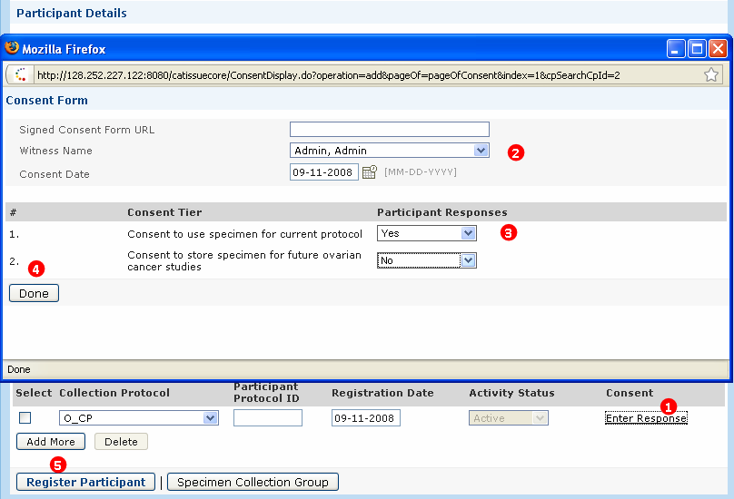

Figure : Capturing Responses at Participant Registration Level

1. To set the participant’s response as **Withdrawn,** click the **Edit Response** link on the Edit Participantpage, then select **Withdrawn** from the **Participant Responses** drop-down list.

To withdraw consent for all consent tiers, select the **Withdrawn** button on the lower left-hand side next to the **Submit** button. This updates all of the responses to Withdrawn.

**Note:** The participant responses captured at the participant registration level are reflected down the hierarchy on the Specimen Collection Group page and on the Specimen page. On the Specimen Collection Group page or Specimen page, you cannot edit **Participant Responses**. You can enter the consent status as **Yes**, **No**, and **Not Specified**.

### Specimen Collection Group (SCG) Level

To capture responses at the Specimen Collection Group (SCG) level:

**Note:** You can submit a specimen collection group without any associated consent data.

1. Click the **Consents** tab on the Edit Specimen Collection Group page.
2. Select the required responses.
3. Click **Submit** to submit the consent status at SCG level.

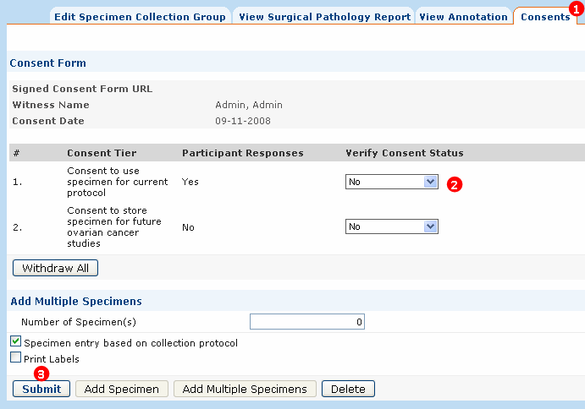

Figure : Capturing Responses at SCG Level

After submitting the consent status, if the consent status at the SCG level is different than the consent status at the Participant registration level, then the message *What do you want to do with the consent status of specimen/s?* displays.

1. To apply the current status to only non-conflicting specimen(s), click **Apply**. To apply the current status on all specimens, click **Apply All.**

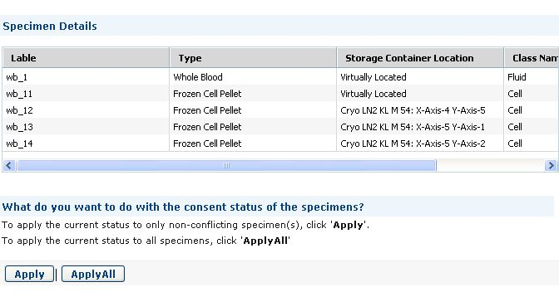

Figure : Varying Consent Status - SCG Level

1. If you click **Apply**, the status is preserved for all conflicting consent status at thespecimen level. If you click **ApplyAll**, the individual consent status is overridden at specimen level.

### Specimen Level

To capture responses at the specimen level, navigate to the Specimen page.

**Note:** You can submit a specimen without any associated consent data.

1. Click **Consents** on the Specimen page.
2. Select the required responses.
3. Click **Submit**.

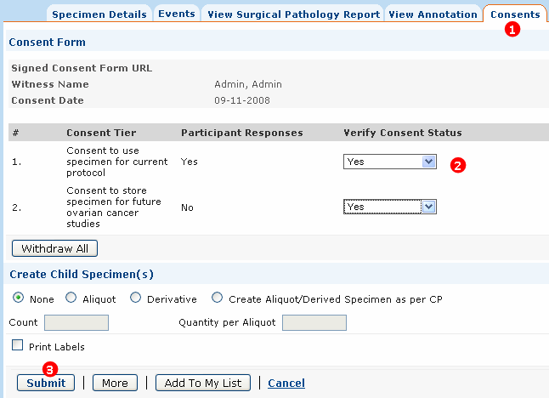

Figure : Capturing Responses at Specimen Level

After submitting the consent status, if the consent status at the SCG level is different than the consent status at the Participant registration level, then the message *What do you want to do with the consent status of specimen/s?* displays.

1. To apply the current status to only non-conflicting specimen(s), click **Apply**. To apply the current status on all specimens, click **Apply All.**

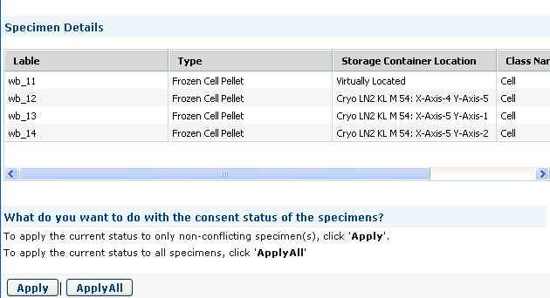

Figure : Varying Consent Status – Specimen Level

You can select **Apply** or **ApplyAll**. If you select Apply, it preserves the status of all conflicting consent status at specimen level. If you select **Apply All**, it overrides the individual consent status at specimen level.

A participant can withdraw the consents for using a specimen and associated data for studies. allows you to change the consent status of one or more consent tiers to Withdrawn on the Edit Participant Registration page or the Specimen Group or Specimen page. When one or more but not all the consents are withdrawn at the participant registration level, the specimen group level, or the specimen level, displays the following message, *What do you want to do with the withdrawn specimens?*

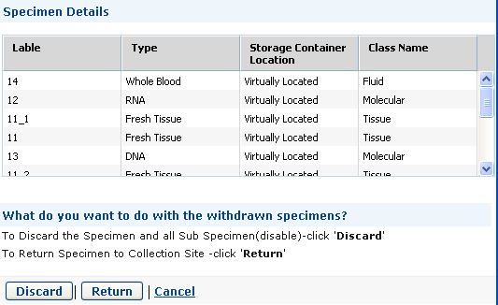

Figure : Withdraw Consent

1. To discard the specimen and all sub-specimens (Disable), click **Discard**.   
   To return a specimen to a collection site, click **Return**.
2. You can withdraw consent and specify to return or discard the specimens. You can withdraw the consents at the following levels:

* Participant level:

1. The participant registration is not disabled if one or more consents are withdrawn. The Withdrawn status at the participant registration level is propagated to the SCG and specimens under it. If you withdraw all the consents, you can dispose or return all the specimens. Once you dispose all the specimens, you can disable the registration. You cannot disable a registration until all the SCGs and specimens in that registration are disabled.
2. All specimens are marked as *Unavailable*, and the value in the **IsAvailable** field is set as *False*.
3. All specimens add a **Disposal Event**.
4. All specimens have an activity status as *Disabled*.
5. All parent SCG activity statuses is set as *Disabled*.
6. Participant registration activity status is set as *Disabled*.

* SCG level
* Steps a to d from the Participant level are applicable only for the selected SCG.
* The registration remains active and the concerned consent tier(s) are marked as *Withdrawn*.
* Specimen level
* Steps a, b, and c from the Participant level are applicable only for that specimen.
* The registration remains active, and the concerned consent tier(s) are marked as *Withdrawn*.
* If you select **Perform** **action** on the Specimen page, the consent status is updated to *Withdrawn*, and no action is performed.

# Handling Biospecimens for Technicians and Supervisors (Biospecimen Data)

This chapter provides instructions to register participants and collect biopecimens using the **Biospecimen Data** tab.

**Note:** If you are a Supervisor or Technician and encounter an issue, such as there are not enough storage containers to place aliquots, contact your caTissue Administrator. The Administrator will add new storage containers or assigns privileges to access other storage containers.

* on this page
* on page 144

## Registering Participants and Collecting Biospecimens

A *participant* is an individual from whom specimens are collected. This version of supports human participants only. In , you can collect the biospecimens from a participant **only** under an Internal Review Board (IRB) approved collection protocol, that is, you must register a participant to a collection protocol in order to collect specimens.

* **Collecting specimends for new participants**: In the Collection Protocol Based View, select a collection protocol, add the participant information, and create a specimen collection group and biospecimens.
* **Collect specimens for registered participants**: In the Collection Protocol Based View, select a collection protocol, select a participant from the list, and create a specimen collection group and biospecimens.
* **Perform operations on existing biospecimen**: To manage an existing biospecimen, search for the biospecimen using the Edit option, select the biospecimen from the Collection Protocol Based View, and edit the details, create derivatives, create aliquots, add events, and add annotation.

The following figure outlines a high level look at different workflows as described previously.

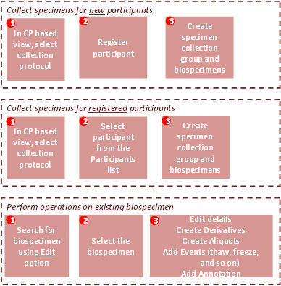

Figure : Workflow to Collect Specimens and Performing Operations for the Specimens

### Collection Protocol (CP) Based View

The Collection Protocol (CP) Based View is an integrated view of the entire biospecimen data in . You see the collection protocols to which you are assigned. Anticipated events were defined with the collection protocol, as well as specific requirements when you register the participant to the collection protocols defined using a Collection Protocol. The specimen requirements are mentioned under events. You can define the requirements when you define the collection protocols. As a result, when a participant is registered to a collection protocol, the anticipated Specimen Collection Groups (SCGs) and anticipated specimens are listed under the Specimen Details section.

Using the Collection Based View one can perform the following actions:

* Register a new participant to a protocol.
* Create, edit, or view specimen collection groups.
* Create, edit, or view new specimens, derivatives and aliquots.
* Add new events to specimens.

To navigate through Collection Protocol Based view:

1. Click the **Biospecimen Data** tab.
2. Select **Collection Protocol Based View**.
3. Select a collection protocol from the **Collection Protocol** drop-down list. displays the list of participants already registered to the selected collection protocol.
4. Continue to the following procedure to register a new or existing participant to the selected collection protocol.

**Note:** When you click any object on the tree on the left pane, the participant or specimen details list is refreshed on the right pane of the screen. It displays the details of the selected object. You can perform all the biospecimen operations here.

### Registering a Participant to a Collection Protocol

Follow the instructions below for a standard registration of a participant. Additional registration instructions are provided for the following:

* Registering a Participant to a Longitudinal Collection Protocol
* Registering a Participant to an Arm Manually
* Offsetting a Registration or Specimen Collection and Shift of Anticipated Dates

**Note:** By default, Administrators and Supervisors have the Registration privilege.

To register a participant to a protocol:

1. Click the **Biospecimen Data** tab.
2. Select **Collection Protocol Based View**.

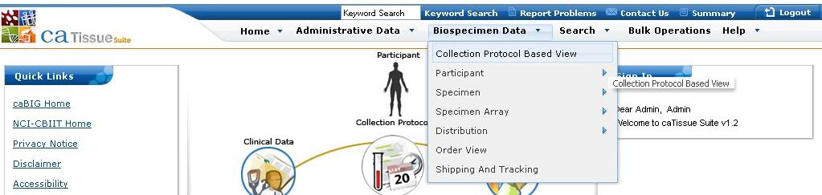

Figure : Collection Protocol Based View

1. Select the collection protocol under which you want to register the participant.

**Note:** When you select an existing participant, auto-populates event points and the specimen hierarchy in the Specimen Details window, and the right pane displays the details of the participant.

1. Click **Register New**.

The right pane of the screen displays the participant form.

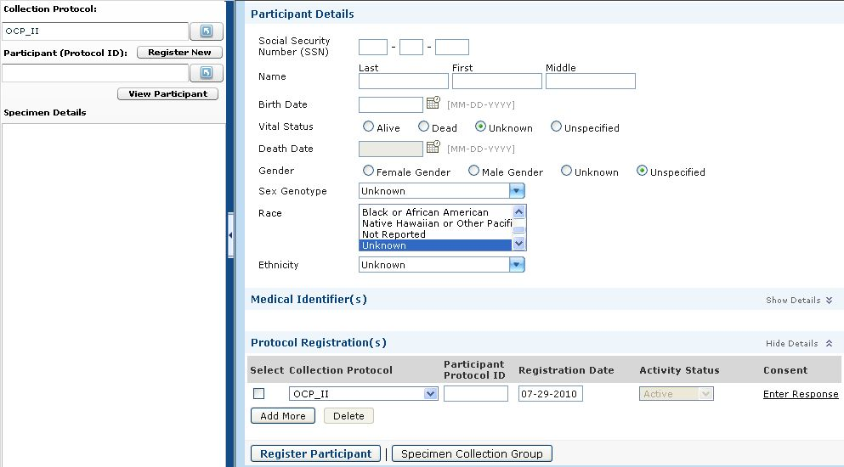

Figure : Registering a Participant

1. Enter the participant’s information.

You can register a participant without entering the participant details. Data entry is optional in all the fields under Participant Details.

1. You can enter one or more **Medical Identifier(s)** for the participant. The **Source** indicates the site that generated the ID.
2. To register a participant based on de-identified id, enter a **Participant Protocol ID**.

The Participant Protocol ID can be generated by . Refer to the *Deployment Guide* on details on how to switch on automatic Participant Protocol ID generation. When auto-generation is enabled, the ID created is a combination of the -generated Collection Protocol ID and the -generated Participant ID (specifically CollectionProtocolID_ParticipantID)

1. If consent tiers are defined for a collection protocol, click **Enter Response** under **Consent** to capture the participant response.

Use the **Add More** button under **Participant Registration(s)** to register the same participant to more than one collection protocol.

1. Click **Submit**.

* The Activity Status of a participant is set to **Active** by default. If a participant does not want to participate in the collection protocol, then the Activity Status of the participant changes to **Closed** or **Disabled**.
* **Closed** signifies no future biospecimen collection is possible, but SCG and already accessioned biospecimens associated with the participant are visible for query and distribution.
* **Disabled** signifies already present biospecimens are not visible for query or distribution, and that no future collections can take place. It indicates that the participant and associated SCGs and specimens are deleted from .

1. Once you submit a participant, scans the database to check if you are entering an existing participant. This check is performed across all banks running on the same instance of . This is called as the ***Participant Duplicate Check*.**
2. then displays all possible participant matches. Once you review the matches, you can perform one of the following actions:
3. Select one of the matches as a new participant.
4. Select **Ignore matches and create new participant** to ignore all the matches and to create a new participant.
5. Select **Lookup again** to search again after making a few changes to the participant details.
6. After selecting one of the above options, click **Register Participant**.

The participant is registered to the collection protocol.

populates the anticipated Specimen Collection Groups (SCGs) and specimens of the participant in the Specimen Detail window.

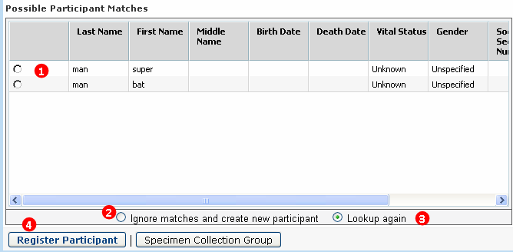

Figure : Participant Duplicate Check

**Note:** The participant-matching algorithm in is designed in such a way that the algorithm can be easily replaced or customized. Please refer to the *caTissue Technical Guide* for more details or if you wish to customize this algorithm.

#### Registering a Participant to a Longitudinal Collection Protocol

Registering a participant to a longitudinal collection protocol follows the same steps as described in registering a participant to a protocol. Once the participant is registered to the main Collection Protocol, the specimen details tree displays the hierarchy of sub-protocols and specimen collection groups present within the main collection protocol.

Each sub-protocol requires a registration like the parent protocol. Once the participant is registered to the parent protocol, the creates automatic registrations for the sub-protocols. The participant needs to be manually registered on any one arm from a set of arms.

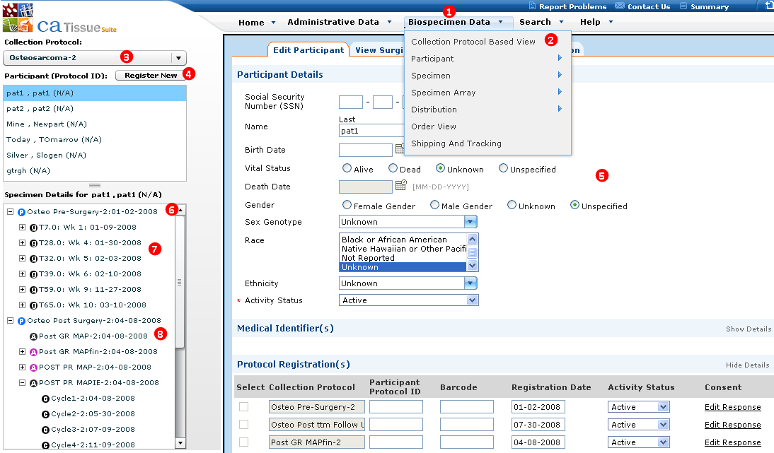

Figure : Registering a participant to a longitudinal protocol

To register a participant to a longitudinal protocol:

1. Click the **Biospecimen Data** tab.
2. Click **Collection Protocol Based View**.
3. Select the longitudinal protocol from the **Collection Protocol** drop-down list.
4. Click **Register New** to register a new participant. The Add participant page opens.
5. Enter the participant details, and click **Submit**.
6. On submitting a participant the specimen details tree is refreshed to show the sub-protocol hierarchy. Automatic registrations are created for sub-protocols that can be predicted, that is until a set of arms is reached.
7. Anticipated specimen collection groups and specimens are created for sub-protocols to which the participant is registered.
8. Once a set of arms is encountered, no further automatic registration occurs. A manual registration is required to register an arm or any other following sub-protocol to begin the automatic registration process until another set of arms is encountered.

**Note:** Selecting a sub-protocol in the specimen details tree displays the participant registration details to the sub-protocol.

#### Registering a Participant to an Arm Manually

Automatic registration ceases once a set of arms is encountered. You must do a manual registration to register the participant under an arm or to register the participant to other following sub-protocols.

This triggers the automatic registration process on following sub-protocols until another set of arms is encountered.

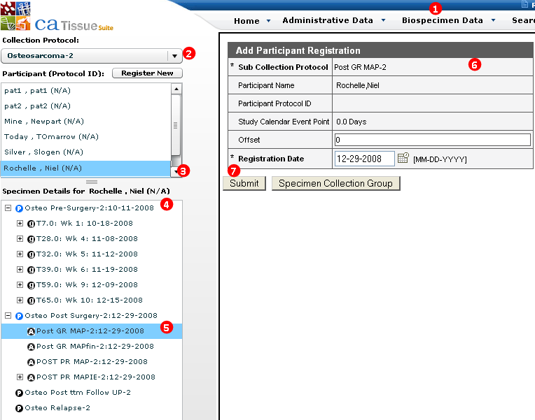

Figure : Manual Registration to an Arm

To register a participant to an arm manually:

1. Click the **Biospecimen Data** tab and click Collection Protocol Based View.
2. Select the longitudinal collection protocol.
3. Select an already registered participant.
4. The specimen details tree displays the sub-protocol hierarchy. It also displays the anticipated SCGs under the sub-protocol to which the participant is registered.
5. Click an arm to manually register the participant to the selected arm.

The Add Participant Registration page opens.

1. Fill in the participant details.
2. Click **Submit** to register the participant to the selected arm as shown in the preceding figure.

**Note:** When registering the participant to an arm, creates anticipated SCGs for the arm, as well as automatic registrations for the following sub-protocols until the next set of arms is encountered.

#### Offsetting a Registration or Specimen Collection and Shift of Anticipated Dates

Biospecimen banks need to anticipate the biospecimen date. At the same time, the bank must also allow for shifts of anticipated time points, like the shifts in time points are observed frequently in chemotherapy protocols.

Once a participant is registered to the parent protocol, anticipated dates are displayed on all the sub-protocols. The sub-protocols have a study calendar event point in the specimen details tree. The SCGs within the sub-protocols display the anticipated dates if the participant is registered to it. If at any time there is a delay in either participant registration to a sub-protocol or in specimen collection, then you can enter an offset corresponding to the sub-protocol registration or to the anticipated SCGs. The offset entered for a registration or for a SCG is carried forward to all the following objects and the recalculated anticipated dates are displayed in the specimen details tree.

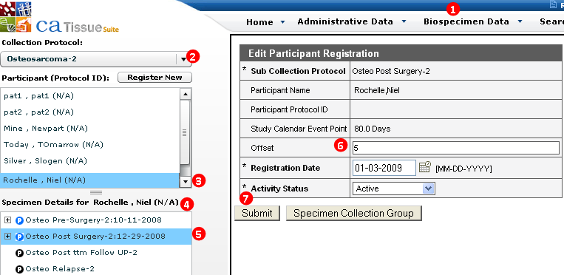

Figure : Display of anticipated dates and offsetting a registration or specimen collection

To add an offset to a sub-protocol registration:

1. Click the **Biospecimen Data** tab.
2. Click the Collection Protocol Based View.
3. Select a longitudinal collection protocol.
4. Select an already registered participant.

The specimen details tree displays the sub-protocol hierarchy, along with the anticipated dates.

1. Select a sub-protocol to display the registration details of the sub-protocol.
2. Enter a value in the **Offset** field to signify a delay in anticipated registration.
3. Click **Submit**.

**Note:** You can also apply similar offsets to specimen collection groups. applies the offsets to all following sub-protocols and specimen collection groups, and displays the recalculated anticipated dates in the specimen details tree

### CP Based Data Entry

The CP based data entry allows you to enter all the specimens for a particular event in a single-click. This feature can be used only if you have specified the specimen details during creation of the protocol that is for **planned** protocols.

The CP based data entry is based on the following principles:

* In case of planned protocols, the details of specimens collected for each event is predefined during collection protocol creation.
* The tissue bank receives all the defined specimens as per protocol definition during the actual collection process.
* However, it is possible that the tissue bank can receive specimens that are inconsistent with the defined protocol. Therefore, there needs to be a provision for receiving more or less number of specimens that is a deviation from the protocol definition.

**Note:** For more information on creating a collecting a collection protocol, refer to Collection Protocols.

#### What are Anticipated Specimens?

When a participant is registered to a protocol, automatically creates *anticipated* specimens for the events based on the protocol definition. The anticipated specimen is similar to the actual specimen except the Collection Status of the specimen is set to *Not collected*.

If you do not receive all the anticipated specimens at a given time or you do not expect them in the near future:

* Navigate to the Edit Specimen Collection Group page for that Specimen Collection Group under which specimens can be collected.
* Set the SCG Collection Status to **Complete**, and click **Submit**. The application navigates to specimen details page.
* When specimens are received, check the **Collected** check box for the parent specimen or the **Collected check** box for the children specimens. If the specimens are not received, simply leave the **Collected** check box unmarked, and the specimens remain as anticipated
* You can also add a disposal event for the required specimen by setting its **Activity Status** to **Disabled**.

#### How Does CP Based Data Entry Work?

Whenever a participant is registered, automatically creates *anticipated* specimens for all the events in the protocol.

* Supervisor registers participants.
* caTissue Suite automatically creates anticipated SCGs and specimens.
* Technician collects specimens for an event.
* User selects **Specimen entry based on collection protocol** checkbox on the SCG page, and clicks **Submit**.
* On the Collection Protocol Based Data Entry page, a Technician unchecks the specimens that were not collected, and clicks **Submit**.
* caTissue Suite changes the status of the specimen from anticipated to collected.

The following diagram depicts the general workflow of using the Collection Based data entry feature:

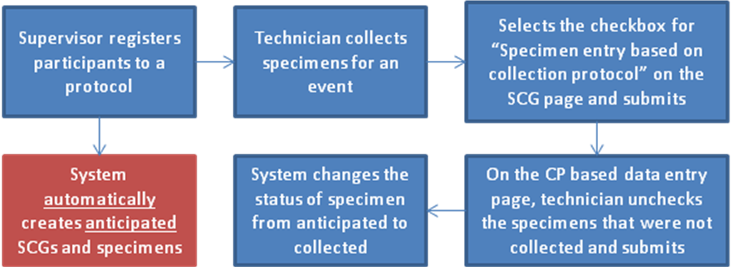

Figure : CP Based Data Entry Workflow

A Specimen Collection Group (SCG) is an event that results in the collection of one or more biospecimens from a participant at a given time. Select the anticipated specimen collection group (black g) . The Specimen Collection Group (SCG) page opens on the right pane.

Step One, Specimen Collection Group (SCG) page:

1. On the Specimen Collection Group page, select a collection site from the **Collection Site** drop-down list as shown in the following figure.
2. Set the **Collection Status** of the SCG to **Complete**.

**Note:** If a specimen is collected, and it is not part of the collection protocol, you can add it as a new specimen using the Collection Protocol Based View. Click **Add Specimen** or **Add Multiple Specimen** on the Edit Specimen Collection Group page.

1. Check the **Specimen entry based on collection protocol** check box.
2. Click **Submit**.

Step One, Collection Protocol Based Data Entry Page:

1. On the Collection Protocol Based Data Entry Page, review the specimen details and clear the specimens that are not collected.
2. Storage location is assigned to each specimen based on the Collection Protocol design.

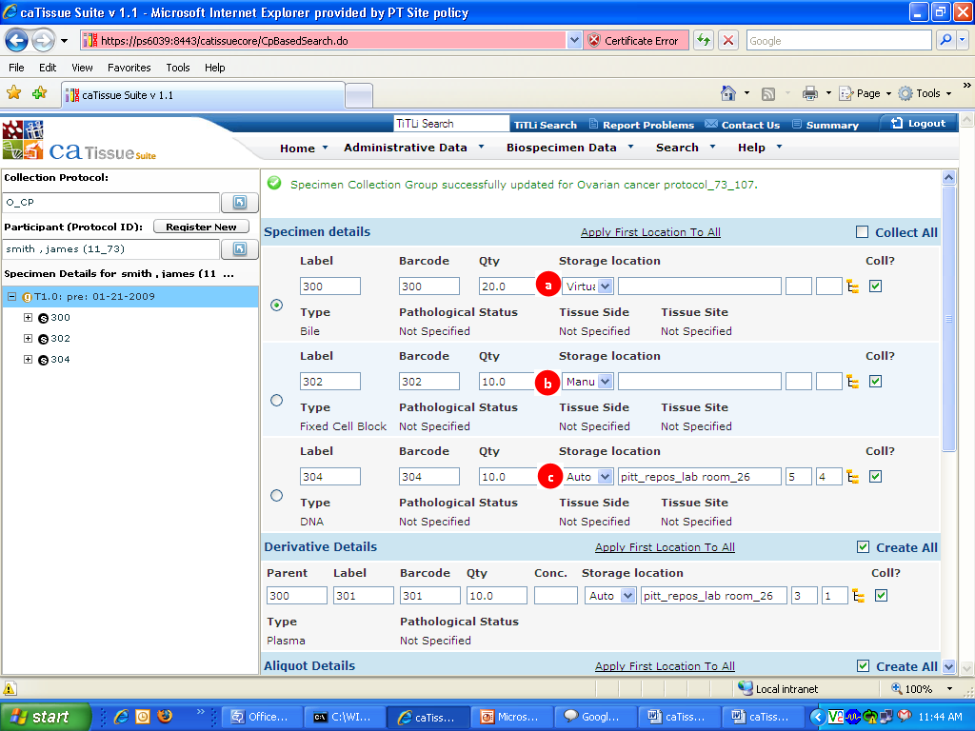

Figure : CP based Data Entry - Specimen Details Page

1. Indicates that the whole blood specimen is stored virtually.
2. Indicates that the fresh tissue specimen is stored manually. It means you can allocate a location to the specimen.

* To do this, click the tree  icon and choose a valid location from the map.

1. Indicates that the total nucleic acid specimen is allocated an auto location. In this case, the location is auto-populated in the boxes based on the container restrictions.
2. Review the child specimens, and clear the specimens that are not collected.
3. Click **Submit**.

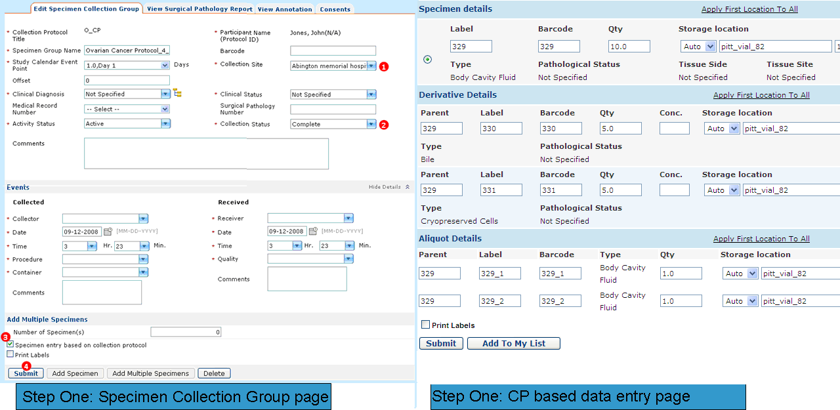

Figure : Workflow to Perform CP Based Data Entry

The following specimen tree shows:

* **Day one**, collection group 319, with specimens 319_1, 319_2, 320, and 321 not collected as the icons are black.
* **Post-surgery**, collection group 322, with specimens 322_1, 322_2, 322_3, 322_4, 322_5, and 323 and not collected as the icons are black.

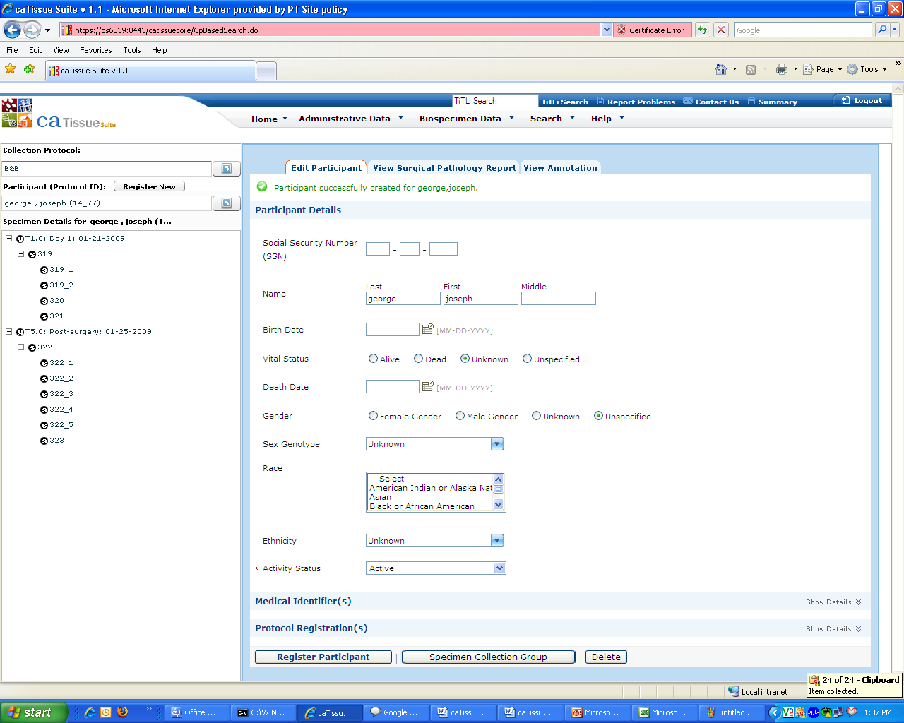

Figure : Specimen Details before Specimen Collection

1. Icons for a specimen collection group and a specimen that are **black** in color indicate they are not yet collected and are anticipated.
2. In the following figure, the icons for the first specimen collection group and specimens associated with it are changed to indicate that they are collected specimens. The second event and specimen icons associated with the second event are black in color, indicating that they are not yet collected.

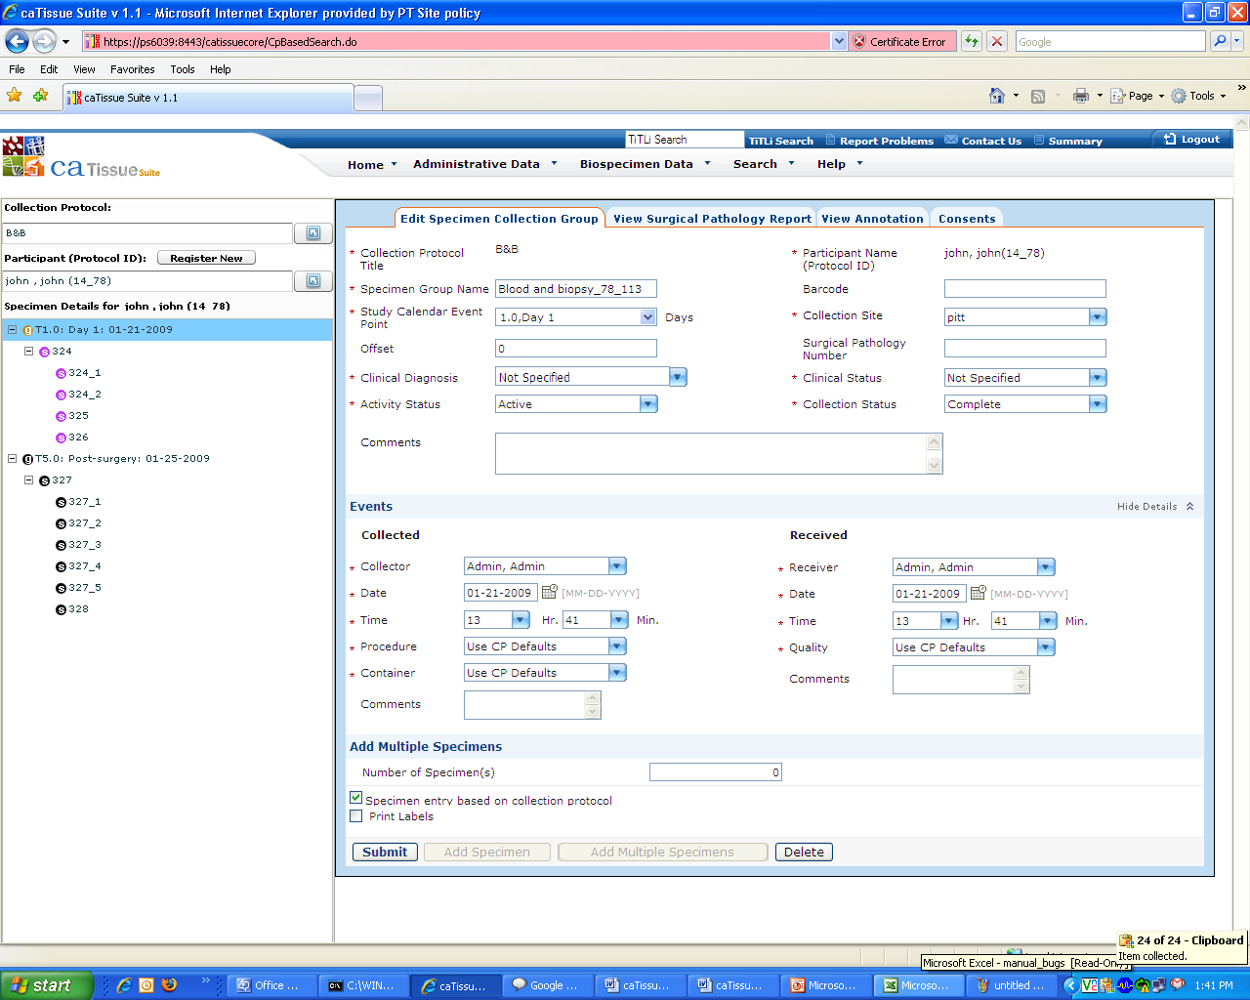

Figure : Specimen Details after Specimen Collection

In the preceding figure, the icons for the first specimen collection group and specimens associated with it are changed to indicate that they are collected specimens. The second event and specimens associated with the second event are in black color icons, indicating that they are not yet collected.

#### What are Collected and Received Events?

Specimens are collected from a participant and received in tissue bank, so collected and received events are required for every specimen. In , the specimen collected event and received event capture information about the specimen as it is collected and received for processing and storage. Collected Events are defined as the event (time) at which a biospecimen is removed from the participant. A Received Event is defined as the event (time) at which a biospecimen is first received for initial processing.

**Note:** Anticipated (pending) specimens or specimens that were never collected should not have collected or received events, since they have been neither collected nor received.

In , you can define individual specimen requirements for all specimens within a Specimen Collection Group (SCG) when creating the Collection Protocol (CP).

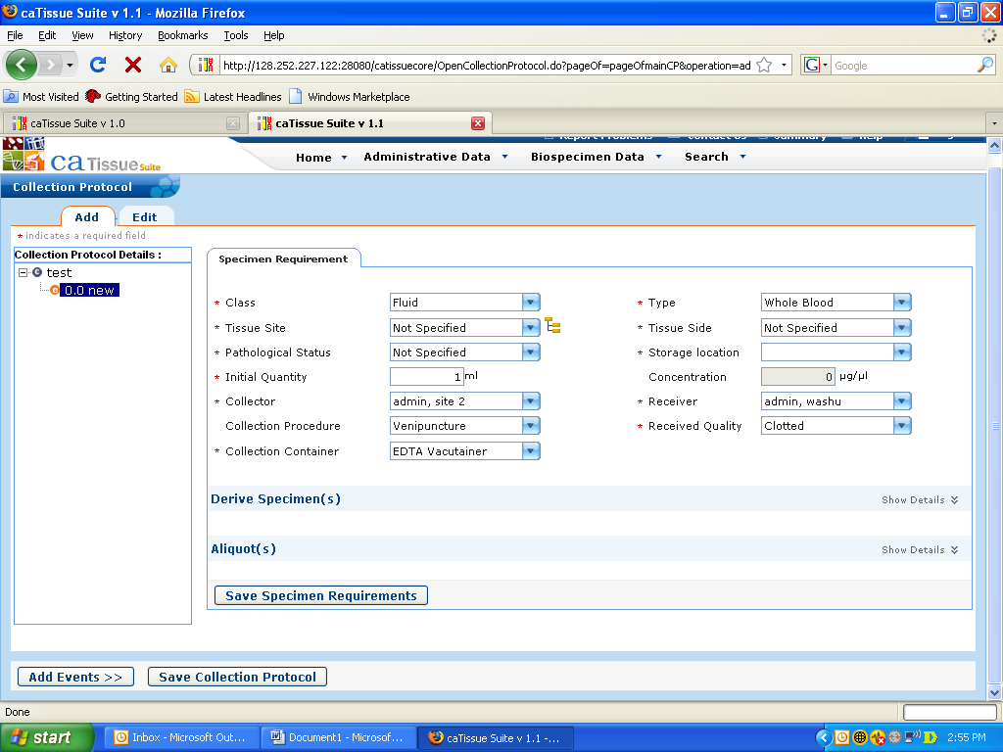

Figure: Predefining Collected and Received event data at collection protocol level

You can also pre-define some of the attributes of collected and received events while defining the Collection Protocol. For example, if a protocol will always collect 1 tube of blood for plasma, the collection container may be pre-set to “EDTA Vacutainer” and the procedure to “Venipuncture.” If a single user will be collecting the specimen from the participant and receiving the specimen for initial processing, it may be desirable to pre-set these values. Do not pre-define perceived quality; unless one assumes that the quality of specimens is always adequate (by default). Nevertheless, this provision is available. It is not possible to pre-define collected or received date/time stamps in the Collection Protocol definition phase.

The following table lists the default values of attributes.

|  |  |
| --- | --- |
| Attribute | Value |
| User (Who collected the specimen) | Current user logged into |
| Procedure (How the specimen was collected) | Use CP Defaults |
| Container (Into what container the specimen was) collected, primarily for blood specimens) | Use CP Defaults |
| Quality (The receipt quality of the specimen) | Use CP Defaults |
| Date/Time (Both Collected and Received Events) | Participant Registration date + study calendar event point |

Use the Collection Protocol Defaults value to use the values defined in the collection protocol. For example, for a specimen requirement, Venipuncture is selected as the Procedure while defining the collection protocol. When you submit the Specimen Collection Group with the value **Use CP Defaults**, then that specimen will have Procedure as Venipuncture in the collected event.

The Date/Time for both collected and received events is set to the registration date time + the study calendar event point (days) of the SCG / collection event.

**Note:** You can edit the date/time stamps to reflect the exact time that specimens were received and update the date if specimens were not received according to the planned study calendar.

All possible edits made to the Collected / Received Event data on the Specimen Collection Group page are propagated to all specimens in the Specimen Collection Group. If any default values are changed on this page, and you click **Submit**, the following message is displayed, *The collected and received events data that you have entered will be propagated to all specimens under the Specimen Collection Group and override any existing data. Do you want to continue?*

This warns you that any previous values set at either the Collection Protocol definition time or at the individual specimen edit level will be overwritten by the values selected on this page. This applies to all specimens in the Specimen Collection Group.

Once you create a specimen, you can manually edit the individual collected / received at the individual specimen level.

Even if you add the individual specimen collected / received data on the edit Specimen Collection Group page, the collected / received data fields show default values.

In , collected and received events are like any other specimen event. That is, a specimen can have multiple collected and received events. In reality, collected and received events are special cases, in that these events only happen once in a biospecimen’s lifecycle. A specimen may be transferred between and received by individual repository sites many times but the specimen is only initially collected and received once from the participant. Also, derived specimens are never Collected or Received, only Created.

## Specimen Operations

A *specimen* is a tissue or body fluid collected from a participant as part of the specimen collection group. This section provides information and procedures to further manage specimens:

* The following figure depicts the specimen page:

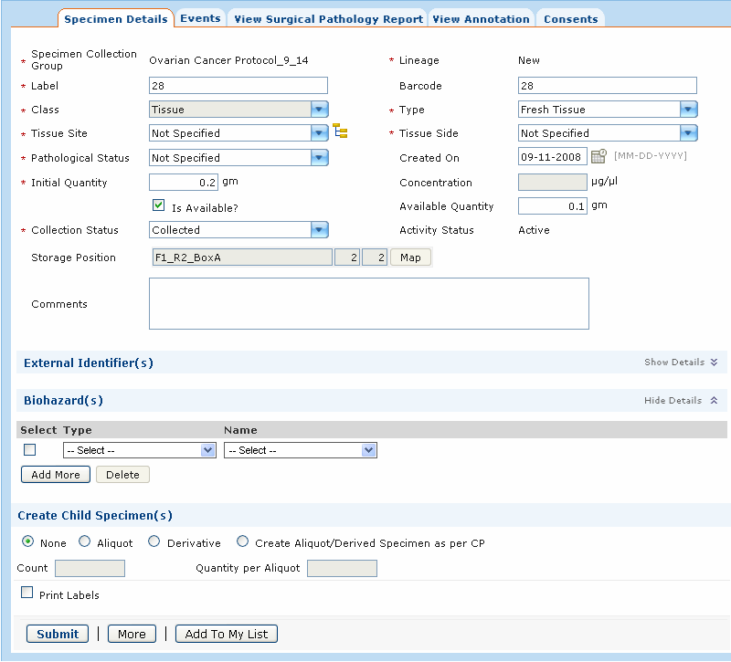

Figure : Specimen Details Page

The following table explains the fields on the specimen page:

| Field | Description |
| --- | --- |
| Lineage | Lineage of the specimen can be New, Aliquot, or Derived |
| Class | Class of the specimen can be Tissue, Fluid, Cell, or Molecular. Note that options for the specimen type change based on the value selected. |
| Tissue Site | Location from where the specimen was procured. |
| Tissue Side | Side from where the specimen was taken, such as, left is selected if the specimen is accessioned from the left breast. Tissue Side has permissible values, such as Left, Right, Not Applicable, and Not Specified. |
| Pathological Status | Refers to the pathological status of the specimen. |
| Created on | Refers to the date on which the specimen was created. |
| Initial Quantity | Refers to the quantity of the specimen when the specimen was first received. |
| Available Quantity | Refers to the specimen quantity available after specimen processing. For example: A specimen has initial quantity as 5 ml. Two aliquots of 1 ml. were created out of this specimen. The Available quantity now changes to 3 ml. |
| Is Available | Select this check box if the specimen is available. The check box is unselected, when the **Is Available** is set to false when:  1. The specimen is anticipated.  2. The specimen quantity is fully used for creating aliquots.  3. The specimen is disposed (Activity status = Closed). |
| Concentration | Enter the concentration of the molecular specimen. |
| Collection Status | Select the collection status of the specimen in this field. The permissible values for the specimen are Collected, Not Collected, Pending, and Overdue. |
| Storage Position | Indicates where the specimen is stored. |
| Comments | Optional text entry box for comments related to the specimen being entered. |
| External Identifier | Refers to a pre-existing, externally-defined identifier associated with a specimen.  Name and Value are entry fields for additional names used to identify the specimen and additional values used to describe the specimen respectively.  To add data fields for additional external identifiers, click the **Add More** button. To delete an external identifier, click the associated check box located to the right of the field, and then click the **Delete** button. |
| Biohazard | An attribute of a specimen that renders it potentially harmful to a user. When handling biospecimens, it is imperative to inform others of any biohazard(s) associated with a specimen.  You can select the Type of biohazard associated with the specimen being entered and Name for the biohazard being applied.  To add data fields for additional biohazards, click the **Add More** button.  To delete a biohazard, click the check box next to the biohazard, and then click on the **Delete** button. |
| Create Child Specimens | By default, the **None** radio button is selected.  To create aliquots, select the **Aliquot** radio button and specify the **Aliquot Count** and **Quantity per Aliquot**.  To create a derivative specimen, select the **Derivative** radio button and then specify the required number of derivatives in the **Count** text box.  To create aliquots and derivatives of the specimen as defined in the collection protocol, click the **Create Aliquot/Derived Specimen as per the Collection Protocol** radio button. |
| Add to My List | Used to add the specimen to My List. To do this, click the **Add to My List** button. |
| Print Labels | Select this check box to print the label for the specimens. For more information on print labels, refer to the *Administration Guide.* |

By default, Administrators, Supervisors, and Technicians have the Specimen Processing privilege. Specimen Processing privilege includes creating sub-specimens, that is aliquots and derivatives, and adding a biospecimen event and specimen arrays.

### What is the Difference Between an Aliquot and a Derivative?

Both aliquots and derivatives are child specimens; They are created from another specimen which is a parent specimen. An aliquot is a division of the parent specimen where the child inherits **all** the properties of the parent other than the quantity. In case of the derived biospecimen, the child specimen is a processed derivative from the parent specimen.

**Note:** If you have Specimen Processing privileges, you can create specimen aliquots and derivatives on the collection protocol under which the specimen is accessioned. You must also physical access to the parent specimen. For example, a specimen TP123 is created under a collection protocol CP1 and stored at Tissue Bank 1. For making aliquots, you must have the specimen processing privilege on CP1 and access to Tissue Bank 1.

**Note:** When you have a site level privilege, you can store aliquots and derivatives at the site along with child specimens. For example, John has Specimen Processing privilege on Site A. While storing the child specimens, John can view and store the sub-specimens in only those containers that are present in Site A.

### Aliquoting a Biospecimen

The following procedure outlines how to aliquot a biospecimen:

1. Click the **Biospecimen Data** tab.
2. Click **Specimen > Aliquot**. The Specimen Aliquot page opens.
3. Select the **Label** or **Barcode** radio button for the Parent Specimen Label for the aliquot to be created. Enter the relevant data in the Label or Barcode field.
4. Enter the **Aliquot Count**.
5. Enter the **Quantity per Aliquot,** if required.

**Note:** If you do not enter a Quantity per Aliquot, divides the available quantity of the specimen into equal amounts for each of the aliquot.

1. Click **Submit**.
2. The **Create Aliquot** section displays the aliquot details specified earlier. You can change the **Aliquot Count** and **Aliquot Quantity** using the **Resubmit** button. The **Aliquot** page is refreshed based on the count and quantity entered.
3. The **Aliquot** section displays the following information:
4. Characteristics of the parent specimen, such as, the **Type** and **Class.**
5. **Quantity** of the aliquots you specified.
6. **Storage location** for each of the aliquots that you can specify.
7. Aliquot storage in the same container. Select **Do you want to store all aliquot(s) in same container?** to store all the aliquots created in one container. The storage locations are refreshed accordingly.
8. Activity status of the parent specimen. Select the **Do you want to dispose parent specimen?** check box to set the activity status of the parent specimen to **Closed** in .
9. Select **Print Labels** to print the label for the specimens. For more information on print labels, refer to the *Administration Guide.*
10. Click **Submit**.
11. The Aliquot Creation Summary page opens. This page displays all the details for the new aliquots. For example, the **Class**, **Type**, **Label**, and **Storage** **location**.

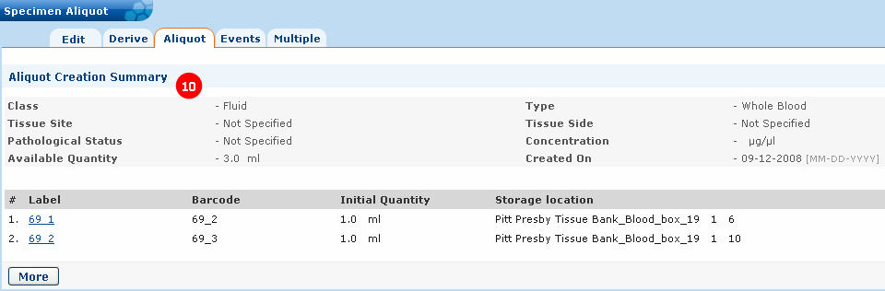

Figure : Aliquot Creation Summary

You can also create aliquots using the Collection Protocol Based View.

### Creating Biospecimen Derivative

You can create a derivative from the existing biospecimen. To create a derivative biospecimen:

1. Click the **Biospecimen Data** tab.
2. Select **Specimen > Derive** under. The Specimen Derive page opens.
3. Select the **Label** or **Barcode** radio button for the parent specimen.
4. Enter all the details of the derivative specimen like Class, Type and so on.

You can also enter the details of any aliquots you wish to create from the derived specimen.

1. Check the **Print Labels** check box to print the label for the derived specimen. For more information on print labels, refer to the *Administration Guide*.
2. Click **Create** to create the derived specimen.

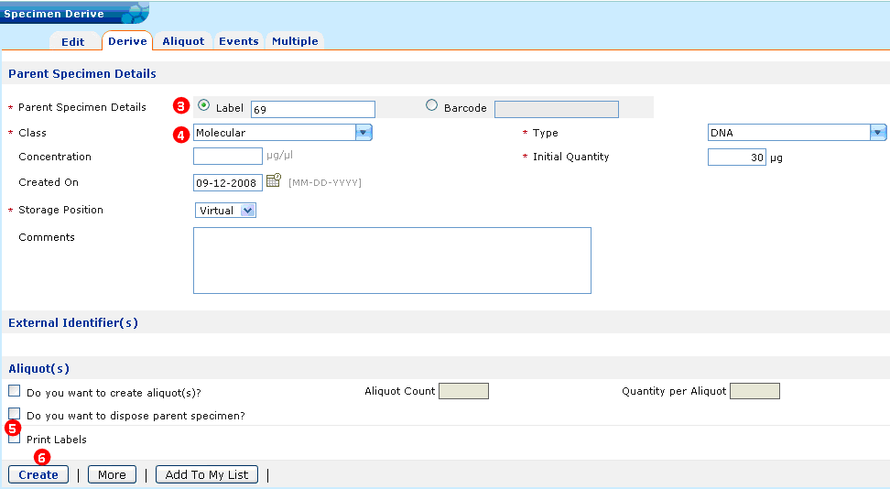

Figure : Creating Derivatives

You can also create derivative specimen using the Collection Protocol Based View.

### Adding Multiple Specimens

This feature allows you to add multiple specimens into without repeatedly adding specimens. This does not require that the specimens entered share the same characteristics.

To add multiple specimens into :

1. Click the **Biospecimen Data** tab.
2. Click **Specimen > Multiple**. The Multiple Specimen page opens.

Click **Add** **More** to add additional columns for entry of specimen data. Click **Delete** to delete a specimen. The specimen is removed from the last column.

1. Enter the required details of the specimen.
2. To copy attributes of **Specimen 1** to **Specimen** **2**, select the required attributes of **Specimen** **1**.
3. Click **Copy**.
4. Select the check box corresponding to **Specimen 2**.
5. Click **Paste**. The selected attribute details of **Specimen 1** are copied to **Specimen** **2**.

**Note:** For the current version of , you can copy only attributes from one specimen to another specimen.

1. To copy all the attributes of **Specimen 2** to **Specimen 3**:
2. Select the check box corresponding to **Specimen 2**.
3. Click **Copy**.
4. Select the check box corresponding to **Specimen 3**.
5. Click **Paste**. The selected attribute details of **Specimen 2** are copied to **Specimen 3**.

**Note:** This functionality copies all attributes from any selected specimen to any another specimen. You cannot select specific attributes to copy.

1. Click **Submit**.

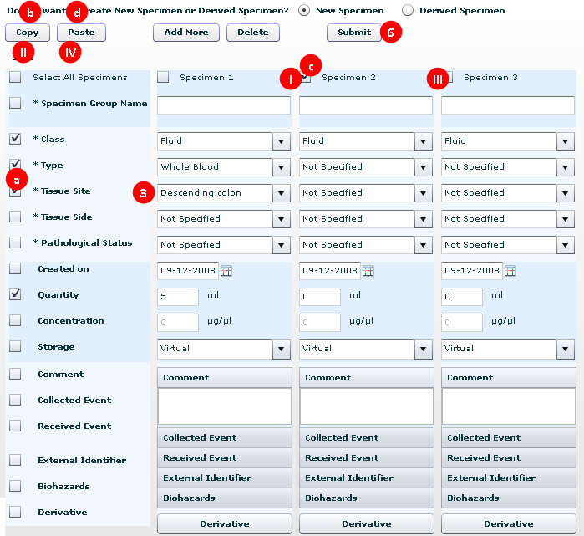

Figure : Multiple Specimen Page

**Note:** You can specify a derivative of a specimen using the **Derivative** button. This displays the Create Derivative page. Click **Add More** on the Create Derivative page to specify more derivatives of the parent specimen.

### Adding a Biospecimen Event

Any action performed on a biospecimen is referred to as an *event*. Events include transfer, review of the specimen, frozen, thaw, fixed, disposal, and spun. To add or edit events, you must have access to the site where the specimen is stored. You can transfer specimens only if you have access to both the sites, the site in which the specimens are stored, and the site to which the specimens are to be transferred.

The following table lists the various Events in

| Name of the Event | Description |
| --- | --- |
| Cell Specimen Review | Refers to performing quality assurance actions on a cell specimen. |
| Check In Check Out | Refers to temporary movement of specimens from a stored location. |
| Collection | Refers to a collection of a specimen from a participant under a collection protocol. |
| Disposal | Refers to disposing or rejecting a specimen. The Activity Status of the specimen can be set to Disabled (Deletes the specimen completely from system) or Closed (Specimen is visible in but unavailable for specimen operations such as aliquoting, and deriving.). |
| Embedded | Refers to embedding a specimen in paraffin, and plastic material. |
| Fixed | Refers to fixing a specimen in a fixing medium like formaldehyde, and ethanol. |
| Fluid Specimen Review | Refers to performing quality assurance actions on a fluid specimen. |
| Frozen | Refers to freezing a specimen at certain temperature using a freezing method, such as Liquid Nitrogen, and Dry Ice. |
| Molecular Specimen Review | Refers to performing quality assurance actions on a molecular specimen. |
| Procedure | Refers to customized procedure that is applied on a specimen to process it. |
| Received | Refers to receiving a specimen in the tissue bank. |
| Spun | Refers to spinning the specimen. |
| Thaw | Refers to defrosting a specimen. |
| Tissue Specimen Review | Refers to performing quality assurance actions on a tissue specimen. |
| Transfer | Refers to moving a specimen from one storage location to another storage location. |

To add an event to a biospecimen:

1. Click the **Biospecimen data** tab.
2. Click **Specimen > Events** under on the left pane.
3. Select the specimen **Label** or **Barcode** radio button.
4. From the **Event** drop-down list, select an event to be added to the specimen.
5. Click **Add Event**.

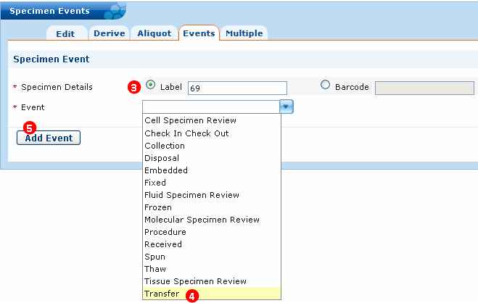

Figure : Adding an Event - Events Tab

1. Enter all the details for the event, and click **Submit**.

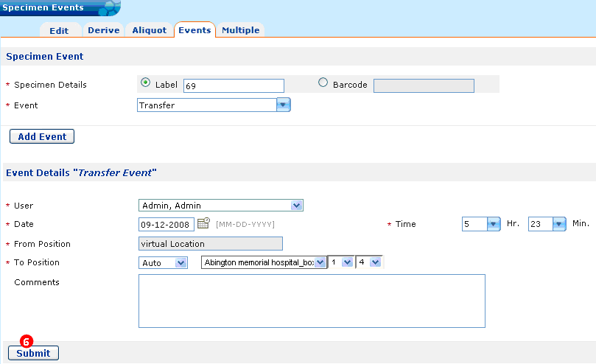

Figure : Adding a Biospecimen Event

The event gets registered for the specimen. You can view this event under the *Existing* eve*nts for the specimen* section under the Events tab for the specimen.

### Performing Bulk Operations for Specimens

*Bulk operation* is a time-saving feature that helps you to add an event to multiple specimens at one time. Bulk operations also include editing several specimens at the same time.

Pre-requisites for adding an event to specimens or editing multiple specimens are performing an advanced search for the specimens that are to be edited or to which an event has to be added.

1. On the View Results page, select the specimens.
2. Click **Add to My List** to add specimens to My List.

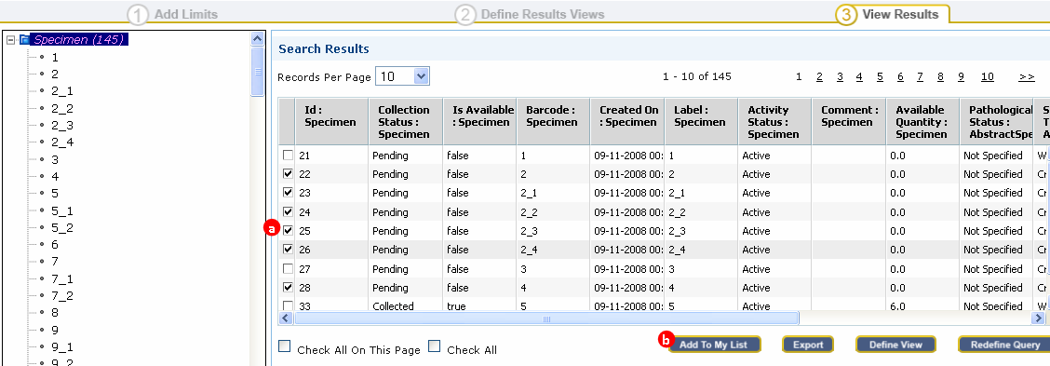

Figure : Search Results

To add an event:

1. Click **Search**.
2. Click **Search > My** **List** **View** under.
3. Click the **Specimen Event** radio button as shown in the following figure.
4. From the **Specimen Event** drop-down list, select the event that has to be added to the specimens.

**Note:** Currently, you can perform only bulk transfer and bulk disposal events.

1. Click **Submit**.

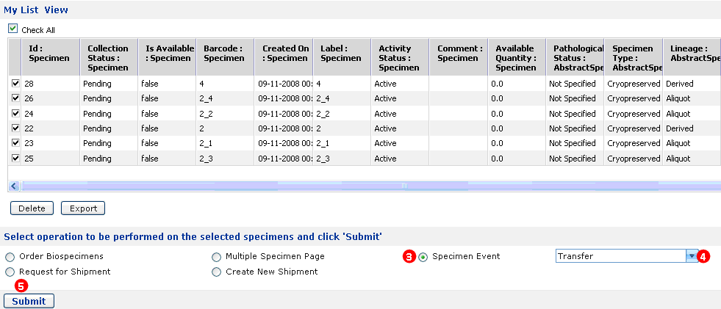

Figure : Adding an Event

1. Enter details of the event. If you transfer an event, specify the Destination Container name.
2. Click **Submit**.

To edit several specimens at one time, perform the following steps:

**Prerequisite:** You must add the specimens of interest to My List before proceeding.

1. Click **Search**.
2. Click **Search > My** **List** **View**.
3. Select the **Multiple Specimen Page** radio button.
4. Click **Submit**.

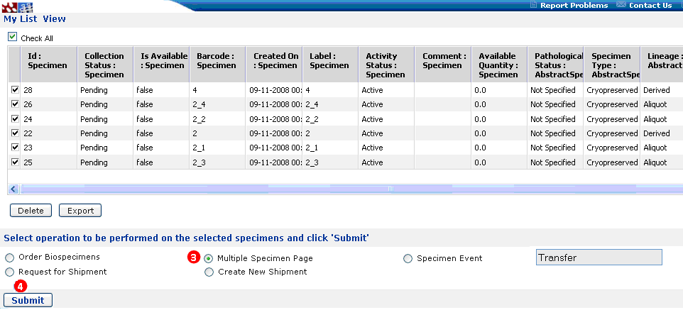

Figure : My List View

1. The Multiple Specimen page opens. Edit the fields for the specimens.
2. Click **Submit**.

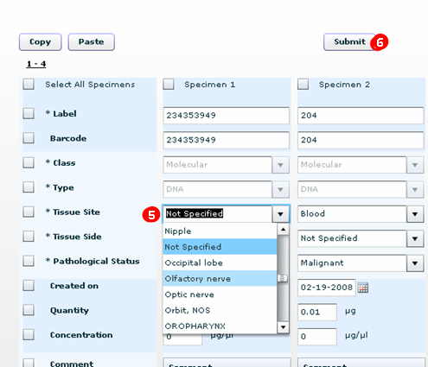

Figure : Multiple Specimen Page

### Adding a Specimen Array

A *specimen array* in is a collection of biospecimens arranged in an ordered pattern, such as a 96-well PCR plate. To create a specimen array, you can use only those specimens that belong to the site and are accessioned under the collection protocol to which the user has access. You can store specimen arrays only in those containers in the sites on which you have the necessary privileges.

Prerequisite for adding specimen array:

* A specimen array type should exist in .
* Storage containers are added for this specimen array type.

To add a specimen array, perform the following steps:

1. Click the **Biospecimen Data** tab.
2. Click **Add** under **Specimen Array** on the left pane. The Add Specimen Array page opens.
3. Select an array type from the **Array Type** drop-down list. According to the array type, generates the array label.
4. auto-populates available Storage Positions for the array. Alternatively, select **Map,** and select the storage position.
5. In the grid, which has dimension of the array type, add compatible specimens belonging to the same Specimen Class and Specimen Type. You can type either specimen labels or barcodes in the grid.
6. For molecular specimens, specify **Concentration** and **Quantity**. To make a quantity of 10 micrograms and a concentration of 1 microgram/microliter for all wells:
7. Set the Concentration to **1**.
8. Set the Quantity to **10**.
9. Select all the wells. To do this, right-click and drag the mouse pointer across all the wells.
10. Click **Apply**.

Use **Copy** and **Paste** buttons to copy label or barcode, quantity, and concentration of one specimen to another specimen.

1. Click **Upload Specimen Array** to submit this specimen array as shown in the following figure.

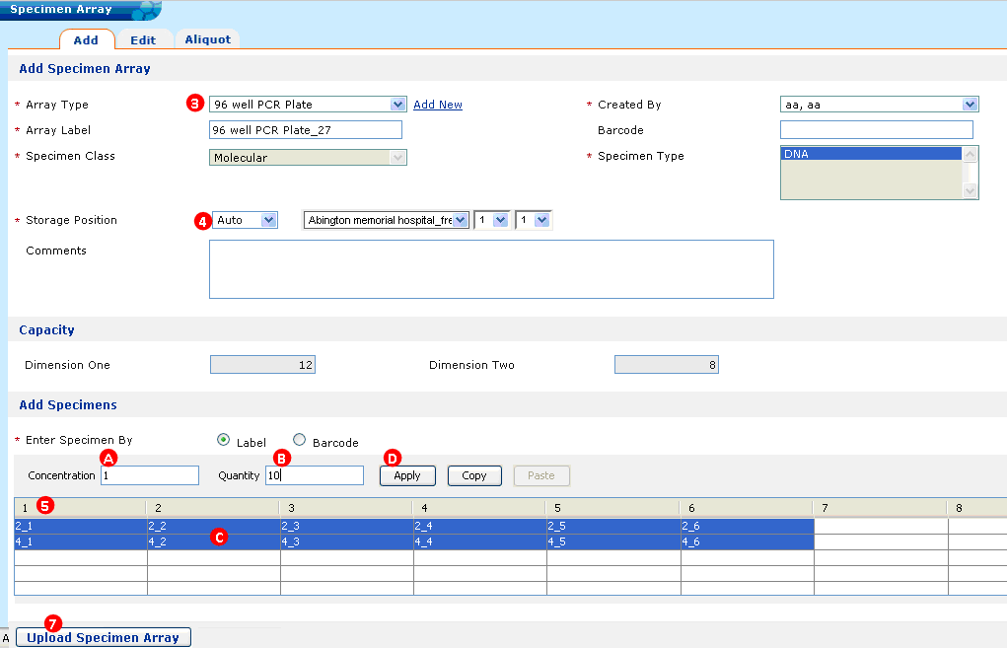

Figure : Specimen Array Creation

To add a specimen array aliquot:

1. Click the **Biospecimen Data** tab.
2. Click **Specimen Array > Aliquot**. The Create Specimen Array Aliquot page opens.
3. Select either the **Label** or **Barcode** of the Parent Specimen Array of the aliquot to be created.
4. Enter the **Aliquot Count**.
5. Click **Submit** as shown in the following figure.

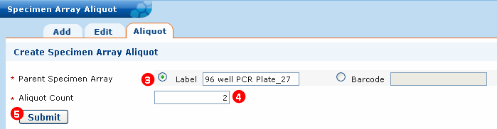

Figure : Adding Specimen Array Aliquot

1. The Specimen Array Aliquot page opens. Click **Create** to create this specimen array aliquot.

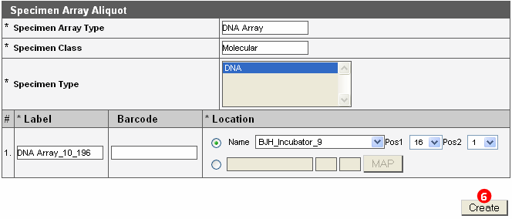

Figure : Specimen Array Aliquot Page

1. navigates to the Specimen Array Aliquot Creation Summary page, A success message displays, *Aliquot(s) have been created successfully.*

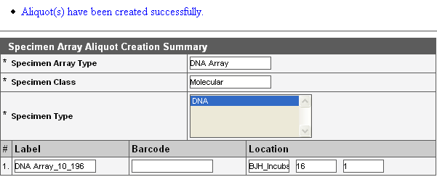

Figure : Specimen Array Aliquot Creation Summary page

#### Unplanned Specimen Collection

An *unplanned specimen collection* is defined as the collection of a specimen that does not have a pre-defined specimen requirement.

To manage an unplanned specimen collection:

1. Select the **Biospecimen Data** tab, and click the **Participant** option.
2. Click **Specimen Collection Group** on the Participant page. navigates to the Add Specimen Collection Group page.

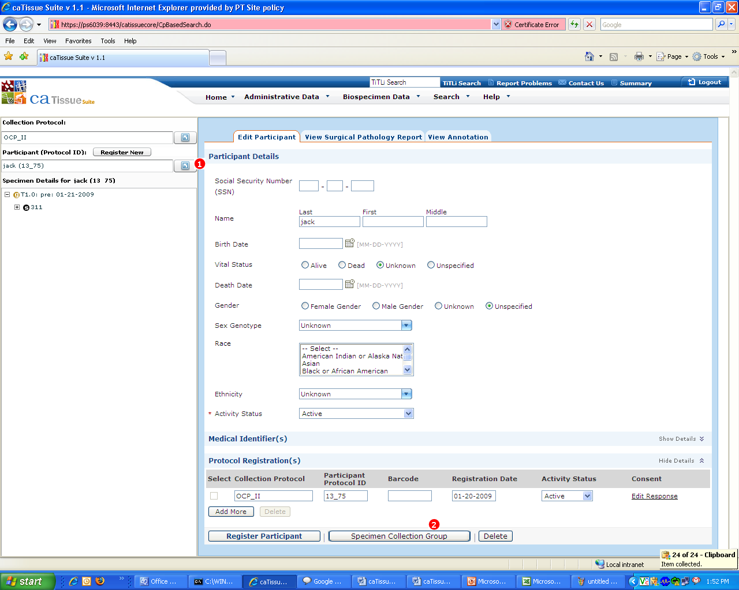

Figure : Unplanned Specimen Collection

1. On the Add Specimen Collection Group page, select the Study Calendar Event .Point under which the specimens are to be added.
2. Enter the Speciment Collection Group details.
3. Clear the **Specimen entry based on collection protocol** check box.
4. To add a single specimen or multiple specimens, click **Add Specimen** or **Add Multiple Specimens**. If you add multiple specimens, enter the required **Number of Specimen(s)**.

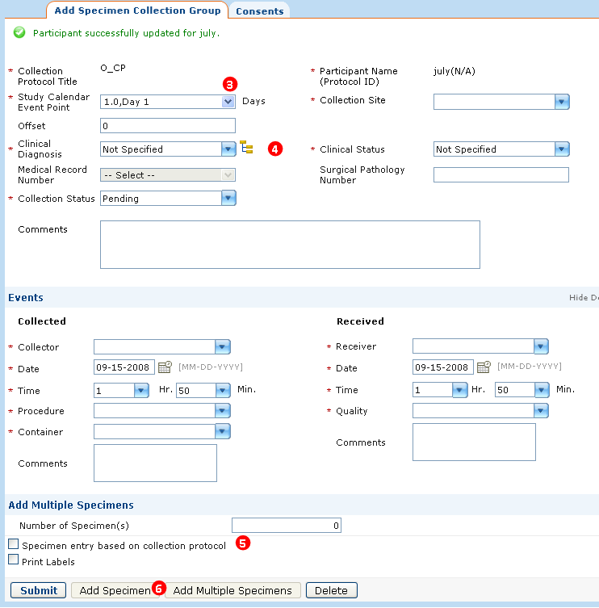

Figure : Adding Unplanned Specimen(s)

### Editing Biospecimen Objects

You can perform editing on all the objects under the Biospecimen Data tab except Distribution and Order. The following procedure outlines how you can perform basic editing:

To perform an edit operation:

1. On the **Biospecimen Data** tab, click **Edit** under the required object on the left pane of the screen. For example: Participant, Specimen. The relevant search window opens.
2. Select the required **Attribute**, **Condition**, and **Value**.
3. Click **Search**. The Search Result page displays the matching records.
4. Double-click the record of interest. The Edit page opens.
5. Make the required changes, and click **Submit**. A success message opens if the record is successfully updated.

#### Performing Collection Protocol Based Editing

You can also perform edit operations using the Collection Protocol Based View. The following procedure outlines how to perform Collection Protocol based editing:

To perform CP based editing:

1. Select the required collection protocol.
2. Select the required participant under **Participant (Protocol ID)** or the required SCG or Specimen under the Specimen Details tree on left pane of the screen. Based on the selection, each selection displays the edit mode on right pane.
3. Edit the required fields. Properties inherited from parent specimens in case of aliquots are not editable. For example: **Class**, **Type**, and so on.
4. Make the required changes and click **Submit**. A success message is displayed, if the record is successfully updated.

#### Editing a Participant Registration on an Arm

It is possible that the participant can drop out of one arm and get registered to another arm at the same level or can be accidentally registered to the wrong arm.

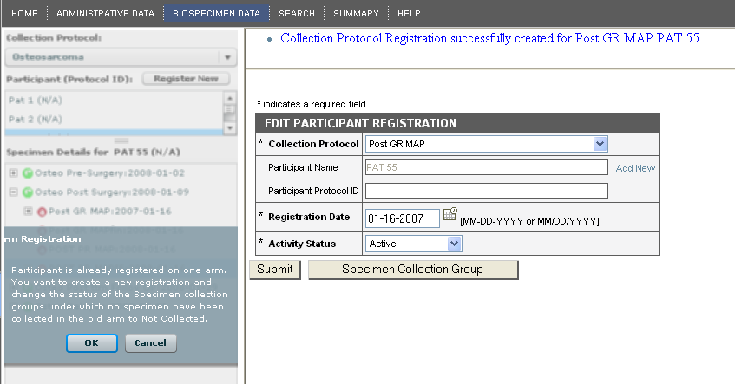  
Figure : Editing a Participant Registration to a Different Arm

To edit a participant registration on an arm:

1. Click the **Biospecimen Data** tab, and click **Collection Protocol Based View**.
2. Select the required longitudinal collection protocol.
3. Select a participant registered to the main protocol.
4. Register the participant to arm one.
5. Once you register the participant to another arm at the same level, the message *Participant is already registered on one arm. You want to create a new registration and change the status of the Specimen Collection Groups under which no specimens are collected in the old arm as Not Collected* message opens. Click **OK**.
6. Once you click **OK**, the participant is registered to the new arm. The collection status of the SCGs under which no specimens are collected is marked as **Not Collected**. If arm two is of a different duration, that is containing more or less time points as compared to arm one, then all the future sub-protocols and Specimen Collection Groups are readjusted to display the updated anticipated dates.

# Surgical Pathology Report (SPR) (Biospecimen Data)

This chapter describes the Surgical Pathology Report (SPR) and provides information about why this report is important.

The topics in the chapter include:

* on page 166

## Surgical Pathology Report (SPR) Overview

A Surgical Pathology Report (SPR) is an important clinical document that plays a vital role as source of data in cancer research. SPRs are stored in hospital IT systems. These reports contain vital information based on the surgeon’s pathological observations about the patient and biospecimens.

The cancer Text Information Extraction System (caTIES) is used to:

* Load Surgical Pathology Reports in HL7 format into .
* De-identify the reports to remove sensitive data so that Scientists can access the data in the report.
* Extract coded information from free text SPRs using controlled terminologies to populate caBIG®-compliant data structures.
* Provide researchers with the ability to query, browse, and acquire annotated tissue data and physical material across a network of federated sources.
* Refer to the *Deployment Guide* for detailed instructions on installing the server components for caTIES.

You can access the SPRs using the three classes under the **Biospecimen Data** tab. To view a surgical pathology report, navigate to the Collection Protocol Based View:

1. Click the **Biospecimen Data** tab.
2. Click **Collection Protocol Based View**. In the left column, click **Collection Protocol**, and select a collection protocol that has SPRs associated with it.

**Note:** The Collection Protocols with associated SPRs are not marked in . The Administrator or the Principal Investigator of your study can inform you whether SPRs are loaded for your protocol.

1. Select a participant. The Edit Participant page opens.
2. To view the report, click **View Surgical Pathology Report**.
3. To view the report, select the **Identified Report** as shown in the following figure.

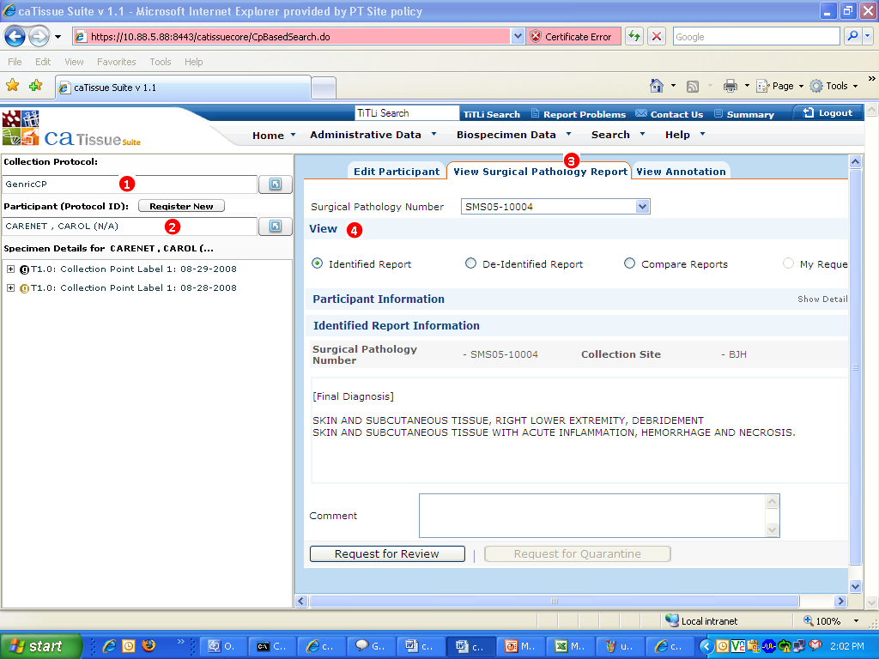

Figure : View Surgical Pathology Report

**Note:** You can also navigate to the specimen or specimen collection group page and view the SPR associated with them.

## What You Can Do With the Surgical Pathology Report

The Surgical Pathology Report (SPR) page displays identified or de-identified reports based on the role and privileges to which you are assigned.

The following table lists User Role Access to SPR system:

| Users | User Access to SPR |
| --- | --- |
| Administrator | View identified and de-identified reports.  Compare reports using the user interface.  Use the concept highlighter to color code the report.  Review of the report.  Quarantine the requested report. |
| Supervisor | View identified and de-identified reports using the advanced query option.  Use the concept highlighter to color code the report.  Request a review of the report.  Request to quarantine a de-identified report. |
| Technician | View de-identified reports using the advanced query option.  Use the concept highlighter to color code the report.  Request a review of the report.  Request to quarantine the report. |
| Scientist | View the SPRs using the advanced query option. If you are the Principal Investigator for that Collection Protocol, you can view the identified reports. By default, you can view only the de-identified reports. You can also export the data to Excel.  Use the concept highlighter to color code the report.  Request a review of the report.  Request to quarantine a de-identified report. |

#### Compare Identified-De-identified Reports

The Compare Identified De-identified Reportsyou hides the identified data, and opens the Identified Report Information and De-Identified Report Information pages.

#### Category Highlighter

The Category Highlighter enables you to display De-Identified reports. You select the **Show De-Identified Report** option or the **Compare Identified-De-identified Reports** option. Selecting the Procedure, Organ, Modifier, or Diagnosis check box highlights the selected categories in a particular color under the De-Identified Report Information. You can select multiple highlighters at the same time.

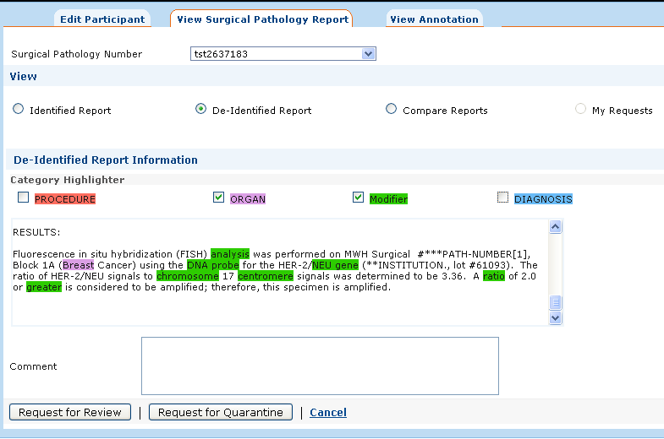

Figure : Category Highlighter

#### Quarantine Request

If you you have access to a de-identified report and get to view identified data to which you do not have access, you can request to quarantine the report. For this, enter the required comment in the **Comment** field, and click **Request for Quarantine**. This operation immediately makes the report invisible to all users other than the Administrator. Each institution that uses develops its own procedures for reviewing quarantined reports and making them available once they are fully de-identified.

#### Reviewing a Request

If you see any kind of discrepancy in the report, such as a term not properly concept-coded, then you can request a report review. For this, enter the required comment in the **Comment** field, and click **Request for Review**. Each institution that uses caTissue develops its own procedures for reviewing reports.

Currently, there is no user interface for the Administrator to review the quarantine requests and review requests. The Administrator verifies the report querying the tables below in the database:

* catissue_review_params
* catissue_quarantine_params

Report entries in these tables with a Pending status indicate a request for review or quarantine.

## Conflicting SPRs

To display any pending Surgical Pathology Reports (SPRs) that are Ambiguous Participants or Ambiguous Specimen Collection Groups, click the **Administrative Data** tab and **Conflicting SPRs**.The Pending Conflict Report opens. Select the appropriate **Filter:**

* **All**
* **Ambiguous Participants**
* **Ambiguous Specimen Collection Groups**

# Biorepository Summary Page

The purpose of the caTissue Biorepository Summary Page (BSP) is to provide a quick overview of the magnitude and scope of any given instance. Some information presented includes the total registered participants and total specimens by type.

The data contained within the BSP is useful to identify repositories containing biospecimens that meet research needs. The data is also useful to administrators and funding agencies who wish to quickly determine the magnitude and scope of individual repositories (based upon data within a instance).

The counts include objects that are potentially accessible. For example, aggregate counts do not include anticipated specimens or disabled objects. Objects which are Closed are considered in aggregate counts as are specimens that are marked Not Available.

To access the BSP:

Click the **Summary** link on the upper right-hand corner of .

Names and Contact Information for all Super Administrators is available. Administrative Information like the total registered users, total Collection/Repository/Laboratory sites, total of Collection and Distribution Protocols is also displayed.

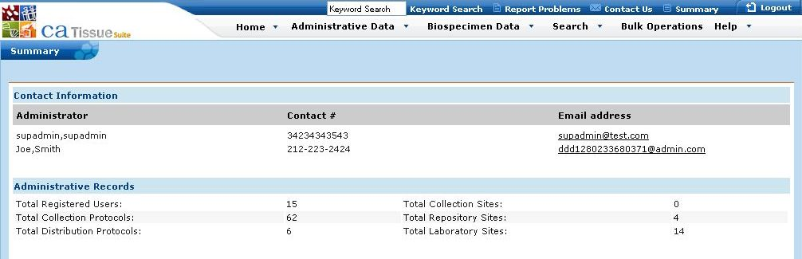

Figure : Summary Page – Contact Information and Administrative Records

Participant summary information is grouped by clinical diagnosis or status.

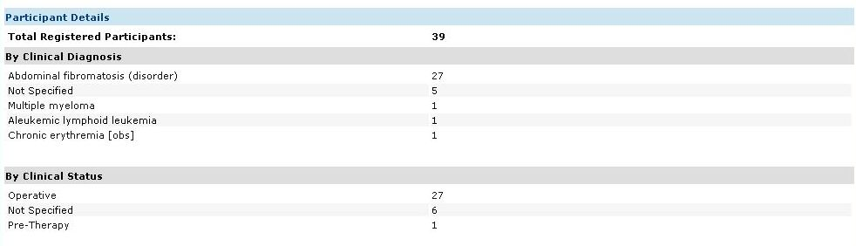

Figure : Summary page – Participant Details

Counts of specimens grouped by class, pathological status, and anatomic site are shown as well.

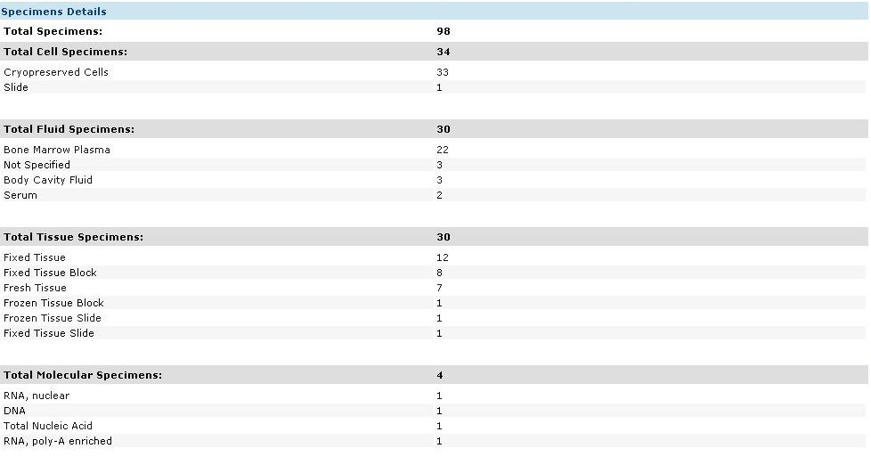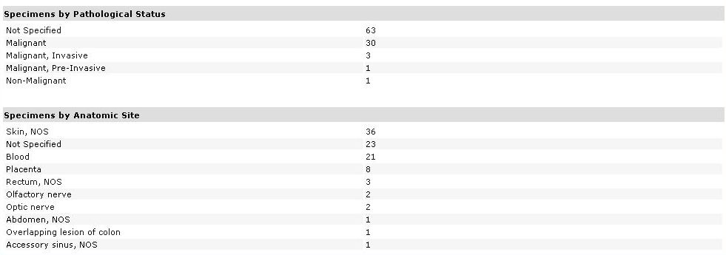

Figure : Summary page – Specimen Details

# Introduction to Clinical Annotations

This chapter provides descriptions and instructions to use Clinical Annotations (CA). Clinical Annotations allows you to collect additional clinical and pathological information of the participant, accession, and biospecimens. Clinical Annotations is divided into pathology information and clinical and health information.

The topics in this chapter include:

* on page 173
* on page 173
* on page 175
* on page 177

## Pathology Information

This section outlines CAP-based (College of American Pathologists) pathology annotations. It involves a collection of information on a broad spectrum of tumors. It captures information about various features associated with tumors, such as TNM staging (tumor, node, and metastasis stage determination), histologic grading, histo-pathological examination, positive or negative margins, and other fundamental pathology details. The module consists of nine organ systems and data for these organ systems is independently captured. The nine organ systems are:

* Prostate
* Pancreas
* Kidney
* Lung
* Blood/Bone Marrow (labeled as *Heme* in )
* CNS
* Colon and Rectum
* Breast
* Skin (labeled as *Melanoma* in )

To accommodate pathology data for tumors that do not fall under the nine organ systems, there is a generic annotation to capture information specific to that organ system.

## Clinical and Health Information

Clinical and health information comprises clinical information about the participant‘s:

* Medical history
* Follow-up
* Medications administered (such as chemotherapy, radiation therapy, and so on)
* Social history (smoking and alcohol history)
* Environmental exposure history (for example: exposure to asbestos)
* Physical examinations
* Laboratory test details
* Family health history

The clinical annotations available in can be found under the hook entities as outlined in the following table.

| Participant | Specimen Collection Group | Specimen |
| --- | --- | --- |
| * Lab Annotation * Family History Annotation * Treatment Annotation * Rad RX Annotation * Chemo RX Annotation * Treatment Regimen * Environmental Exposure Health Annotation * Alcohol Health Annotation * Smoking Health Annotation * Health Examination Annotation * New Diagnosis Health Annotation * No Evident Disease Health Annotation * Recurrence Health Examination Annotation * Local Recurrence Health Examination Annotation * Distant Recurrence Health Examination Annotation | * Base Solid Tissue Pathology Annotation * Base Hematology Pathology Annotation * Radical Prostatectomy Pathology Annotation * Needle Biopsy Prostate Pathology Annotation * Retropubic Enucleation Pathology Annotation * Transurethral Prostatic Resection Pathology Annotation * Pancreas Pathology Annotation * Lung Biopsy Pathology Annotation * Lung Resection Based Pathology Annotation * Kidney Biopsy Based Pathology Annotation * Kidney Nephrectomy Pathology Annotation * Melanoma Pathology Annotation * CNS Pathology Annotation * Breast Pathology Annotation * Local Excision Based Colorectal Pathology Annotation * Excisional Biopsy Based Colorectal Pathology Annotation * Resection Based Colorectal Pathology Annotation | * Specimen Based Solid Tissue Pathology Annotation * Colorectal Specimen Pathology Annotation * Pancreas Specimen Pathology Annotation * Melanoma Specimen Pathology Annotation * CNS Specimen Pathology Annotation * Prostate Specimen Pathology Annotation * Kidney Specimen Pathology Annotation * Lung Specimen Pathology Annotation * Breast Specimen Pathology Annotation |

## Features of Clinical Annotations (CA)

Clinical Annotations provides the following features:

1. Assign a Clinical Annotation selectively to specific collection protocols.
2. Enter data for organ specific or generic pathology annotations.
3. Query on annotation data.

## Clinical Annotations Workflow

The clinical annotation workflow has three types of activities: assign annotations to protocols, enter annotations data, and query on annotation data. The following steps describe a typical clinical annotations workflow.

1. A Super Administrator associates annotations to one or more than one relevant collection protocols.
2. An Administrator, Supervisor, or Technician enters clinical data or pathological data for the annotations under the site and collection protocol to which they have access. The Registration or Specimen Processing privilege is required for this operation too.
3. An Administrator, Supervisor, Technician, or Scientist queries on the data entered for the specific annotations under specific collection protocols.

## Assigning Annotations to a Collection Protocol

Various clinical annotations capture data that is specific to a particular collection protocol. Using the Conditions on Collection Protocol feature of DE, the Administrator can restrict specific annotations to specific protocols.

To assign clinical annotations to a particular collection protocol:

1. Click the **Administrative Data** tab.
2. Click **Local Extensions > Edit**.

A warning message opens. It warns about the possible alterations to the database tables while creating or editing the dynamic extensions.

1. Click **Next** and the Assign Clinical Annotations – Warning page opens with the message, *Please note that creating or editing a dynamic extension will create or alter tables in caTissue database. As a good data administration practice, we suggest that you take a backup of the database before creating any new Dynamic Extensions or editing the existing Dynamic Extensions.*
2. On the Build Annotation Form page, select the required **Clinical Annotation Group** under Group.

All the forms created for the selected group are displayed under Form Title. For example, if you select the **pathology_specimen** group, all the Clinical Annotation forms created under this group are displayed under Form Title.

1. Click the **Edit** link under **Conditions** for the annotation on which the collection protocol restrictions are to be assigned. For eexample, click **Edit** next to the **ColorectalSpecimen PathologyAnnotation**.

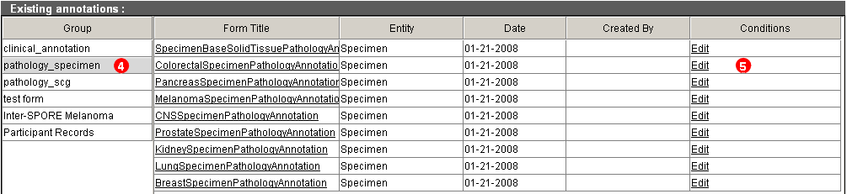

Figure : Assign Clinical Annotations – Edit Annotation

1. To set restrictions on the availability of that annotation, select or update the required collection protocol in the **Title** list box (e.g., **C_C_P (Colon Cancer Protocol**)as shown in the following figure.

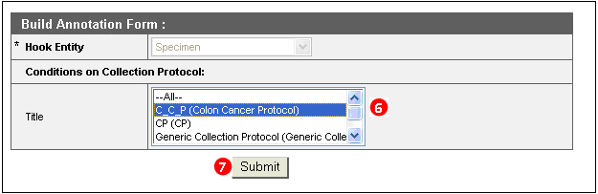

Figure : Assign Clinical Annotations - Build Annotation Form

1. Click **Submit** to save the changes.

Click **Cancel** to ignore the changes made to the collection protocol restrictions.

1. You can continue assigning annotations to specific collection protocols, or you can select multiple collection protocols. Select the required collection protocol, press the <Ctrl> key, and select another collection protocol.

## Adding Clinical and Pathological Data to an Annotation

Once an annotation is assigned to a collection protocol, you can add the clinical and pathological data to the annotation.

To add data to the associated clinical annotation:

1. Click the **Biospecimen Data** tab.
2. Select the Collection Protocol Based View.
3. In the **Collection Protocol** box, type or select the collection protocol to which your annotation is restricted.

A list of participants already registered under the selected collection protocol displays.

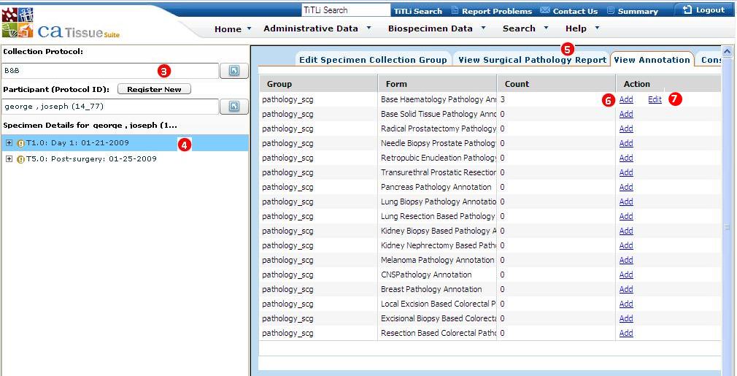

Figure : Add new annotation

1. From the following list, select a hook entity that the Collection Protocol is associated with:

* Participant
* Specimen Collection Group
* Specimen

1. Click the **View Annotation** tab on the right pane.

All the annotations associated with the collection protocol are displayed in a tabular format:

* The **Group** column displays the entity group name.

The **Form** column displays the annotation name.

* The **Count** column displays the number of records added to the annotations.
* The **Action** column displays the **Add** or **Edit** options for adding a record to an annotation or editing an existing record.

The **Edit** option appears if the count is greater than zero, that is, after at least one record is added to an annotation.

1. To add a new annotation:
2. Click **Add** for the annotation to which you want to add data.

The form opens for data entry.

1. Type or select the clinical and pathological data.

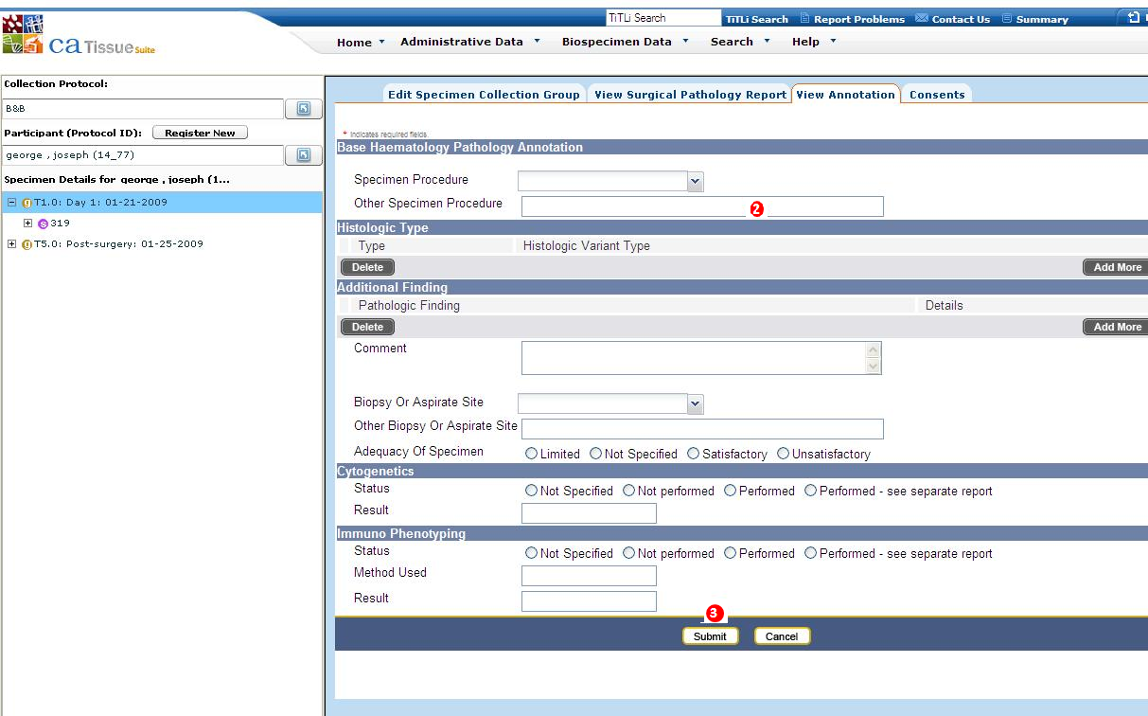

Figure : Data Entry Page

1. Click **Submit.**

The View Annotation page opens with the count for the updated annotation increases by one.

1. To edit the annotation:
2. Click the **Edit** link on the Action column.

Under **Update Records**, records added to the entity group are displayed in a tabular format:

* The **Record** **Id** column displays the record Id of the added annotations.
* The **Created Date** column displays the date on which the record is inserted.
* The **Updated By** column displays the name of the user who inserted the record.
* The **Action** column contains the **Edit** link.

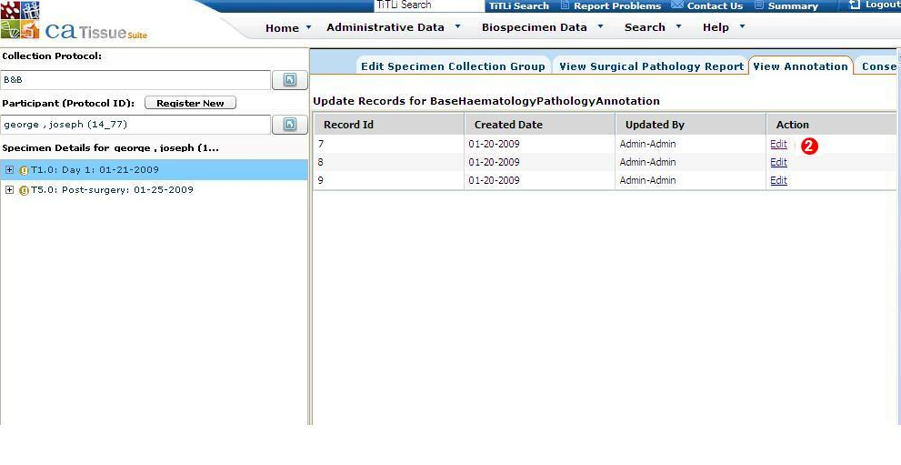

Figure Records added for the entity group

1. Click **Edit** in the row for the annotation you want to edit.

The Annotation details are displayed.

1. Edit the existing details that you want to change, and click **Submit**

navigates back to records page.

For more information on default annotations in , refer to Data Entry for Clinical Information Annotation.

## Querying on Annotations

Once you enter data in the annotations, you can search for the required annotations under specific collection protocols. For more information on advanced querying, refer to . For more information on querying clinical annotations and viewing related examples, refer to .

# Ordering Biospecimens (Biospecimen Data)

This chapter outlines the biospecimen ordering or biospecimen distribution.

Topics in this chapter include:

* on this page
* on page 182
* on page 185
* on page 187
* on page 190
* on page 192

## Biospecimen Distribution and Ordering Overview

This chapter outlines the biospecimen ordering. One of the main goals of collecting biospecimens is to distribute them to the investigators for research. This process is known as biospecimen distribution. By default, Administrators, Supervisors, and Technicians have the Distribution privilege.

A user with the Distribution privilege can perform the following operations:

* View pending orders for the specimens and specimen arrays belonging to those sites to which the user has access.
* View the pending orders list for Surgical Pathology Reports belonging to collection protocols to which the user has access.
* Process the orders and distribute the specimens and specimen arrays stored in sites to which the user has access.

To facilitate this, a Scientist is allowed to place an order for specimens that belong to one site at a time. In the order view, after you select a specimen from one site, the specimens belonging to other sites are disabled. Similarly, a Scientist can order Surgical Pathology Reports associated with one collection protocol at a time.

**Note:** Even though the users of an offsite storage site have physical access to the specimens, they do not have the privileges to distribute the specimens. The users of the main site with the Distribution privilege can distribute specimens that belong to an offsite storage site.

In earlier versions of caTissue Core, distribution support was not automated. It meant users had to query for the biospecimens, export the data into a CSV file, and send it manually to the Administrator.

In caTissue Suite this process has been automated. The users can directly submit orders using the application.

Any researcher having a registered distribution protocol in the system can order:

1. Biospecimens or arrays that reside in the tissue bank (for example: tissue, DNA, RNA, serum, and plasma).
2. Biospecimens that do not exist, but can be derived from an existing biospecimen in the system. For example: a user identifies a frozen tissue specimen of prostate tumor and requests 3 μg RNA from that tumor tissue. RNA for this sample does not exist in the system. Therefore, RNA will be first created from the tissue, accessioned into the system, and then distributed.

Biospecimens that are part of a surgical pathology case but do not exist in the system as individual specimens (paraffin blocks), or derived specimens or aliquots (cut sections). For example: a user identifies a particular surgical pathology report and wants ten uncut slides from the tumor and metastatic lymph node block from that case. The biospecimen resource retrieves the appropriate blocks from the requested case and accessions them into the system as individual specimens. These individual specimens or aliquots from each block will be cut (that is, sections cut into slides) and then distributed.

Any researcher having a registered distribution protocol in can order:

* Biospecimens or arrays that reside in the tissue bank, such as tissue, DNA, RNA, serum, and plasma.
* Biospecimens that do not exist, but can be derived from an existing biospecimen in . For example, if a user identifies a frozen tissue specimen of prostate tumor and requests 3 μg RNA from that tumor tissue, RNA for this sample does not exist in . Therefore, RNA is created first from the tissue, accessioned into , and then distributed.
* Biospecimens that are part of a surgical pathology case but do not exist in as individual specimens (paraffin blocks), derived specimens, or aliquots (cut sections). For example, a user identifies a particular Surgical Pathology Report and wants ten uncut slides from the tumor and metastatic lymph node block from that case. The biospecimen resource retrieves the appropriate blocks from the requested case and accessions them into as individual specimens. These individual specimens or aliquots from each block are cut (sections cut into slides) and then distributed.

### Displaying Specimen Distribution Reports

To display specimen distribution reports:

1. Click the **Biospecimen Data** tab.
2. Click **Distribution > Specimen Report**. The Specimen Distribution Search page opens.
3. Click **Attribute** and specify the type of value for which to search.
4. Specify the Condition to apply to the search:

* **Starts With** finds attributes that start with the specified value. **Ends With** finds attributes that end with the specified value.
* **Contains** finds attributes that contain the specified value anywhere within the attribute.
* **Equals** finds attributes that exactly equal the specified value. **Not Equals** finds attributes that are not the same as the specified value.
* If you select **is Null** or **is Not Null**, the Value is disabled.

1. Enter the Value for which to search, if available.
2. Click **Search**.

If there is one specimen found, the Distribution Report page opens.  
If there is more than one match, double click on the specimen in the list.

1. To export the item to a CSV file, click **Export**.

### Displaying Array Distribution Reports

To display array distribution reports:

1. Click the **Biospecimen Data** tab.
2. Click **Distribution > Array Report**. The Array Distribution Search page opens.
3. Click **Attribute** and specify the type of value for which to search.
4. Specify the Condition to apply to the search:

* **Starts With** finds attributes that start with the specified value. **Ends With** finds attributes that end with the specified value.
* **Contains** finds attributes that contain the specified value anywhere within the attribute.
* **Equals** finds attributes that exactly equal the specified value. **Not Equals** finds attributes that are not the same as the specified value.
* If you select **is Null** or **is Not Null**, the Value is disabled.

1. Enter the Value for which to search, if available.
2. Click **Search**.

If there is one specimen found, the Array Report page opens.  
If there is more than one match, double click on the array in the list.

1. To export the item to a CSV file, click **Export**.

## Ordering Workflow

To order biospecimens:

**Note:** You can order biospecimens if you are the Principal Investigator of a Distribution Protocol in . Super Administrators can order specimens under any distribution protocol. Also, users having distribution privilege can order specimens under any distribution protocol.

1. A Scientist performs a query and adds specimens, pathology cases, or arrays of interest to My List. This step can be repeated across multiple queries. See .
2. From My List, a Scientist accumulates the items to be ordered, and the Scientist submits the order. If you have the Distribution privilege, you can view the order on the Order View page. See .
3. An Administrator reviews the request and approves or rejects the order.
4. If approved, a Technician can create new specimens and distribute them. See Distributing Ordered Items.
5. Once an order is processed and distributed, a distribution report is generated.

The following figure outlines the workflow of ordering biospecimens.

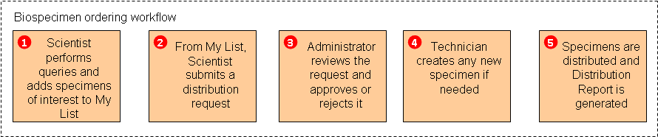

Figure : Biospecimen Ordering Workflow

### Step 1: Add Specimens of Interest to My List

The following table lists the objects in My List

|  |  |
| --- | --- |
| Ordered Items | Objects to Add to My List from the Query Results |
| Biospecimens, or their aliquots or its derivatives | Specimen, MolecularSpecimen, TissueSpecimen, FluidSpecimen, CellSpecimen |
| Arrays | SpecimenArrays |
| Pathological case | IdentifiedSurgicalPathologyReport or De-identifiedSurgicalPathologyReport  (Specimens and specimen arrays from these reports can be ordered.) |

### Step 2: Order Biospecimens from My List

To order biospecimens from My List:

#### Step 2a: Submitting an Order from My List

To submit an Order from My List:

**Note:** You can place an order based on biospecimens, pathology cases, and arrays, or all three. To place pathology case orders, add identified Surgical Pathology Reports (SPRs) or de-identified surgical pathology reports to My List.

1. Click the **Search** tab.
2. Click **My List View**.
3. Select the specimens to order.
4. Select the **Order Biospecimens** radio button.
5. Click **Submit**. navigates to the Create Order page.

**Note:** You cannot order specimens that are located virtually, have zero quantity, are not available, or are anticipated.

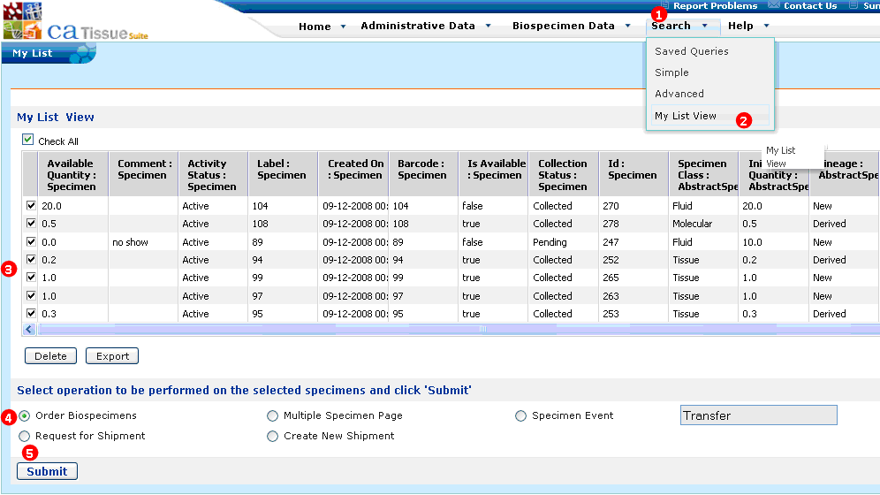

Figure : Submitting an Order

#### Step 2b: Selecting the Distribution Protocol

To select the Distribution Protocol:

1. Enter the **Order List Title**.
2. Select the appropriate distribution protocol for the specimens being ordered from the **Distribution** **Protocol** drop-down list.
3. Click **Next**.

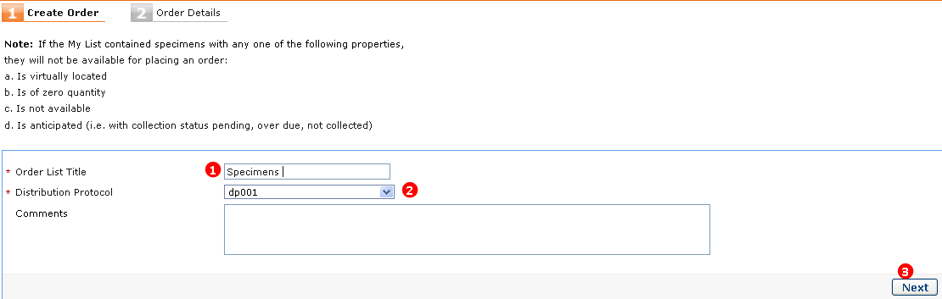

Figure : Selecting Distribution Protocol

#### Step 2c: Preparing the Order List

The detailed steps to prepare order lists are enumerated under the following sections.

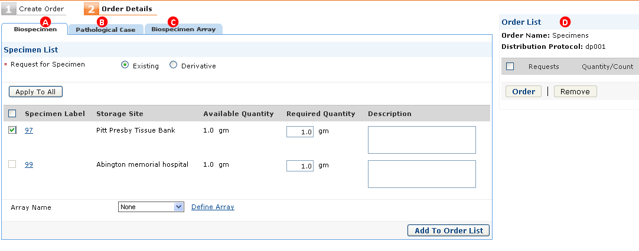

Figure : Preparing Order List

1. To order biospecimens and its derivatives, click the **Biospecimen** tab, and refer to *.*
2. To order specimens or specimen arrays based on surgical pathology report (SPR), click the **Pathological Case** tab. For more information, refer to .
3. To order existing and user-defined arrays, click the **Biospecimen Array** tab. For more information, refer to *Ordering Biospecimen Arrays*.
4. To view the current contents of the order request, refer to the Order List section. The list refreshes as you add new items to the order.

**Note:** Once you submit an order, an e-mail notification is sent to the Administrator.

## Ordering a Specimen and Specimen Derivatives from an Existing Derivative

You can order a specimen and its derivatives that is already in . You can request for specimens and derivatives in one order or in a separate order as needed. The following procedure outlines how to order an existing specimen.

* Ordering an Existing Specimen
* Ordering a Derivative From an Existing Specimen

### Ordering an Existing Specimen

To order an existing specimen:

1. Step 2a: Submitting an Order from My List or Step 2b: Selecting the Distribution Protocol
2. Enter the **Required Quantity** for the biospecimen you want to order as shown in the following figure. Enter comments in the **Description** field while placing an order.
3. Click **Add to Order** List. The requested specimens are displayed in the Order List.
4. Click **Order**. A success message opens and navigates back to My List.

**Note:** In one order, you can order only those specimens or arrays belonging to a single site. To facilitate this, the storage site column is shown and when a specimen of one site is selected to add to the order list, specimens of other sites will not be disabled to select.

To delete items added to the Order List, select the items and click **Remove**.

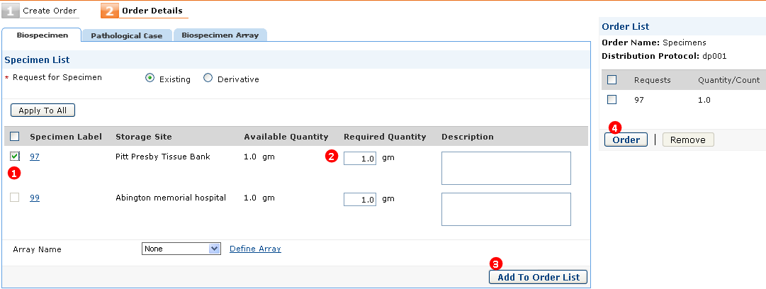

Figure : Order Existing Specimen

### Ordering a Derivative From an Existing Specimen

To order a derivative from an existing specimen:

1. Step 2a: Submitting an Order from My List or Step 2b: Selecting the Distribution Protocol

The Specimen List page opens. Select the **Derivative** radio button.

1. Select the required **Specimen Class** and **Specimen Type** for the required derivative.
2. Select the check box next to specimens you want to order.
3. Enter the **Required Quantity** for the derivative being ordered.
4. Click **Add to Order** List. The requested derivatives are displayed in the Order List.
5. Click **Order**. A success message opens and navigates back to My List.

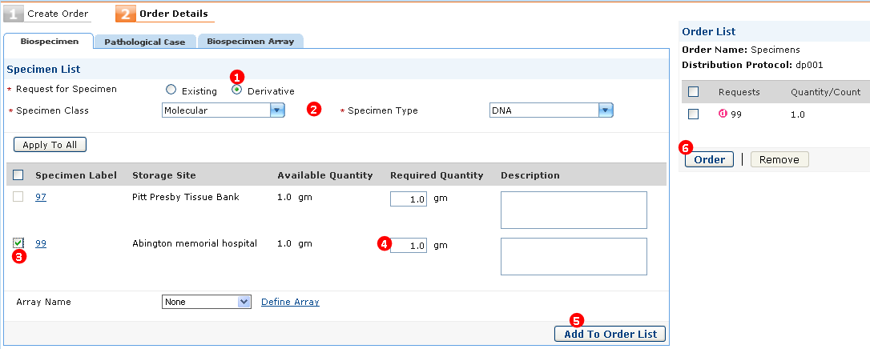

Figure : Order Derivative from Existing Specimen

**Note:** A derived specimen is denoted by the red lower-case d icon. The number *99* denotes the parent specimen label from which you derive the specimen.

## Ordering Specimens Associated with a Surgical Pathology Report (SPR)

You can order a specimen and its derivatives associated with a Surgical Pathology Report (SPR) that exists in . The accession number for the surgical specimen is the same as the surgical pathology report number.

This section presents procedures to order a specimen:

* Collected Specimens Associated with SPRs
* Specimen or Arrays Associated with SPRs That are Yet to be Collected

### Ordering a Specimen Associated with an Surgical Pathology Report

If specimens associated with SPR are collected, see .

Requested specimens may or may not exist in the biospecimen resource. An order can have biospecimens that are part of a surgical pathology case (a Specimen Collection Group) but do not exist in as individual specimens (paraffin blocks), derivative specimens, or aliquots.

For example, a Scientist identifies a particular Surgical Pathology Report or case that is of interest and wants ten uncut slides from the tumor and a metastatic lymph node block from that case. The biospecimen resource needs to retrieve the appropriate blocks from the requested case and accession them into as individual specimens. Then, specimens or aliquots from each block are created (sections cut into slides) and distributed.

### Ordering a Specimen Associated with an SPR Not Collected

To order an uncollected specimen associated with a Surgical Pathology Report (SPR):

Perform or Step 2b: Selecting the Distribution Protocol

1. The **Biospecimen** tab opens. Click the **Pathological Case** tab. The Case List page opens.
2. Select the **Specimens** or **Block** radio button under Request For.
3. Enter the **Specimen Class** and **Specimen Type**. These options are disabled if you select the **Block** option.
4. Select the required **Tissue Site** and **Pathological Status**.
5. Select the check box next to the associated SPR for these specimens or block and enter the **Required Quantity** for the biospecimens or block being ordered.
6. Click **Add to Order** List. The requested specimens or blocks are displayed in the Order List.
7. Click **Order**. A success message opens and navigates back to My List.

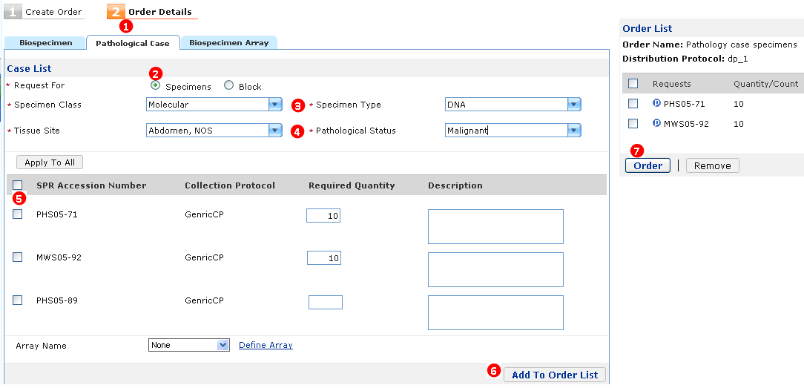

Figure : Order a Specimen Associated with an SPR that is not Collected

### Ordering a User-Defined Specimen Arrant Associated with an SPR

To order a user-defined specimen array associated with a Surgical Pathology Report (SPR):

PerformStep 2a: Submitting an Order from My List or Step 2b: Selecting the Distribution Protocol

1. The **Biospecimen** tab opens. Click **Define Array**. The Define array page opens. Enter the required details to proceed.
2. Select the **Specimens** radio button under **Request For** on the Case List page.
3. Select the **Specimen Class**, **Specimen Type**, **Tissue Site** and **Pathological Status**.
4. Select the check box next to the required SPR from which you want to order the specimen arrays.
5. Enter the **Required Quantity** for the biospecimen being ordered as shown in the following figure.
6. Select the required **Array Name** from the drop-down list.
7. Click **Add to Order List**. The requested specimen arrays are displayed in the Order List.
8. Click **Order**. A success message opens and navigates back to My List.

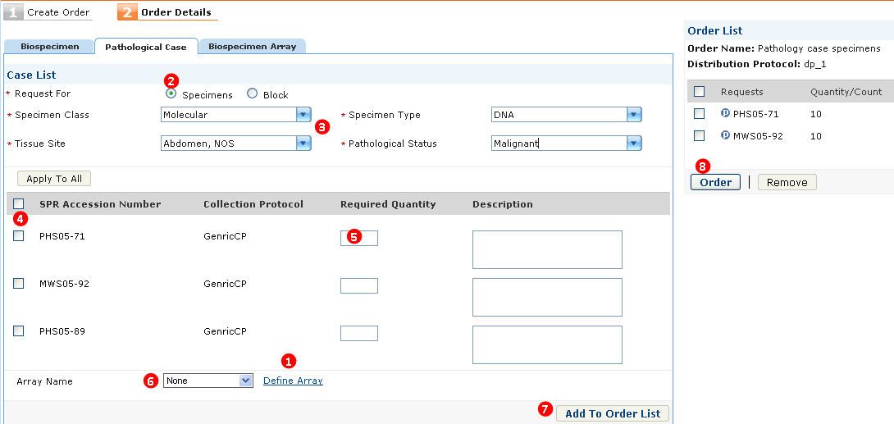

Figure : Order a User-Defined Specimen Array Associated with SPR

## Ordering Biospecimen Arrays

You can order existing specimen arrays or define arrays based on your requirements. The following procedures provide instructions to order biospecimen arrays.

### Ordering Existing Biospecimen Array

To order an existing biospecimen array:

PerformStep 2a: Submitting an Order from My List *or* Step 2b: Selecting the Distribution Protocol*.*

1. The **Biospecimen** tab opens. Click the **Biospecimen Array** tab. The Request Details-Array page opens.
2. Select the check box next to the required array under Array Name as shown in the following figure.

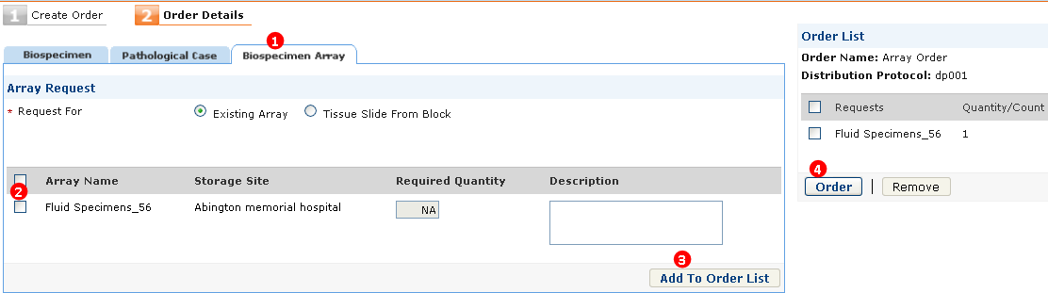

Figure : Order an Existing Biospecimen Array

1. Click **Add to Order** List. The requested specimen arrays are displayed in the Order List.
2. Click **Order**. A success message opens and navigates back to My List.

### Ordering a User-Defined Array

To order a user-defined array:

Performor

1. The **Biospecimen** tab opens. You can define an array-based on the specimens displayed under the Specimen List. Click **Define Array**. The Define array page opens.
2. Enter the **Array Name** and **Array Type**. The Array Dimensions field auto- populates based on the Array Type selected.
3. Click **Create**. navigates back to the **Biospecimen** tab.
4. Select the check box next to the required specimen under Specimen Label.
5. Enter the **Required Quantity** for the ordered biospecimen.
6. Select the created array from the **Array Name** drop-down list.
7. Click **Add to Order** **List**. The requested specimens are displayed in the Order List as shown in the following figure. The arrays are created based on the selected specimens.

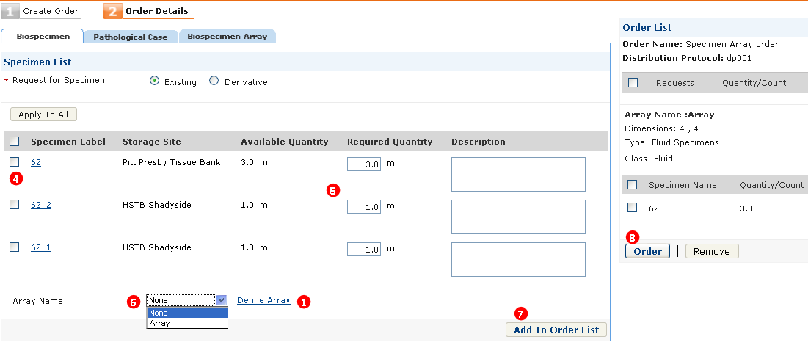

Figure : Order a User-Defined Array

1. Click **Order**. A success message opens and navigates back to My List.

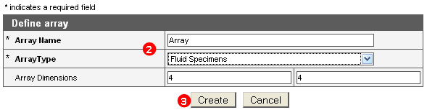

Figure : Order a User-Defined Array - Define Array

1. Click **Apply To All** after you add the Required Quantity for the ordered items. This value auto-populates all the rows under the **Required Quantity** column.

## Distributing Ordered Items

Once the Scientist places an order for specimens, if you have the Distribution privilege, you can view the pending orders list of the specimens or arrays belonging to the sites, for which you have access. You can process the orders and distribute only the specimens or arrays stored in the site to which you have access.

To distribute ordered items:

The Administrator sets the status of each specimen, specimen array, and specimen and specimen arrays associated with an SPR.

The following figure displays the available options under **Status on the Specimen Requests** **and** **Array Requests** tab. These tabs are located under **Order View** of the Biospecimen Data tab.

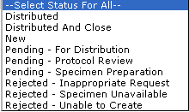

Figure : Order Status

### Distributing a Parent and Derived Specimen

The following procedure outlines how an Administrator distributes an order based on a parent and derived specimen.

To view and distribute ordered items:

**Note:** The Administrator can view the specimen page by clicking the required specimen link under Specimen label.

1. Click the **Biospecimen Data** tab.
2. Click **Order View**. The Requests List page opens.
3. Click the link for the required order under Order Name as shown in the following figure. The Order Details page opens. The **Specimen Requests** tab is selected by default.
4. You can view the details of the requested specimen, namely: Specimen Label, Request For, Type, Quantity, and Available Quantity.

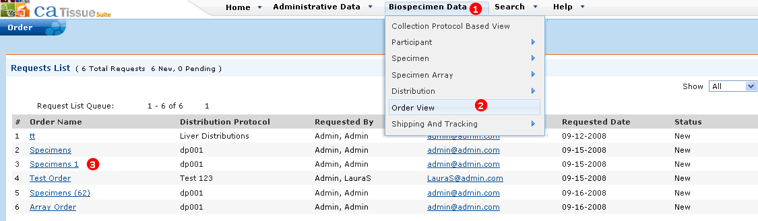

Figure : View and Distribute Ordered Items - Order Details Page

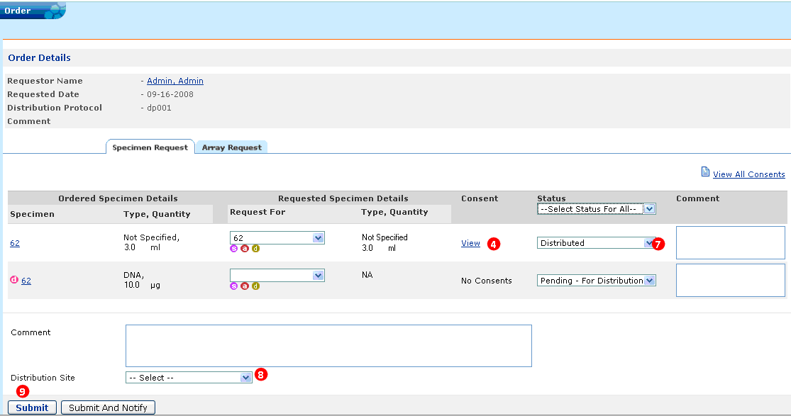

Figure : View and Distribute Ordered Items - Specimen Requests Page

**Note:** In the case where a parent specimen is ordered and if the requested quantity is lesser than the available quantity, then you can create an aliquot (by clicking the red a icon) of that specimen for the quantity ordered and then distribute it. This is important since distribution always happens for the whole specimen. You can select a parent specimen or its aliquot from the **Request For** drop-down list. Accordingly, the **Quantity** field is populated.

Click the link next to the required specimen under **Consent** for the specimen to view the consent.

1. Select the **I have verified that distribution of the specimen is as per consent of Participant** check box as shown in the following figure.

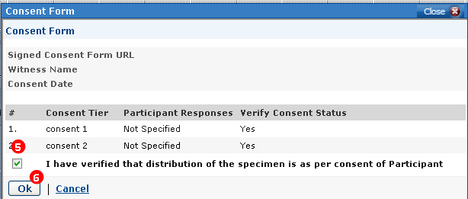

Figure : View and Distribute Ordered Items - Consent Form

1. Click **OK**. The Order Details page opens and the selected link under Consent for specimen is changed from View to Verified.
2. Update the **Status** for the specimen as required.
3. Select a **Distribution Site** from the drop-down list.
4. Click **Submit**. The following Distribution Report is generated after distributing a specimen. Similar reports are generated after distribution of specimen arrays, and distribution of specimen and specimen arrays associated with SPR.

**Note:** When the waived consent for a collection protocol is true, then during distribution of specimens under this collection protocol, you do not have to verify the consent data of these specimens.

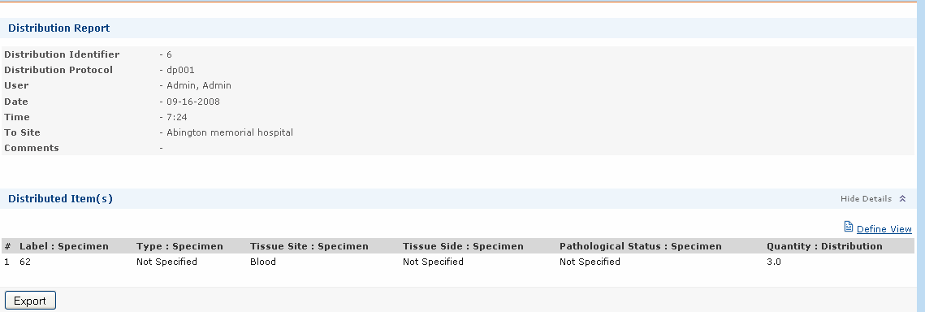

Figure : Distribution Report

#### Exporting a Distribution Report

The Administrator can export the distribution report data into a CSV [1]format text file. To export the data, click **Export**. Click **Define View** and select a set of attributes. These attributes are displayed in the spreadsheet.

The following table lists and describes the specimen icons.

| Icon | Description |
| --- | --- |
|  | Purple s icon indicates a parent specimen. Click this icon to navigate to the specimen page. |
|  | Red a icon indicates an aliquot. Click this icon to navigate to the Create Aliquot page. You can create aliquots of required quantity. |
|  | Brown d icon indicates a derivative. Click this icon to navigate to the Specimen Derive page. You can create the required derivative. |
|  | Red c icon indicates create. If the ordered specimen does not exist in system, click the Create icon to create the required specimen. |

### Distributing an Existing Array and a User-Defined Array

The following procedure outlines how the Administrator distributes an order based on an existing array and user-defined array.

#### Viewing and Distributing Existing Arrays

To view and distribute existing arrays:

1. Click the **Biospecimen Data** tab.
2. Click **Order View**. The Requests List page opens.
3. Click the link for the required order under Order Name. The Order Details page opens. The **Specimen Requests** tab is selected by default.
4. Click the **Array Requests** tab.
5. Click the **Show Details** link next to Existing Array.
6. Update the **Status** as required.
7. Select the **Distribution Site** from the drop-down list.
8. Click **Submit**. The Distribution Report page opens.

**Note:** The Administrator can view the Edit Specimen Array page. Click the required existing specimen array link under Array Name.

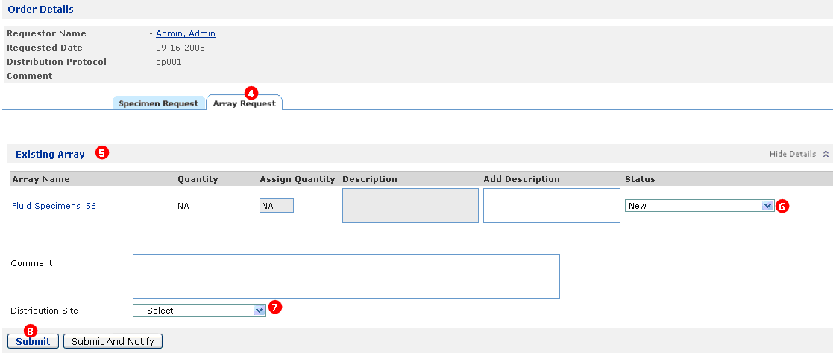

Figure : View and Distribute Existing Array - Array Requests Page

#### Viewing and Distributing User-Defined Arrays

To view and distribute user-defined arrays:

1. Click the **Biospecimen Data** tab.
2. Click **Order View**. The Requests List page opens.
3. Click the link for the required order under Order Name. To view and distribute ordered items procedure. The Order Details page opens. The Specimen Requests tab is selected by default.
4. Click the **Array Request** tab.
5. Select the array you want to create under New Array.
6. Click **Create Array** to create the array. Once the array is created, navigates back to the Order Details page.
7. Update the **Array Status** as required.
8. Select the **Distribution Site** from the drop-down list.
9. Click **Submit**. The Distribution Report page opens.

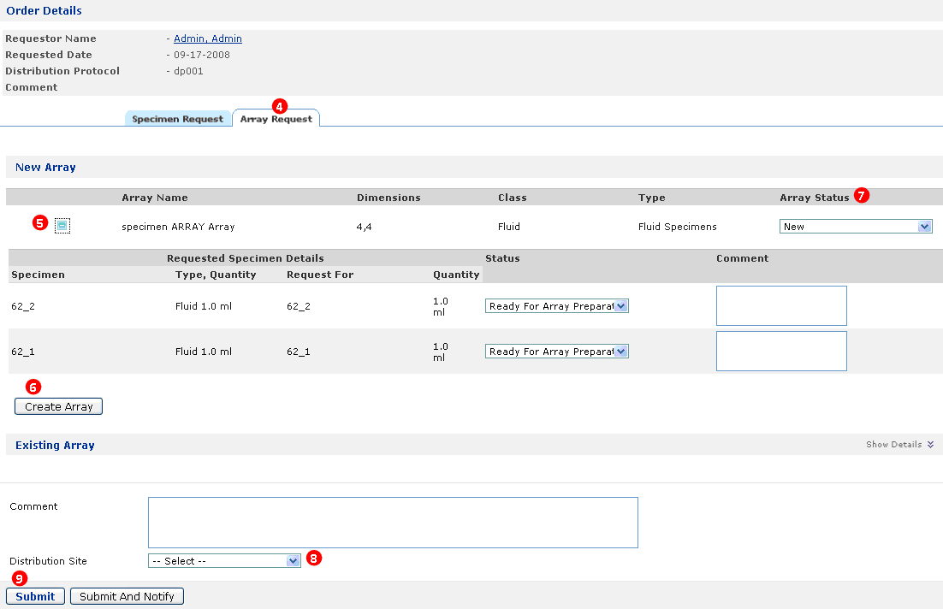

Figure : View and Distribute User-Defined Arrays - Array Requests Page

### Distributing a Specimen and Arrays Associated with an SPR

The specimens or arrays associated with Surgical Pathology Reports (SPR) are distributed as already collected or not yet collected.

#### Collected Specimens Associated with SPRs

To view and distribute specimens associated with a Surgical Pathology Report (SPR) that are already collected, see .

#### Specimen or Arrays Associated with SPRs That are Yet to be Collected

To place an order of specimens associated with a Surgical Pathology Report (SPR) or an array associated with a SPR.

**Note:** All users having access to Distribution privilege can view the pending orders list of the SPRs belonging to the collection protocols for which they have access.

To distribute specimen associated with SPR

1. Navigate to the Order Details page. To do this, click the **Biospecimen Data** tab. Then, click **Order View** under Order. The Requests List page opens. Click the link for the required order under Order Name. The Order Details page opens.

The requested Specimens are visible under the **Specimen Requests** tab.

1. Click the red c icon  under Request For to create the specimen. The new specimen page opens. Create the specimen. Once the specimen is created, the label number is populated in the **Request For** box.
2. Update the specimen **Status** as required.
3. Select the **Distribution Site** from the drop-down list.
4. Click **Submit**. The Distribution Report page opens.

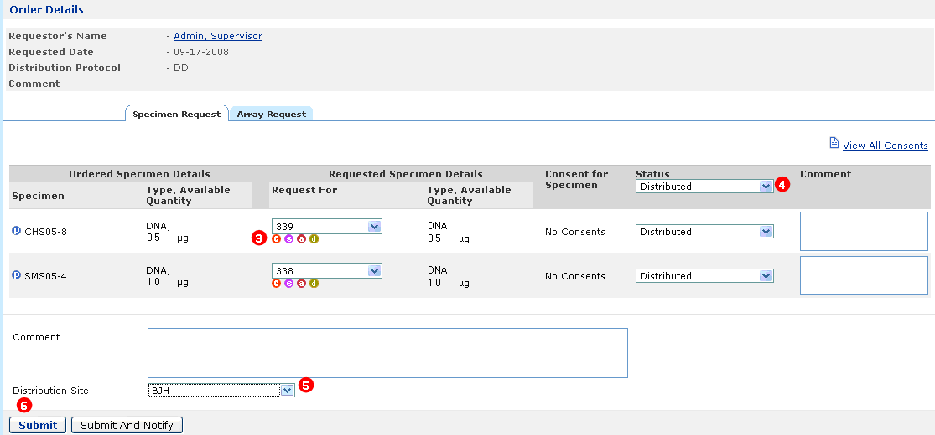

Figure : Distributed Specimens Associated with SPR

To distribute specimen arrays associated with an SPR:

**Note:** If a user places an order and the item is delayed, rejected, or not available for distribution, anAdministrator must inform the user about the status via e-mail or phone. does not send any auto-notification.

1. Click the **Biospecimen Data** tab, and then, click **Order View**. The Requests List page opens. Click the link for the required order under Order Name. The Order Details page opens.

The requested arrays are visible under the **Array Requests** tab.

1. Click the **Array Requests** tab.
2. Under New Array, select the array that you want to create.
3. Click **Create** under Request For to create the specimens.
4. Once the specimen is created, select the **Status** as **Ready for Array Preparation**. The **Create Array** button is now enabled.
5. Click **Create Array**.
6. Once the array is created, navigates back to the Order Details page. Update the **Array Status** as required.
7. Select the **Distribution Site** from the list.
8. Click **Submit**. The Distribution Report page opens.

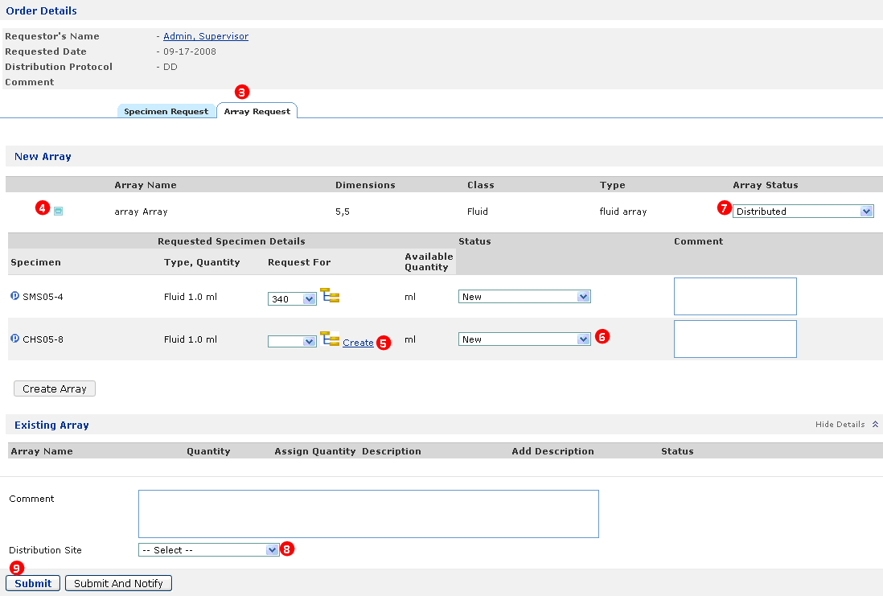

Figure : Distribute Specimen Array Associated with SPR

# Shipping and Tracking (Biospecimen Data)

This chapter outlines the Shipping and Tracking feature of caTissue.

Topics in this chapter include:

* on this page
* on page 202
* on page 204
* on page 206
* on page 209
* on page 212
* on page 213

## Introduction to Shipping and Tracking

Tissue banks, also know as sites, are interdependent on each other for their biospecimen requirements. These sites interact with each other for various reasons like requesting particular specimens or shipping the specimens requested by other sites. Some sites act as a central repository where other sites store specimens or containers.

For example:

* Site A sends a request to Site B for a specimen labeled AG15875, which is out of stock at Site A or it does not have the required specimen to perform specific task.
* Site X creates a new shipment based on the request received from Site Y.

The basic flow of the Shipping and Tracking feature are the following steps:

The following figure outlines the basic flow of Shipping and Tracking:

Create a New

Shipment

Create a New Shipment Request

Process the Shipment or

Shipment Request

Shipping and Tracking Dashboard

Create a Shipment or Request based on My List View

Figure : Basic Flow of Shipping and Tracking

## **Viewing the Dashboard**

The dashboard is the workspace in that displays the status of the incoming or outgoing shipment and shipment requests. The text in curly braces explains the meaning of the sections on the dashboard.

To view the shipping and tracking dashboard:

Note: You can access the Shipping and Tracking feature only if you are assigned the Shipment Processing privilege.

1. Click the **Biospecimen Data** tab.
2. Select **Shipping and Tracking**. navigates to the dashboard. The dashboard displays the following sections:

* Incoming Shipment Requests
* Incoming Shipments
* Outgoing Shipments
* Outgoing Shipment Requests

**Note:** If you login as the Super Administrator, you can view only the Shipment Requests and Shipments.

By default, the dashboard is collapsed. The following figure shows the collapsed view of the dashboard.

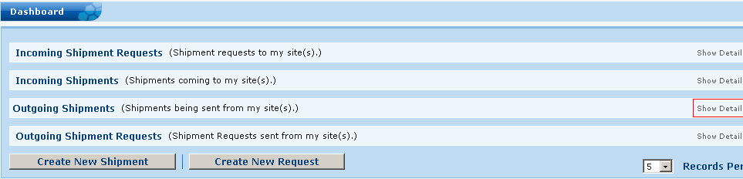

Figure : Shipping and Tracking Dashboard

1. To view the details for each of the sections, click **Show Details** next to the corresponding section.

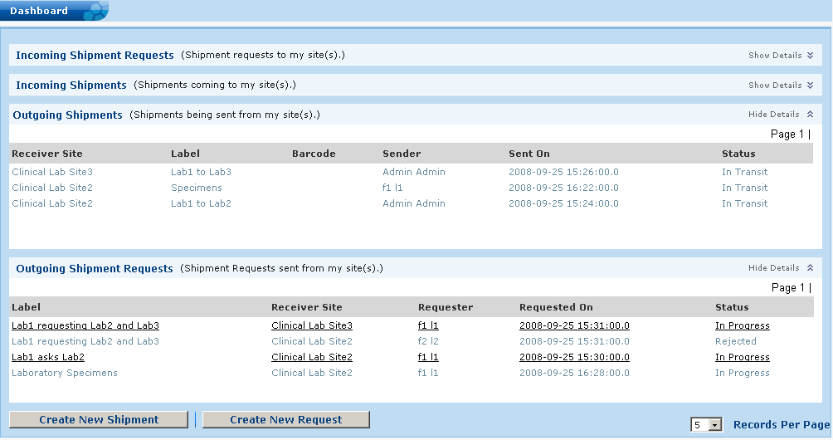

Figure : Shipping and Tracking Expanded Dashboard

The following table outlines the various fields on the expanded dashboard.

**Note:** You can also collapse each section of the dashboard to hide data that is not relevant. To do this, click **Hide Details** next to the corresponding section.

| Field Name | Description |
| --- | --- |
| Incoming Shipment Requests | |
| Label | Displays the identifier for each shipment request. The label can be an alphanumeric value and must be a unique identifier. |
| Requester Site | Displays the name of the site requesting the shipment. |
| Requester | Displays the name of the person creating the shipment request. This person is the point of contact for the requester site. |
| Requested On | Displays the date that the shipment request was created. |
| Status | Displays the status of the shipment request. The status values are:  **In Progress**: The shipment request is added to the database.  **Received**: The receiver site has processed the request and created a shipment for the request.  **Rejected**: The shipment request was not accepted by the receiver site for some reasons. |
| Incoming Shipments | |
| Sender Site | Displays the name of the site dispatching the shipment. |
| Label | Displays the identifier for each shipment. The label can be an alphanumeric value, and must be a unique identifier. |
| Barcode | Displays the shipment identifier code for each shipment. |
| Sender | Displays the name of the person dispatching the shipment. This person is the point of contact for the sender site. |
| Sent On | Displays the date the shipment was dispatched. |
| Status | Displays the status of the shipment. The status values are:  In Transit: The requested shipment is on its way to the receiver site.  Received: The requested shipment has arrived and was processed by the receiver site. |
| Outgoing Shipments | |
| Receiver Site | Displays the name of the site receiving the shipment. |
| Label | Displays the identifier for each shipment. The label can be an alphanumeric value and it is a unique identifier. |
| Barcode | Displays the shipment identifier code for each shipment. |
| Sender | Displays the name of the person sending the shipment. This person is the point of contact for the sender site. |
| Sent On | Displays the date the shipment was dispatched. |
| Status | Displays the status of the shipment. The status values are:  In Transit: The shipment is on its way to the receiver site.  Received: The shipment has arrived at the receiver site. |
| Outgoing Shipment Requests | |
| Label | Displays the identifier for each shipment request. The label can be an alphanumeric value and must be a unique identifier. |
| Receiver Site | Displays the name of the site receiving the shipment request. |
| Requestor | Displays the name of the person requesting the shipment. This person is the point of contact for the requestor site. |
| Requested On | Displays the date the shipment request was created. |
| Status | Displays the status of the shipment request. The status values are:  **In Progress**: The shipment request is created, sent to the receiver site, and waiting for the receiver site to update the status to either Reject or In Process.  **Received**: The shipment request has reached the receiver site. |

## Creating a New Shipment

You can create a new shipment if you are assigned the *Shipment Processing* privilege. You can create a new shipment in one of the following cases:

* A site has requested specific biospecimens, containers, or both.
* Your site has excess stock and wants to distribute it to other tissue banks.
* Your site is the central biospecimens repository.
* Your site wants to store its biospecimens at another site, as the environment required for stocking the biospecimens in your site is not conducive.

While creating a new shipment, the principle identifier of the shipment is the *label*. It is mandatory to enter a label for each shipment. The *barcode* is also an identifier, but entering a barcode is optional.

To create a new shipment:

**Note:** It is mandatory that the requested item is available in the site’s repository, or the shipment will not be created.

1. Click the **Biospecimen Data** tab.
2. Select **Shipping and Tracking**. navigates to the dashboard.
3. Click **Create New Shipment**. The Create New Shipment page opens.

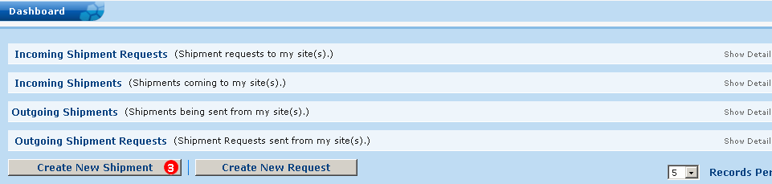

Figure : Dashboard - Create New Shipment

1. Enter the shipment label in the **Label** field under the **Shipment Details** section,. This label will be unique for each shipment.
2. Enter a barcode in the **Barcode** field if required. Data entry in this field is optional.
3. Select your site’s name from the **Sender’s Site** drop-down list.
4. Select the site name that will receive the shipment from the **Receiver’s Site** drop-down list.
5. Enter the date and time to send the shipment in the **Shipping Time** field. You can also select a date from the calendar picker. By default, enters the current date and time for the shipment.
6. Add information about the shipment or any other relevant information, if required, in the **Comments** field.
7. Select the **Label** or **Barcode** radio button under the **Contents** section to enter the label or barcode for the specimens or containers.
8. Enter the appropriate label, barcode, or name for specimens or containers under **Label/Barcode** or **Name/Barcode** respectively based on the selected radio button.
9. Click the **Add More** button to add a row to enter the specimen or container to the shipment.

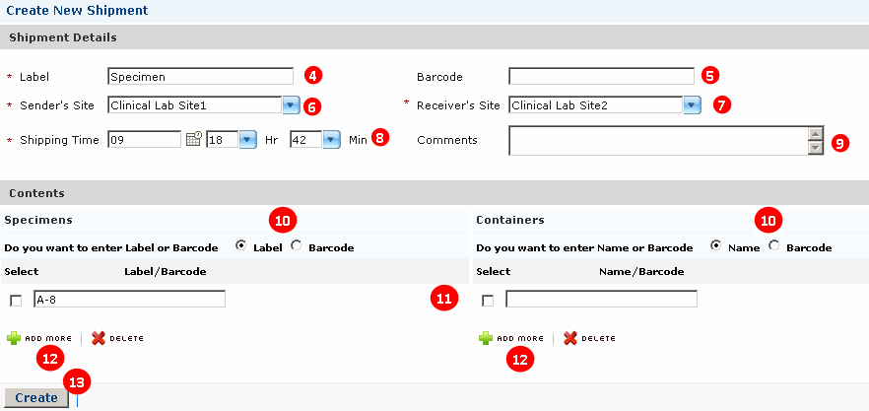

Figure : Create New Shipment

To delete a row, select the check box next to the specimen label or container label, and click **Delete**.

1. Click **Create** to create the shipment. navigates to the Shipment Summary page.

To cancel the shipment and to navigate back to the dashboard, click **Cancel**.

While creating a new shipment, performs an availability check for the added specimen or container based on the label, barcode, or name. If the added specimen or container is not available, displays an error message. To remove this unavailable item from the shipment, select the check box next to the label, and click **Delete**. You can then proceed to create the shipment with other specimens, containers, or both, or cancel the shipment.

1. An e-mail is sent to the receiver site indicating that the shipment has been dispatched. The status of this shipment is set to *In Transit*.

## Requesting a Shipment

You can place a shipment request if you are assigned the Shipment Processing privilege on a site. You can request a shipment from another site in one of the following cases:

* Your site does not have the environment to stock the required biospecimens; therefore you do not have the required specimens for your research or processing.
* Your site does not have enough quantity of the required biospecimens.

To request a new shipment:

1. Click the **Biospecimen Data** tab.
2. Select **Shipping and Tracking**. The dashboard opens.
3. Click **Create New Request**. The New Shipment Request page opens.

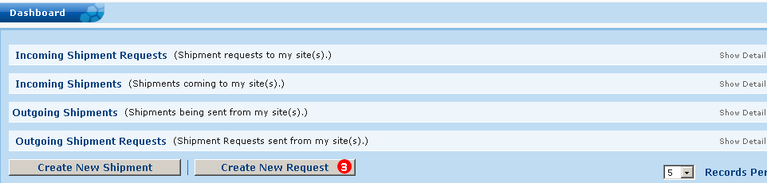

Figure : Dashboard - Create New Request

1. Enter a label for the shipment request in the **Label** field under the **Shipment Request Details** section.
2. Select your site name from the **Requester’s Site** drop-down list.

**Note:** The default site is the site with which you are registered. You can select another site from the Requester’s Site list. This list displays those sites to which you have the access.

1. Enter the request date in the **Shipping Time** field. You can also select a date using the calendar picker. By default, enters the current date and time for the shipment.
2. Add information about the shipment request or any other relevant information in the **Comments** field.
3. Select the **Label** or **Barcode** radio button under the **Contents** section to enter the label or barcode for the specimens or containers.
4. Enter the appropriate label or barcode for specimens or containers, or both under **Label/Barcode** or **Name/Barcode** based on the selected radio button.
5. Click the **Add More** button to add a row to enter the label or barcode information for a specimen or container.

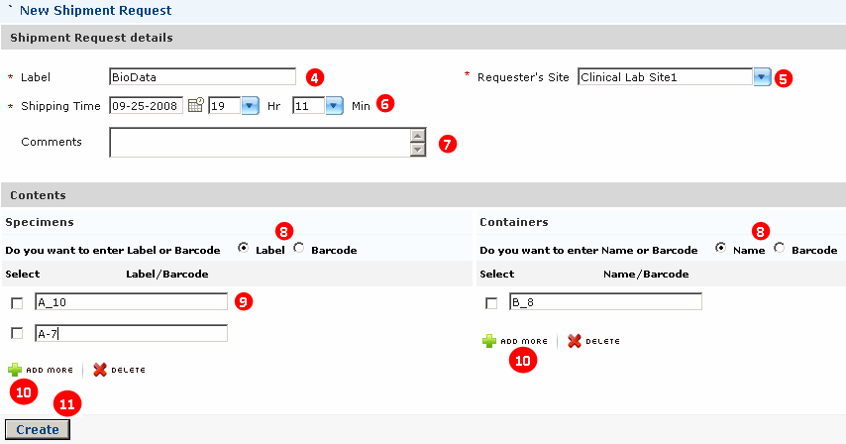

Figure : Create New Shipment Request

To delete a row, select the check box corresponding to the specimen label or container label, and click **Delete**.

1. Click **Create**. navigates to the Request Summary page.

To cancel the shipment request and navigate back to the dashboard, click **Cancel**.

1. On the Request Summary page, you can view the shipment request details. These details are read-only and cannot be modified. To navigate back to the dashboard, click **Submit**. An e-mail is sent to the receiver site indicating that there is a request.
2. To edit the details of the request, click **Back**. navigates back to the Shipment Request page where you can make the required changes. To return to the dashboard without saving any changes, click **Cancel**.

## Processing the Shipment or Shipment Request

You can view or process a shipment or shipment request on the dashboard. The dashboard displays the number of received shipments under the Incoming Shipments section. The dashboard also displays the number of received requests under the Incoming Shipment Requests section.

To view the individual details of the shipment or request and to take further action, click the shipment or request label link. navigates to the Received Shipment or Shipment Request Details page respectively. The Shipment Details section displays the information about the shipment label, barcode, the site name from where the shipment was dispatched, the name of the site where the shipment was sent, the date the shipment was dispatched, and comments from the sender, if any. The Shipment Request details section displays similar data related to the selected request.

The Specimen Details section and the Container Details section displays the specimens or containers received in the shipment or request.

You can either accept or reject the specimen or container based on the condition of the received specimens or containers in the shipment or request. The status for these specimens or containers can be set individually. You can:

* **Accept the specimen or container**: Accept is selected by default under the Status section. If the specimen or container is in a perfect condition, you can select it and assign it to a storage location. You can store the specimen or container at a virtual, manual, or select a location from the list of available containers under Storage Location.
* **Reject the specimen or container**: In this case the specimen or container is not in a viable condition, you can:
* **Reject and Destroy**: Select this option under the Status section to reject the unfit specimens or containers, and destroy it within your premises in a way that is deemed suitable as per U.S. medical laws.
* **Reject and Resend**: Select this option to reject and resend the selected specimens, containers, or both to the site that dispatched the shipment.

To reject multiple specimens or containers, select the check box next to the required specimens or containers and click the **Reject** **and** **Resend** button or the **Reject and Destroy** button.

### Processing a Shipment Request

To process a shipment request:

**Prerequisite:** The status of the shipment request should be *In Progress* under the   
Incoming Shipment Requests section.

1. On the dashboard, click the link of the required shipment request under the **Incoming Shipment Requests** section. caTissue Suite navigates to the Shipment Request details page.

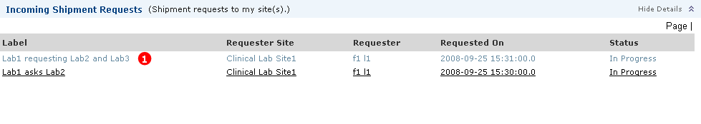

Figure : Dashboard - Incoming Shipment Requests

1. View the details of the shipment under the **Shipment Request details** section.

**Note:** You cannot edit the specimen label or barcode or the container name or barcode.

1. Click **Create Shipment** to create a shipment for this request.
2. Click **Reject** to reject the shipment request.

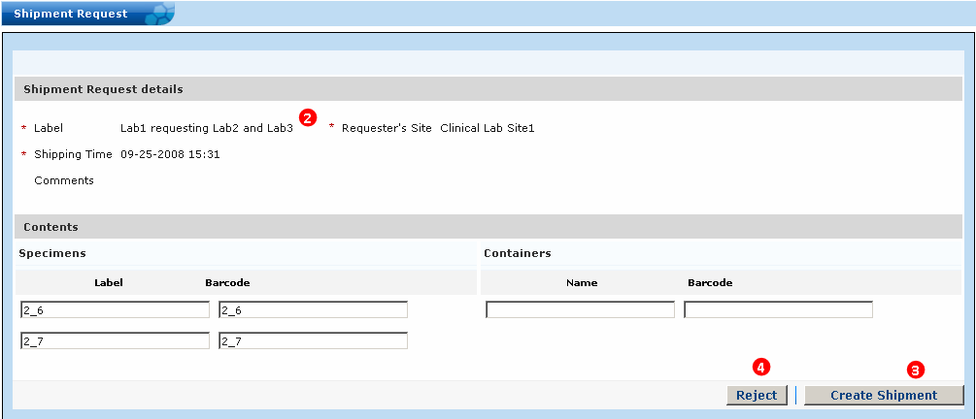

Figure : Process Shipment Request

To cancel the shipment request and to navigate back to the dashboard, click **Cancel**.

### Processing a Received Shipment

To process the received shipment:

**Prerequisite:** The status of the shipment should be *In Transit* under the Incoming Shipments section.

1. On the dashboard, click the link of the required shipment under the **Incoming Shipments** section. navigates to the Received Shipment page.

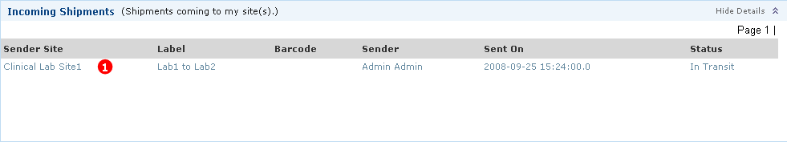

Figure : Dashboard - Incoming Shipments

1. View the details of the shipment under the **Shipment Details** section.
2. Set a status for the specimen or container under the **Specimen Details** section or the **Container Details** section respectively. To do this, select a value from the **Status** drop-down list.
3. Select a location to store the specimen or container from the **Storage Location** drop-down list.
4. Enter relevant information about the received shipment, if required in the **Comments** field.
5. Click **Submit**. The updated data is stored in the caTissue database and caTissue Suite navigates back to the dashboard.

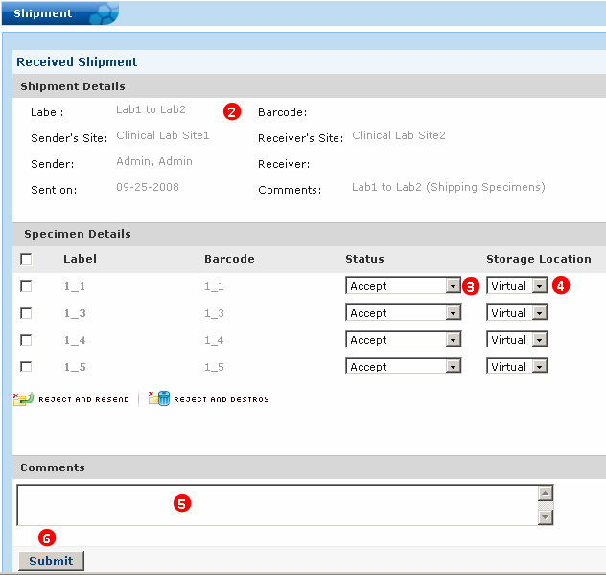

Figure : Process Received Shipment Details

To cancel the shipment and to navigate back to the dashboard, click **Cancel**.

## Creating a Shipment or a Shipment Request

At times, you do not know the labels or names of certain specimens or containers that you wish to request. You can proceed to either create a new shipment or request a shipment from *My List View*.

To create a new shipment or request a new shipment:

**Prerequisite:** Populate My List View page with the required specimens or containers.

1. Click the **Search** tab.
2. Select **My List View**. caTissue Suite navigates to the My List page.
3. Select the specimen or container under **My List View**. To do this, select the check box next to the required specimen or container.

To proceed:

1. Click the **Request Shipment** radio button to request a new shipment, and click **Submit**. caTissue Suite navigates to the New Shipment Request page with the selected contents. See .

OR

1. Click the **Create New Shipment** radio button to create a new shipment, and click **Submit**. caTissue Suite navigates to the Create New Shipment page with the selected contents. See Creating a New Shipment.

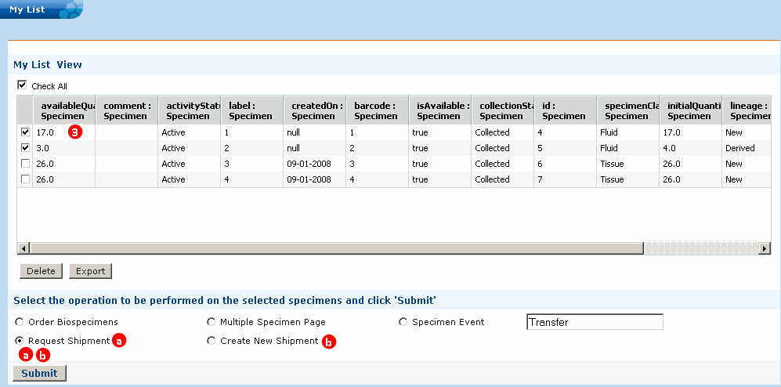

Figure : My List Page

To abort the search-based operations and to navigate back to the dashboard, click **Cancel**.

To remove a specimen or container, select the check box next to a specimen or container, and click **Delete**.

To export the data, select the required specimen or container and click **Export**. The data is exported as a CSV file.

## Editing a Shipment and Shipment Request

In certain conditions, you may wish to modify the details of the shipment you sent or the request you created for a shipment. You can edit the shipment or the shipment request only if the status for them is set to *In Transit* or *In Progress* respectively. You can edit the details like the receiver site, sender site, site name, label name, specimens, and containers for the shipment or shipment request.

**Note:** In Transit is a virtual site that indicates that the requested shipment is on its way to the receiver site.

### Editing a Shipment Request

To edit a shipment request:

1. Navigate to the dashboard.
2. Click the label of the request you wish to edit under the **Outgoing Shipment Requests** section. caTissue Suite navigates to the Edit Request page.
3. Edit the required data.
4. Click **Submit**.

caTissue Suite navigates to the dashboard once the modifications are done, and the status of this request opens as *In Progress*.

### Editing a Shipment

To edit a shipment:

1. Navigate to the dashboard.
2. Click any link for the shipment you wish to edit under the **Outgoing Shipments s**ection. caTissue Suite navigates to the Edit Shipment page.
3. Edit the required data.
4. Click **Submit**.

caTissue Suite navigates to the dashboard once the modifications are done, and the status of this request opens as *In Transit*.

# Performing Searches

This chapter describes the types of searches that caTissue Suite supports.

Topics in this chapter include:

* on this page
* on page 216
* on page 231
* on page 238

## Performing a Simple Search

Once you specify an object for a simple search, you can specify additional objects that are subsequently filtered based on the first object. For example, if you select Participant as the first object, the subsequent objects available for selection include Collection Protocol Registration and Participant.

The following table outlines the fields that you can select to perform a simple search.

| Field Name | Description |
| --- | --- |
| Object | All Administrative Data classes and Biospecimen classes for query. |
| Attribute | Multiple characteristics related to the object you select. |
| Condition | Various situations on which you can perform the search. |
| Value | Related to the Condition field. Depending on the condition selected, you need to enter appropriate values. The values entered in this field are alphanumeric. |
| Operators | Operators *AND* or *OR* used to perform a search on more than one object. Used as connectors between two or more objects. Expressions are evaluated from top to bottom and do not have any parentheses control. |

**Note:** If you select the Condition **is Null** or **is Not Null**, the Value is disabled.

To perform a simple search:

1. Click the **Search** tab.
2. Click **Simple > Search** on the left pane. The Simple Search page opens.
3. Select the required object from the drop-down list underObject.
4. Select the required attribute from the drop-down list under Attribute.

The options in this list are filtered based on the Object you select.

1. Select the appropriate condition from the drop-down list under Condition.
2. Enter a value in the **Value** field, if required. If you do not enter a value, all records are displayed based on the selected Object and Attribute.
3. Select an operator from the drop-down list under **Operator** to connect more than one object.
4. Click **Add More,** if required, to add a new object row to the search criterion.
5. Click **Search** to view the filtered records.

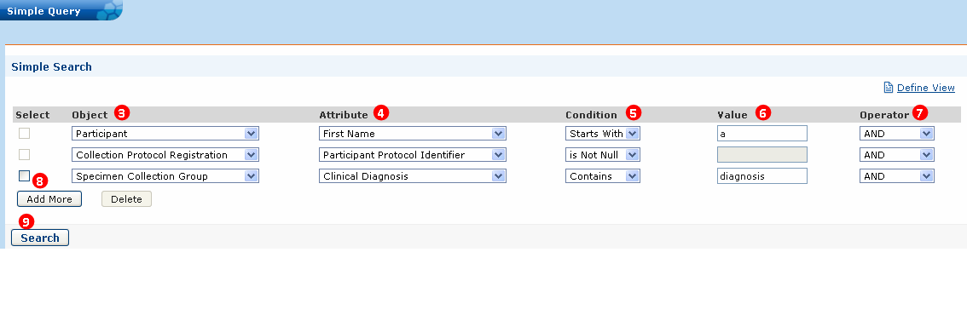

Figure : Define Simple Search

To delete the last object row from your query, select the check box next to the row, and click **Delete**.

## Using the Advanced Query Wizard

The caTissue Suite advanced query wizard provides a powerful and flexible query interface where you can query and view any data in the caTissue database.

**Note:** Tissue bank Administrators and Data Managers should create queries and save them for end users to use, such as Scientists and tissue bankers.

To navigate to the advanced query interface:

**Note:** The Advanced query wizard is a text-based or concept code-based search. You are not required to use *wildcards* to perform the search.

1. Click the **Search** tab.
2. Click **Advanced**.

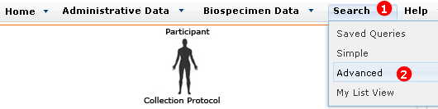

Figure : Advanced Search Menu

1. The query wizard walks you through the following steps to create an advanced search.

The query wizard contains the following three steps:

1. Add Limits – define the limits (criteria or predicates) of the query.
2. Metadata search on items of interest.
3. Add limits on selected objects.
4. Connect the limits.
5. Define View (optional).
6. Add additional objects to the view.
7. Connect newly added objects.
8. View Results.
9. View results.
10. Export and save the query.
11. Redefine view and add to My List (shopping cart).

The following figure outlines these steps.

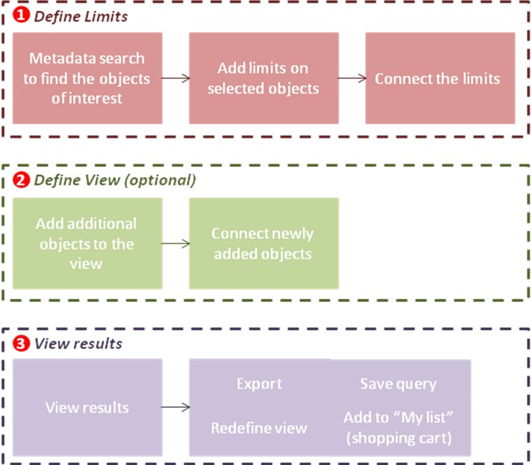

Figure : Query interface features and workflow

## Defining Limits

A *limit* is a condition (or criterion or predicate) on an object. One or more limits together form a query. For example, in the *all active male participant* query, *active* and *male* are limits on the participant object.

### Advanced Options

If returns too many results for the category search, use **Advanced Options** to narrow your search. Expand the **Advanced Options** list to display the options that help you refine the category search.

The following figure displays the default selection of the available options:

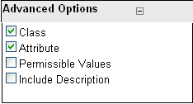

Figure : Advanced Options

The following table lists and describes the advanced option.

| Option | Description |
| --- | --- |
| Check Boxes | |
| Class | Includes the class names in the search. |
| Attribute | Also known as data element, this is the lowest unit of the items that can be searched. A class contains many attributes.  Select this check box to include the individual attribute names in the search.  For example, if you select *attribute* and search for *gender*, displays the Participant category as it contains the *Gender* attribute. |
| Permissible Values | Some attributes contain a fixed set of values like Gender is Male, Female, or Unspecified. This fixed set is known as Permissible Values.  Select this check box to include the permissible values in the search. For example: if you select the permissible value as *Male*, will display the Participant class as it contains the *Gender* attribute. This attribute contains a permissible value *Male* *Gender*. |
| Include Description | Includes the description text in the search. This option is disabled if you select the Permissible Values check box. |
| Option Buttons | |
| Text | matches the search string entered with the name of the class, its attributes, or the permissible values based on the text.  This is the simplest, most commonly-used way of searching a category. |
| Concept Code | A concept code is a concept unique identifier within the NCI Enterprise Vocabulary Service's NCI Thesaurus.  treats the search string as an EVS concept code. matches this concept code with the concept code of the class, its attributes, or the permissible values. The results contain matching categories.  **Note**:TheInclude Description check box is enabled only for a text-based search if you select the Class check box, the Attribute check box, or both.  This option is currently disabled as the functionality is under construction. |

To define limits:

* 1 Performing a Metadata Search

#### 1 Performing a Metadata Search

To search for objects to which you want to add limits, perform a metadata search:

1. Enter a keyword in the search text box.
2. Click **Go** displays the list of matching objects.
3. Click the object of interest to enter the details of the limit on the right pane.

**Note:** If returns too many results, you can fine-tune the search. See **Error! Reference source not found.**.

#### 2 Defining Limits

Step 1 described how to search for the object of interest. Next, you need to specify the limits on the selected object. The following figure outlines the two limits defined for class participants. For example, Activity Status as Active and Gender as Male Gender.

1. For each attribute there are possible operators depending upon its data type. Select an appropriate operator from the drop-down list.
2. You can enter the limiting value for that attribute in a text box or select it from the drop-down list. Two text boxes are provided when the *Between* operator is selected. The text box is disabled when the operator selects **Is Null** or **Is Not Null**. Enter comma-separated values when the *In* operator is selected.

Currently, the advanced query shows all enumerated attributes as a list, but if there is more than 1,000 values, enter the value manually in the edit box.

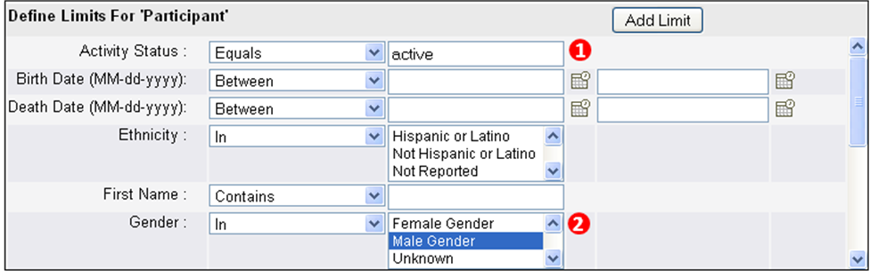

Figure : Add Limit Page for Active Male Participants

#### 3 Displaying the Diagrammatic View

The diagrammatic (DAG) view displays all the limits you added to the query. Whenever you add a new limit, caTissue Suite adds a yellow rectangle to the DAG view. As you continue to add limits, caTissue Suite adds corresponding rectangles to the DAG view.

The following table lists the limits that you can apply to the view.

|  |  |
| --- | --- |
| Task | Performing the Task |
| View details of the limit | Position your mouse over an object to view the details of that limit. |
| Edit or Delete the limit | Click the **>** icon in the yellow box. |

### Connecting the Limits

When you add more than one limit, you must connect all the limits within the DAG view before proceeding to the next step.

To connect two objects:

1. Left-click the first object.
2. Left-click the second object.
3. Click **Add Link**.
4. By default the *AND* operator is selected for every link. If you wish to add an *OR* operator, select **OR** from the drop-down list.

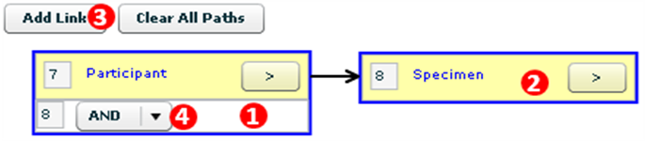

Figure : Connected Objects

#### Why Is It Important to Connect the Objects?

The main purpose of linking the objects is to form the *query tree*. The query tree is a set of interconnected limits that helps in interpreting the query. For example, the figure below shows how the query changes depending on how the limits are linked.

In the first example, the query represents, “There exits at least one fixed tissue *and* at least one DNA collected from the same participant”.

In the second example, the query represents, “There exists at least one DNA which has been derived from a fixed tissue collected from a participant”

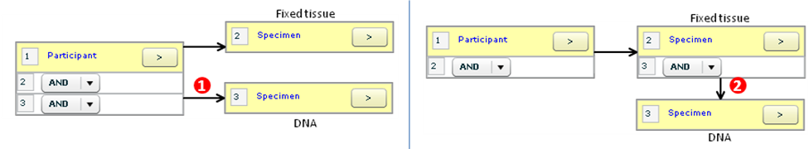

Figure : Query Tree

To delete a connection, click the connection, and click **Delete**. Click **Clear All Paths** to clear all the connections.

#### Why a Connection is Not Established Between Two Objects?

If you connect unrelated classes, for example, a Collection Protocol and a Specimen, an error message displays. This is because there is a missing object that connects these two classes. To connect a collection protocol to a specimen, the path is Collection Protocol > Specimen Collection Group > Specimen.

## Information Panel

The information panel is located at the bottom of the Limit Set panel.

The information panel provides the following:

* Depending on the way you connected the limits, view the expression formed.
* Viewing limits that are not yet connected to any other limit.
* Connecting all limits before executing the query.

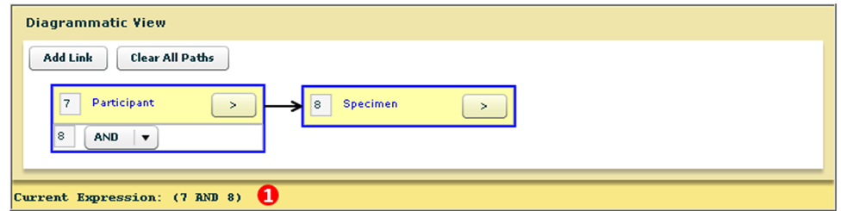

Figure : The Information Panel

## Defining the Results View

Defining the Results View is the next step in the advanced query wizard. The Define Results View enables you to specify the objects to display in the final search results. You can add any other objects to the view that is not currently present in the DAG. After adding the new objects, you must connect the new objects to the existing query tree. You can also hide the objects in the query from the view.

For example, you can display the collection protocol details for all participants whose DNA specimen exists in . In this query, the query limits are on the participant and specimen, whereas the user wants to view the collection protocol details.

The Define Results View window is similar to the add limits window where you perform a metadata search to find the object you want to add to the view. The following figure outlines the addition of collection protocol object to the view:

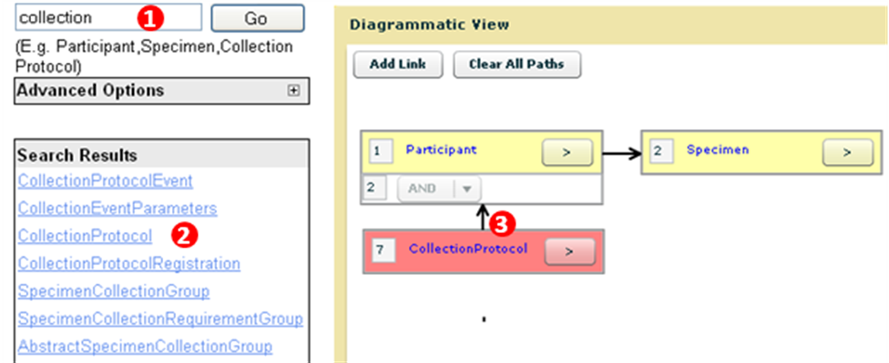

Figure : Adding Collection Protocol Object to the View

1. Perform metadata search for the collection protocol object.
2. Click **Collection Protocol**.

The object is added to the Diagrammatic View (left side in a pink color) box. The pink color denotes that no limit is added on that object, but the result for the object can be viewed on the Results View tab

1. Connect the collection protocol box with the participant box. See Connecting the Limits.

You can repeat the process to add multiple objects to the view.

## Reviewing the Results View

From the Results View, there are the following options:

* **Hierarchical data representation with drill-down capabilities**: You can filter data based on the selected object in the tree.
* **Spreadsheet view**: You can view details of specific attributes.
* **Attributes definition**: You can define attributes displayed in the spreadsheet.
* Other features like Export, Add to My List, and Redefine Query.

**Note:** If you have restricted access to PHI queries with a condition on a PHI attribute, the query does not return any results. This is true for Simple and Advanced Search.

### Hierarchical Data Representation

The hierarchical data tree is similar to the Windows Explorer interface. In Windows Explorer, when you click a folder, it displays the folders or files within the selected folder. Similarly, in Results, when you select any object, the records related to the next level in the tree are displayed.

### Spreadsheet Data Representation

The spreadsheet data representation contains individual data elements or attributes. For example, if you search for a participant, the attributes displayed in the spreadsheet will be First Name, Last Name, Gender, and so on. The values that are displayed are the individual values of that particular attribute.

### Defining Attributes in a Spreadsheet

There are two types of spreadsheet views:

1. **Default View** opens when the results view opens for the first time.
2. **Defined View** opens when you click **Define View** and select a particular set of attributes to be displayed in the spreadsheet.

The following table describes the two views.

| Default View | Defined View |
| --- | --- |
| The spreadsheet displays the attributes related to the object selected in the tree. For example, if you select a participant, the page displays the participant objects attributes. If you select a specimen, the page displays the specimen object’s attributes. | The spreadsheet view is fixed to display the same set of attributes irrespective of the object selected in the tree. That is, the attribute displayed is always constant. |
| The number of rows displayed depends on the number of child objects in the tree. That is, similar to Windows Explorer. | The number of rows decreases as you move to the lower levels. The number of rows is the maximum at the highest level. |

1. To export your data into a CSV format text file, you must select the records to be exported:
2. Select the **Check All On This Page** check box to select the records on the current page.  
   OR  
   Select the **Check All** check box to select all the records returned in the results.
3. Click **Export**.
4. Click **Redefine Query** to navigate back to first step of the query wizard.
5. My List is a feature that allows you to gather records of interest across different queries. The features provided in My List are:
6. Specimen operations like edit, transfer, and order specimens.
7. **Export** to export the file.
8. **Save** to save the defined query.

**Note:** You can perform specimen-based operations only if My List contains the specimen ID, barcode, or label in the view.

## Saving the Query

The following sections provide instructions on saving queries:

### Managing Regularly-Scheduled (Canned) Queries

Administrators create regularly-scheduled queries and save them. Scientists and Technicians can then execute the queries with one click.

To create canned queries:

1. Define the query, and click **Save** on the Redefine Query page or on the View Results page.
2. Enter the query **Title** and **Description**.
3. Click **Save**.

The following figure outlines the steps to create and save a canned query. The query in the following figure searches for samples collected under a particular protocol.

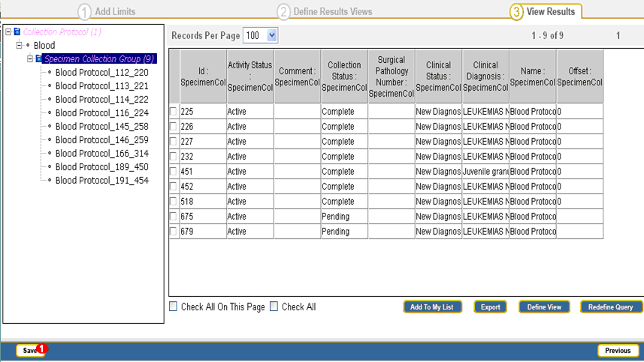

Figure : Save Query from the Results View

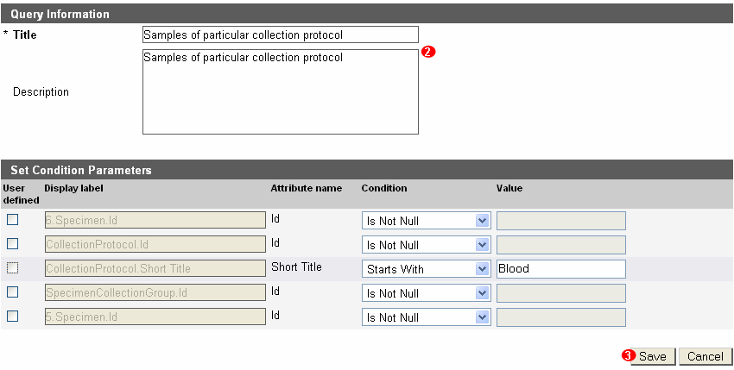

Figure : Enter Query Description

The query created and saved in the preceding figure appears in the list of saved queries on the dashboard of the **Search** tab.

### Managing Parameterized or Saved Queries

Parameterized queries are saved queries where you enter data for some or all of the query criteria before executing the query. Thus the query definition is saved, but the condition value on certain parameters is defined before executing the query.

To create parameterized queries:

1. Define the query, and click **Save** on the Redefine Query page or on the View Results page.
2. Enter the query **Title** and **Description**.
3. Select the query conditions that are parameterized, so that the user can change the query condition value before executing.
4. Click **Save**.

Consider an example that is described in the following figures based on the preceding procedure. The example saves the query to search for all surgical pathological reports containing particular concept names. The user can change the value of the concept names to be queried before executing the query.

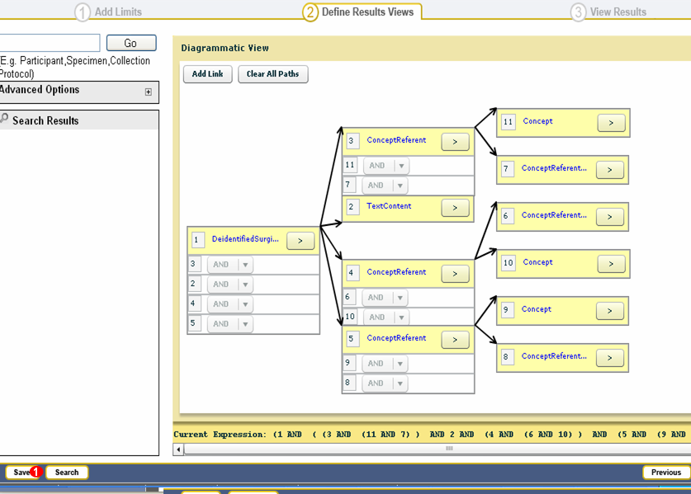

Figure : Save Query After It Is Defined

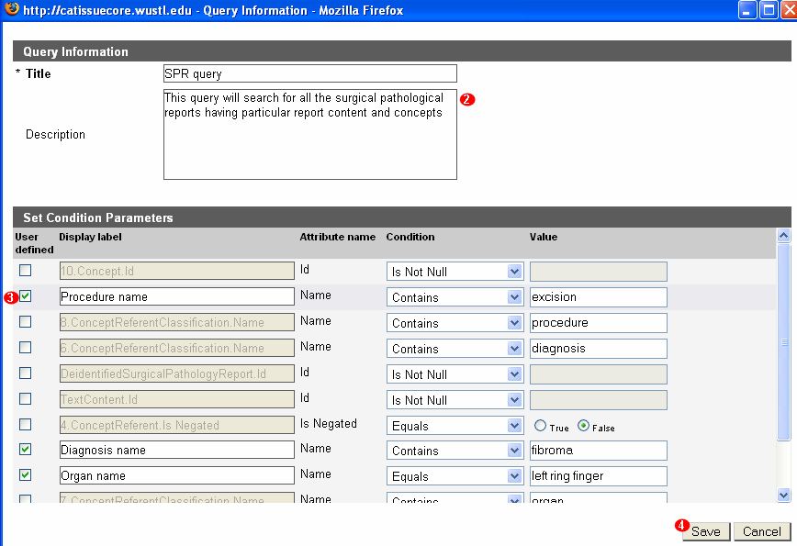

Figure : Enter Query Description and Define Parameters

**Note:** You can provide a user-friendly display name to the parameters. This helps the user who is executing the query to better understand what can be stipulated. Also, the other query conditions that are not parameterized will be hidden from the user who is executing it.

### Sharing the Saved Queries

You can share the queries with other users while saving them. There are options for selecting to whom you want to share a query:

1. **None**: The query is visible only to you.
2. **All**: The query is visible to all current and the future users of .
3. **Selected Users**: You can add selected users to the list box on the right side. This query is visible to you and to the users you have chosen.

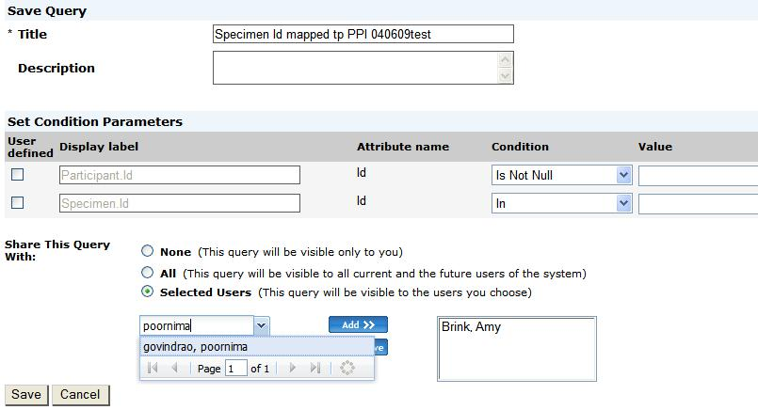

Figure : Sharing a query

### Accessing the Saved Queries

Once you save the queries, they are listed in the saved queries page. There are three filter options for the list of saved queries.

* **My Queries**: View the queries saved by you.
* **Shared Queries**: View the queries saved by other users and shared with you.
* **All Queries**: View the queries saved by you and also shared with you by other users.

The following details are displayed for each saved query:

* **Sequence Number**: The numeric sequence assigned to the query
* **Title**: Shows the name of the query
* **Results**: Displays the name of the root entity from the query and parenthetically, the number of total records returned when it was executed last time. Displays N/A (N/A) for queries not executed.
* **Executed On**: Shows the date and time when it was executed last. Displays N/A for queries not executed.
* **Owner**: Shows the name of the user who saved the query.
* **Actions**: Displays graphics for editing or executing the query.

You can perform following three actions on each saved query.

* **Edit**: Takes the DAG view from where you can edit the saved query.
* **Delete**: Removes the query from the list. This action icon opens only the queries saved by you.
* **Execute**: Executes the query. If it is a canned query, it takes you directly to the results page. If it is a parameterized query, then you need to specify the condition values and then view the results that satisfy the conditions.

You can view the PHI data on the results page if you are the Principal Investigator (PI) for that Collection Protocol. For example, you are a Technician and try to access a query saved by a Scientist, you will not be able to view the PHI data in the results view for this query as the PI is not the PI for that study.

### Executing the Saved Queries

To execute a saved query:

1. Click the **Search** tab.
2. Select **Saved Queries**.

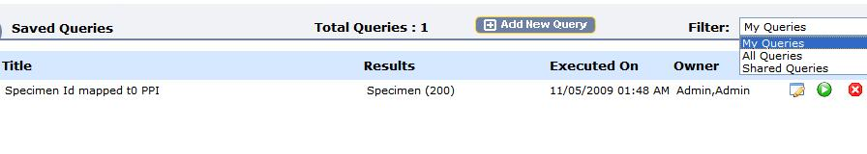

Figure : Saved queries page

To execute a Parameterized Query:

1. Upon selecting the saved query, navigates to the query condition page for the selected query. Specify the conditions.
2. Click **Execute**.

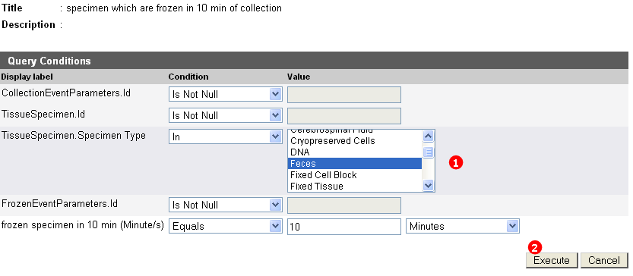

Figure : Enter Value for the Parameterized Condition and Execute

navigates to results page.

To delete a query, click the trashcan icon.

## Performing a Temporal Query

Scientists often need to obtain information about participants and their biospecimens in the context of time. Specimens collected at a specific time or from some specific age-group are sometimes needed for investigation and research. A temporal query uses the *Time* attribute to make the time-based searches possible.

PHI is filtered for the following temporal queries:

* **Query on any date** – All dates are masked in the results if you do not have PHI access
* **Query on time interval** > 89 – Temporal query on any date which results in a value greater than 89 is shown as 90+ in the result.
* **Queries like today’s date** - BirthDate = 36.28493150684931506849315068493151

Such a query is not allowed as it could be used to get a person’s birth date. To avoid this, when you select a birth date, the time interval is restricted to years.

To create a temporal query:

* Creating a Temporal Query
* Editing and Deleting a Temporal Query

.

* Viewing Search Results
* Saving and Executing a Temporal Query with User-Defined Values

### Creating a Temporal Query

To create a Temporal Query, you need to define an advanced query. Once the advanced query is defined, you can select objects that contain time attributes (fields), and define temporal conditions based on these attributes.

**Note:** The order in which the objects are selected is significant. For example, if a user wants all the participants for whom the difference between registration date and birth date is less than three years. For this, the you need to add two objects; Participant (with condition on Birth Date) and Collection Protocol Registration (with condition on registration date). While defining a temporal query, if you select the Collection Protocol Registration object first and Participant object later, the desired results are obtained. However, if you select the Participant object first and the Collection Protocol Registration object later, the query in this case returns all participants for whom the difference between birth date and registration date is less than three years.

To create a temporal query:

1. Define an advanced query. Adding limits as needed.
2. Connect the objects in the required order and add links.
3. Select the objects in the Diagrammatic View (DAG view), and click **Temporal Query** to add the temporal condition.

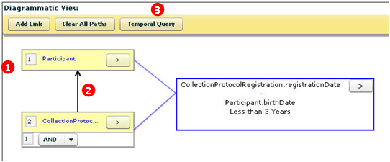

Figure 182a: Diagrammatic View of the Temporal Query

As shown in the figure above, “Find all Participants where the difference between the date the Participant registered to the protocol and the Participant’s birth date is less than 3 years,” in other words, all Participants who were 3 years old or less when they registered to the protocol.

TheDefine Condition dialog box opens where you can specify the operation between the events to obtain the required temporal conditions.

1. Select the event attribute from the drop-down list.
2. Select an operator from the **Arithmetic Operators** drop-down list.

**Note**: For two-date attributes, only the - operator is valid. For a date and interval attributes, you can use both + or -, resulting in a date prior to or after the base date respectively.

To define the condition:

1. Specify the **Collection Protocol** from the drop-down list.
2. Specify any **Arithmetic Operators** from the drop-down list.
3. Specify an existing **Participant**.
4. Select an operator from the **Relational Operator** drop-down list for the two events.
5. Enter the period in the **Time Value** field.
6. Select a value from the **Time Interval** drop-down list.

Users can enter a custom column name for the attribute displayed in the results.

The following figure outlines the conditions and the values that you can configure in the temporal query.

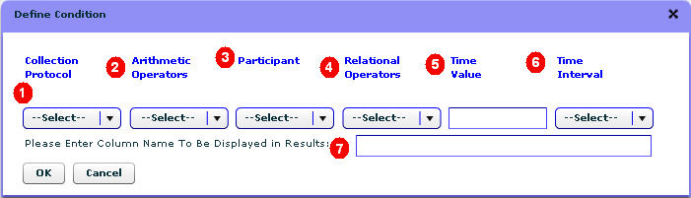

Figure : Temporal Query Define Condition page

1. Click **OK**. A DAG view of the defined temporal query opens.
2. Click **Search** to view the search results.

The following table outlines the fields on the Define Condition page.

| No. | Name of the Field | Description |
| --- | --- | --- |
| 1 and 3 | Objects to which the temporal condition is related. | Indicates the events on which a temporal query is based. The options in the drop-down list change according to the objects that you select. |
| 2 | Arithmetic Operators | This list contains the + and - arithmetic operators. For example: date, time, or offset. |
| 4 | Relational Operators | This is a list of comparison relationship, such as Equals, Not Equals, Less than or equal to, Greater than or equal to. |
| 5 | Time Value | This is a user-specified number, the numeric part of the time condition the user wants to specify, for example, 30 minutes, where 30 is the time value. |
| 6 | Time Interval | This list specifies different units for time interval. |
| 7 | Custom Column Name | displays the calculated value (e.g. the time interval between two events) in the result. In this text box, you can enter the name of the column where the result will be displayed. For example, enter **Age of the Participant** in Custom Column Name to view a column containing age in the result view. |

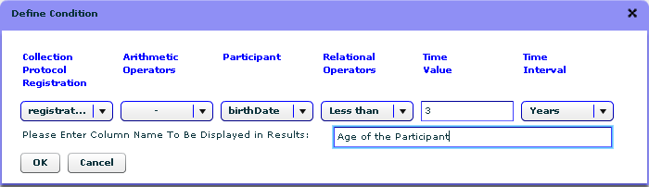

Figure : Define Condition for the Temporal Query

As shown in the figure above, “Find all Participants where the difference between the date the Participant registered to the protocol and the Participant’s birth date is less than 3 years”; in other words, all Participants who were 3 years old or less when they registered to the protocol.

### Editing and Deleting a Temporal Query

To edit a temporal query:

1. Click the **>** icon in the temporal query box.
2. Select **Edit**. The Edit Condition page opens.

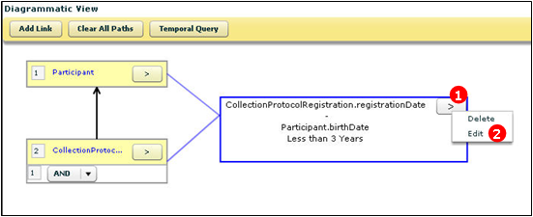

1. Review the conditions in the temporal query, and click **Edit**.

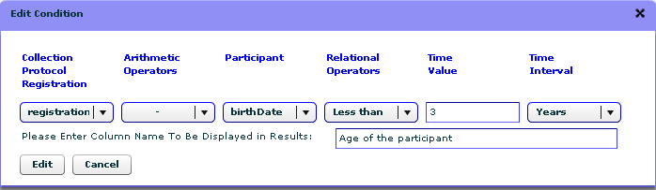  
Figure : Edit Condition Dialog Box

To delete a temporal query, click the **>** icon in the temporal query box. Select **Delete**.

### Viewing Search Results

The View Results page displays the values computed as a result of a query, in the **Custom Column Name** field.

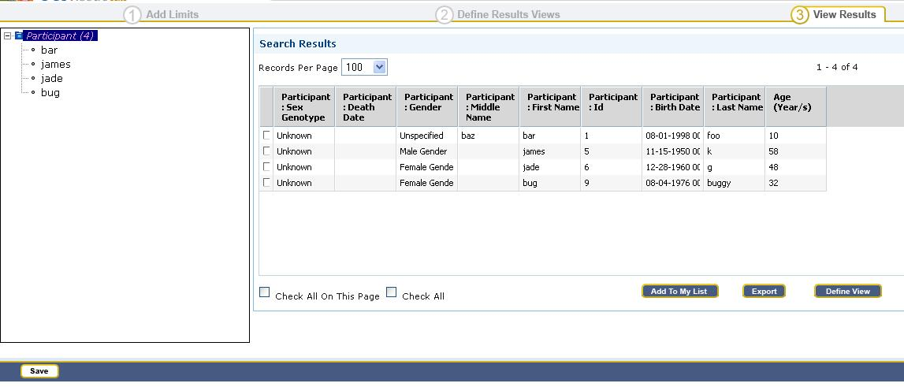

Figure : View Search Result

### Saving and Executing a Temporal Query with User-Defined Values

If you want to save a temporal query for later use, the query can be saved in a parameterized form (that is, values that you enter before you submit the query). When the user clicks on the saved query, displays a window that allows a user to select or enter values for some or all of the query conditions.

#### Saving a Parameterized Temporal Query

Saving a parameterized temporal query is the same as saving any advanced query:

1. Define the temporal query.

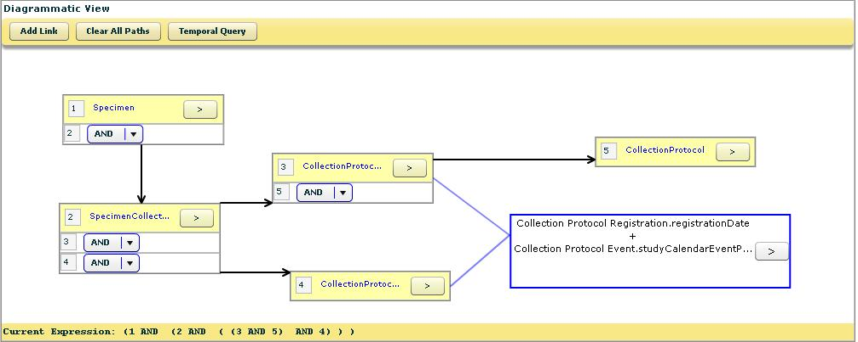

Figure : Diagrammatic View of the Temporal Query

1. Click **Save**. The Query Information page opens.

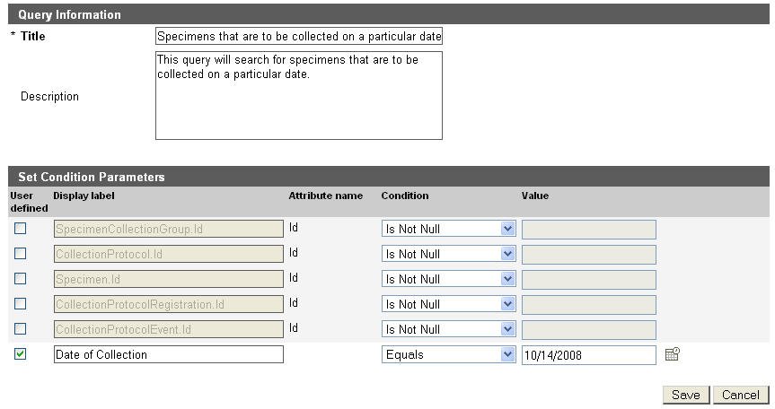

Figure : Enter Query Description and Define Parameters

1. Enter the query title and description.
2. Select the query conditions to parameterize. Before you run the query, you can change the value for the parameterized condition. In this example: you can change the current date as per the conditions.
3. Click **Save**.

#### Executing a Saved Temporal Query

To execute a saved temporal query:

1. Navigate to **Search >> Saved Queries**.
2. Select the saved query, and enter the required values,and click **Execute**.

The results of the query are displayed:

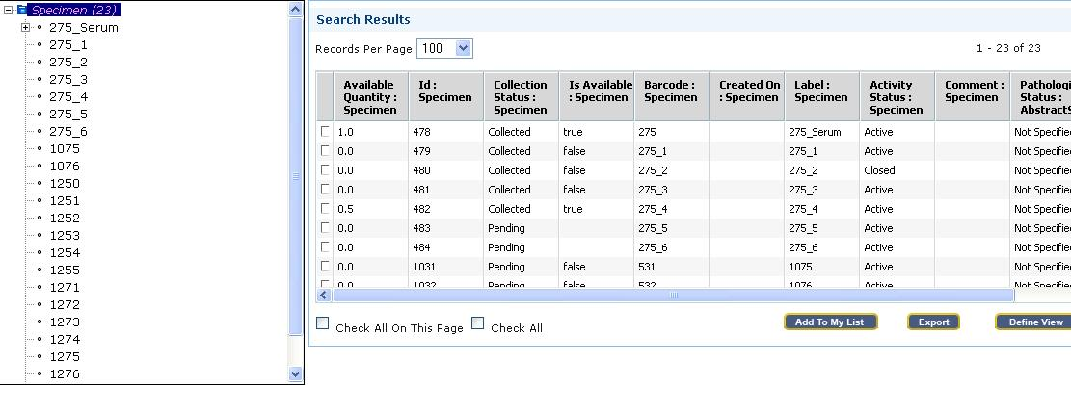

**Note:** The additional column “Date of Collection” is added in the search results. This column is NOT shown by default. You need to click on Define View and then on Finish in order to display the column.

## Performing a Keyword Search

caTissue Suite v1.2 has a ‘Google’ type search tool called Keyword Search. This allows users to specify search criteria and displays data matching the search criteria. This type of search offers users a quick way to search and return results based on an input value. For example, in case you want to process a specimen, if you know the specimen label, you can quickly search using the label name; this will lead you directly to the specimen edit page so as to process the specimen.

The Keyword Search box appears on the menu bar.



Figure : Keyword Search box

The search results are displayed in any one of the following manner:

* If only one match is found, the edit page of the record opens.
* If all the matches found related to the same object, all the records are displayed in a grid. You can navigate to the edit page of the record by double-clicking the appropriate record.
* If matches related to more than one object are found, all the objects are displayed along with the number of records for each object.

The most common Keyword Searches are using label or barcode ID, or Participant Protocol ID.

### Searching for Labels and Barcodes using Keyword Search

To navigate directly to the edit page of the desired specimen, perform the following steps on the menu bar:

1. Type the label or barcode of the specimen in the search-box.
2. Click **Keyword Search**. The Specimen Edit page opens, if the specimen exists.

### Searching by Attributes

To search for a specimen on the basis of attributes, such as clinical diagnosis, perform the following steps from the menu bar:

1. Type a clinical diagnosis, for example, *“Malignant meningitis*,” in the **Keyword Search** field.



1. Click **Keyword Search**. The Keyword Search Results table opens. It includes:

* Specimen collection group objects with clinical malignant meningitis as diagnosis.
* All the specimens with pathological status containing malignant meningitis.

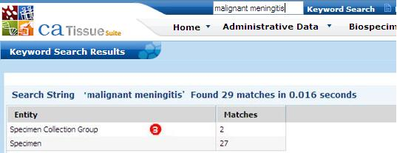

Figure : Keyword Search for specimens.

1. Double-click the appropriate entity. All the matching records of the object are displayed.

### Searching by Type Serum

To search for all specimens of the type serum, perform the following steps from the menu bar:

1. Type **serum** in the **Keyword Search** field.
2. Click **Keyword Search**.

A list of all the specimens of type serum opens.

1. Double-click the appropriate specimen. The edit page of the specimen opens.

### Searching with “AND” and “OR” Operators

To search for a specimen on the basis of two or more criteria in Keyword Search, you can use “AND” and “OR” operators.

For example, to search for all “tissue” specimens with pathological status “malignant”, you can give a search for “Tissue AND Malignant.” To search for all specimens of the type “tissue” and tissue site “brain”, you can give a search for “Tissue OR Brain”

**Note**: The “OR” operator searches for either term. The “AND” operator searches for the presence of both the items.

### Search Using Wild Card Character

You can also perform a wild-card search using the asterisk (*) character.

For example, to search for all specimen with a pathological conditional malignant, execute the search for “Mal*”. Specimens with a status of malignant, malignant invasive, or malignant pre-invasive are displayed.

# Bulk Operations

Bulk operations is a feature in caTissue that allows users to collect and/or manipulate data outside of the application in a comma separated value file and subsequently load the data through the user interface. As the name suggests, this feature allows for processing of large quantities of data that might take a significant longer time to process through typical user interactions with the application. Consider a case of legacy data migration where data is extracted from the legacy system, mapped to values in caTissue and (via bulk operations) loaded without the intervention of system programmers or database specialists. Bulk operations can also be used in routine data entry or corrections. For example, bulk operation templates can be used by sites that batch deliver biospecimens to a repository thus allowing the technician on the receiving end to be able to bulk load all biospecimens collected that day.

**Note:** In this version of , the bulk operations feature supports only objects in the model.

This chapter includes the following topics:

1. on this page
2. on page 241
3. on page 241

## About Bulk Operations CSV File and XML Template

The Bulk Operations is a command line feature which takes two inputs.

* **A data file in CSV format** – This contains the to be added or updated in bulk
* **An XML template file**: This is an Extended Mark-up File (XML) also called the Bulk Operation XML template. This represents the object model in a form of tree-structure format for which you are adding or editing data in caTissue Suite. See the caTissue technical manual for details about creating a Bulk Operations template.

## Using Bulk Operations

The following steps are required to perform bulk operations through :

* To load bulk operations XML and a CSV template into the database, see the caTissue Suite Technical Manual.
* To run bulk operations from the caTissue Suite user interface, see the following section.

## Running Bulk Operations from caTissue Suite

To run bulk operations with caTissue Suite:

1. Login into application and click on the **Bulk Operations** tab present on the home page.

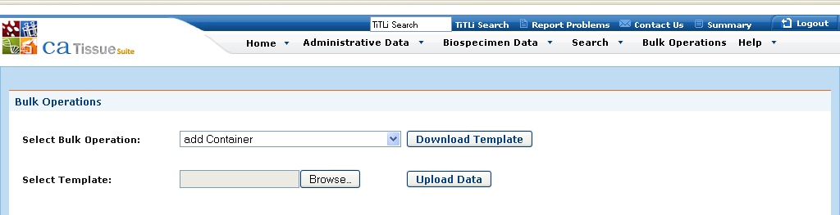

Figure : Bulk Operations page

1. The Bulk Operations page comprises values in which the user loaded the XML and CSV templates.
2. Select the appropriate Bulk Operation name for which you want to perform a bulk upload.
3. Click the **Download Template** button. Download and save the CSV file on machine.
4. Fill the data in the corresponding column name specified in downloaded CSV file.
5. Save file again as CSV.

**Note:** Changing or deleted any column will cause the template to not load correctly. As a general rule, all fields marked as **required** in the user interface are also required for bulk operations.

1. Click on the **Browse** button, and locate the CSV data file.
2. Click the **Upload Data** button.

**Note:** Check the Bulk Operation Name selected before clicking **Upload Data**. The Bulk operation Name needs to match the function you wish to preform

The Bulk Operation starts, and you can view the Bulk Operation as it is added in the grid Dashboard.

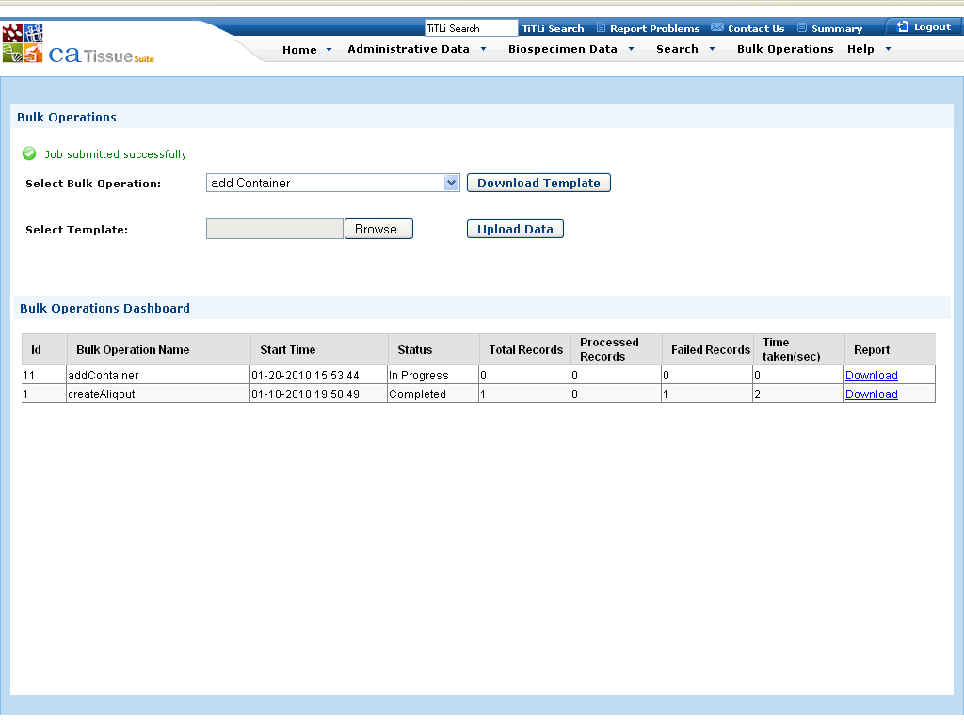

1. If you wish to view a report for any Bulk Operation, click on the “**Download**” link in the Bulk Operations Dashboard grid. The report is useful for reviewing records that failed to upload. The output report file is in zip format and contains a CSV file. The CSV file has the same data uploaded by the user for performing bulk operations and has additional two columns “Status” and “Message” appended to it. The Status column contains either “Success” or “Failure” per record indicating whether the record was successfully uploaded or not. In case of a failure, the message column contains details which indicate the reason for failure. For e.g. a message can be something like “Please provide valid value for site identifier” which tells you that the Site Identifier provided is incorrect and a valid value needs to be specified.

# Deriving Plasma and Serum and RNA and DNA

This chapter describes how to derive plasma and serum from blood and aliquote the plasma and serum. This chapter also describes how to derive DNA and/or RNA from tumor and matched non-malignant tissue in bulk.

The topics include:

## Deriving Plasma and Serum

To derive plasma and serum from blood and aliquot:

1. Navigate to the Collection Protocol Based View.
2. Select the required collection protocol and then the required participant.
3. Navigate to the blood specimen under Specimen Details.
4. Select the blood specimen. The specimen details page opens.
5. Enter **2** in the **Number of Derivative(s)** field under Add Multiple Derivatives.
6. Click **Derive Multiple**. The Multiple Specimen Details page opens and the **Parent Name** is auto-populated.
7. Select the **Class as Fluid and Type** as **Plasma** under Specimen 1.
8. Enter other required details.
9. Select the **Class as Fluid and Type** as **Serum** under Specimen 2.
10. Enter other required details.
11. Click **Submit**. A success message opens and the Specimen details summary page opens.
12. Click **Submit** once again. Another success message opens.
13. Navigate to the Specimen Details tree and view the newly added derivatives.
14. Select the newly created plasma derivative. The Specimen Details page opens.
15. Select the **Do you want to create aliquots?** check box.
16. Enter a value in the **Aliquot Count** and **Quantity per Aliquot** fields.
17. Click **Submit**. A success message opens and navigates to the Create Aliquot page.
18. Confirm the data and click **Submit**. A success message opens.
19. To aliquot the newly created serum derivative, repeat the procedure from step 13 till step 18. Enter the details as required to proceed.

## Deriving RNA and DNA

To derive RNA and DNA or both from tumor and matched non-malignant tissue in bulk:

1. Navigate to the Collection Protocol Based View.
2. Select the required collection protocol and then the required participant.
3. Navigate to the tumor specimen under Specimen Detail.
4. Select the tumor specimen. The specimen details page opens.
5. Select the **Pathological Status** as **Malignant** and edit other details if required.
6. Enter **2** in the **Number of Derivative(s)** field under Add Multiple Derivatives.
7. Click **Derive Multiple**. The Multiple Specimen Details page opens and the Parent Name is auto populated.
8. Select the **Class** as **Molecular** and **Type as RNA** under Specimen 1.
9. Enter other required details.
10. Select the **Class** as **Molecular** and **Type** as **DNA** under Specimen 2.
11. Enter other required details.
12. Click **Submit**. A success message opens and the Specimen details summary page opens.
13. Click **Submit** once again. Another success message opens.
14. Navigate to the Specimen Details tree and view the newly added derivatives under the tumor specimen.
15. To derive RNA and DNA from a non malignant tissue specimen, repeat the procedure from step 3 till step 14. Enter the Pathological Status for the specimen as Non Malignant and enter other details as required to proceed.
16. Clinical Annotations

This section outlines all the clinical annotations found under the participant hook entity.

* on page 247
* on page 250
* on page 254
* on page 296

## Data Entry for Clinical Information Annotation

This section outlines the following annotations found under the participant hook entity:

### Lab Annotation

This annotation helps you to capture information on the clinical and laboratory tests that the participant has undergone or is undergoing.

The following table lists the attributes of the lab annotation.

| Attribute and Sub-Form Name | Action |
| --- | --- |
| Lab Test Name | Select the appropriate laboratory test name from the drop-down list. |
| Other Lab Test Name | Enter the lab test name if same is not available in the Lab Test Name drop-down list. This field can be left blank. |
| Test date | Enter the date laboratory test was conducted. To do this, use the calendar. |
| Result | Enter the result of the test conducted. This data field can store alphanumeric values, which means you can add numeric values and values like *positive* and *negative*. |
| Result Units | Enter the measurement units for quantitative result. You can enter the units as abbreviations, for example: gm, ml; or enter the unit name, for example: gram, milliliter. |

#### Known Issue with LabAnnotation.result Data Type

You cannot query on a *result* attribute in a LabAnnotation class using enumerated conditions. The *result* attribute in a LabAnnotation class has a data type of *String* in the database. While querying, the conditions displayed for the attribute result in the entity LabAnnotation which is non-numeric. For many LabAnnotation Tests, the result values are numeric. If the data type in the database is *String* for *result*, you cannot query the numeric values using numeric operators like <, >, <=, >=, but you can query using the non-numeric operators.

### Family History Annotation

This annotation captures the data related to the family medical history of the participant. For each family member, you can capture details of one or more clinical diagnosis.

The following table lists the attributes for the Family History Annotation.

| Attribute and Sub-Form Name | Action |
| --- | --- |
| Relation | Select the appropriate relation name from the drop-down list. |
| Other Lab Test Name | Enter the relation name if the same is not available in the previous attribute’s (Relation) drop-down list. Data entry in this field is optional. |
| General Health Diagnosis | To enter information about the General Health Diagnosis, click the Add More button. |
| Clinical Diagnosis | Select the appropriate Clinical Diagnosis from the drop-down list. |
| Other Clinical Diagnosis | Enter the clinical diagnosis value if the same is not available in the previous attribute’s (Clinical Diagnosis) drop-down list. Data entry in this field is optional. |
| Age at Diagnosis | Enter the Age at Diagnosis. This field accepts integer (whole number) values only. If you enter a decimal value, the value is rounded off. |

**Note:** To delete a General Health Diagnosis record, select the check box next to that record and click **Delete**.

### Treatment Annotation

This annotation tracks the general treatments that a participant has undergone or is undergoing.

The following table lists the attributes of the Treatment Annotation.

| Attribute and Sub-Form Name | | Action |
| --- | --- | --- |
| Agent | Select the appropriate Agent name from the drop-down list. | |
| Other Agent | Enter the agent name if it is not available in the previous attribute’s (Agent) drop-down list. Data entry in this field is optional. | |
| Dose | Enter the amount or dose of radiation administered to the patient. This field accepts numerical value with decimal. | |
| Dose Unit | Enter the measurement unit for the dose of radiation. | |
| Duration | To enter information about the Duration of the treatment, click the Add More button. | |
| Start Date | Enter the date treatment began using the calendar. | |
| End Date | Enter the date treatment ended using the calendar. | |
| Duration In Days | Enter the number of days the treatment lasted. This field accepts integer values only. If you enter a decimal value, the value is rounded off. | |

**Note:** To delete a row that contains data about the duration of treatment, select the check box next to the row and click **Delete**.

### Rad RX Annotation

This annotation allows you to enter the details about the radiation therapy that the participant is undergoing or has undergone.

The following table lists the attributes of the Rad RX Annotation.

| Attribute and Sub-Form Name | | Action |
| --- | --- | --- |
| Agent | Select the appropriate radiation therapy agent name from the drop-down list. | |
| Other Agent | Enter the radiation therapy agent name if it is not available in the previous attribute’s (Agent) drop-down list. Data entry in this field is optional. | |
| Dose | Enter the amount or dose of radiation administered to the patient. This field accepts a numerical value with decimal. | |
| Dose Unit | Enter the measurement unit for the dose of radiation. | |
| Duration | To enter information about the Duration of the treatment, click the Add More button. | |
| Start Date | Enter the date treatment began using the calendar. | |
| End Date | Enter the date treatment ended using the calendar. | |
| Duration In Days | Enter the number of days the treatment lasted. This field accepts integer values only. If you enter a decimal value, the value is rounded off. | |

### Chemo RX Annotation

This annotation allows you to enter details about the chemotherapy that the participant is undergoing or has undergone.

The following table lists the attributes of the Chemo RX Annotation.

| Attribute and Sub-Form Name | | Action |
| --- | --- | --- |
| Agent | Select the appropriate chemotherapy agent name from the drop-down list. | |
| Other Agent | Enter the chemotherapy agent name if it is not available in the previous attribute’s (Agent) drop-down list. This field can be left blank. | |
| Dose | Enter the amount or dose of chemical agent administered to the patient. This field accepts a numerical value with decimal. | |
| Dose Unit | Enter the measurement unit for the dose of chemical agent. | |
| Duration | To enter information about the Duration of the treatment, click the Add More button. | |
| Start Date | Enter the date treatment began using the calendar. | |
| End Date | Enter the date treatment ended using the calendar. | |
| Duration In Days | Enter the number of days the treatment lasted. This field accepts integer values only. If you enter a decimal value, the value is rounded off. | |

## Treatment Regimen

This section outlines the following annotations found under the participant hook entity:

This annotation helps you to capture any treatment as a part of a well-defined treatment regimen. A treatment regimen may involve one or more chemotherapy or radiation therapy or a combination of both.

The following table lists the attributes of the Treatment Regimen Annotation

| Attribute and Sub-Form Name | Action |
| --- | --- |
| Treatment Regimen | Enter the name of the treatment regimen. |
| Treatment Order | To enter information about the  Treatment Order, click the Add More button. |
| Cycle | Enter the sequence or cycle number of the treatment regimen. |
| Chemotherapy | To enter information about the Chemotherapy, click the Details link. Then, click the Add More button to add records for the same. |
| Radiation Therapy | To enter information about the Radiation Therapy, click the Details link. Then, click the Add More button to add records for the same. |

**Note:** Once you add the Chemotherapy or Radiation Therapy information, enter data for each row as described above for Chemo RX Annotation and RAD RX Annotation respectively.

### Environmental Exposure Health Annotation

This annotation helps in capturing information about the environmental hazards or agents to which the participant is subjected to and the duration of the exposure.

The following table lists the attributes of the Environmental Exposure Health Annotation

| Attribute and Sub-Form Name | | Action |
| --- | --- | --- |
| Agent | Select the appropriate environmental agent from the drop-down list. | |
| Other Agent | Enter the name of environmental agent if it is not available in the previous attribute’s (Agent) drop-down list. Data entry in this field is optional. | |
| Years Agent Free | Enter the number of years the participant was *Not* subjected to the environmental agent. This field accepts numerical value with decimal. | |
| Duration | To enter information about the Duration, click the Add More button. | |
| Start Date | Enter the date the environmental exposure started using the calendar. | |
| End Date | Enter the date the environmental exposure ended using the calendar. | |
| Duration In Days | Enter the number of days the environmental exposure lasted. This field accepts integer values only. If you enter a decimal value, the value is rounded off. | |

### Alcohol Health Annotation

This annotation captures the data about the alcohol consumption history of the participant.

The following table lists the attributes Alcohol Health Annotation.

| Attribute/Sub -Form-Name | Action |
| --- | --- |
| Agent | Select the agent as Ethanol from the drop-down list. |
| Other Agent | Enter the name of agent if you need to specify a particular alcoholic beverage. Data entry in this field is optional. |
| Years Agent Free | Enter the number of years participant did Not consume Alcohol. This field accepts numerical value with decimal. |
| Duration | To enter information about the Duration, click the Add More button. |
| Start Date | Enter the date when alcohol consumption started using the calendar. |
| End Date | Enter the date when alcohol consumption ended using the calendar. |
| Duration In Days | Enter the number of days the participant consumed alcohol. This field accepts integer values only. If you enter a decimal value, the value is rounded off. |
| Drinks Per Week | Enter the number of alcoholic drinks consumed in a week. This field accepts integer values only. If you enter a decimal value, the value is rounded off. |

### Smoking Health Annotation

This annotation captures information about the smoking history of the participant.

The following table lists the attributes Smoking Health Annotation.

| Attribute and Sub-Form Name | Action |
| --- | --- |
| Agent | Select the agent as Tobacco Smoking And Tobacco Smoke or Tobacco from the drop-down list. |
| Other Agent | Enter the name of agent if need to specify a particular value. Data entry in this field is optional. |
| Years Agent Free | Enter the number of years participant did *Not* smoke or consume tobacco. This field accepts numerical value with decimal. |
| Duration | To enter information about the Duration, click the Add More button. |
| Start Date | Enter the date when smoking started using the calendar. |
| End Date | Enter the date when smoking ended using the calendar. |
| Duration In Days | Enter the number of days the participant smoked. This field accepts integer values only. If you enter a decimal value, the value is rounded off. |
| Packs Per Day | Enter the number of packs of cigarettes consumed in a day. This field accepts integer values only. If you enter a decimal value, the value is rounded off. |

### Health Examination Annotation

This annotation covers the participant’s health by providing information on various procedures for making a medical diagnosis.

The following table lists the attributes Health Examination Annotation.

| Attribute and Sub-Form Name | Action |
| --- | --- |
| Name of Procedure | Select the procedure from the drop-down list. |
| Other Procedure | Enter the name of procedure if it is not available in the previous attribute’s (Name of Procedure) drop-down list. Data entry in this field is optional. |
| Date of Examination | Enter the date the procedure was carried out using the calendar. |

### New Diagnosis Health Annotation

This annotation helps you to capture information about any new disease’s diagnosed in a participant.

The following table lists the attributes New Diagnosis Health Annotation.

| Attribute and Sub-Form Name | Action |
| --- | --- |
| Name of Procedure | Select the procedure from the drop-down list. |
| Other Procedure | Enter the name of procedure if it is not available in the previous attribute’s (Name of Procedure) drop-down list. Data entry in this field is optional. |
| Date of Examination | Enter the date the procedure was carried out using the calendar. |

### No Evident Disease Health Annotation

This annotation captures information about the procedures that confirm that the participant has no evident disease.

The following table lists the attributes No Evident Disease Health Annotation.

|  |  |
| --- | --- |
| Attribute and Sub-Form Name | Action |
| Name of Procedure | Select the procedure from the drop-down list. |
| Other Procedure | Enter the name of procedure if it is not available in the previous attribute’s (Name of Procedure) drop-down list. Data entry in this field is optional. |
| Date of Examination | Enter the date on which the procedure was carried out using the calendar. |

### Recurrence Health Examination Annotation

This annotation captures information about the procedures and diagnoses of the recurrence of a disease diagnosed in the participant earlier.

The following table lists the attributes Recurrence Health Examination Annotation.

| Attribute and Sub-Form Name | Action |
| --- | --- |
| Name of Procedure | Select the procedure from the drop-down list. |
| Other Procedure | Enter the name of procedure if it is not available in the previous attribute’s (Name of Procedure) drop-down list. Data entry in this field is optional. |
| Date of Examination | Enter the date the procedure was carried out using the calendar. |
| Clinical Diagnosis | Select the appropriate Clinical Diagnosis from the drop-down list. |
| Other Clinical Diagnosis | Enter the clinical diagnosis value if it is not available in the previous attribute’s (Clinical Diagnosis) drop-down list. Data entry in this field is optional. |

### Local Recurrence Health Examination Annotation

This annotation captures information about the procedures used to diagnose recurrence of a disease diagnosed in the participant within the local anatomic site (same site where the disease was diagnosed earlier) in the body.

The following table lists the attributes Local Recurrence Health Examination Annotation.

|  |  |
| --- | --- |
| Attribute and Sub-Form Name | Action |
| Name of Procedure | Select the procedure from the drop-down list. |
| Other Procedure | Enter the name of procedure if it is not available in the previous attribute’s (Name of Procedure) drop-down list. Data entry in this field is optional. |
| Date of Examination | Enter the date the procedure was carried out using the calendar. |
| Clinical Diagnosis | Select the appropriate Clinical Diagnosis from the drop-down list. |
| Other Clinical Diagnosis | Enter the clinical diagnosis value if it is not available in the previous attribute’s (Clinical Diagnosis) drop-down list. Data entry in this field is optional. |

### Distant Recurrence Health Examination Annotation

This annotation captures information about the procedures used to diagnose recurrence of a disease diagnosed in the participant at a distant anatomic site (site other than where the disease was diagnosed earlier) in the body.

The following table lists the attributes Distant Recurrence Health Examination Annotation.

| Attribute and Sub-Form Name | Action |
| --- | --- |
| Name of Procedure | Select the procedure from the drop-down list. |
| Other Procedure | Enter the name of procedure if it is not available in the previous attribute’s (Name of Procedure) drop-down list. Data entry in this field is optional. |
| Date of Examination | Enter the date the procedure was carried out using the calendar. |
| Clinical Diagnosis | Select the appropriate Clinical Diagnosis from the drop-down list. |
| Other Clinical Diagnosis | Enter the clinical diagnosis value if it is not available in the previous attribute’s (Clinical Diagnosis) drop-down list. Data entry in this field is optional. |
| Tissue Site | Select the Tissue Site where the disease spread from the drop-down list. |
| Other Tissue Site | Enter the name of tissue site if it is not available in the previous attribute’s (Tissue Site) drop-down list. Data entry in this field is optional. |

## Pathology-Specimen Collection Group Clinical Annotation

This section outlines the following annotations found under Specimen Collection Group:

### Base Solid Tissue Pathology Annotation

This generic annotation captures the pathological details about a group of specimens collected from any organ in the body by a particular procedure.

The following table lists the attributes Base Solid Tissue Pathology Annotation.

| Attribute and Sub-Form Name | Action |
| --- | --- |
| Specimen Procedure | Select the appropriate Specimen Procedure from the drop-down list. |
| Other Specimen Procedure | Enter the name of Other Specimen Procedure if it is not available in the previous attribute’s (Specimen Procedure) drop-down list. Data entry in this field is optional. |
| Histologic Type | To enter information about the Histologic Type, click the Add More button. |
| Type | Select the appropriate Histologic Type from the drop-down list. |
| Histologic Variant Type | To enter information about the Histologic Variant Type, click the Details link. Click the Add More button to add a row. |
| Other Histologic Type | Enter the variant or other Histologic type. Click Submit to save data entered and to navigate back to the main form. |
| Additional Finding | To enter information about the Additional Finding, click the Add More button. |
| Pathologic finding | Select the appropriate Pathologic Finding from the drop-down list. |
| Details | To enter information about the Details, click the Details Link. Click Add More to add a row. |
| Details | Enter the details about the Additional Finding. Click Submit to save the data entered and to navigate back to the main form. |
| Comments | Enter any additional information about the specimen, site of specimen, or other basic details. |
| Histologic Grade | To enter information about the Histologic Grade, click the Add More button. |
| Grading System Name | Select the appropriate grading system name from the drop-down list. |
| Other Grading System Name | Enter the name of grading system if it is not available in the previous attribute’s (Grading System Name) drop-down list. Data entry in this field is optional. |
| Grade | Enter the Grade. This field accepts alphanumeric values. |
| Invasion |  |
| Lymphatic Invasion | Select the radio button for the appropriate value for Lymphatic Invasion. |
| Venous Invasion | Select the radio button for the appropriate value for Venous Invasion. |
| Perineural Invasion | Select the radio button for the appropriate value for Perineural Invasion. |
| Pathologic Staging |  |
| Primary Tumor Stage | To enter information about the Primary Tumor Stage, click the Enter Details Link. |
| Primary Tumor Stage | Select the appropriate Primary Tumor Stage from the drop-down list. |
| Regional Lymph Node | To enter information about the Regional Lymph Node, click the Enter Details link. |
| Lymph Node Stage | Select the appropriate Lymph Node Stage from the drop-down list. |
| Number Examined | Enter the number of lymph nodes examined. This field accepts integer values only. If you enter a decimal value, the value is rounded off. |
| Number Involved | Enter the number of lymph nodes involved. This field accepts integer values only. If you enter a decimal value, the value is rounded off. |
| Number Positive  Macroscopically | Enter the number of lymph nodes macroscopically found. This field accepts integer values only. If you enter a decimal value, the value is rounded off. |
| Number Positive  Microscopically | Enter the number of lymph nodes microscopically found. This field accepts integer values only. If you enter a decimal value, the value is rounded off. |
| Matted Nodes | Select the radio button for the appropriate value for Matted Nodes. |
| Distant Metastasis | To enter information about the Distant Metastasis, click the Enter Details link. |
| Metastasis Stage | Select the appropriate Metastasis Stage from the drop-down list. |
| Metastasis Tissue Site | To enter information about the Metastasis Tissue Site, click the Enter Details link. Click Add More to add a row. |
| Tissue Site | Select the appropriate Tissue Site from the drop-down list. |
| Other Tissue Site | Enter the name of tissue site if it is not available in the previous attribute’s (Tissue Site) drop-down list. Data entry in this field is optional. |
| Tumor Tissue Site | To enter information about the Tumor Tissue Site, click the Add More button. |
| Site | Select the appropriate tissue site from the drop-down list. |
| Other Site | Enter the name of tissue site if it is not available in the previous attribute’s (Site) drop-down list. Data entry in this field is optional. |
| Tissue Side | To enter information about the Tissue Side, click the Details Link. Click Add More to add a row. |
| Side | Select the appropriate Side from the drop-down list. Click Submit to save the data entered and to navigate back to the main form. |
| Tumor Size |  |
| Greatest Dimension | Enter the Greatest Dimension of the tumor. This field accepts numerical values with decimal. |
| Additional Dimension One | Enter the first dimension of the tumor. This field accepts numerical values with decimal. |
| Additional Dimension Two | Enter the second dimension of the tumor. This field accepts numerical values with decimal. |
| Cannot Be Determined | Select the check box if the tumor size cannot be determined. If this check box is selected, do not enter data in the preceding three fields (Greatest Dimension, Additional Dimension One, and Additional Dimension Two). |

### Base Hematology Tissue Pathology Annotation

This annotation captures the pathological details about a group of specimens collected from blood by a particular procedure.

The following table lists the attributes for Base Hematology Tissue Pathology Annotation.

| Attribute and Sub-Form Name | Action |
| --- | --- |
| Specimen Procedure | Select the appropriate Specimen Procedure from the drop-down list. |
| Other Specimen Procedure | Enter the name of Other Specimen Procedure if it is not available in the previous attribute’s (Specimen Procedure) drop-down list. Data entry in this field is optional. |
| Histologic Type | To enter information about the Histologic Type, click the Add More button. |
| Type | Select the appropriate Histologic Type from the drop-down list. |
| Histologic Variant Type | To enter information about the Histologic Variant Type, click the Details link. Click the Add More button to add a row. |
| Other Histologic Type | Enter the variant or Other Histologic Type. Click Submit to save data entered and to navigate back to the main form. |
| Additional Finding | To enter information about the Additional Finding, click the Add More button. |
| Pathologic finding | Select the appropriate Pathologic Finding from the drop-down list. |
| Details | To enter information about the Details, click the Details link. Click Add More to add a row. |
| Details | Enter the details about the Additional Finding. Click Submit to save the data entered and to navigate back to the main form. |
| Comments | Enter any additional information about the specimen, site of specimen, or other basic details. |
| Biopsy or Aspirate Site | Select appropriate biopsy or aspirate site from the drop-down list. |
| Other Biopsy or Aspirate Site | Enter the name of Other Biopsy Or Aspirate Site if it is not available in the previous attributes (Biopsy or Aspirate Site) drop-down list. Data entry in this field is optional. |
| Adequacy of Specimen | Select the radio button for the appropriate value for Adequacy of Specimen. |
| Cytogenetics |  |
| Status | Select the radio button for the appropriate value for Cytogenetic study status. |
| Result | Enter the result of the Cytogenetic study in the edit box. |
| Immuno Phenotyping |  |
| Status | Select the radio button for the appropriate value for Immuno Phenotyping analysis status. |
| Method Used | Enter the name of the method used to carry out Immuno Phenotyping analysis in the edit box. |
| Result | Enter the result of the Immuno Phenotyping analysis in the edit box. |

### Radical Prostatectomy Pathology Annotation

This annotation captures pathological details about a group of specimen collected from the Prostate gland by a procedure called *Radical Prostatectomy*.

The following table lists the attributes for the Radical Prostatectomy Pathology Annotation.

| Attribute and Sub-Form Name | Action |
| --- | --- |
| Specimen Procedure | Select the appropriate Specimen Procedure from the drop-down list. |
| Other Specimen Procedure | Data entry is not required in this field. |
| Histologic Type | To enter information about the Histologic Type, click the Add More button. |
| Type | Select the appropriate Histologic Type from the drop-down list. |
| Histologic Variant Type | To enter information about the Histologic Variant Type, click the Details link. Click the Add More button to add a row. |
| Other Histologic Type | Enter the variant or other Histologic type. Click Submit to save data entered and to navigate back to the main form. |
| Additional Finding | To enter information about the Additional Finding, click the Add More button. |
| Pathologic finding | Select the appropriate Pathologic Finding from the drop-down list. |
| Details | To enter information about the Details, click the Details link. Click Add More to add a row. |
| Details | Enter the details about the Additional Finding. Click Submit to save the data entered and to navigate back to the main form. |
| Comments | Enter additional information about the specimen, site of specimen, or other basic details. |
| Histologic Grade | To enter information about the Histologic Grade, click the Add More button. |
| Grading System Name | Select the appropriate Grading System Name from the drop-down list. |
| Other Grading System Name | Enter the name of grading system if it is not available in the previous attribute’s (Grading System Name) drop-down list. Data entry in this field is optional. |
| Grade | Enter the Grade. This field accepts alphanumeric values. |
| Invasion |  |
| Lymphatic Invasion | Select the radio button for the appropriate value for Lymphatic Invasion. |
| Venous Invasion | Select the radio button for the appropriate value for Venous Invasion. |
| Perineural Invasion | Select the radio button for the appropriate value for Perineural Invasion. |
| Pathologic Staging |  |
| Primary Tumor Stage | To enter information about the Primary Tumor Stage, click the Enter Details Link. |
| Primary Tumor Stage | Select the appropriate Primary Tumor Stage from the drop-down list. |
| Regional Lymph Node | To enter information about the Regional Lymph Node, click the Enter Details link. |
| Lymph Node Stage | Select the appropriate Lymph Node Stage from the drop-down list. |
| Number Examined | Enter the number of lymph nodes examined. This field accepts integer values only. If you enter a decimal value, the value is rounded off. |
| Number Involved | Enter the number of lymph nodes Involved. This field accepts integer values only. If you enter a decimal value, the value is rounded off. |
| Number Positive  Macroscopically | Enter the number of lymph nodes macroscopically found. This field accepts integer values only. If you enter a decimal value, the value is rounded off. |
| Number Positive  Microscopically | Enter the number of lymph nodes microscopically found. This field accepts integer values only. If you enter a decimal value, the value is rounded off. |
| Matted Nodes | Select the radio button for the appropriate value for Matted Nodes. |
| Distant Metastasis | To enter information about the Distant Metastasis, click the Enter Details link. |
| Metastasis Stage | Select the appropriate Metastasis Stage from the drop-down list. |
| Metastasis Tissue Site | To enter information about the Metastasis Tissue Site, click the Enter Details link. Click the Add More button to add a row. |
| Tissue Site | Select the appropriate Tissue Site from the drop-down list. |
| Other Tissue Site | Enter the name of tissue site if it is not available in the previous attribute’s (Tissue Site) drop-down list. Data entry in this field is optional. |
| Tumor Tissue Site | To enter information about the Tumor Tissue Site, click the Add More button. |
| Site | Select the appropriate Tissue Site from the drop-down list. |
| Other Site | Enter the name of tissue site if it is not available in the previous attribute’s (Site) drop-down list. Data entry in this field is optional. |
| Tissue Side | To enter information about the Tissue Side, click the Details Link. Click Add More to add a row. |
| Side | Select the appropriate Side from the drop-down list. Click Submit to save the data entered and to navigate back to the main form. |
| Tumor Size |  |
| Greatest Dimension | Enter the Greatest Dimension of the tumor. This field accepts numerical values with decimal. |
| Additional Dimension One | Enter the first dimension of the tumor. This field accepts numerical values with decimal. |
| Additional Dimension Two | Enter the second dimension of the tumor. This field accepts numerical values with decimal. |
| Cannot Be Determined | Select the check box if the tumor size cannot be determined. If this check box is selected, do not enter data in the preceding three fields (Greatest Dimension, Additional Dimension One, and Additional Dimension Two). |
| Proportion Or Percent Of Prostatic Tissue Involved By Tumor | Enter the percentage of prostatic tissue involved by tumor. This field accepts numerical value with a decimal between the range (0.0,100.0). |
| Periprostatic Fat Invasion | Select the radio button for the appropriate value for Periprostatic Fat Invasion. |
| Seminal Vesicle Invasion | Select the radio button for the appropriate value for Seminal Vesicle Invasion. |
| Gleason Score |  |
| Primary Pattern Score | Select the appropriate Primary Pattern Gleason Score from the drop-down list. |
| Secondary Pattern Score | Select the appropriate Secondary Pattern Gleason Score from the drop-down list. |
| Tertiary Pattern Score | Select the appropriate Tertiary Pattern Gleason Score from the drop-down list. |
| Extraprostatic Invasion |  |
| Status | Select the radio button for the appropriate value for Extraprostatic Invasion Status. |
| Is Focal | Select the check box if the extraprostatic invasion Is Focal. |
| Extraprostatic Extension Tissue Site | To enter information about the Extraprostatic Extension Tissue Site, click the Enter Details link. |
| Tissue Site | Select the appropriate Tissue Site from the drop-down list. Click Submit to save the data entered and to navigate back to the main form. |
| Radical Prostatectomy Margin |  |
| Margin Status | Select the appropriate Margin Status from the drop-down list. |
| Focality of Involved Margin | Select the radio button for the appropriate value for Focality Of Involved Margin. |
| Margin Location | To enter information about the Extraprostatic Extension Tissue Site, click the Enter Details link. |
| Involved Margin Location | Select the appropriate margin location from the drop-down list. |
| Other Location | Enter the name of other margin location if it is not available in the previous attribute’s (Involved Margin Location) drop-down list. Data entry in this field is optional. Click Submit to save the data entered and to navigate back to the main form. |

### Needle Biopsy Prostate Pathology Annotation

This annotation captures pathological details about a group of specimen collected from the Prostate gland by a particular procedure called Needle Biopsy.

The following table lists the attributes for the Needle Biopsy Prostate Pathology Annotation.

| Attribute and Sub-Form Name | Action |
| --- | --- |
| Specimen Procedure | Select the appropriate Specimen Procedure from the drop-down list. |
| Other Specimen Procedure | Do not enter data in this field. |
| Histologic Type | To enter information about the Histologic Type, click the Add More button. |
| Type | Select the appropriate Histologic Type from the drop-down list. |
| Histologic Variant Type | To enter information about the Histologic Variant Type, click the Details link. Click the Add More button to add a row. |
| Other Histologic Type | Enter the variant or Other Histologic Type. Click Submit to save data entered and to navigate back to the main form. |
| Additional Finding | To enter information about the Additional Finding, click the Add More button. |
| Pathologic finding | Select the appropriate Pathologic Finding from the drop-down list. |
| Details | To enter information about the Details, click the Details link. Click Add More to add a row. |
| Details | Enter the details about the Additional Finding. Click Submit to save the data entered and to navigate back to the main form. |
| Comments | Enter additional information about the specimen, site of specimen, or other basic details. |
| Histologic Grade | To enter information about the Histologic Grade, click the Add More button. |
| Grading System Name | Select the appropriate Grading System Name from the drop-down list. |
| Other Grading System Name | Enter the name of grading system if it is not available in the previous attribute’s (Grading System Name) drop-down list. Data entry in this field is optional. |
| Grade | Enter the Grade. This field accepts alphanumeric values. |
| Invasion |  |
| Lymphatic Invasion | Select the radio button for the appropriate value for Lymphatic Invasion. |
| Venous Invasion | Select the radio button for the appropriate value for Venous Invasion. |
| Perineural Invasion | Select the radio button for the appropriate value for Perineural Invasion. |
| Pathologic Staging |  |
| Primary Tumor Stage | To enter information about the Primary Tumor Stage, click the Enter Details link. |
| Primary Tumor Stage | Select the appropriate Primary Tumor Stage from the drop-down list. |
| Regional Lymph Node | To enter information about the Regional Lymph Node, click the Enter Details link. |
| Lymph Node Stage | Select the appropriate Lymph Node Stage from the drop-down list. |
| Number Examined | Enter the number of lymph nodes examined. This field accepts integer values only. If you enter a decimal value, the value is rounded off. |
| Number Involved | Enter the number of lymph nodes Involved. This field accepts integer values only. If you enter a decimal value, the value is rounded off. |
| Number Positive  Macroscopically | Enter the number of lymph nodes macroscopically involved. This field accepts integer values only. If you enter a decimal value, the value is rounded off. |
| Number Positive  Microscopically | Enter the number of lymph nodes microscopically involved. This field accepts integer values only. If you enter a decimal value, the value is rounded off. |
| Matted Nodes | Select the radio button for the appropriate value for Matted Nodes. |
| Distant Metastasis | To enter information about the Distant Metastasis, click the Enter Details link. |
| Metastasis Stage | Select the appropriate Metastasis Stage from the drop-down list. |
| Metastasis Tissue Site | To enter information about the Metastasis Tissue Site, click the Enter Details link. Click Add More to add a row. |
| Tissue Site | Select the appropriate Tissue Site from the drop-down list. |
| Other Tissue Site | Enter the name of the tissue site if it is not available in the previous attribute’s (Tissue Site) drop –down list. Data entry is optional. |
| Tumor Tissue Site | To enter information about the Tumor Tissue Site, click the Add More button. |
| Site | Select the appropriate tissue site from the drop-down list. |
| Other Site | Enter the name of tissue site if it is not available in the previous attribute’s (Site) drop-down list. Data entry is optional. |
| Tissue Side | To enter information about the Tissue Side, click the Details link. Click Add More to add a row. |
| Side | Select the appropriate side from the drop-down list. Click Submit to save the data entered and to navigate back to the main form. |
| Tumor Size |  |
| Greatest Dimension | Enter the Greatest Dimension of the tumor. This field accepts numerical values with decimal. |
| Additional Dimension One | Enter the first dimension of the tumor. This field accepts numerical values with decimal. |
| Additional Dimension Two | Enter the second dimension of the tumor. This field accepts numerical values with decimal. |
| Cannot Be Determined | Select the check box if the tumor size cannot be determined. If this check box is selected, do not enter data in the preceding three fields (Greatest Dimension, Additional Dimension One, and Additional Dimension Two). |
| Proportion Or Percent Of Prostatic Tissue Involved By Tumor | Enter the percentage of prostatic tissue involved by tumor. This field accepts numerical value with decimal between the range (0.0,100.0). |
| Periprostatic Fat Invasion | Select the radio button for the appropriate value for Periprostatic Fat Invasion. |
| Seminal Vesicle Invasion | Select the radio button for the appropriate value for Seminal Vesicle Invasion. |
| Gleason Score |  |
| Primary Pattern Score | Select the appropriate Primary Pattern Gleason Score from the drop-down list. |
| Secondary Pattern Score | Select the appropriate Secondary Pattern Gleason Score from the drop-down list. |
| Tertiary Pattern Score | Select the appropriate Tertiary Pattern Gleason Score from the drop-down list. |
| Total Linear Carcinoma In Millimeter | Enter the length of the carcinoma in millimeters. This field accepts numerical values with decimal. |
| Core Length In Millimeter | Enter the length of the core in millimeters. This field accepts numerical values with decimal. |
| Other Quantification | Enter data about any other quantitative information about the tumor. |
| Number Of Positive Cores | Enter the number of cores found positive for the tumor. This field accepts integer values only. If you enter a decimal value, the value is rounded off. |
| Total Number Of Cores | Enter the total number of cores. This field accepts integer values only. If you enter a decimal value, the value is rounded off. |

### Retropubic Enucleation Pathology Annotation

This annotation captures pathological details about a group of specimen collected from the Prostate gland by a particular procedure called Retropubic Enucleation.

The following table lists the attributes for the Retropubic Enucleation Pathology Annotation.

| Attribute and Sub-Form Name | Action |
| --- | --- |
| Specimen Procedure | Select the Suprapubic or Retropubic Enucleation specimen procedure from the drop-down list. |
| Other Specimen Procedure | Leave this field blank. |
| Histologic Type | To enter information about the Histologic Type, click the Add More button. |
| Type | Select the appropriate Histologic type from the drop-down list. |
| Histologic Variant Type | To enter information about the Histologic Variant Type, click the Details link. Click the Add More button to add a row. |
| Other Histologic Type | Enter the variant or Other Histologic Type. Click Submit to save the data entered and to navigate back to the main form. |
| Additional Finding | To enter information about the Additional Finding, click the Add More button. |
| Pathologic finding | Select the appropriate Pathologic Finding from the drop-down list. |
| Details | To enter information about the Details, click the Details link. Click Add More to add a row. |
| Details | Enter the details about the additional finding. Click Submit to save the data entered and to navigate back to the main form. |
| Comments | Enter any additional information about the specimen, site of specimen, or other basic details. |
| Histologic Grade | To enter information about the Histologic Grade, click the Add More button. |
| Grading System Name | Select the appropriate Grading System Name from the drop-down list. |
| Other Grading System Name | Enter the name of grading system if it is not available in the previous attribute’s (Grading System Name) drop-down list. Data entry is optional. |
| Grade | Enter the Grade. This field accepts alphanumeric values. |
| Invasion |  |
| Lymphatic Invasion | Select the radio button for the appropriate value for Lymphatic Invasion. |
| Venous Invasion | Select the radio button for the appropriate value for Venous Invasion. |
| Perineural Invasion | Select the radio button for the appropriate value for Perineural Invasion. |
| Pathologic Staging |  |
| Primary Tumor Stage | To enter information about the Primary Tumor Stage, click the Enter Details link. |
| Primary Tumor Stage | Select the appropriate Primary Tumor Stage from the drop-down list. |
| Regional Lymph Node | To enter information about the Regional Lymph Node, click the Enter Details link. |
| Lymph Node Stage | Select the appropriate Lymph Node Stage from the drop-down list. |
| Number Examined | Enter the number of lymph nodes examined. This field accepts integer values only. If you enter a decimal value, the value is rounded off. |
| Number Involved | Enter the number of lymph nodes involved. This field accepts integer values only. If you enter a decimal value, the value is rounded off. |
| Number Positive  Macroscopically | Enter the number of lymph nodes macroscopically involved. This field accepts integer values only. If you enter a decimal value, the value is rounded off. |
| Number Positive  Microscopically | Enter the number of lymph nodes microscopically involved. This field accepts integer values only. If you enter a decimal value, the value is rounded off. |
| Matted Nodes | Select the radio button for the appropriate value for the Matted Nodes. |
| Distant Metastasis | To enter information about the Distant Metastasis, click the Enter Details link. |
| Metastasis Stage | Select the appropriate Metastasis Stage from the drop-down list. |
| Metastasis Tissue Site | To enter information about the Metastasis Tissue Site, click the Enter Details link. Click Add More to add a row. |
| Tissue Site | Select the appropriate Tissue Site from the drop-down list. |
| Other Tissue Site | Enter the name of tissue site if it is not available in the previous attribute’s (Tissue Site) drop-down list. Data entry is optional. |
| Tumor Tissue Site | To enter information about the Tumor Tissue Site, click the Add More button. |
| Site | Select the appropriate tissue site from the drop-down list. |
| Other Site | Enter the name of tissue site if it is not available in the previous attribute’s (Site) drop-down list. Data entry is optional |
| Tissue Side | To enter information about the Tissue Side, click the Details link. Click Add More to add a row. |
| Side | Select the appropriate side from the drop-down list. Click Submit to save the data entered and to navigate back to the main form. |
| Tumor Size |  |
| Greatest Dimension | Enter the Greatest Dimension of the tumor. This field accepts numerical values with decimal. |
| Additional Dimension One | Enter the first dimension of the tumor. This field accepts numerical values with decimal. |
| Additional Dimension Two | Enter the second dimension of the tumor. This field accepts numerical values with decimal. |
| Cannot Be Determined | Select the check box if the tumor size cannot be determined. If this check box is selected, do not enter data in the preceding three fields (Greatest Dimension, Additional Dimension One, and Additional Dimension Two). |
| Proportion Or Percent Of Prostatic Tissue Involved By Tumor | Enter the percentage of prostatic tissue involved by tumor. This field accepts numerical value with decimal between the range (0.0,100.0). |
| Periprostatic Fat Invasion | Select the radio button for the appropriate value for Periprostatic Fat Invasion. |
| Seminal Vesicle Invasion | Select the radio button for the appropriate value for Seminal Vesicle Invasion. |
| Gleason Score |  |
| Primary Pattern Score | Select the appropriate Primary Pattern Gleason score from the drop-down list. |
| Secondary Pattern Score | Select the appropriate Secondary Pattern Gleason Score from the drop-down list. |
| Tertiary Pattern Score | Select the appropriate Tertiary Pattern Gleason Score from the drop-down list. |
| Specimen Weight (g) | Enter the weight of specimen in grams. This field accepts numerical values with decimal. |

### Transurethral Prostatic Resection Pathology Annotation

This annotation captures pathological details about a group of specimen collected from the Prostate gland by a particular procedure called Transurethral Prostatic resection.

The following table lists the attributes for the Transurethral Prostatic Resection Pathology Annotation.

| Attribute and Sub-Form Name | Action |
| --- | --- |
| Specimen Procedure | Select the Transurethral Prostatic Resection specimen procedure from the drop-down list. |
| Other Specimen Procedure | Leave this field blank. |
| Histologic Type | To enter information about the Histologic Type, click the Add More button. |
| Type | Select the appropriate Histologic  Type from the drop-down list. |
| Histologic Variant Type | To enter information about the Histologic Variant Type, click the Details link. Click the Add More button to add a row. |
| Other Histologic Type | Enter the variant or Other Histologic Type. Click Submit to save the data entered and to navigate back to the main form. |
| Additional Finding | To enter information about the Additional Finding, click the Add More button. |
| Pathologic finding | Select the appropriate Pathologic Finding from the drop-down list. |
| Details | To enter information about the Details, click the Details link. Click Add More to add a row. |
| Details | Enter the details about the additional finding. Click Submit to save the data entered and to navigate back to the main form. |
| Comments | Enter any additional information about the specimen, site of specimen, or other basic details. |
| Histologic Grade | To enter information about the Histologic Grade, click the Add More button. |
| Grading System Name | Select the appropriate Grading System Name from the drop-down list. |
| Other Grading System Name | Enter the name of the grading system if it is not available in the previous attribute’s (Grading System Name) drop-down list. Data entry is optional. |
| Grade | Enter the Grade. This field accepts alphanumeric values. |
| Invasion |  |
| Lymphatic Invasion | Select the radio button for the appropriate value for Lymphatic Invasion. |
| Venous Invasion | Select the radio button for the appropriate value for Venous Invasion. |
| Perineural Invasion | Select the radio button for the appropriate value for Perineural Invasion. |
| Pathologic Staging |  |
| Primary Tumor Stage | To enter information about the Primary Tumor Stage, click the Enter Details link. |
| Primary Tumor Stage | Select the appropriate Primary Tumor Stage from the drop-down list. |
| Regional Lymph Node | To enter information about the Regional Lymph Node, click the Enter Details link. |
| Lymph Node Stage | Select the appropriate Lymph Node Stage from the drop-down list. |
| Number Examined | Enter the number of lymph nodes examined. This field accepts integer values only. If you enter a decimal value, the value is rounded off. |
| Number Involved | Enter the number of lymph nodes involved. This field accepts integer values only. If you enter a decimal value, the value is rounded off. |
| Number Positive  Macroscopically | Enter the number of lymph nodes macroscopically involved. This field accepts integer values only. If you enter a decimal value, the value is rounded off. |
| Number Positive  Microscopically | Enter the number of lymph nodes microscopically involved. This field accepts integer values only. If you enter a decimal value, the value is rounded off. |
| Matted Nodes | Select the radio button for the appropriate value for the Matted Nodes. |
| Distant Metastasis | To enter information about the Distant Metastasis, click the Enter Details link. |
| Metastasis Stage | Select the appropriate Metastasis Stage from the drop-down list. |
| Metastasis Tissue Site | To enter information about the Metastasis Tissue Site, click the Enter Details link. Click Add More to add a row. |
| Tissue Site | Select the appropriate Tissue Site from the drop-down list. |
| Other Tissue Site | Enter the name of tissue site if it is not available in the previous attribute’s (Tissue Site) drop-down list. Data entry is optional. |
| Tumor Tissue Site | To enter information about the Tumor Tissue Site, click the Add More button. |
| Site | Select the appropriate tissue site from the drop-down list. |
| Other Site | Enter the name of tissue site if it is not available in the previous attribute’s (Site) drop-down list. Data entry is optional |
| Tissue Side | To enter information about the Tissue Side, click the Details link. Click Add More to add a row. |
| Side | Select the appropriate side from the drop-down list. Click Submit to save the data entered and to navigate back to the main form. |
| Tumor Size |  |
| Greatest Dimension | Enter the Greatest Dimension of the tumor. This field accepts numerical values with decimal. |
| Additional Dimension One | Enter the first dimension of the tumor. This field accepts numerical values with decimal. |
| Additional Dimension Two | Enter the second dimension of the tumor. This field accepts numerical values with decimal. |
| Cannot Be Determined | Select the check box if the tumor size cannot be determined. If this check box is selected, do not enter data in the preceding three fields (Greatest Dimension, Additional Dimension One, and Additional Dimension Two). |
| Proportion Or Percent Of Prostatic Tissue Involved By Tumor | Enter the percentage of prostatic tissue involved by tumor. This field accepts numerical value with decimal between the range (0.0,100.0). |
| Periprostatic Fat Invasion | Select the radio button for the appropriate value for Periprostatic Fat Invasion. |
| Seminal Vesicle Invasion | Select the radio button for the appropriate value for Seminal Vesicle Invasion. |
| Gleason Score |  |
| Primary Pattern Score | Select the appropriate Primary Pattern Gleason Score from the drop-down list. |
| Secondary Pattern Score | Select the appropriate Secondary Pattern Gleason Score from the drop-down list. |
| Tertiary Pattern Score | Select the appropriate Tertiary Pattern Gleason Score from the drop-down list. |
| Specimen Weight (g) | Enter the weight of the specimen in grams. This field accepts numerical values with decimal. |
| Is Tumor Incidental Histologic Finding Above5 Percent | Select the check box if the percentage of incidental histologic finding is more than 5%. |
| Number Of Positive Chips | Enter the Number of Positive Chips found for the tumor. This field accepts integer values only. If you enter a decimal value, the value is rounded off. |
| Total Number Of Chips | Enter the Total Number Of Chips. This field accepts integer values only. If you enter a decimal value, the value is rounded off. |

### Pancreas Pathology Annotation

This annotation captures the pathological details about a group of specimen collected from the Pancreas by a particular procedure.

The following table lists the attributes for the Pancreas Pathology Annotation.

| Attribute and Sub-Form Name | Action |
| --- | --- |
| Specimen Procedure | Select the appropriate specimen procedure from the drop-down list. |
| Other Specimen Procedure | Leave this field blank. |
| Histologic Type | To enter information about the Histologic Type, click the Add More button. |
| Type | Select the appropriate Histologic  Type from the drop-down list. |
| Histologic Variant Type | To enter information about the Histologic Variant Type, click the Details link. Click the Add More button to add a row. |
| Other Histologic Type | Enter the variant or Other Histologic Type. Click Submit to save the data entered and to navigate back to the main form. |
| Additional Finding | To enter information about the Additional Finding, click the Add More button. |
| Pathologic finding | Select the appropriate Pathologic Finding from the drop-down list. |
| Details | To enter information about the Details, click the Details link. Click Add More to add a row. |
| Details | Enter the details about the additional finding. Click Submit to save the data entered and to navigate back to the main form. |
| Comments | Enter any additional information about the specimen, site of specimen, or other basic details. |
| Histologic Grade | To enter information about the Histologic Grade, click the Add More button. |
| Grading System Name | Select the appropriate Grading System Name from the drop-down list. |
| Other Grading System Name | Enter the name of the grading system if it is not available in the previous attribute’s (Grading System Name) drop-down list. Data entry is optional. |
| Grade | Enter the Grade. This field accepts alphanumeric values. |
| Invasion |  |
| Lymphatic Invasion | Select the radio button for the appropriate value for Lymphatic Invasion. |
| Venous Invasion | Select the radio button for the appropriate value for Venous Invasion. |
| Perineural Invasion | Select the radio button for the appropriate value for Perineural Invasion. |
| Pathologic Staging |  |
| Primary Tumor Stage | To enter information about the Primary Tumor Stage, click the Enter Details link. |
| Primary Tumor Stage | Select the appropriate Primary Tumor Stage from the drop-down list. |
| Regional Lymph Node | To enter information about the Regional Lymph Node, click the Enter Details link. |
| Lymph Node Stage | Select the appropriate Lymph Node Stage from the drop-down list. |
| Number Examined | Enter the number of lymph nodes examined. This field accepts integer values only. If you enter a decimal value, the value is rounded off. |
| Number Involved | Enter the number of lymph nodes involved. This field accepts integer values only. If you enter a decimal value, the value is rounded off. |
| Number Positive  Macroscopically | Enter the number of lymph nodes macroscopically involved. This field accepts integer values only. If you enter a decimal value, the value is rounded off. |
| Number Positive  Microscopically | Enter the number of lymph nodes microscopically involved. This field accepts integer values only. If you enter a decimal value, the value is rounded off. |
| Matted Nodes | Select the radio button for the appropriate value for the Matted Nodes. |
| Distant Metastasis | To enter information about the Distant Metastasis, click the Enter Details link. |
| Metastasis Stage | Select the appropriate Metastasis Stage from the drop-down list. |
| Metastasis Tissue Site | To enter information about the Metastasis Tissue Site, click the Enter Details link. Click Add More to add a row. |
| Tissue Site | Select the appropriate Tissue Site from the drop-down list. |
| Other Tissue Site | Enter the name of tissue site if it is not available in the previous attribute’s (Tissue Site) drop-down list. Data entry is optional. |
| Tumor Tissue Site | To enter information about the Tumor Tissue Site, click the Add More button. |
| Site | Select the appropriate tissue site from the drop-down list. |
| Other Site | Enter the name of tissue site if it is not available in the previous attribute’s (Site) drop-down list. Data entry is optional |
| Tissue Side | To enter information about the Tissue Side, click the Details link. Click Add More to add a row. |
| Side | Select the appropriate side from the drop-down list. Click Submit to save the data entered and to navigate back to the main form. |
| Tumor Size |  |
| Greatest Dimension | Enter the Greatest Dimension of the tumor. This field accepts numerical values with decimal. |
| Additional Dimension One | Enter the first dimension of the tumor. This field accepts numerical values with decimal. |
| Additional Dimension Two | Enter the second dimension of the tumor. This field accepts numerical values with decimal. |
| Cannot Be Determined | Select the check box if the tumor size cannot be determined. If this check box is selected, do not enter data in the preceding three fields (Greatest Dimension, Additional Dimension One, and Additional Dimension Two). |
| Other Resected Organs | To enter information about the Other Resected Organ, click the Add More button. |
| Other Organs Resected | Select the appropriate resected organ name from the drop-down list. |
| Other Other Organs Resected | Enter the name of other organ resected if it is not available in the previous attribute’s (Other Organs Resected) drop-down list. Data entry is optional. |
| Pancreas Margin |  |
| Margin Status | Select the appropriate pancreas margin from the drop-down list. |
| Involved Margin | To enter information about the Involved Margin, click the Enter Details link. Click Add More to add a row. |
| Margin Location | Select the appropriate location of margin involved by invasive carcinoma from the drop-down list. |
| Other Margin Location | Enter the name of the other involved margin location if it is not available in the previous attribute’s (Margin Location) drop-down list. Data entry is optional. |
| Uninvolved Margin | To enter information about the Uninvolved Margin, click the Enter Details link. |
| Margin Location | Enter the location of the margin uninvolved by invasive carcinoma in the edit box. |
| Closest Distance To Tumor | Enter the distance closest to tumor. This field accepts numerical values with decimal. |
| Carcinoma In Situ Status | To enter information about the Carcinoma In Situ Status, click the Enter Details link. Click Add More to add a row. |
| Status | Select the appropriate status for the carcinoma in situ from the drop-down list. Click Submit to save the data entered and to navigate back to main form. |

### Lung Biopsy Pathology Annotation

This annotation captures pathological details about a group of specimen collected from the Lung by a particular procedure Biopsy.

The following table lists the attributes for the Lung Biopsy Pathology Annotation.

| Attribute and Sub-Form Name | Action |
| --- | --- |
| Specimen Procedure | Select the Biopsy specimen procedure from the drop-down list. |
| Other Specimen Procedure | Leave this field blank. |
| Histologic Type | To enter information about the Histologic Type, click the Add More button. |
| Type | Select the appropriate Histologic  Type from the drop-down list. |
| Histologic Variant Type | To enter information about the Histologic Variant Type, click the Details link. Click the Add More button to add a row. |
| Other Histologic Type | Enter the variant or Other Histologic Type. Click Submit to save the data entered and to navigate back to the main form. |
| Additional Finding | To enter information about the Additional Finding, click the Add More button. |
| Pathologic finding | Select the appropriate Pathologic Finding from the drop-down list. |
| Details | To enter information about the Details, click the Details link. Click Add More to add a row. |
| Details | Enter the details about the additional finding. Click Submit to save the data entered and to navigate back to the main form. |
| Comments | Enter any additional information about the specimen, site of specimen, or other basic details. |
| Histologic Grade | To enter information about the Histologic Grade, click the Add More button. |
| Grading System Name | Select the appropriate Grading System Name from the drop-down list. |
| Other Grading System Name | Enter the name of the grading system if it is not available in the previous attribute’s (Grading System Name) drop-down list. Data entry is optional. |
| Grade | Enter the Grade. This field accepts alphanumeric values. |
| Invasion |  |
| Lymphatic Invasion | Select the radio button for the appropriate value for Lymphatic Invasion. |
| Venous Invasion | Select the radio button for the appropriate value for Venous Invasion. |
| Perineural Invasion | Select the radio button for the appropriate value for Perineural Invasion. |
| Pathologic Staging |  |
| Primary Tumor Stage | To enter information about the Primary Tumor Stage, click the Enter Details link. |
| Primary Tumor Stage | Select the appropriate Primary Tumor Stage from the drop-down list. |
| Regional Lymph Node | To enter information about the Regional Lymph Node, click the Enter Details link. |
| Lymph Node Stage | Select the appropriate Lymph Node Stage from the drop-down list. |
| Number Examined | Enter the number of lymph nodes examined. This field accepts integer values only. If you enter a decimal value, the value is rounded off. |
| Number Involved | Enter the number of lymph nodes involved. This field accepts integer values only. If you enter a decimal value, the value is rounded off. |
| Number Positive  Macroscopically | Enter the number of lymph nodes macroscopically involved. This field accepts integer values only. If you enter a decimal value, the value is rounded off. |
| Number Positive  Microscopically | Enter the number of lymph nodes microscopically involved. This field accepts integer values only. If you enter a decimal value, the value is rounded off. |
| Matted Nodes | Select the radio button for the appropriate value for the Matted Nodes. |
| Distant Metastasis | To enter information about the Distant Metastasis, click the Enter Details link. |
| Metastasis Stage | Select the appropriate Metastasis Stage from the drop-down list. |
| Metastasis Tissue Site | To enter information about the Metastasis Tissue Site, click the Enter Details link. Click Add More to add a row. |
| Tissue Site | Select the appropriate Tissue Site from the drop-down list. |
| Other Tissue Site | Enter the name of tissue site if it is not available in the previous attribute’s (Tissue Site) drop-down list. Data entry is optional. |
| Tumor Tissue Site | To enter information about the Tumor Tissue Site, click the Add More button. |
| Site | Select the appropriate tissue site from the drop-down list. |
| Other Site | Enter the name of tissue site if it is not available in the previous attribute’s (Site) drop-down list. Data entry is optional |
| Tissue Side | To enter information about the Tissue Side, click the Details link. Click Add More to add a row. |
| Side | Select the appropriate side from the drop-down list. Click Submit to save the data entered and to navigate back to the main form. |
| Tumor Size |  |
| Greatest Dimension | Enter the Greatest Dimension of the tumor. This field accepts numerical values with decimal. |
| Additional Dimension One | Enter the first dimension of the tumor. This field accepts numerical values with decimal. |
| Additional Dimension Two | Enter the second dimension of the tumor. This field accepts numerical values with decimal. |
| Cannot Be Determined | Select the check box if the tumor size cannot be determined. If this check box is selected, do not enter data in the preceding three fields (Greatest Dimension, Additional Dimension One, and Additional Dimension Two). |
| Visceral Pleural Invasion | Select the radio button for the appropriate value for Visceral Pleural Invasion. |

### Lung Resection Based Pathology Annotation

This annotation captures pathological details about a group of specimen collected from the Lung by a procedure called Resection.

The following table lists the attributes for the Lung Resection Based Pathology Annotation.

| Attribute and Sub-Form Name | Action |
| --- | --- |
| Specimen Procedure | Select the Total Resection specimen procedure from the drop-down list. |
| Other Specimen Procedure | Leave this field blank. |
| Histologic Type | To enter information about the Histologic Type, click the Add More button. |
| Type | Select the appropriate Histologic  Type from the drop-down list. |
| Histologic Variant Type | To enter information about the Histologic Variant Type, click the Details link. Click the Add More button to add a row. |
| Other Histologic Type | Enter the variant or Other Histologic Type. Click Submit to save the data entered and to navigate back to the main form. |
| Additional Finding | To enter information about the Additional Finding, click the Add More button. |
| Pathologic finding | Select the appropriate Pathologic Finding from the drop-down list. |
| Details | To enter information about the Details, click the Details link. Click Add More to add a row. |
| Details | Enter the details about the additional finding. Click Submit to save the data entered and to navigate back to the main form. |
| Comments | Enter any additional information about the specimen, site of specimen, or other basic details. |
| Histologic Grade | To enter information about the Histologic Grade, click the Add More button. |
| Grading System Name | Select the appropriate Grading System Name from the drop-down list. |
| Other Grading System Name | Enter the name of the grading system if it is not available in the previous attribute’s (Grading System Name) drop-down list. Data entry is optional. |
| Grade | Enter the Grade. This field accepts alphanumeric values. |
| Invasion |  |
| Lymphatic Invasion | Select the radio button for the appropriate value for Lymphatic Invasion. |
| Venous Invasion | Select the radio button for the appropriate value for Venous Invasion. |
| Perineural Invasion | Select the radio button for the appropriate value for Perineural Invasion. |
| Pathologic Staging |  |
| Primary Tumor Stage | To enter information about the Primary Tumor Stage, click the Enter Details link. |
| Primary Tumor Stage | Select the appropriate Primary Tumor Stage from the drop-down list. |
| Regional Lymph Node | To enter information about the Regional Lymph Node, click the Enter Details link. |
| Lymph Node Stage | Select the appropriate Lymph Node Stage from the drop-down list. |
| Number Examined | Enter the number of lymph nodes examined. This field accepts integer values only. If you enter a decimal value, the value is rounded off. |
| Number Involved | Enter the number of lymph nodes involved. This field accepts integer values only. If you enter a decimal value, the value is rounded off. |
| Number Positive  Macroscopically | Enter the number of lymph nodes macroscopically involved. This field accepts integer values only. If you enter a decimal value, the value is rounded off. |
| Number Positive  Microscopically | Enter the number of lymph nodes microscopically involved. This field accepts integer values only. If you enter a decimal value, the value is rounded off. |
| Matted Nodes | Select the radio button for the appropriate value for the Matted Nodes. |
| Distant Metastasis | To enter information about the Distant Metastasis, click the Enter Details link. |
| Metastasis Stage | Select the appropriate Metastasis Stage from the drop-down list. |
| Metastasis Tissue Site | To enter information about the Metastasis Tissue Site, click the Enter Details link. Click Add More to add a row. |
| Tissue Site | Select the appropriate Tissue Site from the drop-down list. |
| Other Tissue Site | Enter the name of tissue site if it is not available in the previous attribute’s (Tissue Site) drop-down list. Data entry is optional. |
| Tumor Tissue Site | To enter information about the Tumor Tissue Site, click the Add More button. |
| Site | Select the appropriate tissue site from the drop-down list. |
| Other Site | Enter the name of tissue site if it is not available in the previous attribute’s (Site) drop-down list. Data entry is optional |
| Tissue Side | To enter information about the Tissue Side, click the Details link. Click Add More to add a row. |
| Side | Select the appropriate side from the drop-down list. Click Submit to save the data entered and to navigate back to the main form. |
| Tumor Size |  |
| Greatest Dimension | Enter the Greatest Dimension of the tumor. This field accepts numerical values with decimal. |
| Additional Dimension One | Enter the first dimension of the tumor. This field accepts numerical values with decimal. |
| Additional Dimension Two | Enter the second dimension of the tumor. This field accepts numerical values with decimal. |
| Cannot Be Determined | Select the check box if the tumor size cannot be determined. If this check box is selected, do not enter data in the preceding three fields (Greatest Dimension, Additional Dimension One, and Additional Dimension Two). |
| Direct Extension of Tumor | To enter information about the Direct Extension of Tumor, click the Add More button. |
| Extension of tumor | Select the appropriate tumor extension form the drop-down list. |
| Other Tumor Extensions | Enter the tumor extension details if it is not available in the previous attribute’s (Extension of Tumor) drop-down list. Data entry is optional. |
| Arterial Invasion | Select the radio button for the appropriate value for Arterial Invasion. |
| Lung Resection Margin | To enter information about the Lung Resection Margin, click the Add More button. |
| Margin Status | Select the appropriate Lung Margin Status from the drop-down list. |
| Margin Location | Select the appropriate margin location involved by invasive carcinoma from the drop-down list. |
| Other Location | Enter the name of the other involved margin location if it is not available in the previous attribute’s (Margin Location) drop-down list. Data entry is optional. |
| Uninvolved Margin | To enter information about the Uninvolved Margin, click the Details link. |
| Closest Distance To Tumor | Enter the distance closest to the tumor. This field accepts numerical values with decimal. Click Submit to save the data entered and to navigate back to the main form. |

### Kidney Biopsy Based Pathology Annotation

This annotation captures pathological details about a group of specimen collected from the kidney by a particular procedure Biopsy.

The following table lists the attributes for the Kidney Biopsy Based Pathology Annotation

| Attribute and Sub-Form Name | Action |
| --- | --- |
| Specimen Procedure | Select the appropriate specimen procedure from the drop-down list. |
| Other Specimen Procedure | Leave this field blank. |
| Histologic Type | To enter information about the Histologic Type, click the Add More button. |
| Type | Select the appropriate Histologic  Type from the drop-down list. |
| Histologic Variant Type | To enter information about the Histologic Variant Type, click the Details link. Click the Add More button to add a row. |
| Other Histologic Type | Enter the variant or Other Histologic Type. Click Submit to save the data entered and to navigate back to the main form. |
| Additional Finding | To enter information about the Additional Finding, click the Add More button. |
| Pathologic finding | Select the appropriate Pathologic Finding from the drop-down list. |
| Details | To enter information about the Details, click the Details link. Click Add More to add a row. |
| Details | Enter the details about the additional finding. Click Submit to save the data entered and to navigate back to the main form. |
| Comments | Enter any additional information about the specimen, site of specimen, or other basic details. |
| Histologic Grade | To enter information about the Histologic Grade, click the Add More button. |
| Grading System Name | Select the appropriate Grading System Name from the drop-down list. |
| Other Grading System Name | Enter the name of the grading system if it is not available in the previous attribute’s (Grading System Name) drop-down list. Data entry is optional. |
| Grade | Enter the Grade. This field accepts alphanumeric values. |
| Invasion |  |
| Lymphatic Invasion | Select the radio button for the appropriate value for Lymphatic Invasion. |
| Venous Invasion | Select the radio button for the appropriate value for Venous Invasion. |
| Perineural Invasion | Select the radio button for the appropriate value for Perineural Invasion. |
| Pathologic Staging |  |
| Primary Tumor Stage | To enter information about the Primary Tumor Stage, click the Enter Details link. |
| Primary Tumor Stage | Select the appropriate Primary Tumor Stage from the drop-down list. |
| Regional Lymph Node | To enter information about the Regional Lymph Node, click the Enter Details link. |
| Lymph Node Stage | Select the appropriate Lymph Node Stage from the drop-down list. |
| Number Examined | Enter the number of lymph nodes examined. This field accepts integer values only. If you enter a decimal value, the value is rounded off. |
| Number Involved | Enter the number of lymph nodes involved. This field accepts integer values only. If you enter a decimal value, the value is rounded off. |
| Number Positive  Macroscopically | Enter the number of lymph nodes macroscopically involved. This field accepts integer values only. If you enter a decimal value, the value is rounded off. |
| Number Positive  Microscopically | Enter the number of lymph nodes microscopically involved. This field accepts integer values only. If you enter a decimal value, the value is rounded off. |
| Matted Nodes | Select the radio button for the appropriate value for the Matted Nodes. |
| Distant Metastasis | To enter information about the Distant Metastasis, click the Enter Details link. |
| Metastasis Stage | Select the appropriate Metastasis Stage from the drop-down list. |
| Metastasis Tissue Site | To enter information about the Metastasis Tissue Site, click the Enter Details link. Click Add More to add a row. |
| Tissue Site | Select the appropriate Tissue Site from the drop-down list. |
| Other Tissue Site | Enter the name of tissue site if it is not available in the previous attribute’s (Tissue Site) drop-down list. Data entry is optional. |
| Tumor Tissue Site | To enter information about the Tumor Tissue Site, click the Add More button. |
| Site | Select the appropriate tissue site from the drop-down list. |
| Other Site | Enter the name of tissue site if it is not available in the previous attribute’s (Site) drop-down list. Data entry is optional |
| Tissue Side | To enter information about the Tissue Side, click the Details link. Click Add More to add a row. |
| Side | Select the appropriate side from the drop-down list. Click Submit to save the data entered and to navigate back to the main form. |
| Tumor Size |  |
| Greatest Dimension | Enter the Greatest Dimension of the tumor. This field accepts numerical values with decimal. |
| Additional Dimension One | Enter the first dimension of the tumor. This field accepts numerical values with decimal. |
| Additional Dimension Two | Enter the second dimension of the tumor. This field accepts numerical values with decimal. |
| Cannot Be Determined | Select the check box if the tumor size cannot be determined. If this check box is selected, do not enter data in the preceding three fields (Greatest Dimension, Additional Dimension One, and Additional Dimension Two). |
| Percent Of Sarcomatoid Element | Enter the percentage of Sarcomatoid element observed. This field accepts numerical value with decimal between the range (0.0,100.0) |

### Kidney Nephrectomy Pathology Annotation

This annotation captures pathological details about a group of specimen collected from the kidney by a particular procedure Nephrectomy.

The following table lists the attributes for the Kidney Nephrectomy Pathology Annotation.

| Attribute and Sub-Form Name | Action |
| --- | --- |
| Specimen Procedure | Select the appropriate specimen procedure from the drop-down list. |
| Other Specimen Procedure | Leave this field blank. |
| Histologic Type | To enter information about the Histologic Type, click the Add More button. |
| Type | Select the appropriate Histologic  Type from the drop-down list. |
| Histologic Variant Type | To enter information about the Histologic Variant Type, click the Details link. Click the Add More button to add a row. |
| Other Histologic Type | Enter the variant or Other Histologic Type. Click Submit to save the data entered and to navigate back to the main form. |
| Additional Finding | To enter information about the Additional Finding, click the Add More button. |
| Pathologic finding | Select the appropriate Pathologic Finding from the drop-down list. |
| Details | To enter information about the Details, click the Details link. Click Add More to add a row. |
| Details | Enter the details about the additional finding. Click Submit to save the data entered and to navigate back to the main form. |
| Comments | Enter any additional information about the specimen, site of specimen, or other basic details. |
| Histologic Grade | To enter information about the Histologic Grade, click the Add More button. |
| Grading System Name | Select the appropriate Grading System Name from the drop-down list. |
| Other Grading System Name | Enter the name of the grading system if it is not available in the previous attribute’s (Grading System Name) drop-down list. Data entry is optional. |
| Grade | Enter the Grade. This field accepts alphanumeric values. |
| Invasion |  |
| Lymphatic Invasion | Select the radio button for the appropriate value for Lymphatic Invasion. |
| Venous Invasion | Select the radio button for the appropriate value for Venous Invasion. |
| Perineural Invasion | Select the radio button for the appropriate value for Perineural Invasion. |
| Pathologic Staging |  |
| Primary Tumor Stage | To enter information about the Primary Tumor Stage, click the Enter Details link. |
| Primary Tumor Stage | Select the appropriate Primary Tumor Stage from the drop-down list. |
| Regional Lymph Node | To enter information about the Regional Lymph Node, click the Enter Details link. |
| Lymph Node Stage | Select the appropriate Lymph Node Stage from the drop-down list. |
| Number Examined | Enter the number of lymph nodes examined. This field accepts integer values only. If you enter a decimal value, the value is rounded off. |
| Number Involved | Enter the number of lymph nodes involved. This field accepts integer values only. If you enter a decimal value, the value is rounded off. |
| Number Positive  Macroscopically | Enter the number of lymph nodes macroscopically involved. This field accepts integer values only. If you enter a decimal value, the value is rounded off. |
| Number Positive  Microscopically | Enter the number of lymph nodes microscopically involved. This field accepts integer values only. If you enter a decimal value, the value is rounded off. |
| Matted Nodes | Select the radio button for the appropriate value for the Matted Nodes. |
| Distant Metastasis | To enter information about the Distant Metastasis, click the Enter Details link. |
| Metastasis Stage | Select the appropriate Metastasis Stage from the drop-down list. |
| Metastasis Tissue Site | To enter information about the Metastasis Tissue Site, click the Enter Details link. Click Add More to add a row. |
| Tissue Site | Select the appropriate Tissue Site from the drop-down list. |
| Other Tissue Site | Enter the name of tissue site if it is not available in the previous attribute’s (Tissue Site) drop-down list. Data entry is optional. |
| Tumor Tissue Site | To enter information about the Tumor Tissue Site, click the Add More button. |
| Site | Select the appropriate tissue site from the drop-down list. |
| Other Site | Enter the name of tissue site if it is not available in the previous attribute’s (Site) drop-down list. Data entry is optional |
| Tissue Side | To enter information about the Tissue Side, click the Details link. Click Add More to add a row. |
| Side | Select the appropriate side from the drop-down list. Click Submit to save the data entered and to navigate back to the main form. |
| Tumor Size |  |
| Greatest Dimension | Enter the Greatest Dimension of the tumor. This field accepts numerical values with decimal. |
| Additional Dimension One | Enter the first dimension of the tumor. This field accepts numerical values with decimal. |
| Additional Dimension Two | Enter the second dimension of the tumor. This field accepts numerical values with decimal. |
| Cannot Be Determined | Select the check box if the tumor size cannot be determined. If this check box is selected, do not enter data in the preceding three fields (Greatest Dimension, Additional Dimension One, and Additional Dimension Two). |
| Percent of Sarcomatoid Element | Enter the percentage of Sarcomatoid element observed. This field accepts numerical value with decimal between the range (0.0,100.0). |
| Focality | Select the radio button for the appropriate value for Focality of tumor. |
| Macroscopic Extent of Tumor | To enter information about the Macroscopic Extent of Tumor, click the Add More button. |
| Extent of Tumor | Select the appropriate tumor extension type from the drop-down list. |
| Adrenal Gland Stage | Select the radio button for the appropriate value for Adrenal Gland Stage. |
| Kidney Nephrectomy Margin |  |
| Margin Status | Select the appropriate Margin Status from the drop-down list. |
| Margin Location | To enter information about the Involved Margin, click the Enter Details link. Click Add More to add a row. |
| Location | Select the appropriate location of the involved margin by invasive carcinoma from the drop-down list. |
| Other Location | Enter the name of other involved margin location if it is not available in the previous attribute’s (Margin Location) drop-down list. Data entry is optional. Click Submit to save the data entered and to navigate back to the main form. |

### Melanoma Pathology Annotation

This annotation captures pathological details about a group of specimen collected from the skin by a particular procedure.

The following table lists the attributes for the Melanoma Pathology Annotation.

| Attribute and Sub-Form Name | Action |
| --- | --- |
| Specimen Procedure | Select the appropriate Specimen Procedure from the drop-down list. |
| Other Specimen Procedure | Enter the name of Other Specimen Procedure if it is not available in the previous attribute’s (Specimen Procedure) drop-down list. Data entry is optional. |
| Histologic Type | To enter information about the Histologic Type, click the Add More button. |
| Type | Select the appropriate Histologic  Type from the drop-down list. |
| Histologic Variant Type | To enter information about the Histologic Variant Type, click the Details link. Click the Add More button to add a row. |
| Other Histologic Type | Enter the variant or Other Histologic Type. Click Submit to save the data entered and to navigate back to the main form. |
| Additional Finding | To enter information about the Additional Finding, click the Add More button. |
| Pathologic finding | Select the appropriate Pathologic Finding from the drop-down list. |
| Details | To enter information about the Details, click the Details link. Click Add More to add a row. |
| Details | Enter the details about the additional finding. Click Submit to save the data entered and to navigate back to the main form. |
| Comments | Enter any additional information about the specimen, site of specimen, or other basic details. |
| Histologic Grade | To enter information about the Histologic Grade, click the Add More button. |
| Grading System Name | Select the appropriate Grading System Name from the drop-down list. |
| Other Grading System Name | Enter the name of the grading system if it is not available in the previous attribute’s (Grading System Name) drop-down list. Data entry is optional. |
| Grade | Enter the Grade. This field accepts alphanumeric values. |
| Invasion |  |
| Lymphatic Invasion | Select the radio button for the appropriate value for Lymphatic Invasion. |
| Venous Invasion | Select the radio button for the appropriate value for Venous Invasion. |
| Perineural Invasion | Select the radio button for the appropriate value for Perineural Invasion. |
| Pathologic Staging |  |
| Primary Tumor Stage | To enter information about the Primary Tumor Stage, click the Enter Details link. |
| Primary Tumor Stage | Select the appropriate Primary Tumor Stage from the drop-down list. |
| Regional Lymph Node | To enter information about the Regional Lymph Node, click the Enter Details link. |
| Lymph Node Stage | Select the appropriate Lymph Node Stage from the drop-down list. |
| Number Examined | Enter the number of lymph nodes examined. This field accepts integer values only. If you enter a decimal value, the value is rounded off. |
| Number Involved | Enter the number of lymph nodes involved. This field accepts integer values only. If you enter a decimal value, the value is rounded off. |
| Number Positive  Macroscopically | Enter the number of lymph nodes macroscopically involved. This field accepts integer values only. If you enter a decimal value, the value is rounded off. |
| Number Positive  Microscopically | Enter the number of lymph nodes microscopically involved. This field accepts integer values only. If you enter a decimal value, the value is rounded off. |
| Matted Nodes | Select the radio button for the appropriate value for the Matted Nodes. |
| Distant Metastasis | To enter information about the Distant Metastasis, click the Enter Details link. |
| Metastasis Stage | Select the appropriate Metastasis Stage from the drop-down list. |
| Metastasis Tissue Site | To enter information about the Metastasis Tissue Site, click the Enter Details link. Click Add More to add a row. |
| Tissue Site | Select the appropriate Tissue Site from the drop-down list. |
| Other Tissue Site | Enter the name of tissue site if it is not available in the previous attribute’s (Tissue Site) drop-down list. Data entry is optional. |
| Tumor Tissue Site | To enter information about the Tumor Tissue Site, click the Add More button. |
| Site | Select the appropriate tissue site from the drop-down list. |
| Other Site | Enter the name of tissue site if it is not available in the previous attribute’s (Site) drop-down list. Data entry is optional |
| Tissue Side | To enter information about the Tissue Side, click the Details link. Click Add More to add a row. |
| Side | Select the appropriate side from the drop-down list. Click Submit to save the data entered and to navigate back to the main form. |
| Tumor Size |  |
| Greatest Dimension | Enter the Greatest Dimension of the tumor. This field accepts numerical values with decimal. |
| Additional Dimension One | Enter the first dimension of the tumor. This field accepts numerical values with decimal. |
| Additional Dimension Two | Enter the second dimension of the tumor. This field accepts numerical values with decimal. |
| Cannot Be Determined | Select the check box if the tumor size cannot be determined. If this check box is selected, do not enter data in the preceding three fields (Greatest Dimension, Additional Dimension One, and Additional Dimension Two). |
| Macroscopic Tumor | Select the radio button for the appropriate value for Macroscopic Tumor. |
| Pigmentation | Select the radio button for the appropriate value for Pigmentation. |
| Ulceration | Select the radio button for the appropriate value for Ulceration. |
| Depth Of Invasion Cannot Be Determined | Select the check box if the depth of invasion cannot be determined. |
| Depth Of Invasion(mm) | Enter the value for Depth Of Invasion, if determined. This field accepts numerical value with decimal. |
| Tumor Infiltrating Lymphocytes | Select the radio button for the appropriate value for Tumor Infiltrating Lymphocytes. |
| Tumor Regression | Select the radio button for the appropriate value for Tumor Regression. |
| Mitotic Index | Select the radio button for the appropriate value for Mitotic Index. |
| Satellite Nodule Status | Select the radio button of the appropriate value for Satellite Nodule Status. |
| Satellite Nodule | To enter information about the Satellite Nodule, click Add More. |
| Site | Enter the name of the site where the satellite nodule is observed. |
| Deep Melanoma Margin | To enter information about the Deep Melanoma Margin, click Add More. |
| Margin Status | Select the appropriate Margin Status from the drop-down list. |
| Margin Location | Enter the appropriate location for the deep melanoma margin in the edit box. |
| Uninvolved Margin | To enter information about the Uninvolved Margin, click the Details link. |
| Closest Distance to Tumor | Enter the distance closest to the tumor. This field accepts numerical values with decimal. Click Submit to save the data entered and to navigate back to the main form. |
| Lateral Melanoma Margin | To enter information about the Lateral Melanoma Margin, click the Add More button. |
| Margin Status | Select the appropriate Margin Status from the drop-down list. |
| Margin Location | Enter the appropriate location for the lateral melanoma margin in the edit box. |
| Uninvolved Margin | To enter information about the Uninvolved Margin, click the Details link. |
| Closest Distance to Tumor | Enter the distance closest to the tumor. This field accepts numerical values with decimal. Click Submit to save the data entered and to navigate back to the main form. |

### CNS Pathology Annotation

This annotation captures pathological details about a group of specimen collected from the Brain or spinal cord by a particular procedure.

The following table lists the attributes for the CNS Pathology Annotation.

| Attribute and Sub-Form Name | Action |
| --- | --- |
| Specimen Procedure | Select the appropriate specimen procedure from the drop-down list. |
| Other Specimen Procedure | Enter the name of other Specimen Procedure if it is not available in the previous attribute’s (Specimen Procedure) drop-down list. Data entry is optional. |
| Histologic Type | To enter information about the Histologic Type, click the Add More button. |
| Type | Select the appropriate Histologic  Type from the drop-down list. |
| Histologic Variant Type | To enter information about the Histologic Variant Type, click the Details link. Click the Add More button to add a row. |
| Other Histologic Type | Enter the variant or Other Histologic Type. Click Submit to save the data entered and to navigate back to the main form. |
| Additional Finding | To enter information about the Additional Finding, click the Add More button. |
| Pathologic finding | Select the appropriate Pathologic Finding from the drop-down list. |
| Details | To enter information about the Details, click the Details link. Click Add More to add a row. |
| Details | Enter the details about the additional finding. Click Submit to save the data entered and to navigate back to the main form. |
| Comments | Enter any additional information about the specimen, site of specimen, or other basic details. |
| Histologic Grade | To enter information about the Histologic Grade, click the Add More button. |
| Grading System Name | Select the appropriate Grading System Name from the drop-down list. |
| Other Grading System Name | Enter the name of the grading system if it is not available in the previous attribute’s (Grading System Name) drop-down list. Data entry is optional. |
| Grade | Enter the Grade. This field accepts alphanumeric values. |
| Invasion |  |
| Lymphatic Invasion | Select the radio button for the appropriate value for Lymphatic Invasion. |
| Venous Invasion | Select the radio button for the appropriate value for Venous Invasion. |
| Perineural Invasion | Select the radio button for the appropriate value for Perineural Invasion. |
| Pathologic Staging |  |
| Primary Tumor Stage | To enter information about the Primary Tumor Stage, click the Enter Details link. |
| Primary Tumor Stage | Select the appropriate Primary Tumor Stage from the drop-down list. |
| Regional Lymph Node | To enter information about the Regional Lymph Node, click the Enter Details link. |
| Lymph Node Stage | Select the appropriate Lymph Node Stage from the drop-down list. |
| Number Examined | Enter the number of lymph nodes examined. This field accepts integer values only. If you enter a decimal value, the value is rounded off. |
| Number Involved | Enter the number of lymph nodes involved. This field accepts integer values only. If you enter a decimal value, the value is rounded off. |
| Number Positive  Macroscopically | Enter the number of lymph nodes macroscopically involved. This field accepts integer values only. If you enter a decimal value, the value is rounded off. |
| Number Positive  Microscopically | Enter the number of lymph nodes microscopically involved. This field accepts integer values only. If you enter a decimal value, the value is rounded off. |
| Matted Nodes | Select the radio button for the appropriate value for the Matted Nodes. |
| Distant Metastasis | To enter information about the Distant Metastasis, click the Enter Details link. |
| Metastasis Stage | Select the appropriate Metastasis Stage from the drop-down list. |
| Metastasis Tissue Site | To enter information about the Metastasis Tissue Site, click the Enter Details link. Click Add More to add a row. |
| Tissue Site | Select the appropriate Tissue Site from the drop-down list. |
| Other Tissue Site | Enter the name of tissue site if it is not available in the previous attribute’s (Tissue Site) drop-down list. Data entry is optional. |
| Tumor Tissue Site | To enter information about the Tumor Tissue Site, click the Add More button. |
| Site | Select the appropriate tissue site from the drop-down list. |
| Other Site | Enter the name of tissue site if it is not available in the previous attribute’s (Site) drop-down list. Data entry is optional |
| Tissue Side | To enter information about the Tissue Side, click the Details link. Click Add More to add a row. |
| Side | Select the appropriate side from the drop-down list. Click Submit to save the data entered and to navigate back to the main form. |
| Tumor Size |  |
| Greatest Dimension | Enter the greatest dimension of the tumor. This field accepts numerical values with decimal. |
| Additional Dimension One | Enter the first dimension of the tumor. This field accepts numerical values with decimal. |
| Additional Dimension Two | Enter the second dimension of the tumor. This field accepts numerical values with decimal. |
| Cannot Be Determined | Select the check box if tumor size cannot be determined, else leave un-checked. If this check box is checked the above three fields are to be left empty. |
| CNS Margin |  |
| Margin Status | Select the appropriate Margin Status from the drop-down list. |
| Margin Location | To enter information about the Tissue Side, click the Enter Details link. Click Add More to add a row. |
| Margin Location | Enter the appropriate Margin Location in the edit box. |
| Specimen Size |  |
| Greatest Dimension | Enter the Greatest Dimension of the tumor. This field accepts numerical values with decimal. |
| Additional Dimension One | Enter the first dimension of the tumor. This field accepts numerical values with decimal. |
| Additional Dimension Two | Enter the second dimension of the tumor. This field accepts numerical values with decimal. |
| Cannot Be Determined | Select the check box if the tumor size cannot be determined. If this check box is selected, do not enter data in the preceding three fields (Greatest Dimension, Additional Dimension One, and Additional Dimension Two). |

### Breast Pathology Annotation

This annotation captures pathological details about a group of specimen collected from the breast by a particular procedure.

The following table lists the attributes for the Breast Pathology Annotation.

| Attribute and Sub-Form Name | Action |
| --- | --- |
| Specimen Procedure | Select the appropriate specimen procedure from the drop-down list. |
| Other Specimen Procedure | Enter the name of other Specimen Procedure if it is not available in the previous attribute’s (Specimen Procedure) drop-down list. Data entry is optional. |
| Histologic Type | To enter information about the Histologic Type, click the Add More button. |
| Type | Select the appropriate Histologic  Type from the drop-down list. |
| Histologic Variant Type | To enter information about the Histologic Variant Type, click the Details link. Click the Add More button to add a row. |
| Other Histologic Type | Enter the variant or Other Histologic Type. Click Submit to save the data entered and to navigate back to the main form. |
| Additional Finding | To enter information about the Additional Finding, click the Add More button. |
| Pathologic finding | Select the appropriate Pathologic Finding from the drop-down list. |
| Details | To enter information about the Details, click the Details link. Click Add More to add a row. |
| Details | Enter the details about the additional finding. Click Submit to save the data entered and to navigate back to the main form. |
| Comments | Enter any additional information about the specimen, site of specimen, or other basic details. |
| Histologic Grade | To enter information about the Histologic Grade, click the Add More button. |
| Grading System Name | Select the appropriate Grading System Name from the drop-down list. |
| Other Grading System Name | Enter the name of the grading system if it is not available in the previous attribute’s (Grading System Name) drop-down list. Data entry is optional. |
| Grade | Enter the Grade. This field accepts alphanumeric values. |
| Invasion |  |
| Lymphatic Invasion | Select the radio button for the appropriate value for Lymphatic Invasion. |
| Venous Invasion | Select the radio button for the appropriate value for Venous Invasion. |
| Perineural Invasion | Select the radio button for the appropriate value for Perineural Invasion. |
| Pathologic Staging |  |
| Primary Tumor Stage | To enter information about the Primary Tumor Stage, click the Enter Details link. |
| Primary Tumor Stage | Select the appropriate Primary Tumor Stage from the drop-down list. |
| Regional Lymph Node | To enter information about the Regional Lymph Node, click the Enter Details link. |
| Lymph Node Stage | Select the appropriate Lymph Node Stage from the drop-down list. |
| Number Examined | Enter the number of lymph nodes examined. This field accepts integer values only. If you enter a decimal value, the value is rounded off. |
| Number Involved | Enter the number of lymph nodes involved. This field accepts integer values only. If you enter a decimal value, the value is rounded off. |
| Number Positive  Macroscopically | Enter the number of lymph nodes macroscopically involved. This field accepts integer values only. If you enter a decimal value, the value is rounded off. |
| Number Positive  Microscopically | Enter the number of lymph nodes microscopically involved. This field accepts integer values only. If you enter a decimal value, the value is rounded off. |
| Matted Nodes | Select the radio button for the appropriate value for the Matted Nodes. |
| Distant Metastasis | To enter information about the Distant Metastasis, click the Enter Details link. |
| Metastasis Stage | Select the appropriate Metastasis Stage from the drop-down list. |
| Metastasis Tissue Site | To enter information about the Metastasis Tissue Site, click the Enter Details link. Click Add More to add a row. |
| Tissue Site | Select the appropriate Tissue Site from the drop-down list. |
| Other Tissue Site | Enter the name of tissue site if it is not available in the previous attribute’s (Tissue Site) drop-down list. Data entry is optional. |
| Tumor Tissue Site | To enter information about the Tumor Tissue Site, click the Add More button. |
| Site | Select the appropriate tissue site from the drop-down list. |
| Other Site | Enter the name of tissue site if it is not available in the previous attribute’s (Site) drop-down list. Data entry is optional |
| Tissue Side | To enter information about the Tissue Side, click the Details link. Click Add More to add a row. |
| Side | Select the appropriate side from the drop-down list. Click Submit to save the data entered and to navigate back to the main form. |
| Tumor Size |  |
| Greatest Dimension | Enter the Greatest Dimension of the tumor. This field accepts numerical values with decimal. |
| Additional Dimension One | Enter the first dimension of the tumor. This field accepts numerical values with decimal. |
| Additional Dimension Two | Enter the second dimension of the tumor. This field accepts numerical values with decimal. |
| Cannot Be Determined | Select the check box if the tumor size cannot be determined. If this check box is selected, do not enter data in the preceding three fields (Greatest Dimension, Additional Dimension One, and Additional Dimension Two). |
| Lymph Node Sampling | Select the appropriate Lymph Node Sampling option from the drop-down list. |
| Mitotic Count If Other Grading System Used | Enter the mitotic count if the grading system used is not Nottingham Histologic Score. This field accepts integer values only. If you enter a decimal value, the value is rounded off. |
| Microcalcification | To enter information about the Microcalcification, click the Add More button. |
| Value | Select the appropriate value for microcalcification from the drop-down list. |
| Size Of Invasive Carcinoma |  |
| Greatest Dimension | Enter the greatest dimension of the invasive carcinoma. This field accepts numerical values with decimal. |
| Additional Dimension One | Enter the first dimension of the invasive carcinoma. This field accepts numerical values with decimal. |
| Additional Dimension Two | Enter the second dimension of the invasive carcinoma. This field accepts numerical values with decimal. |
| Cannot Be Determined | Select the check box if the invasive carcinoma size cannot be determined. If this check box is selected, do not enter data in the preceding three fields (Greatest Dimension, Additional Dimension One, and Additional Dimension Two). |
| Size Of Specimen |  |
| Greatest Dimension | Enter the greatest dimension of the Specimen. This field accepts numerical values with a decimal. |
| Additional Dimension One | Enter the first dimension of the Specimen. This field accepts numerical values with a decimal. |
| Additional Dimension Two | Enter the second dimension of the Specimen. This field accepts numerical values with a decimal. |
| Cannot Be Determined | Select the check box if the specimen size cannot be determined. If this check box is selected, do not enter data in the preceding three fields (Greatest Dimension, Additional Dimension One, and Additional Dimension Two). |
| Nottingham Histologic Score |  |
| Tubule Formation Score | Select the appropriate Tubule Formation Score from the drop-down list. |
| Nuclear Pleomorphism Score | Select the appropriate Nuclear Pleomorphism score from the drop-down list. |
| Mitotic Count Score | Select the appropriate Mitotic Count Score from the drop-down list. |
| Total Nottingham Score | Enter the sum of the three fields, namely: Tubule Formation Score, Nuclear Pleomorphism Score, and Mitotic Count Score). This field accepts integer values only. If you enter a decimal value, the value is rounded off. |
| Breast Margin | To enter information about the Breast Margin, click the Add More button located. |
| Margin Status | Select the appropriate Margin Status from the drop-down list. |
| Margin Location | Enter the appropriate location for the margin in the edit box. |
| Uninvolved Margin | To enter information about the Uninvolved Margin, click the Details link. |
| Closest Distance to Tumor | Enter the distance closest to the tumor. This field accepts numerical values with a decimal. Click Submit to save the data entered and to navigate back to the main form. |
| Involved Margin | To enter information about the Involved Margin, click the Details link. |
| Extent Of Involvement | Select the appropriate Extent Of Involvement option from the drop-down list. |
| Other Extent Of Involvement | Enter the Other Extent of Involvement if it is not available in the previous attribute’s (Extent of Involvement) drop-down list. Data entry is optional. |

### Local Excision Baseds Pathology Annotation

This annotation captures pathological details about a group of specimen collected from the colon and rectum by a procedure called Local Excision.

The following table lists the attributes for the Local Excision Based Colorectal Pathology Annotation.

| Attribute and Sub-Form Name | Action |
| --- | --- |
| Specimen Procedure | Select the Local Excision – Transanal Disk Excision specimen procedure from the drop-down list. |
| Other Specimen Procedure | Leave this field blank. |
| Histologic Type | To enter information about the Histologic Type, click the Add More button. |
| Type | Select the appropriate Histologic  Type from the drop-down list. |
| Histologic Variant Type | To enter information about the Histologic Variant Type, click the Details link. Click the Add More button to add a row. |
| Other Histologic Type | Enter the variant or Other Histologic Type. Click Submit to save the data entered and to navigate back to the main form. |
| Additional Finding | To enter information about the Additional Finding, click the Add More button. |
| Pathologic finding | Select the appropriate Pathologic Finding from the drop-down list. |
| Details | To enter information about the Details, click the Details link. Click Add More to add a row. |
| Details | Enter the details about the additional finding. Click Submit to save the data entered and to navigate back to the main form. |
| Comments | Enter any additional information about the specimen, site of specimen, or other basic details. |
| Histologic Grade | To enter information about the Histologic Grade, click the Add More button. |
| Grading System Name | Select the appropriate Grading System Name from the drop-down list. |
| Other Grading System Name | Enter the name of the grading system if it is not available in the previous attribute’s (Grading System Name) drop-down list. Data entry is optional. |
| Grade | Enter the Grade. This field accepts alphanumeric values. |
| Invasion |  |
| Lymphatic Invasion | Select the radio button for the appropriate value for Lymphatic Invasion. |
| Venous Invasion | Select the radio button for the appropriate value for Venous Invasion. |
| Perineural Invasion | Select the radio button for the appropriate value for Perineural Invasion. |
| Pathologic Staging |  |
| Primary Tumor Stage | To enter information about the Primary Tumor Stage, click the Enter Details link. |
| Primary Tumor Stage | Select the appropriate Primary Tumor Stage from the drop-down list. |
| Regional Lymph Node | To enter information about the Regional Lymph Node, click the Enter Details link. |
| Lymph Node Stage | Select the appropriate Lymph Node Stage from the drop-down list. |
| Number Examined | Enter the number of lymph nodes examined. This field accepts integer values only. If you enter a decimal value, the value is rounded off. |
| Number Involved | Enter the number of lymph nodes involved. This field accepts integer values only. If you enter a decimal value, the value is rounded off. |
| Number Positive  Macroscopically | Enter the number of lymph nodes macroscopically involved. This field accepts integer values only. If you enter a decimal value, the value is rounded off. |
| Number Positive  Microscopically | Enter the number of lymph nodes microscopically involved. This field accepts integer values only. If you enter a decimal value, the value is rounded off. |
| Matted Nodes | Select the radio button for the appropriate value for the Matted Nodes. |
| Distant Metastasis | To enter information about the Distant Metastasis, click the Enter Details link. |
| Metastasis Stage | Select the appropriate Metastasis Stage from the drop-down list. |
| Metastasis Tissue Site | To enter information about the Metastasis Tissue Site, click the Enter Details link. Click Add More to add a row. |
| Tissue Site | Select the appropriate Tissue Site from the drop-down list. |
| Other Tissue Site | Enter the name of tissue site if it is not available in the previous attribute’s (Tissue Site) drop-down list. Data entry is optional. |
| Tumor Tissue Site | To enter information about the Tumor Tissue Site, click the Add More button. |
| Site | Select the appropriate tissue site from the drop-down list. |
| Other Site | Enter the name of tissue site if it is not available in the previous attribute’s (Site) drop-down list. Data entry is optional |
| Tissue Side | To enter information about the Tissue Side, click the Details link. Click Add More to add a row. |
| Side | Select the appropriate side from the drop-down list. Click Submit to save the data entered and to navigate back to the main form. |
| Tumor Size |  |
| Greatest Dimension | Enter the Greatest Dimension of the tumor. This field accepts numerical values with decimal. |
| Additional Dimension One | Enter the first dimension of the tumor. This field accepts numerical values with decimal. |
| Additional Dimension Two | Enter the second dimension of the tumor. This field accepts numerical values with decimal. |
| Cannot Be Determined | Select the check box if the tumor size cannot be determined. If this check box is selected, do not enter data in the preceding three fields (Greatest Dimension, Additional Dimension One, and Additional Dimension Two). |
| Tumor Configuration | Select the appropriate Tumor Configuration form the drop-down list. |
| Other Tumor Configuration | Enter the name of the tumor configuration if it is not available in the previous attribute’s (Tumor Configuration) drop-down list. Data entry is optional. |
| Tumor Border Configuration | Select the radio button for the appropriate value for Tumor Border Configuration. |
| Intratumoral Peritumoral Lymphocytic Response | Select the radio button for the appropriate value for Intratumoral Peritumoral Lymphocytic Response. |
| Polyp Size |  |
| Greatest Dimension | Enter the Greatest Dimension of the polyp. This field accepts numerical values with decimal. |
| Additional Dimension One | Enter the first dimension of the polyp. This field accepts numerical values with decimal. |
| Additional Dimension Two | Enter the second dimension of the polyp. This field accepts numerical values with decimal. |
| Cannot Be Determined | Select the check box if the polyp size cannot be determined. If this check box is selected, do not enter data in the preceding three fields (Greatest Dimension, Additional Dimension One, and Additional Dimension Two). |
| Specimen Integrity |  |
| Type | Select the radio button for the appropriate value for the specimen integrity type. |
| Number of Pieces | Enter the number of specimen pieces if fragmented. This field accepts only integer values. If you enter a decimal value, the value is rounded off. |
| Distance from Anal Verge |  |
| Distance Known | Select the check box if the distance from anal verge has been determined. |
| Length in Centimeters | Enter the distance from the anal verge in centimeters, if the previous attribute’s check box is selected. This field accepts only integer values. If you enter a decimal value, the value is rounded off. |
| Local Excision Colorectal Deep Margin | To enter information about the Deep Margin, click the Add More button. |
| Margin Status | Select the appropriate Margin Status from the drop-down list. |
| Uninvolved Margin | To enter information about the Uninvolved Margin, click the Details link. |
| Closest Distance to Tumor | Enter the distance closest to the tumor. This field accepts numerical values with a decimal. Click Submit to save the data entered and to navigate back to the main form. |
| Local Excision Colorectal Lateral Margin | To enter information about the Lateral Margin, click the Add More button. |
| Margin Status | Select the appropriate Margin Status from the drop-down list. |
| Margin Location | Enter the appropriate location for the lateral margin in the edit box. |
| Uninvolved Margin | To enter information about the Uninvolved Margin, click the Details link. |
| Closest Distance to Tumor | Enter the distance closest to the tumor. This field accepts numerical values with a decimal. Click Submit to save the data entered and to navigate back to the main form. |

### Excisional Biopsy Based Colorectal Pathology Annotation

This annotation captures pathological details about a group of specimen collected from the colon and rectum by a particular procedure Excisional Biopsy.

The following table lists the attributes for the Excisional Biopsy Based Colorectal Pathology Annotation.

| Attribute and Sub-Form Name | Action |
| --- | --- |
| Specimen Procedure | Select the Excisional Biopsy - Polypectomy specimen procedure from the drop-down list. |
| Other Specimen Procedure | Leave this field blank. |
| Histologic Type | To enter information about the Histologic Type, click the Add More button. |
| Type | Select the appropriate Histologic  Type from the drop-down list. |
| Histologic Variant Type | To enter information about the Histologic Variant Type, click the Details link. Click the Add More button to add a row. |
| Other Histologic Type | Enter the variant or Other Histologic Type. Click Submit to save the data entered and to navigate back to the main form. |
| Additional Finding | To enter information about the Additional Finding, click the Add More button. |
| Pathologic finding | Select the appropriate Pathologic Finding from the drop-down list. |
| Details | To enter information about the Details, click the Details link. Click Add More to add a row. |
| Details | Enter the details about the additional finding. Click Submit to save the data entered and to navigate back to the main form. |
| Comments | Enter any additional information about the specimen, site of specimen, or other basic details. |
| Histologic Grade | To enter information about the Histologic Grade, click the Add More button. |
| Grading System Name | Select the appropriate Grading System Name from the drop-down list. |
| Other Grading System Name | Enter the name of the grading system if it is not available in the previous attribute’s (Grading System Name) drop-down list. Data entry is optional. |
| Grade | Enter the Grade. This field accepts alphanumeric values. |
| Invasion |  |
| Lymphatic Invasion | Select the radio button for the appropriate value for Lymphatic Invasion. |
| Venous Invasion | Select the radio button for the appropriate value for Venous Invasion. |
| Perineural Invasion | Select the radio button for the appropriate value for Perineural Invasion. |
| Pathologic Staging |  |
| Primary Tumor Stage | To enter information about the Primary Tumor Stage, click the Enter Details link. |
| Primary Tumor Stage | Select the appropriate Primary Tumor Stage from the drop-down list. |
| Regional Lymph Node | To enter information about the Regional Lymph Node, click the Enter Details link. |
| Lymph Node Stage | Select the appropriate Lymph Node Stage from the drop-down list. |
| Number Examined | Enter the number of lymph nodes examined. This field accepts integer values only. If you enter a decimal value, the value is rounded off. |
| Number Involved | Enter the number of lymph nodes involved. This field accepts integer values only. If you enter a decimal value, the value is rounded off. |
| Number Positive  Macroscopically | Enter the number of lymph nodes macroscopically involved. This field accepts integer values only. If you enter a decimal value, the value is rounded off. |
| Number Positive  Microscopically | Enter the number of lymph nodes microscopically involved. This field accepts integer values only. If you enter a decimal value, the value is rounded off. |
| Matted Nodes | Select the radio button for the appropriate value for the Matted Nodes. |
| Distant Metastasis | To enter information about the Distant Metastasis, click the Enter Details link. |
| Metastasis Stage | Select the appropriate Metastasis Stage from the drop-down list. |
| Metastasis Tissue Site | To enter information about the Metastasis Tissue Site, click the Enter Details link. Click Add More to add a row. |
| Tissue Site | Select the appropriate Tissue Site from the drop-down list. |
| Other Tissue Site | Enter the name of tissue site if it is not available in the previous attribute’s (Tissue Site) drop-down list. Data entry is optional. |
| Tumor Tissue Site | To enter information about the Tumor Tissue Site, click the Add More button. |
| Site | Select the appropriate tissue site from the drop-down list. |
| Other Site | Enter the name of tissue site if it is not available in the previous attribute’s (Site) drop-down list. Data entry is optional |
| Tissue Side | To enter information about the Tissue Side, click the Details link. Click Add More to add a row. |
| Side | Select the appropriate side from the drop-down list. Click Submit to save the data entered and to navigate back to the main form. |
| Tumor Size |  |
| Greatest Dimension | Enter the Greatest Dimension of the tumor. This field accepts numerical values with decimal. |
| Additional Dimension One | Enter the first dimension of the tumor. This field accepts numerical values with decimal. |
| Additional Dimension Two | Enter the second dimension of the tumor. This field accepts numerical values with decimal. |
| Cannot Be Determined | Select the check box if the tumor size cannot be determined. If this check box is selected, do not enter data in the preceding three fields (Greatest Dimension, Additional Dimension One, and Additional Dimension Two). |
| Tumor Configuration | Select the appropriate Tumor Configuration from the drop-down list. |
| Other Tumor Configuration | Enter the name of the tumor configuration if it is not available in the previous attribute’s (Tumor Configuration) drop-down list. Data entry is optional. |
| Tumor Border Configuration | Select the radio button for the appropriate value for Tumor Border Configuration. |
| Intratumoral Peritumoral Lymphocytic Response | Select the radio button for the appropriate value for Intratumoral Peritumoral Lymphocytic Response. |
| Polyp Size |  |
| Greatest Dimension | Enter the Greatest Dimension of the polyp. This field accepts numerical values with decimal. |
| Additional Dimension One | Enter the first dimension of the polyp. This field accepts numerical values with decimal. |
| Additional Dimension Two | Enter the second dimension of the polyp. This field accepts numerical values with decimal. |
| Cannot Be Determined | Select the check box if the polyp size cannot be determined. If this check box is selected, do not enter data in the preceding three fields (Greatest Dimension, Additional Dimension One, and Additional Dimension Two). |
| Extent of Invasion | Select the appropriate Extent Of Invasion from the drop-down list. |
| Type of Polyp In Which Invasive Carcinoma Arose | Select the appropriate type of polyp in which the invasive carcinoma occurred. |
| Polyp Configuration |  |
| Configuration | Select the appropriate configuration type from the drop-down list. |
| Stalk Length (cm) | Enter the length of the stalk if configuration if pedunculated with stalk. This field accepts only numerical values with decimal. |
| Distance of Adenoma |  |
| Distance Known | Select the check box if the distance from anal verge has been determined. |
| Length in Centimeters | Enter the distance of adenoma from anal verge in centimeters, if the previous attribute’s check box is selected. This field accepts only integer values. If you enter a decimal value, the value is rounded off. |
| Distance of Invasive Carcinoma |  |
| Distance Known | Select the check box if the distance from anal verge has been determined. |
| Length in Centimeters | Enter the distance of invasive carcinoma from anal verge in centimeters, if the previous attribute’s check box is selected. This field accepts only integer values. If you enter a decimal value, the value is rounded off. |
| Excisional Biopsy Colorectal Deep Margin | To enter information about the Deep Margin, click the Add More button. |
| Margin Status | Select the appropriate Margin Status from the drop-down list. |
| Uninvolved Margin | To enter information about the Uninvolved Margin, click the Details link. |
| Closest Distance to Tumor | Enter the distance closest to the tumor. This field accepts numerical values with a decimal. Click Submit to save the data entered and to navigate back to the main form. |
| Excisional Biopsy Colorectal Lateral Margin | To enter information about the Lateral Margin, click the Add More button. |
| Margin Status | Select the appropriate Margin Status from the drop-down list |
| Uninvolved Margin | To enter information about the Uninvolved Margin, click the Details link. |
| Closest Distance to Tumor | Enter the distance closest to the tumor. This field accepts numerical values with a decimal. Click Submit to save the data entered and to navigate back to the main form. |

### Resection Based Colorectal Pathology Annotation

This annotation captures pathological details about a group of specimen collected from the colon and rectum by a particular procedure called Resection.

The following table lists the attributes for the Resection Based Colorectal Pathology Annotation.

| Attribute and Sub-Form Name | Action |
| --- | --- |
| Specimen Procedure | Select the appropriate Specimen Procedure from the drop-down list. |
| Other Specimen Procedure | Enter the Other Specimen Procedure name if it is not available in the previous attribute’s (Specimen Procedure) drop-down list. Data entry is optional. |
| Histologic Type | To enter information about the Histologic Type, click the Add More button. |
| Type | Select the appropriate Histologic  Type from the drop-down list. |
| Histologic Variant Type | To enter information about the Histologic Variant Type, click the Details link. Click the Add More button to add a row. |
| Other Histologic Type | Enter the variant or Other Histologic Type. Click Submit to save the data entered and to navigate back to the main form. |
| Additional Finding | To enter information about the Additional Finding, click the Add More button. |
| Pathologic finding | Select the appropriate Pathologic Finding from the drop-down list. |
| Details | To enter information about the Details, click the Details link. Click Add More to add a row. |
| Details | Enter the details about the additional finding. Click Submit to save the data entered and to navigate back to the main form. |
| Comments | Enter any additional information about the specimen, site of specimen, or other basic details. |
| Histologic Grade | To enter information about the Histologic Grade, click the Add More button. |
| Grading System Name | Select the appropriate Grading System Name from the drop-down list. |
| Other Grading System Name | Enter the name of the grading system if it is not available in the previous attribute’s (Grading System Name) drop-down list. Data entry is optional. |
| Grade | Enter the Grade. This field accepts alphanumeric values. |
| Invasion |  |
| Lymphatic Invasion | Select the radio button for the appropriate value for Lymphatic Invasion. |
| Venous Invasion | Select the radio button for the appropriate value for Venous Invasion. |
| Perineural Invasion | Select the radio button for the appropriate value for Perineural Invasion. |
| Pathologic Staging |  |
| Primary Tumor Stage | To enter information about the Primary Tumor Stage, click the Enter Details link. |
| Primary Tumor Stage | Select the appropriate Primary Tumor Stage from the drop-down list. |
| Regional Lymph Node | To enter information about the Regional Lymph Node, click the Enter Details link. |
| Lymph Node Stage | Select the appropriate Lymph Node Stage from the drop-down list. |
| Number Examined | Enter the number of lymph nodes examined. This field accepts integer values only. If you enter a decimal value, the value is rounded off. |
| Number Involved | Enter the number of lymph nodes involved. This field accepts integer values only. If you enter a decimal value, the value is rounded off. |
| Number Positive  Macroscopically | Enter the number of lymph nodes macroscopically involved. This field accepts integer values only. If you enter a decimal value, the value is rounded off. |
| Number Positive  Microscopically | Enter the number of lymph nodes microscopically involved. This field accepts integer values only. If you enter a decimal value, the value is rounded off. |
| Matted Nodes | Select the radio button for the appropriate value for the Matted Nodes. |
| Distant Metastasis | To enter information about the Distant Metastasis, click the Enter Details link. |
| Metastasis Stage | Select the appropriate Metastasis Stage from the drop-down list. |
| Metastasis Tissue Site | To enter information about the Metastasis Tissue Site, click the Enter Details link. Click Add More to add a row. |
| Tissue Site | Select the appropriate Tissue Site from the drop-down list. |
| Other Tissue Site | Enter the name of tissue site if it is not available in the previous attribute’s (Tissue Site) drop-down list. Data entry is optional. |
| Tumor Tissue Site | To enter information about the Tumor Tissue Site, click the Add More button. |
| Site | Select the appropriate tissue site from the drop-down list. |
| Other Site | Enter the name of tissue site if it is not available in the previous attribute’s (Site) drop-down list. Data entry is optional |
| Tissue Side | To enter information about the Tissue Side, click the Details link. Click Add More to add a row. |
| Side | Select the appropriate side from the drop-down list. Click Submit to save the data entered and to navigate back to the main form. |
| Tumor Size |  |
| Greatest Dimension | Enter the Greatest Dimension of the tumor. This field accepts numerical values with decimal. |
| Additional Dimension One | Enter the first dimension of the tumor. This field accepts numerical values with decimal. |
| Additional Dimension Two | Enter the second dimension of the tumor. This field accepts numerical values with decimal. |
| Cannot Be Determined | Select the check box if the tumor size cannot be determined. If this check box is selected, do not enter data in the preceding three fields (Greatest Dimension, Additional Dimension One, and Additional Dimension Two). |
| Tumor Configuration | Select the appropriate Tumor Configuration form the drop-down list. |
| Other Tumor Configuration | Enter the name of the tumor configuration if it is not available in the previous attribute’s (Tumor Configuration) drop-down list. Data entry is optional. |
| Tumor Border Configuration | Select the radio button for the appropriate value for the Tumor Border Configuration. |
| Intratumoral Peritumoral Lymphocytic Response | Select the radio button for the appropriate value for the Intratumoral Peritumoral Lymphocytic Response. |
| Polyp Size |  |
| Greatest Dimension | Enter the Greatest Dimension of the polyp. This field accepts numerical values with decimal. |
| Additional Dimension One | Enter the first dimension of the polyp. This field accepts numerical values with decimal. |
| Additional Dimension Two | Enter the second dimension of the polyp. This field accepts numerical values with decimal. |
| Cannot Be Determined | Select the check box if the polyp size cannot be determined. If this check box is selected, do not enter data in the preceding three fields (Greatest Dimension, Additional Dimension One, and Additional Dimension Two). |
| Specimen Length (cm) | Enter the length of specimen in centimeters. This field accepts numerical values with decimal. |
| Intactness of Mesorectum | Select the radio button for the appropriate value for Quantifying Intactness Of Mesorectum. |
| Radial Margin | To enter information about the Radial Margin, click the Add More button. |
| Margin Status | Select the appropriate Margin Status from the drop-down list. |
| Uninvolved Margin | To enter information about the Uninvolved Margin, click the Details link. |
| Margin Location | Enter the appropriate Margin Location in the edit box. |
| Closest Distance to Tumor | Enter the distance closest to the tumor. This field accepts numerical values with a decimal. Click Submit to save the data entered and to navigate back to the main form. |
| Mesentric Margin | To enter information about the Mesentric Margin, click the Add More button. |
| Margin Status | Select the appropriate Margin Status from the drop-down list. |
| Uninvolved Margin | To enter information about the Uninvolved Margin, click the Details link. |
| Margin Location | Enter the appropriate Margin Location in the edit box. |
| Closest Distance to Tumor | Enter the distance closest to the tumor. This field accepts numerical values with a decimal. Click Submit to save the data entered and to navigate back to the main form. |
| Distal Margin | To enter information about the Distal Margin, click the Add More button. |
| Margin Status | Select the appropriate Margin Status from the drop-down list. |
| Uninvolved Margin | To enter information about the Uninvolved Margin, click the Details link. |
| Margin Location | Enter the appropriate Margin Location in the edit box. |
| Closest Distance to Tumor | Enter the distance closest to the tumor. This field accepts numerical values with decimal. Click Submit to save the data entered and to navigate back to the main form. |
| Proximal Margin | To enter information about the Proximal Margin, click the Add More button. |
| Margin Status | Select the appropriate Margin Status from the drop-down list. |
| Uninvolved Margin | To enter information about the Uninvolved Margin, click the Details link. |
| Margin Location | Enter the appropriate Margin Location in the edit box. |
| Closest Distance to Tumor | Enter the distance closest to the tumor. This field accepts numerical values with a decimal. Click Submit to save the data entered and to navigate back to the main form. |

## Pathology-Specimen Clinical Annotation

This section outlines the following annotations based on specimens:

### Specimen Based Solid Tissue Pathology Annotation

This generic annotation captures the pathological details about a specimen collected from any organ in the body.

The following table lists the attributes for the Specimen Based Solid Tissue Pathology Annotation.

| Attribute and Sub-Form Name | Action |
| --- | --- |
| Histologic Type | To enter information about the Histologic Type, click the Add More button. |
| Type | Select the appropriate Histologic Type from the drop-down list. |
| Histologic Variant Type | To enter information for the Histologic Variant Type, click the Details link. Click the Add More to add a row. |
| Other Histologic Type | Enter the variant or other Histologic Type. Click Submit to save the data entered and to navigate back to the main form. |
| Additional Finding | To enter information about the Additional Finding, click the Add More button. |
| Pathologic finding | Select the appropriate pathologic finding from the drop-down list. |
| Details | To enter information about the Details, click the Details link. Click Add More to add a row. |
| Details | Enter the details about the additional finding. Click Submit to save the data entered and to navigate back to the main form. |
| Histologic Grade | To enter information for the Histologic Grade, click the Add More button. |
| Grading System Name | Select the appropriate Grading System Name from the drop-down list. |
| Other Grading System Name | Enter the name of grading system if the same is not available in the previous attribute’s (Grading System Name) drop-down list, else leave it blank. |
| Grade | Enter the Grade. This field accepts alphanumeric values. |
| Invasion |  |
| Lymphatic Invasion | Select the radio button for the appropriate value for Lymphatic Invasion. |
| Venous Invasion | Select the radio button for the appropriate value for Venous Invasion. |
| Perineural Invasion | Select the radio button for the appropriate value for Perineural Invasion. |
| Comments | Enter any additional information about the specimen, site of specimen, or other basic details. |

**Note:** To add more than one row for spreadsheet type of sub-form, click **Add** **More**. To delete rows, select the check box next to the row and click **Delete**.

### Colorectal Specimen Pathology Annotation

This organ specific annotation captures the pathological details about the specimen collected from colon or rectum.

The following table lists the attributes for the Colorectal Specimen Pathology Annotation.

| Attribute and Sub-Form Name | Action |
| --- | --- |
| Histologic Type | To enter information about the Histologic Type, click the Add More button. |
| Type | Select the appropriate Histologic Type, from the drop-down list. |
| Histologic Variant Type | To enter information about the Histologic Variant Type, click the Details Link. Click the Add More button to add a record. |
| Other Histologic Type | Enter the variant or Other Histologic Type. Click Submit to save the data entered and to navigate back to the main form. |
| Additional Finding | To enter information about the Additional Finding, click the Add More button. |
| Pathologic finding | Select the appropriate Pathologic Finding from the drop-down list. |
| Details | To enter information about the Details, click the Details link. Click Add More to add a record. |
| Details | Enter the details about the additional finding. Click Submit to save the data entered and to navigate back to the main form. |
| Histologic Grade | To enter information about the Histologic Grade, click the Add More button. |
| Grading System Name | Select the appropriate grading system name from the drop-down list. |
| Other Grading System Name | Enter the name of grading system if same is not available in the previous attribute’s (Grading System Name) drop-down list, else leave it blank. |
| Grade | Enter the Grade. This field accepts alphanumeric values. |
| Invasion |  |
| Lymphatic Invasion | Select the radio button for the appropriate value for Lymphatic Invasion. |
| Venous Invasion | Select the radio button for the appropriate value for Venous Invasion. |
| Perineural Invasion | Select the radio button for the appropriate value for Perineural Invasion. |
| Comments | Enter any additional information about the specimen, site of specimen, or other basic details. |
| Tumor Border Configuration | Select the appropriate configuration for the tumor border from the drop-down list. |
| Intratumoral Peritumoral Lymphocytic Response | Select the appropriate lymphocytic response from the drop-down list. |

### Specimen Pathology Annotation

This organ-specific annotation captures the pathological details about the specimen collected from pancreas.

The following table lists the attributes for the Pancreas Specimen Pathology Annotation.

| Attribute and Sub-Form Name | Action |
| --- | --- |
| Histologic Type | To enter information about the Histologic Type, click the Add More button. |
| Type | Select the appropriate Histologic Type from the drop-down list. |
| Histologic Variant Type | To enter information for the Histologic Variant Type, click the Details Link. Click Add More to add a record. |
| Other Histologic Type | Enter the variant or Other Histologic Type. Click Submit to save the data entered and to navigate back to the main form. |
| Additional Finding | To enter information about the Additional Finding, click the Add More button. |
| Pathologic Finding | Select the appropriate Pathologic Finding from the drop-down list. |
| Details | To enter information about the Details, click the Details link. Click the Add More button to add a row. |
| Details | Enter the details about the additional finding. Click Submit to save the data entered and to navigate back to the main form. |
| Histologic Grade | To enter information about the Histologic Grade, click the Add More button. |
| Grading System Name | Select the appropriate grading system name from the drop-down list. |
| Other Grading System Name | Enter the name of grading system if the same is not available in the previous attribute’s (Grading System Name) drop-down list, else leave it blank. |
| Grade | Enter the Grade. This field accepts alphanumeric values. |
| Invasion |  |
| Lymphatic Invasion | Select the radio button for the appropriate value for Lymphatic Invasion. |
| Venous Invasion | Select the radio button for the appropriate value for Venous Invasion. |
| Perineural Invasion | Select the radio button for the appropriate value for Perineural Invasion. |
| Comments | Enter any additional information about the specimen, site of specimen, or other basic details. |

### Melanoma Specimen Pathology Annotation

This organ-specific annotation captures the pathological details about the specimen collected from skin.

The following table lists the attributes for the Melanoma Specimen Pathology Annotation.

| Attribute and Sub-Form Name | Action |
| --- | --- |
| Histologic Type | To enter information about the Histologic Type, click the Add More button. |
| Type | Select the appropriate Histologic Type from the drop-down list. |
| Histologic Variant Type | To enter information about the Histologic Variant Type, click the Details link. Click Add More to add a row. |
| Other Histologic Type | Enter the variant or other Histologic Type. Click Submit to save the data entered and to navigate back to the main form. |
| Additional Finding | To enter information about the Additional Finding, click the Add More button. |
| Pathologic finding | Select the appropriate pathologic finding, from the drop-down list. |
| Details | To enter information about the Details, click the Details link. Click Add More to add a row. |
| Details | Enter the details about the additional finding. Click Submit to save the data entered and to navigate back to the main form. |
| Histologic Grade | To enter record for the Histologic Grade, click the Add More button. |
| Grading System Name | Select the appropriate grading system name from the drop-down list. |
| Other Grading System Name | Enter the name of grading system if same is not available in the previous attribute’s (Grading System Name) drop-down list, else leave it blank. |
| Grade | Enter the Grade. This field accepts alphanumeric values. |
| Invasion |  |
| Lymphatic Invasion | Select the radio button for the appropriate value for Lymphatic Invasion. |
| Venous Invasion | Select the radio button for the appropriate value for Venous Invasion. |
| Perineural Invasion | Select the radio button for the appropriate value for Perineural Invasion. |
| Comments | Enter any additional information about the specimen, site of specimen, or other basic details. |
| Ulceration | Select the radio button for the appropriate value for the Ulceration. |
| Depth of Invasion Cannot be determined | Select the check box if the depth of invasion cannot be determined. |
| Depth of Invasion | Enter the value for Depth of Invasion, if determined. This field accepts numerical value with decimal. |
| Tumor Infiltrating Lymphocytes | Select the radio button for the appropriate value for Tumor Infiltrating Lymphocytes. |
| Tumor Regression | Select the radio button for the appropriate value for Tumor Regression. |
| Mitotic Index | Select the radio button for the appropriate value for Mitotic Index. |

### CNS Specimen Pathology Annotation

This organ-specific annotation captures the pathological details about the specimen collected from the central nervous system.

The following table lists the attributes for the CNS Specimen Pathology Annotation.

| Attribute and Sub-Form Name | Action |
| --- | --- |
| Histologic Type | To enter information about the Histologic Type, click the Add More button. |
| Type | Select the appropriate Histologic Type from the drop-down list. |
| Histologic Variant Type | To enter information about the Histologic Variant Type, click the Details Link. Click the Add More button to add a row. |
| Other Histologic Type | Enter the variant or other Histologic Type. Click Submit to save the data entered and to navigate back to the main form. |
| Additional Finding | To enter information about the Additional Finding, click the Add More button. |
| Pathologic finding | Select the appropriate Pathologic Finding from the drop-down list. |
| Details | To enter information about the Details, click the Details link. Click the Add More button to add a row. |
| Details | Enter the details about the additional finding. Click Submit to save the data entered and to navigate back to the main form. |
| Histologic Grade | To enter information about the Histologic Grade, click the Add More button. |
| Grading System Name | Select the appropriate Grading System Name from the drop-down list. |
| Other Grading System Name | Enter the name of grading system if the same is not available in the previous attribute’s (Grading System Name) drop-down list, else leave it blank. |
| Grade | Enter the Grade. This field accepts alphanumeric values. |
| Invasion |  |
| Lymphatic Invasion | Select the radio button for the appropriate value for Lymphatic Invasion. |
| Venous Invasion | Select the radio button for the appropriate value for Venous Invasion. |
| Perineural Invasion | Select the radio button for the appropriate value for Perineural Invasion. |
| Comments | Enter any additional information about the specimen, site of specimen, or other basic details. |

### Prostate Specimen Pathology Annotation

This organ-specific annotation captures the pathological details about the specimen collected from the prostate.

The following table lists the attributes for the Prostate Specimen Pathology Annotation.

| Attribute and Sub-Form Name | Action |
| --- | --- |
| Histologic Type | To enter information about the Histologic Type, click the Add More button. |
| Type | Select the appropriate Histologic Type from the drop-down list. |
| Histologic Variant Type | To enter information about the Histologic Variant Type, click the Details link. Click the Add More button to add a row. |
| Other Histologic Type | Enter the variant or other Histologic Type. Click Submit to save the data entered and to navigate back to the main form. |
| Additional Finding | To enter information about the Additional Finding, click the Add More button. |
| Pathologic finding | Select the appropriate Pathologic Finding from the drop-down list. |
| Details | To enter information about the Details, click the Details link. Click the Add More button to add a record. |
| Details | Enter the details about the additional finding. Click Submit to save the data entered and to navigate back to the main form. |
| Histologic Grade | To enter information about the Histologic Grade, click the Add More button. |
| Grading System Name | Select the appropriate Grading System Name from the drop-down list. |
| Other Grading System Name | Enter the name of grading system if the same is not available in the previous attribute’s (Grading System Name) drop-down list, else leave it blank. |
| Grade | Enter the Grade. This field accepts alphanumeric values. |
| Invasion |  |
| Lymphatic Invasion | Select the radio button for the appropriate value for Lymphatic Invasion. |
| Venous Invasion | Select the radio button for the appropriate value for Venous Invasion. |
| Perineural Invasion | Select the radio button for the appropriate value for perineural invasion. |
| Comments | Enter any additional information about the specimen, site of specimen, or other basic details. |
| Proportion Or Percent Of Prostatic Tissue Involved By Tumor | Enter the percentage of prostatic tissue involved by tumor. This field accepts numerical value with decimal between the range (0.0,100.0). |
| Gleason Score |  |
| Primary Pattern Score | Select the appropriate Primary Pattern Gleason Score from the drop-down list. |
| Secondary Pattern Score | Select the appropriate Secondary Pattern Gleason Score from the drop-down list. |
| Tertiary Pattern Score | Select the appropriate Tertiary Pattern Gleason Score from the drop-down list. |

### Kidney Specimen Pathology Annotation

This organ-specific annotation captures the pathological details about the specimen collected from Kidney.

The following table lists the attributes for the Kidney Specimen Pathology Annotation.

| Attribute and Sub-Form Name | Action |
| --- | --- |
| Histologic Type | To enter information about the Histologic Type, click the Add More button. |
| Type | Select the appropriate Histologic Type from the drop-down list. |
| Histologic Variant Type | To enter information about the Histologic Variant Type, click the DETAILS link. Click the Add More button to add a row. |
| Other Histologic Type | Enter the variant or other Histologic Type. Click the Submit button save the data entered and to navigate back to the main form. |
| Additional Finding | To enter information about the Additional Finding, click the Add More button. |
| Pathologic finding | Select the appropriate Pathologic Finding from the drop-down list. |
| Details | To enter information about the Details, click the Details link. Click the Add More button to add a row. |
| Details | Enter the details about the additional finding. Click Submit to save the data entered and to navigate back to the main form. |
| Histologic Grade | To enter information about the Histologic Grade, click the Add More button. |
| Grading System Name | Select the appropriate Grading System Name from the drop-down list. |
| Other Grading System Name | Enter the name of grading system if the same is not available in the previous attribute’s (Grading System Name) drop-down list, else leave it blank. |
| Grade | Enter the Grade. This field accepts alphanumeric values. |
| Invasion |  |
| Lymphatic Invasion | Select the radio button for the appropriate value for Lymphatic Invasion. |
| Venous Invasion | Select the radio button for the appropriate value for Venous Invasion. |
| Perineural Invasion | Select the radio button for the appropriate value for Perineural Invasion. |
| Comments | Enter any additional information about the specimen, site of specimen, or other basic details. |

### Lung Specimen Pathology Annotation

This organ-specific annotation captures the pathological details about the specimen collected from Lung.

The following table lists the attributes for the Lung Specimen Pathology Annotation.

| Attribute and Sub-Form Name | Action |
| --- | --- |
| Histologic Type | To enter information about the Histologic Type, click the Add More button. |
| Type | Select the appropriate Histologic Type from the drop-down list. |
| Histologic Variant Type | To enter information about the Histologic Variant Type, click the Details link. Click the Add More button to add a row. |
| Other Histologic Type | Enter the variant or Other Histologic Type. Click Submit to save the data entered and to navigate back to the main form. |
| Additional Finding | To enter more information about the Additional Finding, click the Add More button. |
| Pathologic finding | Select the appropriate Pathologic Finding from the drop-down list. |
| Details | To enter information about the Details, click the Details link. Click the Add More button to add a row. |
| Details | Enter the details about the additional finding. Click Submit to save the data entered and to navigate back to the main form. |
| Histologic Grade | To enter information about the Histologic Grade, click the Add More button. |
| Grading System Name | Select the appropriate Grading System Name from the drop-down list. |
| Other Grading System Name | Enter the name of grading system if the same is not available in the previous attribute’s (Grading System Name) drop-down list, else leave it blank. |
| Grade | Enter the Grade. This field accepts alphanumeric values. |
| Invasion |  |
| Lymphatic Invasion | Select the radio button for the value appropriate for Lymphatic Invasion. |
| Venous Invasion | Select the radio button for the value appropriate for Venous Invasion. |
| Perineural Invasion | Select the radio button for the value appropriate for Perineural Invasion. |
| Comments | Enter any additional information about the specimen, site of specimen, or other basic details. |

### Breast Specimen Pathology Annotation

This organ-specific annotation captures the pathological details about the specimen collected from the breast.

The following table lists the attributes for the Breast Specimen Pathology Annotation.

| Attribute and Sub-Form Name | Action |
| --- | --- |
| Histologic Type | To enter information about the Histologic Type, click the Add More button. |
| Type | Select the appropriate Histologic Type, from the drop-down list. |
| Histologic Variant Type | To enter information about the Histologic Variant Type, click the Details link. Click the Add More button to add a record. |
| Other Histologic Type | Enter the variant or other Histologic Type. Click Submit to save the data entered and to navigate back to the main form. |
| Additional Finding | To enter information about the Additional Finding, click the Add More button. |
| Pathologic finding | Select the appropriate Pathologic Finding, from the drop-down list. |
| Details | To enter information about the Details, click the Details link. Click Add More to add a row. |
| Details | Enter the details about the additional finding. Click Submit to save the data entered and to navigate back to the main form. |
| Histologic Grade | To enter information about the Histologic Grade, click the Add More button. |
| Grading System Name | Select the appropriate grading system name from the drop-down list. |
| Other Grading System Name | Enter the name of grading system if the same is not available in the previous attribute’s (Grading System Name) drop-down list, else leave it blank. |
| Grade | Enter the Grade. This field accepts alphanumeric values. |
| Invasion |  |
| Lymphatic Invasion | Select the radio button for the value appropriate for the Lymphatic Invasion. |
| Venous Invasion | Select the radio button for the value appropriate for the Venous Invasion. |
| Perineural Invasion | Select the radio button for the value appropriate for the Perineural Invasion. |
| Comments | Enter any additional information about the specimen, site of specimen, or other basic details. |
| Mitotic Count if Other Grading System Name Used | Enter the mitotic count if the grading system used is not Nottingham Histologic Score. This field accepts integer values only. If you enter a decimal value, then the value is rounded off. |
| Nottingham Histologic Score | Enter the values in this field if the grading system is Nottingham Histologic Grading system. |
| Tubule Formation Score | Select the appropriate Tubule Formation Score from the drop-down list. |
| Nuclear Pleomorphism Score | Select the appropriate Nuclear Pleomorphism Score from the drop-down list. |
| Mitotic Count Score | Select the appropriate Mitotic Count Score from the drop-down list. |
| Total Nottingham Score | Enter the sum total of the (tubule formation score + nuclear pleomorphism score + mitotic count score). This field accepts integer values only. If you enter a decimal value, then the value is rounded off. |

1. Complex Querying

This appendix explains how you can perform various complex queries based on participants, specimen collection groups, specimens, annotations, orders, and SPRs.

This appendix includes the following topics:

* on this page
* on page 314
* on page 315
* on page 319
* on page 320
* on page 322
* on page 325
* on page 326

## Queries on Participants

There are six sample participant queries in this section.

### Sample 1 Participant Query

Find all cases registered under neoadjuvant protocols where prostate tumor tissue is available before and after treatment.

1. For this query, add the classes in the Diagrammatic View with conditions on the attribute as shown in the following table:

| No. | Class | Attribute | Operator | Condition |
| --- | --- | --- | --- | --- |
| 1 | Participant | Id |  | Is Not Null |
| 2 | CollectionProtocol | Title | Contains | neoadjuvant |
| 3 | SpecimenCollectionGroup | Clinical Status | Equals | Pre-Therapy |
| 4 | SpecimenCollectionGroup | Clinical Status | Equals | Post-Therapy |
| 5 | TissueSpecimen | Type | Equals | Frozen Tissue |
| Pathological Status | Equals | Malignant |
| Available |  | True |
| 6 | SpecimenCharacteristics | Tissue Site | In | Prostate Gland |

1. After adding the classes in the Diagrammatic View, connect the following classes:

* Participant to CollectionProtocol.
* Participant to SpecimenCollectionGroup (Clinical Status Equals Pre-Therapy).
* Participant to SpecimenCollectionGroup (Clinical Status Equals Post-Therapy).
* Both SpecimenCollectionGroup to TissueSpecimen.
* TissueSpecimen to SpecimenCharacteristics.

1. Click the **Search** button. The result will display all the participants registered under neoadjuvant protocols, where prostate tumor tissue is available before and after treatment.

The following figure is a diagrammatic representation of the query.

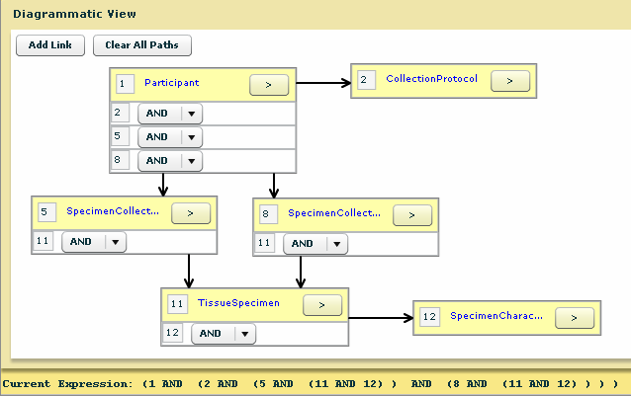

Figure : Diagrammatic Representation of Sample 1 Participant Query

### Sample 2 Participant Query

Find all cases of males over 60 years of age where matching prostate tumor tissue and serum is available at the time of surgery, and also where serum is available at time of relapse.

1. For this query, add the classes in the Diagrammatic View with conditions on the attribute as shown in the following table:

|  |  |  |  |  |
| --- | --- | --- | --- | --- |
| No. | Class | Attribute | Operator | Condition |
| 1 | Participant | Birth Date | Less than or Equal to | 09-21-1947 |
| Gender | In | Male Gender |
| 2 | SpecimenCollectionGroup | Clinical Status | In | Operative |
| 3 | TissueSpecimen | Pathological Status | In | Malignant |
| Available |  | True |
| 4 | SpecimenCharacteristics | Tissue Site | In | Prostate Gland |
| 5 | FluidSpecimen | Type | In | Serum |
| Available |  | True |
| 6 | SpecimenCollectionGroup | Clinical Status | In | Relapse, Distant Site |
| 7 | FluidSpecimen | Type | In | Serum |
| Available |  | True |

1. After adding the classes in the Diagrammatic View, connect the following classes:

* Participant to both SCG.
* SpecimenCollectionGroup (with Clinical Status as Operative) to TissueSpecimen and Fluid Specimen.
* SpecimenCollectionGroup (with Clinical Status as Relapse, Distant Site) to the other FluidSpecimen class.
* Tissue Specimen to SpecimenCharacteristics.

1. Click the **Search** button. The result will display all the male participants over 60 years of age having matching prostate tumor tissue and serum at the time of surgery. Also, these participants will have serum at the time of relapse.

The following figure is a diagrammatic representation of the query.

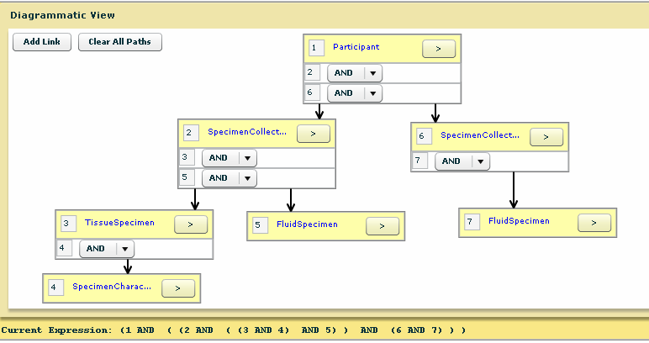

Figure : Diagrammatic Representation of Sample 2 Participant Query

### Sample 3 Participant Query

Find all cases of DCIS in women aged between 40 and 60.

1. For this query, add the classes in the Diagrammatic View with conditions on the attribute as shown in the following table:

|  |  |  |  |  |
| --- | --- | --- | --- | --- |
| No. | Class | Attribute | Operator | Condition |
| 1 | Participant | Birth Date | Between | 09-22-1967 to 09-22-1947 |
| Gender | In | Female Gender |
| 2 | SpecimenCollectionGroup | Clinical Diagnosis | In | Intraductal carcinoma and lobular carcinoma in situ |

1. After adding the classes in the Diagrammatic View, connect the Participant class to SpecimenCollectionGroup class.
2. Click the **Search** button. The result will display all women participants aged between 40 and 60 having DCIS.

The following figure is a diagrammatic representation of the query.

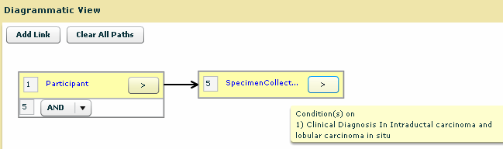

Figure : Diagrammatic Representation of Sample 3 Participant Query

### Sample 4 Participant Query

Find all participants having malignant endometrial tumor and malignant ovarian tumor. The malignant ovary should not have Pathological Status as Metastatic.

1. For this query, add the classes in the Diagrammatic View with conditions on the attribute as shown in the following table:

|  |  |  |  |  |
| --- | --- | --- | --- | --- |
| No. | Class | Attribute | Operator | Condition |
| 1 | Participant | Id |  | Is Not Null |
| 2 | SpecimenCollectionGroup | Id |  | Is Not Null |
| 3 | TissueSpecimen | Pathological Status | In | Malignant |
| 4 | TissueSpecimen | Pathological Status | In | Malignant |
| 5 | TissueSpecimen | Pathological Status | Not In | Metastatic |
| 6 | SpecimenCharacteristics | Tissue Site | In | Endometrium |
| 7 | SpecimenCharacteristics | Tissue Site | In | Ovary |

1. After adding the classes in the Diagrammatic View, connect the following classes:

* Participant to SpecimenCollectionGroup.
* SpecimenCollectionGroup to TissueSpecimen (1 to both).
* SpecimenCharacteristics (with Tissue Site as Ovary) to TissueSpecimen (with Pathological Status In Malignant and Not In Metastatic).
* SpecimenCharacteristics (with Tissue Site as Endometrium) to TissueSpecimen (with Pathological Status in Malignant).

1. Click the **Search** button. The result will display all participants having malignant endometrial tumor and malignant ovarian tumor (primary, not metastatic).

The following figure is a diagrammatic representation of the query.

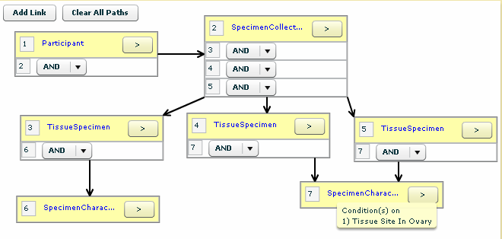

Figure : Diagrammatic Representation of Sample 4 Participant Query

### Sample 5 Participant Query

Find all cases where banked colon tissue and the associated lymph nodes are positive for cancer.

1. For this query, add the classes in the Diagrammatic View with conditions on the attribute as shown in the following table:

|  |  |  |  |  |
| --- | --- | --- | --- | --- |
| No. | Class | Attribute | Operator | Condition |
| 1 | Participant | Id |  | Is Not Null |
| 2 | SpecimenCollectionGroup | Id |  | Is Not Null |
| 3 | TissueSpecimen | Pathological Status | In | Malignant |
| 4 | TissueSpecimen | Pathological Status | In | Malignant |
| 5 | SpecimenCharacteristics | Tissue Site | In | Colon, Nos. |
| 6 | SpecimenCharacteristics | Tissue Site | In | Lymph Node, Nos. |

1. After adding the classes in the Diagrammatic View, connect the following classes:

* Participant to SpecimenCollectionGroup
* Tissue Specimen to SpecimenCharacteristics (1 to 1)
* SpecimenCollectionGroup to TissueSpecimen (1 to both)

1. Click the **Search** button. The result will display all the participants whose banked colon tissue and the associated lymph nodes are cancerous.

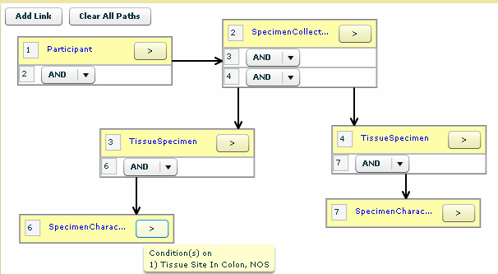

Figure : Diagrammatic Representation of Sample 5 Participant Query

### Sample 6 Participant Query

Find all male participants who have lung cancer for which frozen tumor and matching normal tissues are available.

1. For this query, add the classes in the Diagrammatic View with conditions on the attribute as shown in the following table:

|  |  |  |  |  |
| --- | --- | --- | --- | --- |
| No. | Class | Attribute | Operator | Condition |
| 1 | Participant | Gender | In | Male Gender |
| 2 | SpecimenCollectionGroup | Id |  | Is Not Null |
| 3 | TissueSpecimen | Pathological Status | In | Malignant |
| Type | In | Frozen Tissue |
| 4 | TissueSpecimen | Pathological Status | In | Non Malignant |
| Type | In | Frozen Tissue |
| 5 | SpecimenCharacteristics | Tissue Site | In | Lung, Nos. |
| 6 | SpecimenCharacteristics | Tissue Site | In | Lung, Nos. |

1. After adding the classes in the Diagrammatic View, connect the following classes:

* Participant to SpecimenCollectionGroup.
* SpecimenCollectionGroup to TissueSpecimen (1 to both).
* TissueSpecimen with SpecimenCharacteristics (1 to 1).

1. Click the **Search** button. The result will display all the male participants having lung cancer for which frozen tumor and matching normal tissues are available.

The following figure is a diagrammatic representation of the query.

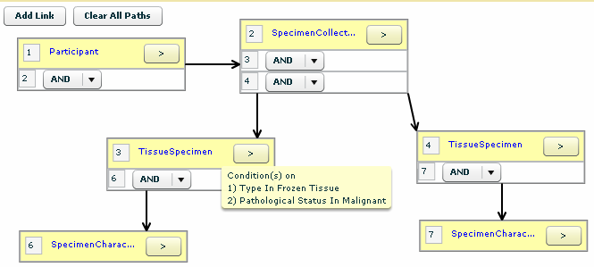

Figure : Diagrammatic Representation of Sample 6 Participant Query

## Queries on Specimen Collection Group (SCG)

### Sample Specimen Collection Group Query

Find all biopsies where the clinical diagnosis is infiltrating duct and lobular carcinoma.

1. For this query, add the classes in the Diagrammatic View with conditions on the attribute as shown in the following table:

| No. | Class | Attribute | Operator | Condition |
| --- | --- | --- | --- | --- |
| 1 | SpecimenCollectionGroup | Clinical Diagnosis | In | Infiltrating duct and lobular carcinoma |
| 2 | CollectionEventParameters | Collection Procedure | In | Needle Core Biopsy |

1. After adding the classes in the Diagrammatic View, connect class SpecimenCollectionGroup to class Collection Event Parameter.
2. Click the **Search** button. The result displays all the SCGs having clinical diagnosis as infiltrating duct and lobular carcinoma and which have the needle core biopsy collection procedure.

The following figure is a diagrammatic representation of the query.

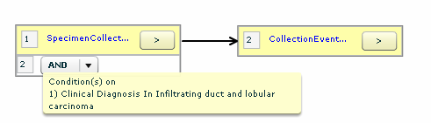

Figure : Diagrammatic Representation for Sample 1 SCG Query

## Queries on Specimens

There are six sample specimen queries in this section.

### Sample 1 Specimen Query

Find all specimens having cryopreserved cells from tumor tissue whose neoplastic cellularity is greater than 50%.

1. For this query, add the classes in the Diagrammatic View with conditions on the attribute as shown in the following table:

|  |  |  |  |  |
| --- | --- | --- | --- | --- |
| No. | Class | Attribute | Operator | Condition |
| 1 | TissueSpecimen | Pathological Status | In | Malignant |
| 2 | CellSpecimen | Id |  | Is Not Null |
| Type | In | Cryopreserved Cells |
| 3 | CellSpecimenReviewParameters | Neoplastic Cellularity Percentage | Greater Than | 50 |

1. After adding the classes in the Diagrammatic View, connect the following classes:

* TissueSpecimen to CellSpecimen.
* CellSpecimen to CellSpecimenReviewParameters.

1. Click the **Search** button. The result will display all the specimens having cryopreserved cells from tumor tissue whose neoplastic cellularity is greater than 50%.

The following figure shows how the diagram will look.

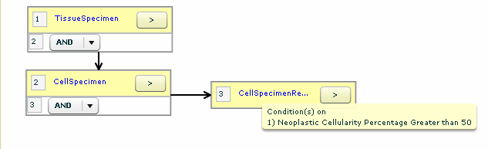

Figure : Diagrammatic Representation for Sample 1 Specimen Query

### Sample 2 Specimen Query

Find all the collected specimens under the Phase III protocol.

1. For this query, add the classes in the Diagrammatic View with conditions on the attribute as shown in the following table:

|  |  |  |  |  |
| --- | --- | --- | --- | --- |
| No. | Class | Attribute | Operator | Condition |
| 1 | CollectionProtocol | Title | Contains | Phase III |
| 2 | SpecimenCollectionGroup | Id |  | Is Not Null |
| 3 | Specimen | Collection Status | Equals | Collected |

1. After adding the classes in the Diagrammatic View, connect the following classes:

* CollectionProtocol to SpecimenCollectionGroup.
* SpecimenCollectionGroup to Specimen.

1. Click the **Search** button. The result displays all the specimens collected under the Phase III protocol.

The following figure shows how the diagram will look.

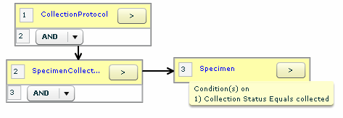

Figure : Diagrammatic Representation for Sample 2 Specimen Query

### Sample 3 Specimen Query

Find all good quality DNA specimens derived from malignant breast tissue.

1. For this query, add the classes in the Diagrammatic View with conditions on the attribute as shown in the following table:

|  |  |  |  |  |
| --- | --- | --- | --- | --- |
| No. | Class | Attribute | Operator | Condition |
| 1 | TissueSpecimen | Collection Status | Equals | Collected |
| Pathological Status | In | Malignant |
| 2 | SpecimenCharacteristics | Tissue Site | In | Breast,NOS |
| 3 | MolecularSpecimen | Type | In | DNA |
| 4. | MolecularSpecimenReviewParameter | Quality Index | Equals | Good |

1. After adding the classes in the Diagrammatic View, connect the following classes:

* TissueSpecimen to SpecimenCharacteristics and MolecularSpecimen.
* MolecularSpecimen to MolecularSpecimenReviewParameter.

1. Click the **Search** button. The result will display all the good quality DNA specimens derived from malignant breast tissue.

The following figure shows how the diagram will look.

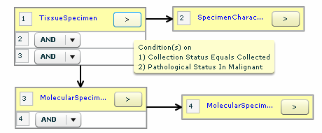

Figure : Diagrammatic Representation for Sample 3

### Sample 4 Specimen Query

Find all the pending specimens under the Phase III protocol. For this query, add the classes in the Diagrammatic View with conditions on the attribute as shown in the following table:

| No. | Class | Attribute | Operator | Condition |
| --- | --- | --- | --- | --- |
| 1 | CollectionProtocol | Title | Contains | Phase III |
| 2 | SpecimenCollectionGroup | Id |  | Is Not Null |
| 3 | Specimen | Collection Status | Equals | Pending |

1. After adding the classes in the Diagrammatic View, connect the following classes:

* CollectionProtocol to SpecimenCollectionGroup.
* SpecimenCollectionGroup to Specimen.

1. Click the **Search** button. The result will display all the pending specimens under the Phase III protocol.

The following figure shows how the diagram will look.

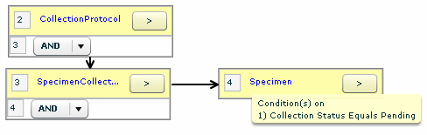

Figure : Diagrammatic Representation Sample 4 Specimen Query

### Sample 5 Specimen Query

Find all the specimens that have been collected in an unacceptable quality.

1. For this query, add the classes in the Diagrammatic View with conditions on the attribute as shown in the following table:

|  |  |  |  |  |
| --- | --- | --- | --- | --- |
| No. | Class | Attribute | Operator | Condition |
| 1 | Specimen | Id |  | Is Not Null |
| 2 | ReceivedEventParameter | Quality | In | Unacceptable, Not Specified |

1. After adding the classes in the Diagrammatic View, connect the Specimen class to RecievedEventParameter class and click the **Search** button. The result displays all the specimens that have been collected in an unacceptable quality.

The following figure shows how the diagram will look.

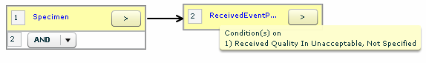

Figure : Diagrammatic Representation Sample 5 Specimen Query

### Sample 6 Specimen Query

Find all tumor tissues with Excellent- Definable Nuclear Detail.

1. For this query, add the classes in the Diagrammatic View with conditions on the attribute as shown in the following table:

|  |  |  |  |  |
| --- | --- | --- | --- | --- |
| No. | Class | Attribute | Operator | Condition |
| 1 | TissueSpecimen | Collection Status | Equals | Collected |
| Pathological Status | In | Malignant |
| 2 | TissueSpecimenReviewEventParameter | Quality | In | Excellent- Definable Nuclear Detail |

1. After adding the classes in the Diagrammatic View, connect the class TissueSpecimenReviewEventParameter to Tissue Specimen and click the **Search** button. The result will display all the tumor tissues with Excellent- Definable Nuclear Detail.

The following figure shows how the diagram will look.

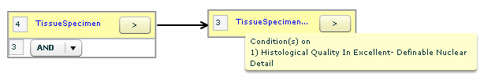

Figure : Diagrammatic Representation Sample 6 Specimen Query

## Outer Join Query

You can create an outer join query using .

Find all specimens that are of the type **RNA**, and along with their available quantity, and (if available) their molecular review event parameters.

1. Add the class in the Diagrammatic View with conditions on the attributes as shown in the following table:

|  |  |  |  |  |
| --- | --- | --- | --- | --- |
| No. | Class | Attribute | Operator | Condition |
| 1 | MolecularSpecimen | Is available | Equals | True |
| Type | In | RNA |

1. Click **Next** to navigate to Define view.

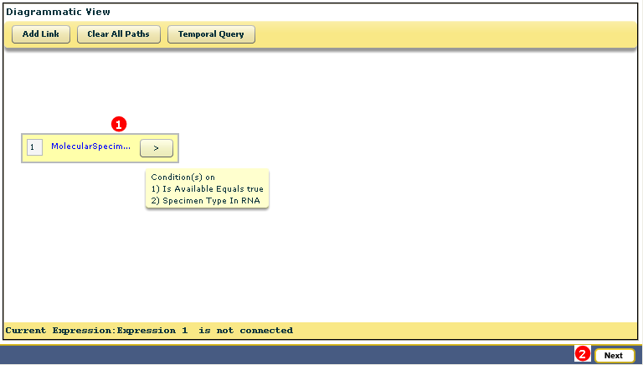

Figure : Adding class in diagrammatic view

1. Add class **Molecular review event parameters**.
2. Connect the two classes and click the **Search** button.

The result displays all the molecular specimens of type RNA and molecular review event parameters (if available).

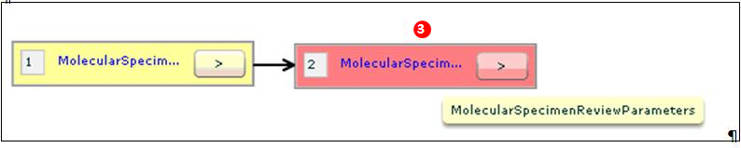

Figure : Diagrammatic Representation for Outer Join Query Sample

## Queries on Orders

There are three sample order queries in this section.

### Sample 1 Order Query

Find all the derivative specimens that need to be created for the placed orders.

1. In the Diagrammatic View, add a class DerivedSpecimenOrderItem with limit: ID Is Not Null. Click the **Search** button. The result will display all the derivative specimens that are present or need to be created for the placed orders.

The following figure shows how the diagram will look.

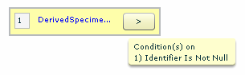

Figure : Diagrammatic Representation Sample 1 Order Query

### Sample 2 Order Query

Find all specimen arrays that are pending for distribution, protocol review, or specimen preparation.

1. For this query, add the classes in the Diagrammatic View with conditions on the attribute as shown in the following table:

|  |  |  |  |  |
| --- | --- | --- | --- | --- |
| No | Class | Attribute | Operator | Condition |
| 1 | OrderDetails | Status | Contains | Pending |
| 2. | ExistingSpecimenArrayOrderItem | Id |  | Is Not Null |

1. After adding the classes in the Diagrammatic View, connect the OrderDetails class to the ExistingSpecimenArrayOrderItem class. Click the **Search** button. The result will display all the specimen arrays which are pending for distribution, protocol review, or specimen preparation.

The following figure shows how the diagram will look.

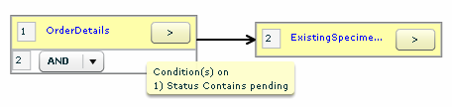

Figure : Diagrammatic Representation Sample 2 Order Query

### Sample 3 Order Query

Find all the orders that are pending for distribution, protocol review, or specimen preparation.

1. In the Diagrammatic View, add a class OrderDetails with limit as ‘status starts with pending’.
2. Click the **Search** button. The result displays all the orders that are pending for distribution, protocol review, or specimen preparation.

The following figure shows how the diagram will look.

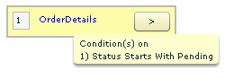

Figure : Diagrammatic Representation Sample 3 Order Query

## Queries on Surgical Pathology Reports (SPRs)

There are two sample Surgical Pathology Report queries.

### Sample 1 SPR Query

Find all reports that have a Concept code of Viral and a Classification of Diagnosis.

1. For this query, add the classes in the Diagrammatic View with conditions on the attribute as shown in the following table:

|  |  |  |  |  |
| --- | --- | --- | --- | --- |
| No | Class | Attribute | Operator | Condition |
| 1 | De-identifiedSurgicalPathologyReport | Identifier |  | Is Not Null |
| 2 | ConceptReferent | Identifier |  | Is Not Null |
| 3 | ConceptReferentClassification | Name | Contains | diagnosis |
| 4 | Concept | Name | Is | viral |

1. After adding the classes in the Diagrammatic View, connect the following classes:

* De-identifiedSurgicalPathologyReport to ConceptReferent.
* ConceptReferent to Concept.
* ConceptReferent to ConceptReferentClassification.

1. Click the **Search** button. The result will display all the reports that have concept as viral and classification as diagnosis.

The following figure shows how the diagram will look.

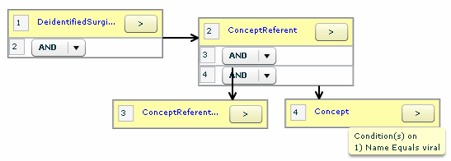

Figure : Diagrammatic Representation Sample 1 SPR Query

### Sample 2 SPR Query

Find all de-identified surgical pathology reports with a particular organ, diagnosis, and procedure concept categories, and having text entry.

1. For this query, add the classes in the Diagrammatic View with conditions on the attribute as shown in the following table:

| No | Class | Attribute | Operator | Condition |
| --- | --- | --- | --- | --- |
| 1 | De-identifiedSurgicalPathologyReport | Identifier |  | Is Not Null |
| 2 | ConceptReferent | Is Negated | Equals | False |
| 3 | TextContent | Identifier |  | <value> |
| 4 | ConceptReferent | Is Negated | Equals | False |
| 5 | ConceptReferent | Is Negated | Equals | False |
| 6 | Concept | Name | Contains | <value> |
| 7 | ConceptReferentClassification | Name | Contains | Organ |
| 8 | Concept | Name | Contains | <value> |
| 9 | ConceptReferentClassification | Name | Contains | diagnosis |
| 10 | Concept | Name | Contains | <value> |
| 11 | ConceptReferentClassification | Name | Contains | procedure |

**Note:** You can parameterize attributes in the above table with a condition of <value>.

1. After adding the classes in the Diagrammatic View, connect the following classes:

* De-identifiedSurgicalPathologyReport to each of the ConceptReferent.
* De-identifiedSurgicalPathologyReport to TextContent.
* Each of the ConceptReferent class to one Concept class and one ConceptReferentClassification class.

The following figure shows how the diagram will look.

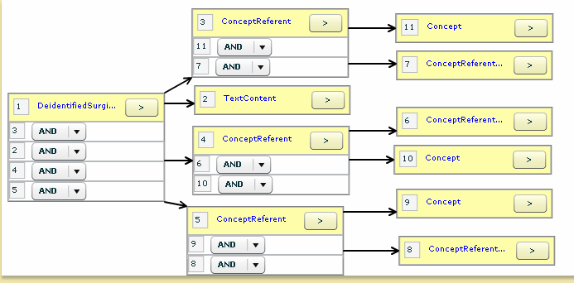

Figure : Diagrammatic Representation Sample 2 SPR Query

1. Save this query and parameterize the values as shown below:

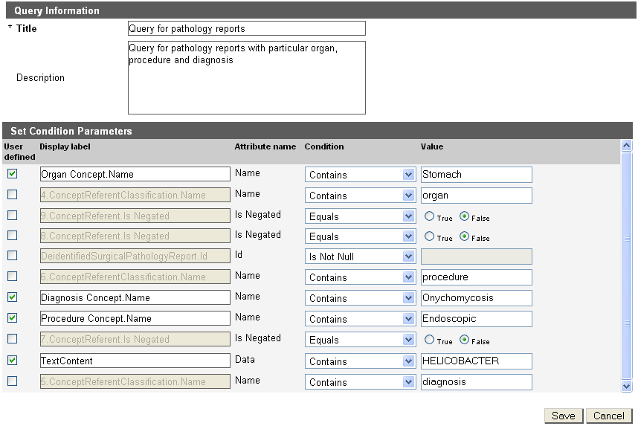

1. Click the **Save** button. You can execute the saved query by specifying values for parameterized conditions. The result displays the de-identified surgical pathology reports with particular organ, diagnosis, and procedure concept categories.

## Queries on Annotations

There are two sample annotation queries in this section.

### Sample 1 Annotation Query

Find all the patients who have a smoking history of 3 or more packs per day.

**Note:** For this query the smoking history annotation is required, since the packs per day attribute is available under the Smoking Health Annotation.

1. For this query, add the classes in the Diagrammatic View with conditions on the attribute as shown in the following table:

|  |  |  |  |  |
| --- | --- | --- | --- | --- |
| No | Class | Attribute | Operator | Condition |
| 2 | Smoking Health Annotation | Packs per day | Greater than or Equal to | 3 |

1. After adding the classes in the Diagrammatic View, connect the Participant node to Smoking Health Annotation node. Click the **Search** button. The result will display all the participants who have a smoking history of 3 or more packs per day.

The following figure shows how the diagram will look.

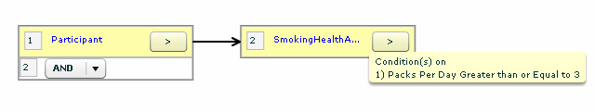

Figure : Diagrammatic Representation Sample 1 Annotation Query

### Sample 2 Annotation Query

Find all Specimen Collection Groups under which fresh breast tissue specimens have been collected which show Microcalcification in invasive carcinoma. Also Lymph node sampling has been done for the Sentinel Lymph Nodes only.

**Note:** For this query the breast pathology annotation is required, since the pathological data is available under the “Breast Pathology Annotation.”

1. For this query, add the classes in the Diagrammatic View with conditions on the attribute as shown in the following table:

| No | Class | Attribute | Operator | Condition |
| --- | --- | --- | --- | --- |
| 1 | SpecimenCollectionGroup | Id |  | Is Not Null |
| 2 | Specimen | Type | In | Fresh Tissue |
| 3 | SpecimenCharacteristics | Tissue Site | In | Breast NOS |
| 4 | BreastPathologyAnnotation | Lymph Node Sampling | In | Sentinel lymph node(s) only |
| 5 | Microcalcification | Value | In | Present in invasive carcinoma |

1. After adding the classes in the Diagrammatic View, connect the following classes:

* SpecimenCollectionGroup to Specimen.
* Specimen to SpecimenCharacteristics.
* SpecimenCollectionGroup to BreastPathologyAnnotation.
* BreastPathologyAnnotation to Microcalcification.

1. Click the **Search** button. The result displays all the specimen collection groups under which fresh breast tissue specimens have been collected, and which shows Microcalcification in invasive carcinoma. Also Lymph node sampling has been done for the Sentinel Lymph Nodes only.

The following figure shows how the diagram will look.

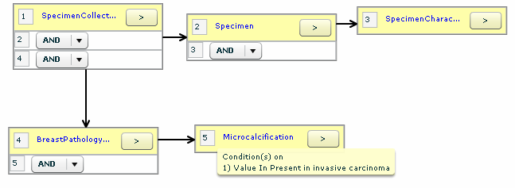

Figure : Diagrammatic Representation Sample 2 Annotation Query

## Temporal Queries

This section explains how to create temporal queries. There are eleven sample temporal queries in this section.

### Sample 1 Temporal Query

Find patients younger than three years at the time they were registered to the collection protocol.

1. In the Diagrammatic View (DAG view,) add the objects and define the conditions on the following attributes.

|  |  |  |  |  |
| --- | --- | --- | --- | --- |
| No. | Class | Attribute | Operator | Condition |
| 1 | Participant | Id | NA | Is Not Null |
| 2 | Collection Protocol Registration | Registration Date | NA | Is Not Null |

1. Connect Collection Protocol Registration to Participant.
2. Select the Collection Protocol Registration object, and then the Participant object.
3. Click **Temporal Query**.
4. Select the temporal conditions.
5. Enter **Age** at Registration in the custom column name.

The following figure outlines the defined query:

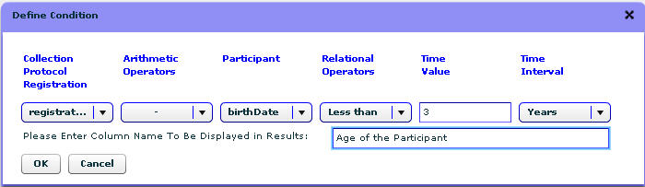

Figure : Defined Temporal Query for Sample 1

1. Click **OK**. The DAG view opens.

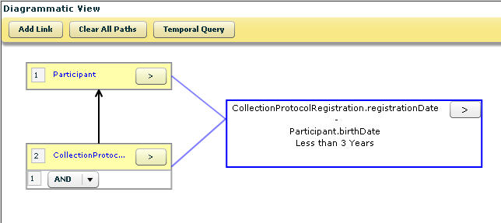

Figure : Diagrammatic Representation of Sample 1 Temporal Query

1. Click **Search** to execute the query.

The search result displays all the participants who were less than three years at diagnosis (or specimen collection).

### Sample 2 Temporal Query

Find out the age of the participants as of today. This is an example where a user can perform a temporal query on a single object. A user can find out the age of all the participants at present date.

1. In the DAG view, add the Participant object and define the following condition.

|  |  |  |  |  |
| --- | --- | --- | --- | --- |
| No. | Class | Attribute | Operator | Condition |
| 1 | Participant | Birth Date | NA | Is Not Null |

1. Select the Participant object.
2. Click **Temporal Query**.
3. Select the temporal condition:
4. Select the current date from the date picker. Select the **-** operator from the Arithmetic Operator drop-down list. Select **Greater than** from the Relational Operators drop-down list. Enter **0** in the Time Value field and then select **Years** from the Time Interval drop-down list.
5. Enter **Age of the Participant** as the custom column name.

The following figure outlines the defined query:

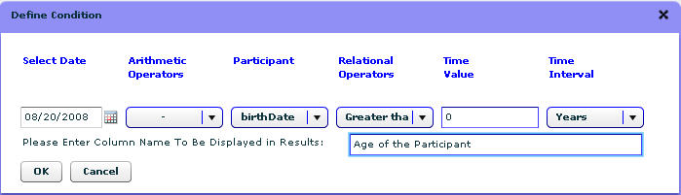

Figure : Defined Temporal Query Sample 2

1. Click **OK**. The DAG view opens.

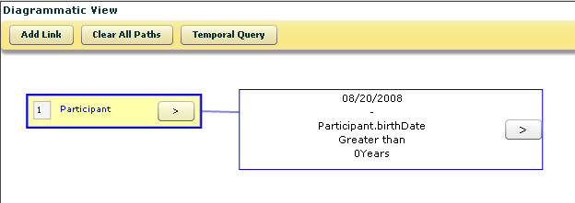

Figure : Diagrammatic Representation Sample 2 Temporal

1. Click **Search** to execute the query.

The search result displays the current age of the participants.

### Sample 3 Temporal Query

Find all the specimens that are to be collected on a given date.

1. In the DAG view, add the objects and define the conditions on the following attributes.

| No. | Class | Attribute | Operator | Condition |
| --- | --- | --- | --- | --- |
| 1 | Specimen | Id | NA | Is Not Null |
| 2 | Specimen Collection Group | Id | NA | Is Not Null |
| 3 | Collection Protocol Registration | Id | NA | Is Not Null |
| 4 | Collection Protocol | Id | NA | Is Not Null |
| 5 | Collection Protocol Event | Id | NA | Is Not Null |

1. Connect the following objects:

* Specimen to Specimen Collection Group
* Specimen Collection Group to Collection Protocol Registration
* Specimen Collection Group to Collection Protocol Event
* Collection Protocol Registration to Collection Protocol
* Collection Protocol to Collection Protocol Event.

1. Select the Collection Protocol Event object followed by the Collection Protocol Registration object.
2. Click **Temporal Query**.
3. Select the temporal conditions.

As this query is adding a time interval (the CollectionProtocolEvent.studyCalendarEventPoint) to a date (the collection protocol registration date), the calculated value that results is a date.

The query compares that data result with the given date.

1. Enter **Date of Collection** as the custom column name.

The following figure outlines the defined query, specifying 8/22/2008 as the date:

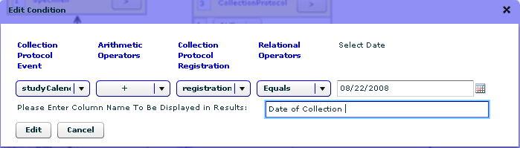

Figure : Defined Temporal Query Sample 3

1. Click **OK**. The DAG view opens.



Figure : Diagrammatic Representation Sample 3 Temporal Query

1. Click **Search** to execute the query.

The search result displays all the specimens that are to be collected on a given date.

### Sample 4 Temporal Query

Find all the biospecimens that were fixed within 30 minutes of collection.

1. In the DAG view, add the objects and define the conditions on the following attributes:

| No. | Class | Attribute | Operator | Condition |
| --- | --- | --- | --- | --- |
| 1 | Specimen | Id | NA | Is Not Null |
| 2 | Fixed Event Parameters | Id | NA | Is Not Null |
| 3 | Collection Event Parameters | Id | NA | Is Not Null |

1. Connect the following objects:

* Specimen to Fixed Event Parameters
* Specimen to Collection Event Parameters

1. Select the Fixed Event Parameters object followed by Collection Event Parameters object.
2. Click **Temporal Query**.
3. Select the temporal conditions.
4. Enter **Time Interval between collection and fixing event** as the custom column name.

The following figure outlines the defined query:

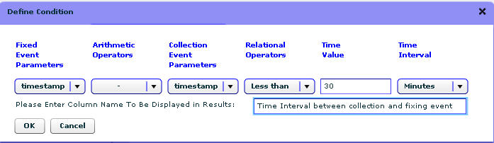

Figure : Defined Temporal Query Sample 4

1. Click **OK**. The DAG view opens.

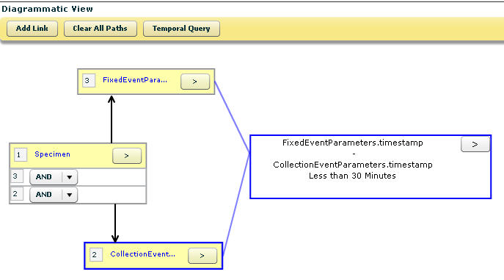

Figure : Diagrammatic Representation Sample 4

1. Click **Search** to execute the query.

The search result displays all the specimens which were fixed in less than 30 minutes of collection.

### Sample 5 Temporal Query

List all the biospecimens frozen within five minutes of collection in 2007.

1. In the DAG view, add the objects and define the conditions on the following attributes:

| No. | Class | Attribute | Operator | Condition |
| --- | --- | --- | --- | --- |
| 1 | Specimen | Id | NA | Is Not Null |
| Activity Status | NA | Is Not Null |
| Collection Status | Contains | Collected |
| Created on | Between | 01-01-2007 to  31-12-2007 |
| 2 | Collection Event Parameters | Id | NA | Is Not Null |
| Timestamp | Between | 01-01-2007 to  31-12-2007 |
| 3 | Frozen Event Parameters | Id | NA | Is Not Null |
| Timestamp | Between | 01-01-2007 to  31-12-2007 |

1. Connect the following objects:

* Specimen to Collection Event Parameters
* Specimen to Frozen Event Parameters

1. Select the Frozen Event Parameters object followed by the Collection Event Parameters object.
2. Click **Temporal Query**.
3. Select the temporal conditions.
4. Enter **Time Interval** as the Custom Column Name.

The following figure outlines the defined query:

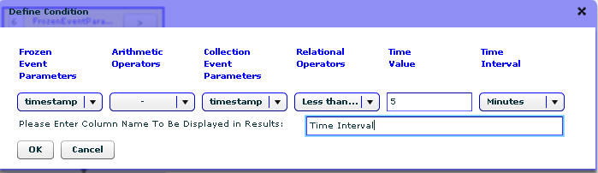

Figure : Defined Temporal Query Sample 5

1. Click **OK**. The DAG view opens.

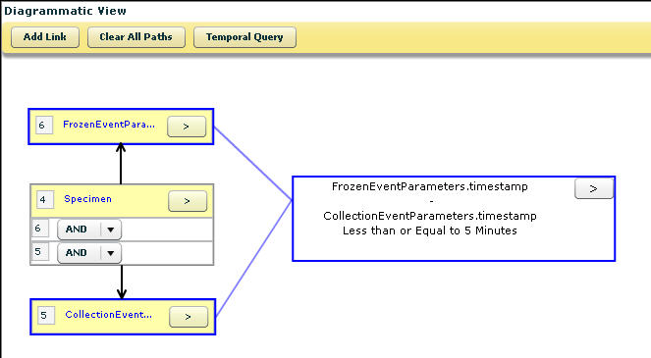

Figure : Diagrammatic Representation Sample 5 temporal query

1. Click **Search** to execute the query.

The search result displays al the biospecimens frozen within five minutes of collection in the year 2007.

### Sample 6 Temporal Query

Find all the biospecimens collected more than a year after end of therapy.

1. In the DAG view, add the objects and define the conditions on the following attributes:

|  |  |  |  |  |
| --- | --- | --- | --- | --- |
| No. | Class | Attribute | Operator | Condition |
| 1 | Participant | Id | NA | Is Not Null |
| 2 | Specimen Collection Group | Id | NA | Is Not Null |
| Clinical Status | Contains | Pre-therapy/ Pre-operative |
| 3 | Collection Event Parameter | Id | NA | Is Not Null |
|  | Created on | NA | Is Not Null |
| 4 | Specimen Collection Group | Id | NA | Is Not Null |
|  | Clinical Status | Contains | Post-therapy/ Post-operative |
|  | Collection Event Parameter | Id | NA | Is Not Null |
|  | Created on | NA | Is Not Null |

1. Connect the following objects:

* Participant to Specimen Collection Group (pre-therapy)
* Specimen Collection Group to Collection Event Parameter
* Participant to Specimen Collection Group (post-therapy)
* Specimen Collection Group to Collection Event Parameter

1. Select the Collection Event Parameter (pre-therapy) object followed by the Collection Event Parameter (post-therapy) object.
2. Click **Temporal Query**.
3. Select the temporal condition.

In this case, select **timestamp** from the Collection Event Parameters drop-down list. Select **-** from the Arithmetic Operator drop-down list and then select **Greater than** from the Relational Operators drop-down list. Enter **1** in the Time Value drop-down list and then select **Years** from Time Interval drop-down list.

1. Enter **Time Interval** as the custom column name.

The following figure outlines the defined query:

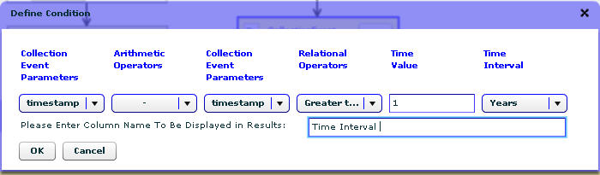

Figure : Defined Temporal Query Sample 6

1. Click **OK**. The DAG view opens.

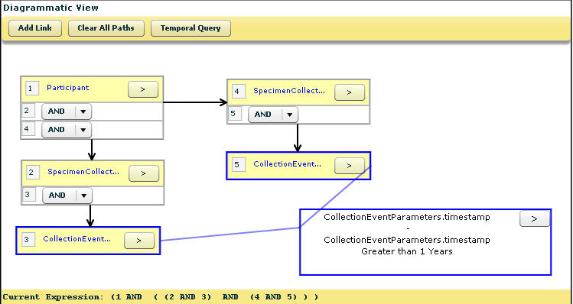

Figure : Diagrammatic Representation Sample 6

1. Click **Search** to execute the query.

The search result displays the all the biospecimens collected more than a year after end of therapy.

### Sample 7 Temporal Query

Find all the biospecimens distributed within 40 days from the date of creation.

1. In the DAG view, add the objects and define the conditions on the following attributes:

|  |  |  |  |  |
| --- | --- | --- | --- | --- |
| No. | Class | Attribute | Operator | Condition |
| 1 | Distribution | Id | NA | Is Not Null |

1. Select the Distribution object.
2. Click **Temporal Query**.
3. Select the temporal condition.
4. Select the date from date picker. Select - from the Arithmetic Operator drop-down list. Select Less than or Equal to from the Relational Operator drop-down list. Enter 40 in Time Value field. Select Days from the Time Interval drop-down list.
5. Enter Distribution Date as the custom column name.

The following figure outlines the defined query:

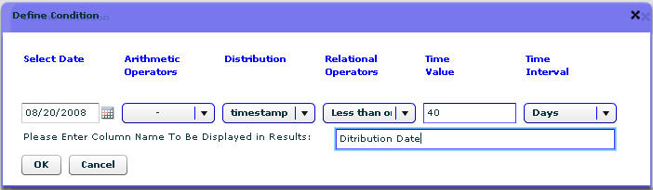

Figure : Defined Temporal Query Sample 7

1. Click **OK**. The DAG view opens.

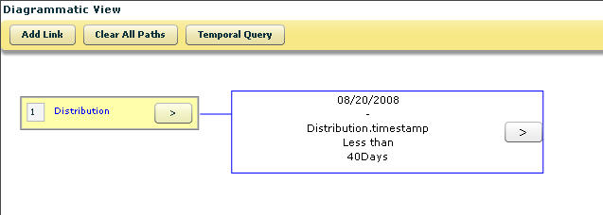

Figure : Diagrammatic Representation Sample 7

1. Click **Search** to execute the query.

The search result displays all the biospecimens distributed within 40 days from the date of creation.

### Sample 8 Temporal Query

Collect all the biospecimens from a Specimen Collection Group with a Study Calendar Event Point of around 45 days.

1. In the DAG view, add the objects and define the conditions on the following attributes:

|  |  |  |  |  |
| --- | --- | --- | --- | --- |
| No. | Class | Attribute | Operator | Condition |
| 1 | Collection Protocol Event | Study Calendar Event Point | Equals | 45 |
| Id | I | Is Not Null |
| 2 | Collection Protocol | Id | NA | Is Not Null |
| 3 | Specimen Collection Group | Clinical Status | Contains | Post-therapy |
| Id | NA | Is Not Null |
| 4 | Specimen | Id | NA | Is Not Null |

1. Connect the following objects:

* Collection Protocol Event to Collection Protocol
* Collection Protocol to Specimen Collection Group
* Specimen Collection Group to Specimen

1. Select the Collection Protocol Event object followed by the Specimen object.
2. Click **Temporal Query**.
3. Enter **Label of the Specimen** as the custom column name.

The following figure outlines the defined query:

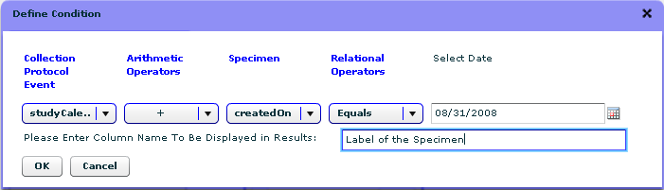

Figure : Defined Temporal Query for Sample 8

1. Click **OK**. The DAG view opens.

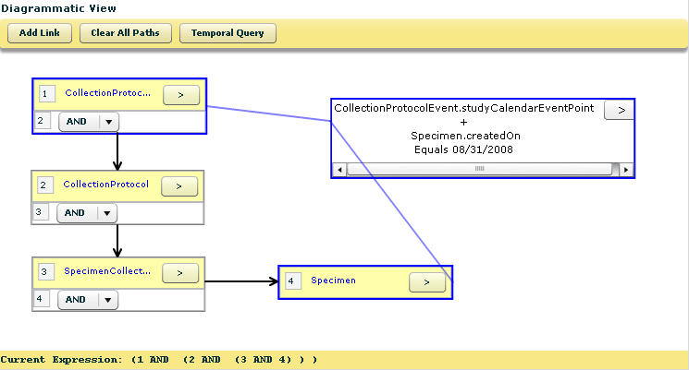

Figure : Diagrammatic Representation for Sample 8

1. Click **Search** to execute the query.

The search result displays all the biospecimens from a Specimen Collection Group with a Study Calendar Event Point of around 45 days.

### Sample 9 Temporal Query

Find male participants suffering from prostate tumor whose biospecimen samples were tested around two weeks after recording the PSA value.

1. In the DAG view, add the objects and define the conditions on the following attributes:

|  |  |  |  |  |
| --- | --- | --- | --- | --- |
| No. | Class | Attribute | Operator | Condition |
| 1 | Participant | Activity Status | Contains | Active |
| Gender | In | Male Gender |
| 2 | Specimen | Collection Status | Contains | Collected |
| Pathological Status | In | Malignant |
| 3 | Specimen Collection Group | Collection Status | Contains | Collected |
| 4 | Collection Event Parameters | Id | NA | Is Not Null |
| Timestamp | NA | Is Not Null |
| 5 | Specimen Characteristics | Tissue Site | NA | Prostate Gland |
| 6 | Lab Annotation | Other Lab Test Name | Contains | Blood PSA Test |
| Result Units | Contains | 10 ng/ml |

1. Connect the following objects:

* Participant to Specimen Collection Group
* Participant to Lab Annotation
* Specimen Collection Group to Specimen
* Specimen to Specimen Characteristics
* Specimen to Collection Event Parameters

1. Select the Collection Event Parameters object followed by the Lab annotation object.
2. Click **Temporal Query**.
3. Select the temporal condition.
4. Enter **Date of Procurement** as the custom column name.

The following figure outlines the defined query:

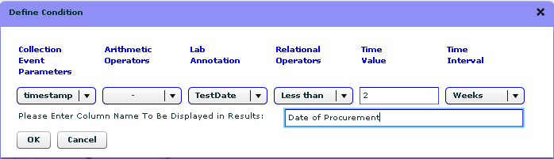

Figure : Defined Temporal Query Sample 9

1. Click **OK**. The DAG view opens.

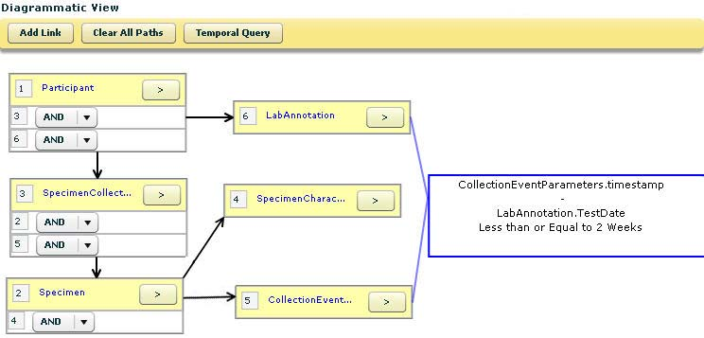

Figure : Diagrammatic Representation Sample 9

1. Click **Search** to execute the query.

The search result displays the male participants suffering from prostate tumor whose biospecimen samples were tested around two weeks after recording the PSA value.

### Sample 10 Temporal Query

Find all the female participants suffering from breast cancer who are being treated with Anastrazole, and whose dosage has increased from 0.5 mg to 2 mg/day in the last six months.

1. In the DAG view, add the objects and define the conditions on the following attributes:

| No. | Class | Attribute | Operator | **Condition** |
| --- | --- | --- | --- | --- |
| 1 | Participant | Id | NA | Is Not Null |
| Gender | In | Female |
| 2 | Treatment Annotation | Agent | In | Anastrazole |
| Dosage Unit | NA | Is Not Null |
| 3 | Treatment Annotation | Agent | In | Anastrazole |
| Dosage Unit | NA | Is Not Null |
| 4 | Duration | Start Date | NA | Is Not Null |
| End Date | NA | Is Not Null |
| Id | NA | Is not Null |
| 5 | Duration | Start Date | NA | Is Not Null |
| End Date | NA | Is Not Null |
| Id | NA | Is not Null |

1. Connect the following objects:

* Participant to both Treatment Annotation objects
* Treatment Annotation to one Duration objects
* Treatment Annotation to other Duration objects

1. Select the two Duration objects.
2. Click **Temporal Query** to define the first temporal condition.
3. Select the temporal conditions.
4. Enter **Time between Two Treatments** as the custom column name.

The following figure outlines the defined query:

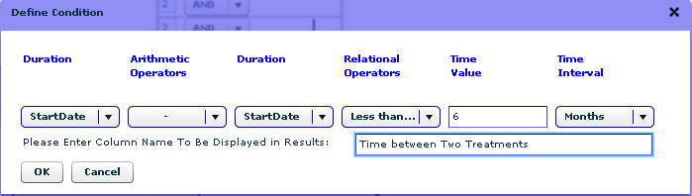

Figure : Defined Temporal Query 1 Sample 10

1. Click **OK**. The DAG view opens.

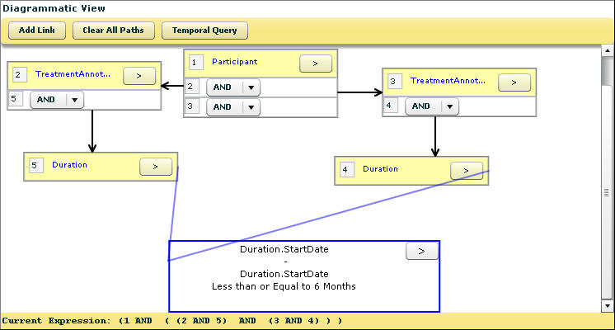

Figure : Diagrammatic Representation of Temporal Query Sample 10

1. Select the two Treatment Annotation objects.
2. Click **Temporal Query** to define the second temporal condition.
3. Enter **Dosage difference in six months** as the custom column name.

The following figure outlines the defined query:

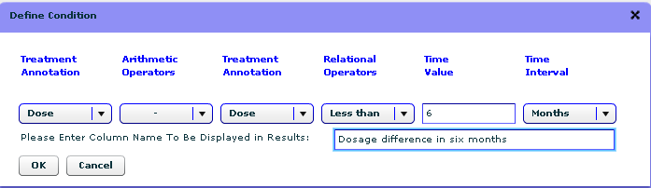

Figure : Defined Temporal Query Sample 10

Click **OK** to see the Diagrammatic View. Find all the female participants suffering from breast cancer who are being treated with Anastrazole, and whose dosage has increased from 0.5 mg to 2 mg/day in the last six months.

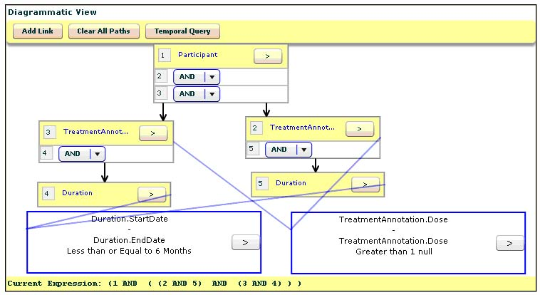

Figure : Diagrammatic Representation of Temporal Sample 10

1. Click **Search** to execute the query.

The search result displays female participants suffering from breast cancer who are being treated with Anastrazole, and whose dosage has increased from 0.5 mg to 2 mg/day in the last six months.

1. Error Messages

This section outlines the common error messages you may encounter while using the . The error messages in this appendix are categorized as:

* Administrative Data Tab Errors
* Biospecimen Data Tab Errors

## Administrative Data Tab Errors

This section outlines the common errors found on the Administrative Data tab.

| Error Message | Why does it occur? | How to resolve? |
| --- | --- | --- |
| Incorrect E-mail Address or Password | Wrong e-mail address or password is entered in the provided field on the home page of the application. | Enter the correct e-mail address and password. |
| New password must include at least one upper case letter, one lower case letter and a number. The password cannot contain spaces. | The new password does not fulfill the specified password requirements. | Add the password as per the specified requirements. |
| At least one event is required to create Collection Protocol | Not a single specimen event is added to the Collection Protocol. | Add a Specimen Event to save the Collection Protocol. |
| Please enter valid values* | An incorrect value is added. For example: In the Temperature field you are required to enter a numeric value. If you add a string value, an error message opens. | Enter the correct alphabetical, numerical, or alphanumerical value. |
| Field Name# is required | A value is not entered in the mentioned field. | Enter a value in the mentioned field. |

* For example: alphabetical, numerical, or alphanumerical value

# For example: Site name, Specimen type, class, and so on.

## Biospecimen Data Tab Errors

This following table outlines the common errors found on the Biospecimen Data tab.

| Error Message | Why does it occur? | How to resolve? |
| --- | --- | --- |
| Duplicate collection protocol selected | A participant is registered twice to the same protocol. | There is no need to register the same participant to the same collection protocol one more time. |
| Either Site or Medical Record Number is missing in Medical Identifier | Source or Medical Record Number under the Medical Identifiers on Participant page is not added. | Add both the Source and Medical Record Number under the Medical Identifiers field. |
| Submission failed since a Collection Protocol Registration with the same COLLECTION_PROTOCOL_ID, PROTOCOL_PARTICIPANT_ID already exists. | A new participant is registered with the PPI same as that of an already existing participant under the same collection protocol. | The combination of PPI and CP should be unique. No two participants registered under a CP can have the same PPI. Enter a different PPI for the other participant to avoid this error. |
| Submit was not successful because some matching participants found. | Participant details are entered that are similar to an existing participant. | Ignore matches to create new participant or add more details and perform another lookup once. For more information, refer to the paragraph on participant duplicate check under **Error! Reference source not found.**. |

|  |  |  |
| --- | --- | --- |
| Collection Site is invalid | An incorrect site name is entered or the Collection Site field is left blank on the SCG page | Select the required site from the Collection Site drop down or enter the correct site name. |
| Number of Specimens should be greater than zero | The Number of Specimen(s) is entered as zero on the edit SCG page and the Add Multiple Specimens button is clicked. | Enter a number greater than zero to add multiple specimen(s). |
| Please enter valid Aliquot Count | An invalid value is entered during the creation of aliquots or the Aliquot Count field is left blank. | Enter a valid aliquot count to create aliquots. |
| Cannot perform operation :Specimen not available | An action is performed on a specimen that is unavailable. The Is Available check box is not selected. | If the specimen is available, check the Is Available check box and then perform an action on the specimen. |
| Unable to disable Specimen Collection Group: Before disabling it, dispose all the associated Specimens. | When you try to disable a SCG that has specimens under it. | Disable all the specimens under the SCG and then disable the SCG. |
| Available Quantity cannot be greater than Initial Quantity | The Available Quantity entered is more than the initial quantity on the Specimen Details page. | Both quantities should be same or the available quantity should be less if the specimen is previously used. |
| Cannot disable specimen. Specimen contains sub-specimen. | When you try to disable a parent specimen that has child specimens (aliquots or derivatives). | Disable the child specimens first and then the parent specimen. |
| System cannot distribute available quantity among the aliquots due to insufficient amount. | The aliquot quantity entered is more than the parent specimen’s available quantity. | The sum of quantity per aliquot for each aliquot should be less than or equal to the available quantity of parent specimen. |
| Please add compatible specimens to specimen array (belong to same specimen class & specimen types of Array). | Specimen of class and type are added that are different from the specimen array type. For example: adding cryopreserved cells to a DNA array. | Add specimens of the same class and type as that of the specimen array type. |
| Please verify Consents for Specimen(s) | Order View >> Order Details page:  The consent responses before distributing the specimen(s) are not verified. | Select the View link under Consent for Specimen. The Consent Form page opens. Verify the consents by selecting the check box and then click the Done button. |

### Search Tab Error Messages

| Error Message | | Why does it occur? | | How to resolve? |
| --- | --- | --- | --- | --- |
| Please enter at least one condition to add a limit to limit set. | The Add Limits button is clicked without entering conditions on the attributes. | | Add at least one condition and then click the Add Limits button to add the object in the DAG view. | |
| Expression graph should be a connected graph. | Two or more classes in the DAG view are not connected and the Search button is clicked. | | Connect all the classes before performing search. | |
| List is empty | No items are added to My List. | | Add items to My List before performing bulk operations or ordering. | |
| Cannot add in to List as view of List is different. | Items are added to My List when My List contains items that have a different view. For example: adding specimens to My List when My List already contains specimen arrays. | | Delete the existing items in My List and add new items. You can also define a view of the items on the advanced query results page to match the view of the existing items in My List. | |

1. Glossary

| Term | Definition |
| --- | --- |
| Administrative Data | One of the three different data types in which caTissue Core data can be categorized. Collection protocol, Distribution protocol, Biohazards, Site, Storage container, User, Department, Institution, Cancer Research Group. |
| Administrator | The Administrator registers new users, sites, containers, and collection and distribution protocols into . |
| Aggregate data | Data collected and reported. |
| Aliquot | Pertaining to a portion of the whole; any one of two or more samples of something, of the same volume or weight. |
| API | Application Programming Interface. |
| Array | An orderly arrangement of biospecimens. |
| Biohazards | An attribute of a Specimen that renders it potentially harmful to a User. |
| Cancer Research Group | A collection of Scientist or clinician users with a common research objective related to biospecimen collection and utilization. |
| Cardinality | Cardinality describes the minimum and maximum number of associated objects within a set. |
| Cell Specimens | A biospecimen composed of purified single cells not in the context of a tissue or other biospecimen fluid. These are discrete in nature and so will always be measured in cell count in . |
| Check-in/Check-out Event | Event that refers to temporary movement of specimens from stored location. |
| Clinical Report | A clinical report associated with the participant at the time of specimen collection event (also referred to as Clinical Annotation). |
| Collection Event | Event that refers to collection of a specimen from participant under a collection protocol. |
| Collection Protocol | A set of written procedures that describe how a biospecimen is collected. |
| Collection Protocol Registration | A registration of a Participant to a Collection Protocol. |
| De-identified data | De-identified information excludes all patient-identifiable information but can include biospecimen identifiers. |
| Department | A department to which a User belongs. |
| Derivative |  |
| Disposal Event | Event that refers disposing/rejecting a specimen. |
| Distribution | The act of distributing or spreading or apportioning. |
| Distribution Protocol | An abbreviated set of written procedures that describe what, how many, and how much of a biospecimen or biospecimens will be utilized for research. Biospecimens may be collected under one collection protocol and then later utilized by single or multiple studies. |
| Embedded Event | Event that refers to embedding a specimen in paraffin or plastic material. |
| Fixed Event | Event that refers to fixing a specimen. |
| Fluid Specimens | A single unit of bodily fluid that is collected from a participant or created from another specimen. These are fluid in nature and so will always be measured µl (microliter) in . |
| Frozen Event | Event that refers freezing a specimen at certain temperature. |
| HIPPA | Health Insurance Portability and Accountability Act. |
| Identified Distribution | Identified information can be disclosed to the receiver of the biospecimens. This type of distribution can be done only if the receiver of the biospecimens is a PI or coordinator of the collection protocol under which the biospecimen is collected. |
| Institution | An institution to which a user belongs. |
| Hook Entity | It is a static class in to which the dynamically created annotation form is linked. A hook entity can be Participant, Specimen Collection Group, or Specimen. |
| Molecular Specimen | A molecular derivative (that is RNA or DNA or PROTEIN) created from a specimen. This is also known as sample. These can be fluid in nature but it will always be measured in micrograms, and concentration of molecular specimen will determine its volume. |
| Participant | An individual from which a biospecimen is collected. |
| Participant data | One of the three different data types in which caTissue Core data can be categorized. Participant, Participant’s medical identifiers, Collection protocol registration, Specimen collection group, Clinical report. |
| Participant Medical Identifier | A medical record identification number that refers to a Participant. |
| Procedure Event | Event that refers customized procedure that is applied on a specimen to process it. |
| Received Event | Event that refers to receiving a specimen in the tissue bank. |
| Review Event | Event that refers to performing quality assurance actions on a specimen. |
| Scientist | A Scientist performs a query and adds specimens, pathology cases or arrays of interest to My List. |
| Site | A physical location involved in biospecimen collection, storage, processing, or utilization. |
| Specimen | A single unit of tissue or body fluid collected from a participant as part of a specimen collection event. A new specimen can be created as a derivative of an existing specimen or by dividing it into small pieces. |
| Specimen Collection Group | An event that results in the collection of one or more biospecimens from a participant. |
| Specimen Distribution | An event that results in transfer of a specimen from a Repository to a Laboratory |
| Specimen Events | Specimen events are actions that can be performed on specimen in a tissue bank. For example: collected, received, frozen, fixed, reviewed, and so on. |
| Specimen External Identifier | A pre-existing, externally defined identifier associated with a specimen. |
| Spun Event | Event that refers to spinning the specimen. |
| Surgical Pathology Report | Detailed findings based on surgical accession and examination of biospecimens. |
| Technician |  |
| Thaw Event | Event that refers defrosting a specimen. |
| Tissue Specimens | A single unit of tissue that is collected from a Participant or created from another specimen. These are solid in nature and so will always be measured in grams in . |
| Transfer Event | Event that refers to moving specimen from one storage location to another storage location. |

Index

A

Add Permissible Value, 69

adding

biohazard, 36

Cancer Research Group (CRG), 20

department, 19

events, 123

institute, 18

site, 27

specimen array, 125

specimen array aliquot, 126

specimen array type, 37

storage container, 32

storage type, 30

Administrative Data, 10

options, 14

pre-requisites for, 17

Advanced option, 15, 184

narrowing the search, 186

advanced search, 184

Alcohol Health Annotation, 219

aliquot

aliquoting a biospecimen, 115

defined, 115

Aliquot Creation Summary page, 116

AND OR operators

searching with, 208

annotation queries, 293

anticipated dates

offsetting or shifting of, 103

anticipated specimens

defined, 104

setting up, 105

approving

a user, 23

arm

editing a participant registration, 130

registering a participant manually, 102

Array Distribution Reports

displaying, 149

Array Report option

displaying, 149

attributes

adding to form, 64

editing, 82

searching for, 207

B

barcodes

searching for, 207

Base Hematology Tissue Pathology Annotation, 225

Base Solid Tissue Pathology Annotation, 223

biohazard

adding, 36

editing, 36

Biohazard option, 14

Biorepository Summary Page (BSP)

accessing, 137

Biospecimen Data

options, 14

biospecimens

adding event to, 119

aliquoting, 115

creating derivatives, 116

editing, 129

ordering from My List, 152

ordering workflow, 150

blue bar, 11

Breast Pathology Annotation, 252

Breast Specimen Pathology Annotation, 272

Build Form Page, 82

building

form, 71

bulk data

from spreadsheet for dynamic extensions, 85

Bulk Operations option, 209

C

Cancer Research Group (CRG)

adding, 20

defined, 20

editing, 20

Category Highlighter, 135

caTIES, 5

caTissue Clinical Annotation Engine, 6

caTissue Core. *See*

caTissue Suite

background, 5

becoming a user, 10

demo, requesting and accessing, 6

help, 15

installing locally, 7

logging in, 11

migration from 1.0 to 1.1, 9

overview, 5

related documentation, 2

searching, 15

user roles, 10

workflow, 12

workflow graphic, 13

Check Box attribute type

attributes, 66

Chemo RX Annotation, 217

Clinical Annotations (CA)

adding clinical and pathological data, 143

assigning to a Collection Protocol, 141

clinical and health information, 140

defined, 139

pathology information, 139

querying, 145

workflow, 141

CNS Pathology Annotation, 250

CNS Specimen Pathology Annotation, 269

collected events, 110

Collection Protocol

adding basic information, 43

defined, 41

editing, 57

editing conditions, 79

planned definition, 41

setting up longitudinal, 54

*setting up planned*, 42

setting up unplanned, 53

unplanned definition, 41

Collection Protocol (CP

assigning Clinical Annotatios, 141

Collection Protocol (CP)

Based View, 96

selecting, 96

Collection Protocol (CP) Based View

navigating to, 97

Collection Protocol option, 14

Collection Site, 28, 30

Colorectal Specimen Pathology Annotation, 265

Compare Identified De-identified Reports, 135

Conflicting SPRs, 136

Conflicting SPRs option, 14

connecting

limits, 189

consent tiers, 87

consent tracking

setting up, 88

Consents tab, 90

Contact Us, 11

Container Restrictions, 29

CP based data entry, 104

CRG, see Cancer Research Group, 20

Custom, 10

D

Dashboard

fields, 171

Date Picker attribute type, 69

attributes, 69

Default view, 183, 193

Define Condition page, 202

fields, 202

Define Results View page, 190

reviewing the results, 191

Defined view, 193

demo

requesting and accessing, 6

department

adding, 19

defined, 19

editing, 19

Department, 10

Department option, 14

derivatives

creating biospecimen, 116

defined, 115

order from an existing specimen, 155

ordering, 154

derive

plasma and serum, 213

RNA and DNA, 214

derived specimens

distributing, 162

Diagrammatic View (DAG), 188

displaying

Specimen Distribution Reports, 149

Distant Recurrence Health Examination Annotation, 222

distributing

orders, 161

parent or derived specimens, 162

Distribution option, 15

Distribution Protocol

defined, 58

selecting, 153

Distribution Protocol option, 14

Distribution Report, 164

DNA

deriving, 214

**drill-down**, 191

dynamic extensions

copying data from spreadsheeting (bulk), 85

creating, 61

E

Edit Box attribute type

attributes, 65

editing

attributes, 82

biohazard, 36

biospecimen, 129

Cancer Research Group (CRG), 20

Collection Protocol, 57

conditions in Collection Protocol, 79

department, 19

form, 80

institute, 18

multiple specimens, 124

shipment, 181

shipment request, 181

site, 28

specimen array, 39

storage container, 35

storage type, 32

user details, 26

Environmental Exposure Health Annotation, 219

error messages, 310

events

adding, 123

adding biospecimen type, 119

adding to multiple specimens, 122

collected and received, 110

event names and descriptions, 120

events tree

summary, 52

Excisional Biopsy Based Colorectal Pathology Annotation, 258

F

Family History Annotation, 216

File Upload attribute type

attributes, 70

form

adding attributes, 64

advanced functions, 85

building, 71

creating, 61

editing, 80

linking, 75

sub-form, creating, 72

viewing, 78

Form Attributes List, 71

G

glossary, 314

H

Health Examination Annotation, 220

help, getting, 15

**Hierarchical data**, 191

hierarchical data tree, 192

Hook Entity

annotations described, 140

I

Importing XMI - Data Entry Form, 78

information pane, 190

informed consent

defined, 87

pre-requisite, 88

installing caTissue Suite, 7

institute

adding, 18

defined, 18

editing, 18

Institute, 10, 12, 14

Institutional Review Board (IRB), 87

K

Keyword Search, 11

AND OR operators, 208

attributes, 207

labels and barcodes, 207

type serum, 208

wild card character, 208

Kidney Biopsy Based Pathology Annotation, 243

Kidney Nephrectomy Pathology Annotation, 245

Kidney Specimen Pathology Annotation, 271

L

lab annotation, 215

labels

searching for, 207

Laboratory, 28, 30

limit

defined, 186

limits

connecting, 189

defining, 187

List Combo Box attribute type, 67

attributes, 68

Local Excision Based Colorectal Pathology Annotation, 255

Local Extensions option, 14

creating extensions, 61

Local Recurrence Health Examination Annotation, 222

Log Out, 11

logging in, 11

longitudinal collection protocol

sub-protocols, 100

longitudinal Collection Protocol, 54

longitudinal colletion protocol

registering a participant, 100

lookup associations

creating, 74

Lung Biopsy Pathology Annotation, 238

Lung Resection Based Pathology Annotation, 240

Lung Specimen Pathology Annotation, 271

M

Make this Attribute Mandatory, 71

Melanoma Pathology Annotation, 247

Melanoma Specimen Pathology Annotation, 267

menu bar, 12

metadata search, 187

migrating

from vs. 1.0 to 1.1, 9

Multi-select Combo Box attribute type, 68

My List

adding specimens, 152

ordering biospecimens, 152

submitting an order, 152

My List View option, 15

N

*n* level containment, 73

figure, 74

Needle Biopsy Prostate Pathology Annotation, 229

New Diagnosis Health Annotation, 221

No Evident Disease Health Annotation, 221

O

Option Button attribute type, 66

attributes, 67

OR AND operators

searching with, 208

order, 148

order list

preparing, 154

order queries, 288

Order Review option, 15

ordering

existing specimen array, 159

specimens from SPR, 156

orders

disributing, 161

outer join query, 287

P

Pancreas Pathology Annotation, 236

Pancreas Specimen Pathology Annotation, 267

parent specimens

distributing, 162

Participan optiont, 15

participant

defined, 95

editing an arm registration, 130

offsetting or shifting anticipated dates, 103

registering to a CP, 97

registering to a longitudinal CP, 100

registering to an arm manually, 102

**participant duplicate check**, 99

participant queries, 275

plasma

deriving, 213

Possible Participant Matches, 99

Prostate Specimen Pathology Annotation, 270

Public Demo Site, 6

Q

Quarantine Request, 135

queries

creating canned, 193

creating regularly-scheduled, 193

creating temporal query, 200

editing and deleting temporal query, 202

executing saved queries, 198

managing saved queries, 195

saving and executing temporal query, 204

sharing saved queries, 197

temporal query, 199

query

saving, 193

QuickLinks, 12

R

Rad RX Annotation, 217

Radical Prostatectomy Pathology Annotation, 226

received events, 110

Recurrence Health Examination Annotation, 221

registering a participant

at specimen level, 91

at the Specimen Collection Group (SCG) level, 90

of an arm, 130

offsetting and shifting XE "participant:offsetting or shifting anticipated dates" XE "anticipated dates:offsetting or shifting of" anticipated dates, 103

registration level, 89

to a CP, 97

to a longitudinal CP, 100

to an arm manually, 102

Reject and Destroy, 177

Reject and Resend, 177

rejecting

a user, 23

Report Problems, 11

Reporting Problems option, 14

Repository, 28, 30

Resection Based Colorectal Pathology Annotation, 261

Retropubic Enucleation Pathology Annotation, 231

review request

Surgical Pathology Report (SPR), 136

RNA

deriving, 214

S

Saved Queries option, 15

saving

query, 193

Scientist, 10

Search option

simple search, 183

serum

deriving, 213

shipment

adding, 180

creating, 172

editing, 181

processing, 177

processing a received, 178

requesting, 174

shipment request

adding, 180

editing, 181

processing, 177

processing pre-requisite, 177

Shipping and Tracking

Dashboard, 170

Dashboard fields, 171

Shipping and Tracking option, 15

Simple option, 15, 183

simple search, 183

site

adding, 27

defined, 27

editing, 28

Site, 10

Site option, 14

Smoking Health Annotation, 220

specimen XE "adding:specimen array" array

adding, 125

specimen array

defined, 37

editing, 39

specimen array aliquot

adding, 126

Specimen Array Aliquot page, 127

Specimen Array option, 15

Specimen Array Type

adding, 37

Specimen Array Type option, 14

specimen arrays

distributing, 164

ordering existing, 159

ordering user-defined, 160

Specimen Based Solid Tissue Pathology Annotation, 265

Specimen Collection Groups (SCG)

queries, 282

registering a participant, 90

Specimen Details page, 108, 113

adding events, 106

fields and descriptions, 114

varying consent status, 91

specimen details tree

summary, 55

Specimen Distribution Reports

displaying, 149

specimen events tree

summary, 52

specimen level

registering a participant, 91

Specimen option, 15

specimen queries, 283

Specimen Report option, 149

specimens

adding event to mu XE "events:adding to multiple specimens" XE "specimens:adding events to multiple" XE "events:adding to multiple specimens" ltiple, 122

adding events to multiple, 122

adding multiple, 117

adding to My List, 152

defined, 112

deleting order, 155

editing multiple, 124

ordering, 154

ordering a derivative, 155

ordering existing, 154

ordering user-defined arrant, 158

ordering when not with SPR, 157

ordering when with SPR, 156

spreadsheet data representation, 192

**Spreadsheet view of attributes**, 191

storage container

adding, 32

define, 29

editing, 35

restrictions, 29

view the hierarchy, 34

Storage Container option, 14

Storage Container Type, 14

storage type

adding, 30

defined, 29

editing, 32

study arms, 54

study phases, 54

sub-form

creating, 72

Summary, 11

Summary link, 137

Super Administrator, 10

Supervisor, 10

Surgical Pathology Report (SPR)

category highlighter, 135

compare identified de-identified reports, 135

description, 133

ordering arrant associated specimens, 158

ordering associated specimens, 156

ordering unassociated specimens, 157

quarantine request, 135

queries, 290

review request, 136

user role access, 134

T

Technician, 10

temporal query

creating, 199, 200

editing and deleting, 202

queries samples, 294

saving and executing, 204

saving parameterized query, 204

Transurethral Prostatic Resection Pathology Annotation, 233

Treatment Annotation, 216

Treatment Regimen Annotation, 218

type serum

searching for, 208

U

unplanned collection group

specimen collection, 127

unplanned collection protocol, 53

user

added in caTissue Suite, 10

editing, 26

reviewing/approving, 23

setting up in caTissue Suite, 21

User, 10

User option, 14

user roles, 10

user-defined arrays

distributing, 164

ordering, 160

User's Guide

chapter descriptions, 1

purpose, 1

related documentation, 2

text conventions, 2

users, 1

V

Validation, 69

View Map

storage container, 34

View Results page, 203

W

wildcard character operators

searching with, 208

1.